iFOOS
Created: Johnz, 2015-11-20

Database
1.1 Database
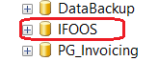
  - deploy latest changes into Local database
C:\dev\database\IFOOS.sln
Rebuild, then deploy:
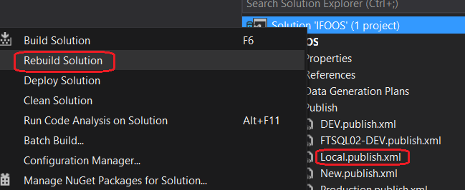

Permission request SN
https://activenetwork.service-now.com/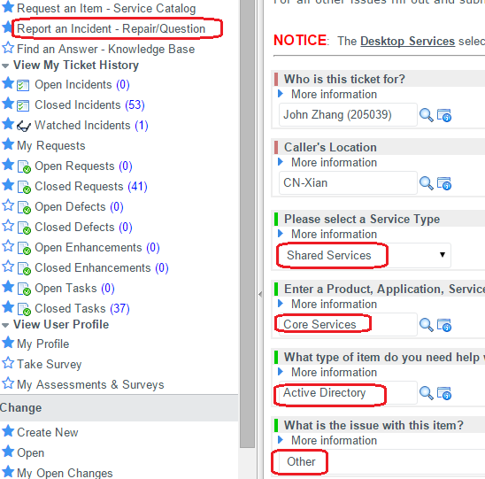

IIS
3.1 IIS site:
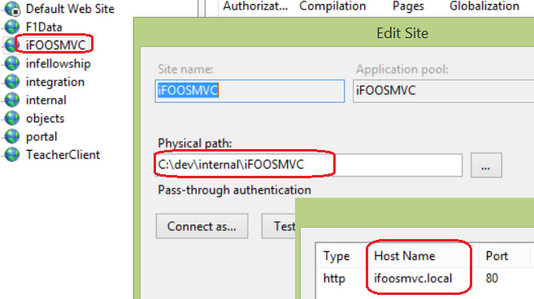
  - C:\Windows\System32\drivers\etc\hosts
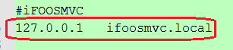

VS – ‘C:\dev\internal\iFOOSMVC.sln’
4.1 Set ‘iFOOSMVC’ as StartUp project
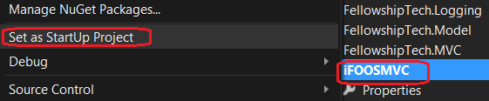
4.2 Rebuild Solution, then F5 to start to debug iFOOS

Related SP
ChmChurch.. CreateNewChurch
pr_ChangePortalVersion

Maybe local database hasn’t enough info, please get from QA or Prod database
- For table iFOOS..Affiliate, copy info from Prod db
- For table chmChurch..Church, copy the record where church_id = 228 from Prod db
- For table chmChurch..Dept, copy the record where church_id = 228 from Prod db
--228 is default setting in
"C:\dev\shared\MachineConfigSettings\config_keys.yml":
iFOOS.CreateChurch.MasterChurchID: "228"

- For table chmChurch..User, copy record where ‘CHURCH_ID = 228 AND [LOGIN] = 'pm'’

iFOOS business
