**Lowest Common Ancestor in Binary Tree**

Medium

50

The lowest common ancestor of two nodes p and q is the lowest node in the binary tree that has p and q as its descendants.  
Note: A node is also considered a descendant of itself.

Given the reference to the root node and two nodes p and q in a binary tree, return the reference to the lowest common ancestor of p and q.

Note: You can assume that p and q will be present in the tree.

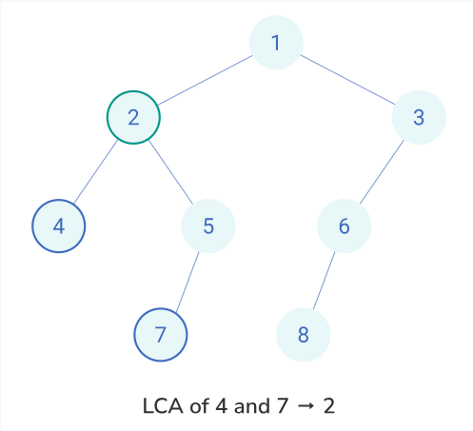

**Testing**

**Input Format**

The first line contains an integer ***T*** denoting the number of test cases.

For each test case, the input has 3 lines:

* The first line contains an integer ***n*** denoting the number of nodes in the tree (including the NULL nodes).
* The second line contains *n* space-separated integers that will form the binary tree. The integers follow level order traversal of the tree where -1 indicates a NULL node.
* The third line contains 2 space-separated integers denoting the 0-based index of p and q in the above list.

**Output Format**

For each test case, the output contains a line with the value of the lowest common ancestor for p and q.

**Sample Input**

6

7

1 2 -1 4 -1 5 6

1 5

3

6 -1 4

0 2

7

8 -1 9 -1 10 11 12

2 5

5

28 14 11 -1 48

4 2

1

6

0 0

7

3 -1 2 1 5 -1 6

3 6

**Expected Output**

2

6

9

28

6

1