**N Queens Problem**

You are given an n*n chess board with n queens. You need to find all the configurations of the pieces such that no two queens attack each other.

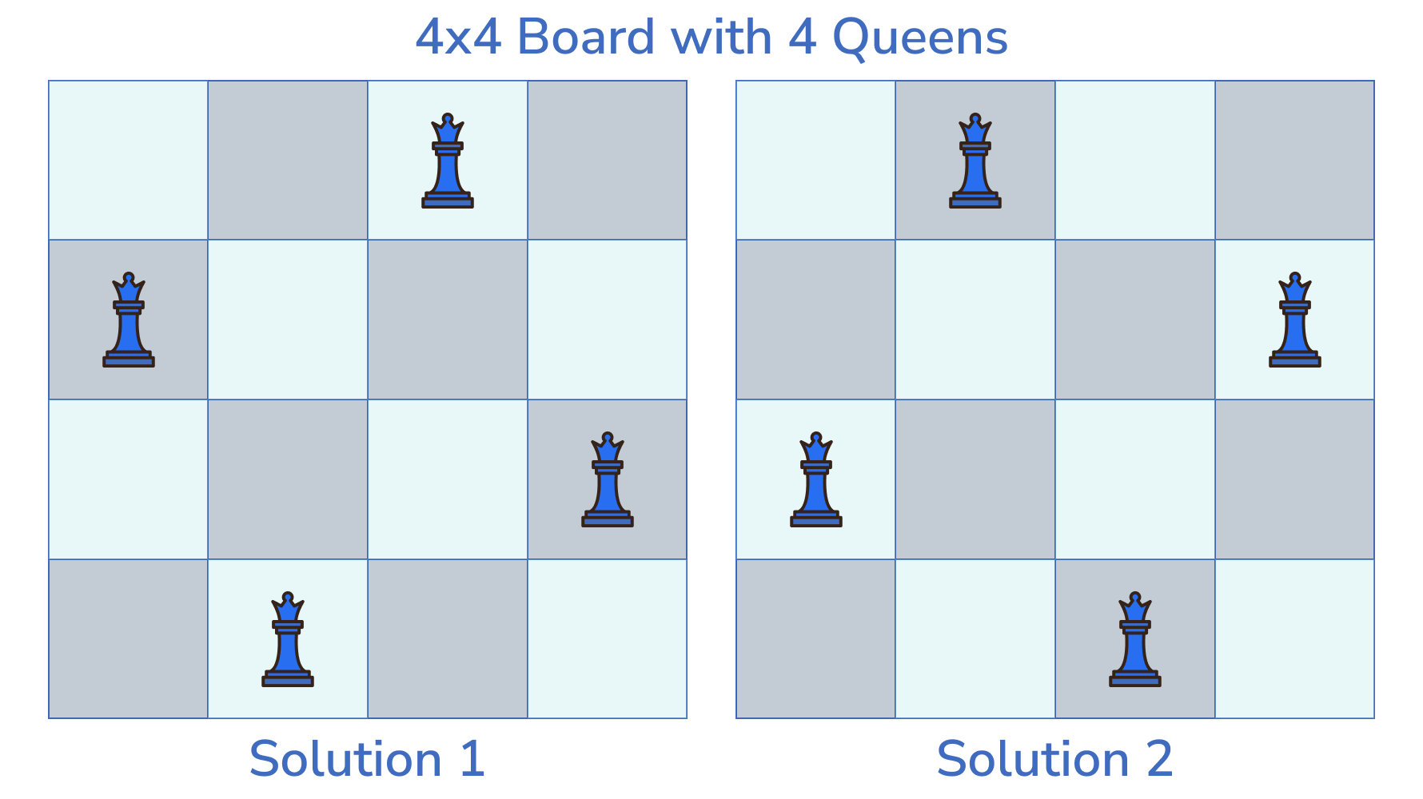

Each valid configuration is a unique list of *n* strings of length *n* where ‘Q’ and ‘.’ represents a Queen and empty space respectively.

**Example:**

Input: n = 4

Output: [["..Q.","Q...","...Q",".Q.."], [".Q..","...Q","Q...","..Q."]]

**Testing**

**Input Format**

The first line contains an integer ‘T’, denoting the number of test cases.  
For each test case, a line containing an integer ‘n’ denoting the dimension of the chess board and the number of queens.

**Output Format**

For each test case, print all the valid configurations with each row on a separate line.

**Examples**

**Sample Input**

2

1

4

**Expected Output**

Q

..Q.

Q...

...Q

.Q..

.Q..

...Q

Q...

..Q.