**Symmetric Binary Tree**

A binary tree is considered symmetric if it is a mirror image of itself, i.e, it is symmetric around its root node.

Given the root node of a binary tree, determine whether it's symmetric.

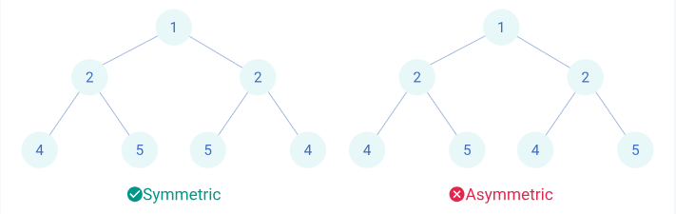

**Testing**

**Input Format**

The first line contains an integer ***T*** denoting the number of test cases.

For each test case, the input has 2 lines:

* The first line contains an integer ***n*** denoting the number of nodes in the tree (including the NULL nodes).
* The second line contains *n* space-separated integers that will form the binary tree. The integers follow level order traversal of the tree where -1 indicates a NULL node.

**Output Format**

For each test case, the output contains a line with 1 or 0 based on whether the tree is symmetric or not respectively.

**Sample Input**

4

7

1 2 2 4 -1 -1 4

7

6 4 4 -1 2 -1 2

7

1 2 3 4 -1 -1 4

1

6

**Expected Output**

1

0

0

1