Jie Zheng

Section 1

**Autobiography**

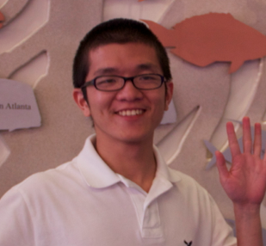

My major is CMPSC. I’m interesting in Java. My only goal is to graduate and get a job. I am currently taking 18 credits. I don’t have a part-time job. I have taken CMPSC 121 and CMPSC 122 and nothing else. The very basic of C++ was emphasized in CMPSC 121. Object orientation programming and data structure were emphasized in CMPSC 122. I have taken Math 140, Math 141 and Math 230. Calculus I, II and III were emphasized in these course. What I like about all the Math courses I took is learning the skill and applying the skill to the problems. What I don’t like about it is some course has too much homework to do. I like all the CMPSC courses I took. I love CMPSC 121 most because I like the teaching style the instructor use.-going over a lot the example and explain as much as he can and assign homework or Lab after class. I do not have any background in computer programming outside of my college course work. I hope to be able to create a dynamic website from scratch after this course.