CMPSC 221 Lab 10 Report
Date: 23 February 2013
Name: Jie Zheng
PSU ID: Jie Zheng
Section: 1

Code
import java.awt.Font;
import java.awt.Graphics;
import java.awt.Color;
import java.awt.BorderLayout;
import javax.swing.JFrame;
import javax.swing.JLabel;
import javax.swing.JPanel;
import javax.swing.ImageIcon;

public class DrawBullseye extends JPanel {
//PRE:
//POST: Class name DrawBullsevye that extends JPanel has been created
public DrawBullseye () { // set up graphics window
super(); // this can be omitted
//Color darkBlue = new Color(0, 0, 150);
setBackground(Color.white);
}

@Override
public void paintComponent(Graphics g) {
//
// POST: Graphics g has been draw
int width = getWidth(); // width of window in pixels
int height = getHeight(); // height of window in pixels
super.paintComponent(g); // call superclass to make panel display correctly
int numberOfCircles=10; //set number of circle

int diameter;

// This condition statement is for the circles to to fully contained within the window
if (width>=height) {
diameter=height;
} else {
diameter=width;
}

int increment=diameter/numberOfCircles;

Color color1=new Color((int)(Math.random()*256),(int)(Math.random()*256),(int)(Math.random()*256)); //random choose color1
Color color2=new Color((int)(Math.random()*256),(int)(Math.random()*256),(int)(Math.random()*256)); //random choose color2 that is different from color1
while (color2==color1) {
color2=new Color((int)(Math.random()*256),(int)(Math.random()*256),(int)(Math.random()*256));
}
for ( int i=0; i<numberOfCircles;i++) {
if(i%2==0) {
g.setColor(color1);
g.fillOval(width/2-diameter/2, height/2-diameter/2, diameter, diameter); //stay in center
} else {

g.setColor(color2);
g.fillOval(width/2-diameter/2, height/2-diameter/2, diameter, diameter); //stay in center
}
diameter-=increment;

}
// g.drawLine(0, height, width, 0);
// g.drawRect(width/2-100, height/2-100, 200, 200);
// g.drawOval(width/2-100, height/2-100, 200, 200);
// g.drawRect(width/2-5, height/2-5, 10, 10);
// g.drawArc(width/2-100, height/2-50, 200, 100, 0, 180);

// set color3 that is different from color1 and color2
Color color3=new Color((int)(Math.random()*256),(int)(Math.random()*256),(int)(Math.random()*256));
while(color3==color1||color3==color2) {
color3=new Color((int)(Math.random()*256),(int)(Math.random()*256),(int)(Math.random()*256));
}

g.setColor(color3); //set name color

Font font1 = new Font("SansSerif", Font.BOLD, 20); //set font
g.setFont(font1);
String s1="Jie Zheng";
g.drawString(s1, (width-getFontMetrics(font1).stringWidth(s1))/2,getFontMetrics(font1).getHeight());
}

public static void main(String[] args) {
DrawBullseye panel = new DrawBullseye (); // window for drawing
JFrame application = new JFrame(); // the program itself

application.setTitle("APPlication");
//application.setBackground( Color.BLACK );
application.getContentPane().setBackground(Color.BLACK);

application.setDefaultCloseOperation(JFrame.EXIT_ON_CLOSE); // set frame to exit
// when it is closed
application.add(panel);

application.setSize(500, 500); // window is 500 pixels wide, 400 high
application.setVisible(true);
}

}

Sample Runs

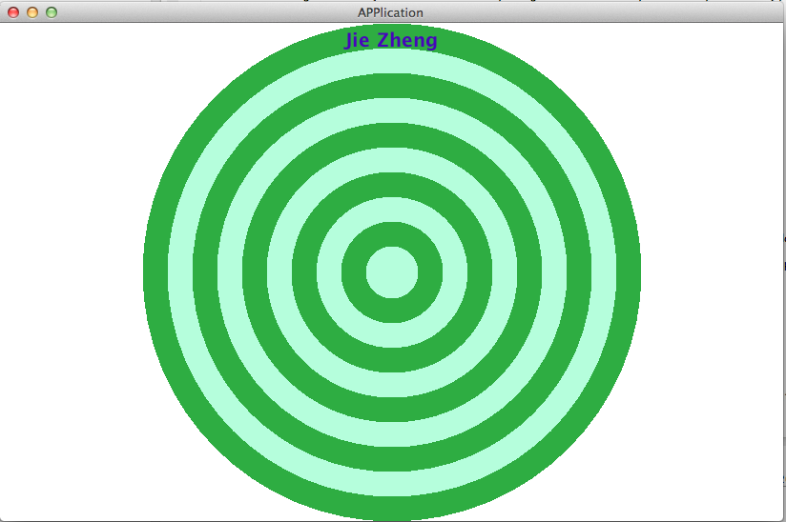

Discussion

GUI is more fun than the console application. There are some tricks in the lab. For example, to let the circle stay in the center, we have to use getWidth() and getHeight() function. To let the circles stay fully contained, I need to call a condition statement to make the diameter of the largest circle to be the smaller of the Width and Height. To make the color random and different from other color, I need to use while() loop and Math.random() function together. Most tricky one is display the name. We have not learn how to set a font, so I Google it and make it work. For the position of the name, I use getFontMetrics(font).stringWidth(stringNmae) and getFontMetrics(font).getHeight(). I think it would been easier had we been taught how to use these functions in class.

