CMPSC 221 Lab 11 Report
Date: 14 March 2013
Name: Jie Zheng
PSU ID: Jie Zheng
Section: 1

Code
import java.awt.Color;
import java.awt.FlowLayout;
import java.awt.Graphics;
import java.awt.event.*;

import javax.swing.*;

public class FrontEndBackEnd extends JApplet implements ItemListener,ActionListener{
private int upLeftX; // top left point x-coordinate of square to draw
private int upLeftY; // top left pint y-coordinate of square to draw
private final int Length=30; // square edge length
private JPanel panel1;
private JPanel panel2;
private JRadioButton drawSqureRadioButton; //RationButton for Drawing Square
private JRadioButton writeMessageRadioButton; //RatioButton for Drawing Message
private boolean ifDrawSquare; //Test to draw square or message
private ButtonGroup buttongroup; //ButtonGroup for RadioButtons
private Color textColor; //Color of the object to be draw
private JTextField textField; //Text Field for entering the message to be draw
private JComboBox dropDownList; //Drop down list
private String[] colorArray={"","Pick randomly","top left"}; //Stirng[] for drop down
private JCheckBox drawInColorCheckButton; //Check box to decide color or black
private JButton drawItButton; //draw button that addActionListener

public void init() {
setLayout(new FlowLayout());

// ************************************
//Panel 1
// ************************************
panel1=new JPanel();

// Add DrawSquare RadioButton
drawSqureRadioButton=new JRadioButton("Draw Square",false);
drawSqureRadioButton.addItemListener(this);
panel1.add(drawSqureRadioButton);

// Add WriteMessage RadioButton
writeMessageRadioButton=new JRadioButton("Write message: ",true);
writeMessageRadioButton.addItemListener(this);
panel1.add(writeMessageRadioButton);

// Add DrawSquare and WriteMessage RadioButton to ButtonGroup
buttongroup=new ButtonGroup();
buttongroup.add(drawSqureRadioButton);
buttongroup.add(writeMessageRadioButton);

// Add TextArea
textField=new JTextField(20);
panel1.add(textField);

// ************************************
//Panel 2
// ************************************
panel2=new JPanel();

// Add a JLabel
panel2.add(new JLabel("Select where to draw: "));

// Add a dropdown list
dropDownList=new JComboBox(colorArray);
dropDownList.setMaximumRowCount(3);
dropDownList.addItemListener(this);
panel2.add(dropDownList);

// Add a DrawInColor JCheckBox
drawInColorCheckButton=new JCheckBox("Draw in color");
drawInColorCheckButton.addItemListener(this);
panel2.add(drawInColorCheckButton);

// Add DrawIt JButton
drawItButton=new JButton("Draw It!");
drawItButton.addActionListener(this);
panel2.add(drawItButton);

// Add Pane1 and Pane2 to JFrame
add(panel1);
add(panel2);
}
public void paint(Graphics g) {
super.paint(g); //call super method
g.setColor(textColor); //set color
if(ifDrawSquare) { //draw square
g.drawRect(upLeftX, upLeftY, Length, Length);
} else { //draw message
g.drawString(textField.getText(), upLeftX,upLeftY);
}
}

@Override
public void itemStateChanged(ItemEvent ie) {

if(ie.getSource()==drawSqureRadioButton && drawSqureRadioButton.isSelected()) {
ifDrawSquare=true; //draw square
}
if(ie.getSource()==writeMessageRadioButton && writeMessageRadioButton.isSelected()) {
ifDrawSquare=false; //draw message
}
}
@Override
public void actionPerformed(ActionEvent ae) {

// set parameter and call repaint when drawItButton is selected and dropDownList is not empty string
if(ae.getSource() == drawItButton && dropDownList.getSelectedItem()!="") {
if (dropDownList.getSelectedItem()=="Pick randomly") {
upLeftX=(int)(getWidth()*1.0/10.0+Math.random()*(getWidth()*8.0/10.0)); // random X location with appropriate padding
upLeftY=(int)(getHeight()*2.0/10.0+Math.random()*(getHeight()*7.0/10.0)); //random Y location appropriate padding

} else {
upLeftX=(int)(getWidth()*1/10.0); //X location with appropriate padding
upLeftY=(int)(getHeight()*2/10.0); //Y location with appropriate padding
}

if(drawInColorCheckButton.isSelected()) {
textColor=new Color((int)(Math.random()*256),(int)(Math.random()*256),(int)(Math.random()*256)); //random color

} else {
textColor=Color.black; //default color
}

repaint();

}

}

}

Sample Runs

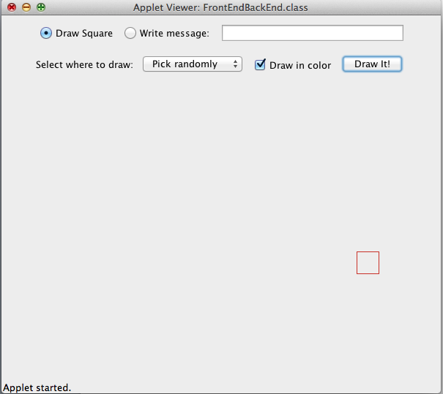

Discussion

I learned how to use panels to organize the GUI components. I used ButtonGroup to make radio Group buttons single selectable. I learned how to implement event handle with itemStateChanged() and actionPerformed() methods. I once had the problem when the empty string in the drop down list was selected, the actionPerformed() will also call repaint(). This is not what I need. I want to make it do nothing when the empty was selected. In the end, I put “ae.getSource() == drawItButton && dropDownList.getSelectedItem()!=""” as the condition that call repaint(), which successfully eliminated the flaw.

