CMPSC 221 Lab 13 Report
Date: 22 March 2013
Name: Jie Zheng
PSU ID: Jie Zheng
Section: 1

Code
import java.applet.Applet;
import java.awt.Color;
import java.awt.FlowLayout;
import java.awt.Graphics;
import java.awt.Polygon;
import java.awt.color.ColorSpace;
import java.awt.event.ActionEvent;
import java.awt.event.ActionListener;
import java.awt.event.ItemEvent;
import java.awt.event.ItemListener;
import java.awt.event.MouseEvent;
import java.awt.event.MouseListener;
import java.lang.reflect.Array;
import java.util.Vector;

import javax.swing.JButton;
import javax.swing.JColorChooser;
import javax.swing.SwingUtilities;

public class DrawingPolygons extends Applet implements MouseListener,ActionListener{

private JButton colorButton; //color picker
private JButton clearButton; //reset button
private Color polygonColor; //color of polygon
private Boolean allowAddPoint; //use to test whether user is done drawing
private Vector<Integer> X; //temp container for Xarray
private Vector<Integer> Y; //temp container for Yarray
private int [] Xarray; //X coordinate for polygon
private int [] Yarray; //Y coordinate for polygon

public void init() {
polygonColor=Color.BLACK; //default color
allowAddPoint=true; //set default to true
setLayout(new FlowLayout(FlowLayout.LEFT)); //set layout

colorButton=new JButton("Color Picker"); //set label of colorButton
colorButton.addActionListener(this); //add action listener
add(colorButton); //add to program

clearButton=new JButton("Reset"); //set label of clearButton
clearButton.addActionListener(this); //add action listener
add(clearButton); //add to program

X=new Vector<Integer>(); //allocate X vector
Y=new Vector<Integer>(); //allocate Y vector
addMouseListener(this); //add Mouse Listener to the program
}

@Override
public void paint(Graphics g) {

super.paint(g); //call super paint class

g.setColor(Color.BLACK); //color for outline to drawing area
g.drawRect(5, 45, (int)(this.getSize().getWidth()-10), (int)(this.getSize().getHeight()-45-5)); //create the drawing area
g.setColor(polygonColor); //set the color

if (X.size()>0) {
if(allowAddPoint) { //if not done draw the polyline
g.drawPolyline(Xarray, Yarray, X.size());
} else { //if done fill the polygon
g.fillPolygon(Xarray,Yarray,X.size());
}
}

}

public void mousePressed(MouseEvent e) {

}

public void mouseClicked(MouseEvent e) {
if(SwingUtilities.isLeftMouseButton(e)){ //it's left mouse click
if(allowAddPoint==true && e.getY()>45) { //if not done

X.add(e.getX()); //add x coordinate
Y.add(e.getY()); //add y coordinate

Xarray=new int[X.size()]; //allocate Xarray
Yarray=new int[Y.size()]; //allocate Yarray

for (int i=0; i<X.size();i++) { //copy from vector array
Xarray[i]=(int)X.get(i);
Yarray[i]=(int)Y.get(i);
}
repaint(); //draw the polygon in paint()
}

}
if (SwingUtilities.isRightMouseButton(e)) { //it's right mouse click
if (allowAddPoint==true) { // if not done
allowAddPoint=false; // set to done
repaint(); //fill the polygon in paint()
}

}
}

public void mouseReleased(MouseEvent e) {

}

public void mouseEntered(MouseEvent e) {

}

public void mouseExited(MouseEvent e) {

}

public void actionPerformed(ActionEvent e) {
if(e.getSource() == colorButton) {
// allow user to choose a color
polygonColor = JColorChooser.showDialog(this, "Choose a color", polygonColor);
}
if(e.getSource() == clearButton) {
//set the allowAddpoint to true and reallocate memory for myPolygon
allowAddPoint=true;
X=new Vector<Integer>(); //reallocate X vector
Y=new Vector<Integer>(); //reallocate Y vector
}

repaint();
}

}
Sample Runs
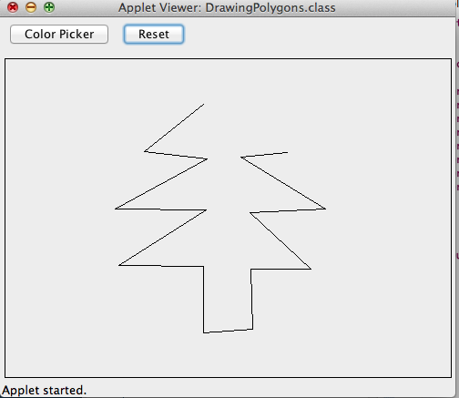

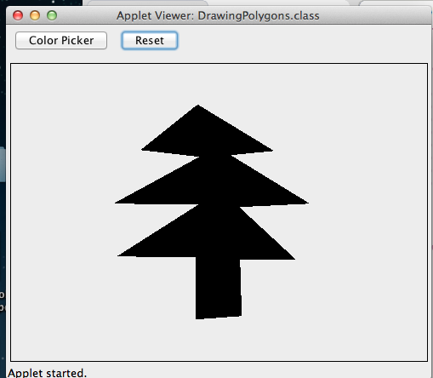

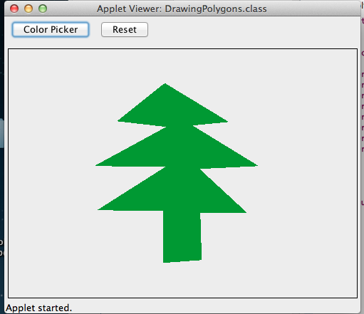

Discussion

This lab is easy, but requiring some tricks. First, it should draw polyline before right click. So I need two int arrays for x and y coordinates. What I did is using a two temp Vector to store the x and y coordinates, because it is much easy to increase the size of vector and track the size of the vector. Then I copied the data from vectors to int arrays. Also, I set a minimum height to draw polyline; otherwise it will cover the buttons in the top. It’s nice to have a rectangle to indicate where you can draw the graphic, so I drew it. A very important thing to check is that make sure you have at least one coordinate before you draw the polyline, otherwise you will have null point error. I did some research about how to distinguish left click and right click. I ended up using SwingUtilities.isLeftMouseButton() and SwingUtilities.isRightMouseButton().

