CMPSC 221 Lab 14 Report
Date: 20 March 2013
Name: Jie Zheng
PSU ID: Jie Zheng
Section: 1

Code
import java.awt.FlowLayout;
import java.awt.Graphics;
import java.awt.Color;
import java.awt.BorderLayout;
import java.awt.GridBagConstraints;
import java.awt.GridBagLayout;
import java.awt.Insets;
import java.awt.event.ItemEvent;
import java.awt.event.ItemListener;
import java.awt.event.MouseEvent;
import java.awt.event.MouseListener;

import javax.swing.ButtonGroup;
import javax.swing.JApplet;
import javax.swing.JButton;
import javax.swing.JFrame;
import javax.swing.JLabel;
import javax.swing.JPanel;
import javax.swing.ImageIcon;
import javax.swing.JRadioButton;

public class DrawRec extends JApplet implements MouseListener,ItemListener {
private JRadioButton RedButton;
private JRadioButton GreenButton;
private JRadioButton BlueButton;

private int x;
private int y;

private Color RecColor;

public void init() {

setLayout(new FlowLayout());
RedButton=new JRadioButton("Red",true);
GreenButton=new JRadioButton("Green",false);
BlueButton=new JRadioButton("Blue",false);

RedButton.addItemListener(this);
GreenButton.addItemListener(this);
BlueButton.addItemListener(this);

ButtonGroup buttongroup1= new ButtonGroup();
buttongroup1.add(RedButton);
buttongroup1.add(GreenButton);
buttongroup1.add(BlueButton);

add(RedButton);
add(GreenButton);
add(BlueButton);

addMouseListener(this);

}

@Override
public void paint(Graphics g) {
super.paint(g);
g.setColor(RecColor);
if(y>=50) {
g.fillRect(x, y, 20, 20);
}
}

public void mousePressed(MouseEvent e) { // save coordinates of presses
x = e.getX();
y = e.getY();

repaint();

}

public void mouseClicked(MouseEvent e) { // save coordinates of clicks
// x = e.getX();
// y = e.getY();
// repaint();
}

public void mouseReleased(MouseEvent e) { // save coordinates of releases

}

public void mouseEntered(MouseEvent e) { // save coordinates when mouse enters applet

}

public void mouseExited(MouseEvent e) { // save coordinates when mouse leaves applet

}

public void itemStateChanged(ItemEvent e) { // handle radio button changes
if(e.getSource() == RedButton && RedButton.isSelected()) { // black chosen
RecColor = Color.RED;
}
if(e.getSource() == GreenButton && GreenButton.isSelected()) { // red chosen
RecColor = Color.GREEN;
}
if(e.getSource() == BlueButton && BlueButton.isSelected()) { // green chosen
RecColor = Color.BLUE;
}
}

}
Sample Runs
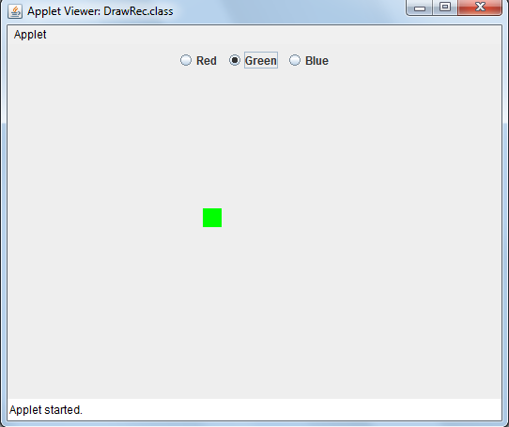

Discussion

Member Data:
I had three JRadioButtons: RedButton, GreenButton, BlueButton. I added them to a ButtonGroup so that only one of the JRadioButton can be selected. I had x , y, RecColor for the location of the Rectangle to be draw and the color of it. I set the default color to COLOR.RED.

Function:
In the init() function. I added itemlistener to each of the Color JRadioButton. I added addMouseListener to the whole panel.

In the paint() function. I called the super.paint(g) function. I set the color of the graphics to RecColor. To avoid overlapping, it drew the Rectangle only when (y>50). I set the size of the Rectangle to width=20 and height=20. The location of the up left point is set to x, y. (the location of the mouse)

In mousePressed() function. I set x and y to the location of the mouse coordinates. And call repaint().

In itemStateChanged(). Set the color depend on which JRadioButton is selected.

