CMPSC 221 Lab 15 Report
Date: 4 April 2013
Name: Jie Zheng
PSU ID: Jie Zheng
Section: 1

Code

Problem 1: select purchase_cost,description from product

Problem 2: select purchase_cost, quantity_on_hand from product where product_code in ('HW', 'FW', 'BK');

Problem 3: select * from product where description like '%Speakers%';

Problem 4: select description,quantity_on_hand from product order by quantity_on_hand desc;

Problem 5: select upper(description) DESCRIPTION,quantity_on_hand from product order by quantity_on_hand desc;

Problem 6: select * from product where Available='TRUE' and purchase_cost between 20 and 100;

Problem 7: select description,manufacturer_id,purchase_cost*quantity_on_hand worth from product order by purchase_cost;

Problem 8: select manufacturer_id, ceil(purchase_cost) Rounded_Cost from product;

Problem 9: select product_id from product where product_code='BK';

Problem 10: select order_num,customer_id,shipping_cost/quantity average_shipping_cost from purchase_order;

Problem 11: select order_num from purchase_order where product_id in(select product_id from product where product_code='BK');

Sample Runs
Problem 1:
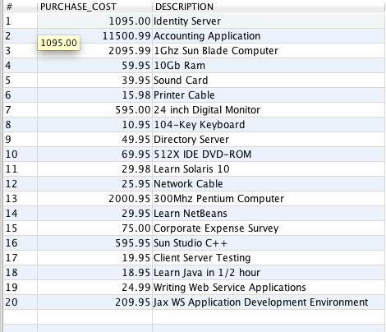

Problem 2:
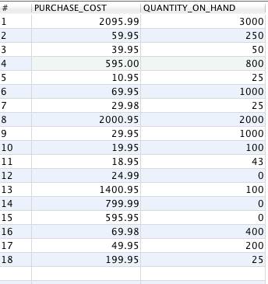

Problem 3:

Problem 4:
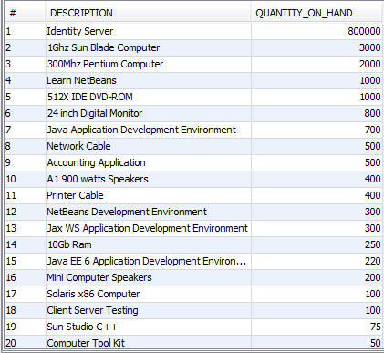

Problem 5:

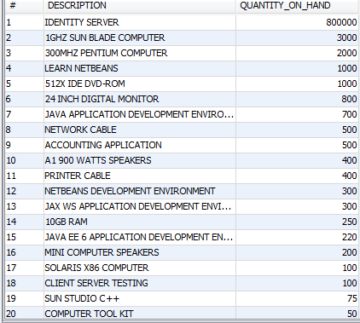

Problem 6:
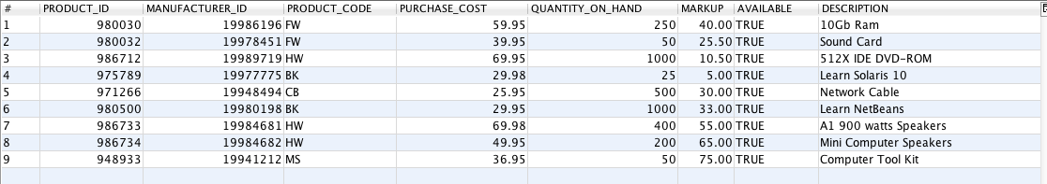

Problem 7:
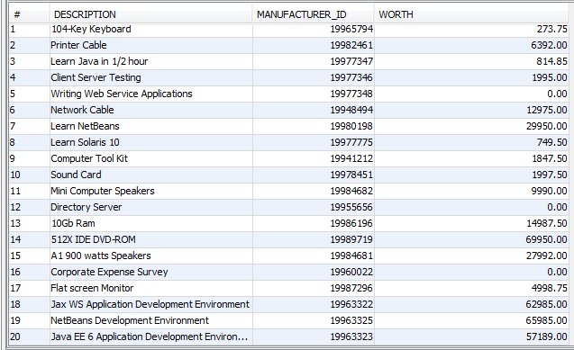

Problem 8:
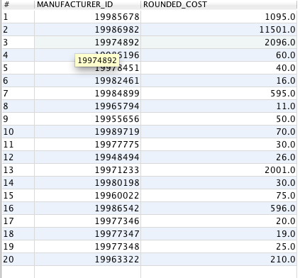

Problem 9:
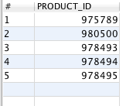

Problem 10:
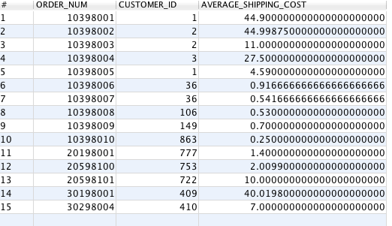

Problem 11:
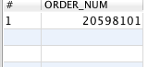

Discussion

It’s much easy to working with database to select and sort table than write java function to do that. I am not sure if discussion is required in this lab, but I wrote it anyway. I didn’t run into any problem with this lab. For #11, we need idea of sub-queries to solve the problem. #3 is a little tricky because the table is too big and Net Beans only display to 20 of the list, so I did not find any speaker in the first 20 rows. (like '%Speakers%' will do it, also be careful with capital letter for S). I expected some problem with “group by” and “having”, while it did not have any in this lab. I learned quite a lot SQL select technique from this lab.

