CMPSC 221 Lab 16 Report
Date: 12 April 2013
Name: Jie Zheng
PSU ID: Jie Zheng
Section: 1

Code

-- Question1:
select sum(shipping_cost) totalShippingCost from purchase_order;

-- Question2:
select sum(quantity) TotalUnitsShipped, sum(shipping_cost) totalShippingCost from purchase_order where customer_id=1;

-- Question3:
select product_code,sum(quantity_on_hand) total_on_hand from product group by product_code;

-- Question4:
select product_code,sum(quantity_on_hand) total_on_hand from product group by product_code having sum(quantity_on_hand)>100 order by sum(quantity_on_hand) desc;

-- Question5:
update product set quantity_on_hand=50 where available='FALSE';

-- Question6:
select description, available,quantity_on_hand from product where available='FALSE';

-- Question7:
update customer set credit_limit=credit_limit+1000 where customer_id between 0 and 100;
-- select customer_id,credit_limit from customer where customer_id between 0 and 100; //add to verify #7

-- Question8:
select state, count(*) numberOfCustomers from customer group by state;

Sample Runs
Problem 1:


Problem 2:


Problem 3:

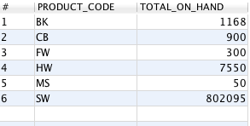

Problem 4:
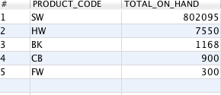

Problem 5:
// Verify in Problem 6

Problem 6:
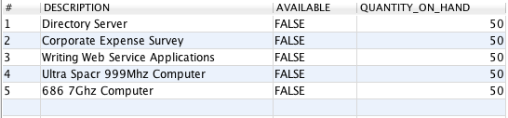

Problem 7:

// add to Verify #7
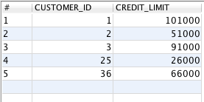

Problem 8:
