CMPSC 221 Lab 17 Report
Date: 18 April 2013
Name: Jie Zheng
PSU ID: Jie Zheng
Section: 1

Code

-- Question1:

select (select name from customer c where c.CUSTOMER_ID=p.CUSTOMER_ID) customer,sales_date,shipping_date from purchase_order p order by sales_date desc;

-- Question2:
select c.name,p.SALES_DATE,p.SHIPPING_DATE from purchase_order p inner join customer c on p.CUSTOMER_ID=c.CUSTOMER_ID order by p.SALES_DATE desc;

-- Question3:
select (select name from customer c where c.CUSTOMER_ID=pur.CUSTOMER_ID) customer, (select description from product pro where pro.PRODUCT_ID=pur.PRODUCT_ID ) product,sales_date,shipping_date from purchase_order pur order by sales_date desc;

-- Question4:
select description,
(select description from product_code procode where procode.PROD_CODE=pro.PRODUCT_CODE ) type,
quantity_on_hand
from product pro
where manufacturer_id in (select manufacturer_id from manufacturer where zip like '9%')
order by quantity_on_hand desc;

-- Question5
CREATE TABLE instructors (
instructor_id smallint not null primary key,
first_name varchar(25) not null,
middle_initial char(1),
last_name varchar(25) not null,
phone varchar(15)
);

-- Question6
ALTER TABLE sections
ADD instructor_id smallint
REFERENCES instructors (instructor_id);

-- Question7
INSERT INTO instructors (instructor_id, first_name, last_name, phone) values (0, 'John','Doe','814-555-1111');
INSERT INTO instructors (instructor_id, first_name, last_name, phone) values (1, 'Alex','Anisworth','814-555-2222');
INSERT INTO instructors (instructor_id, first_name, last_name, phone) values (2, 'Kevin','O''Neill','814-555-1234');
INSERT INTO instructors (instructor_id, first_name, last_name, phone) values (3, 'Jane','Soloway','814-555-6666');

/* also need this statement to be able to see the result from #8*/
update courses set number=121 where course_id=1;
update courses set number=102 where course_id=2;

-- Question8
select (select dept from courses c where c.COURSE_ID=s.COURSE_ID) dept,
(select number from courses c where c.COURSE_ID=s.COURSE_ID)NUMBER,
(select name from courses c where c.COURSE_ID=s.COURSE_ID) name,SECTION,
(select name from buildings b where b.BUILDING_ID=s.BUILDING_ID) building,
(select first_name||' '|| last_name from instructors i where i.INSTRUCTOR_ID=s.INSTRUCTOR_ID ) instructor
from sections s
where course_id in (select course_id from courses where number between 100 and 200);

Sample Runs
Problem 1:
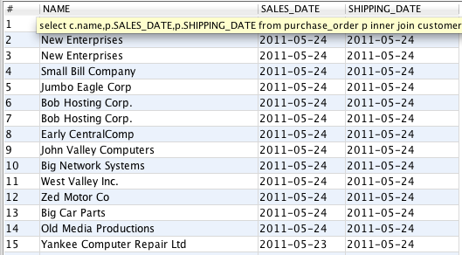

Problem 2:


Problem 3:

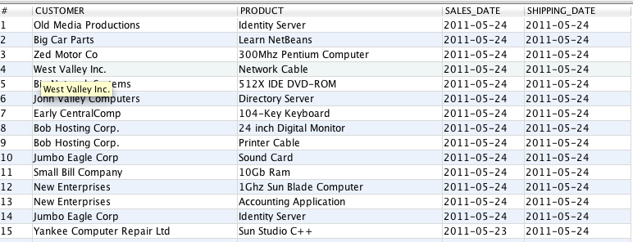

Problem 4:
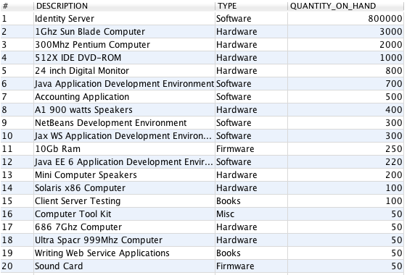

Problem 5:


Problem 6:



Problem 7:

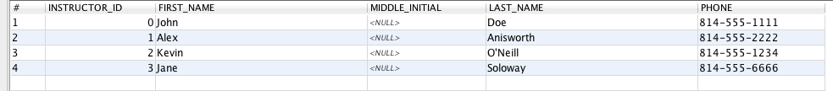

Problem 8:

