CMPSC 221 Lab 16 Report
Date: 1 May 2013
Name: Jie Zheng
PSU ID: Jie Zheng
Section: 1

Code

-- Question1
-- select number, name, (select sum(enrollment) from sections where course_id=c.COURSE_ID) totalEnrollment
-- from courses c
-- where course_id in( select course_id from sections group by course_id having sum(enrollment)!=0) and dept='CMPSC';

select (select number from courses c where c.COURSE_ID=s.COURSE_ID) number,
(select name from courses c where c.COURSE_ID=s.COURSE_ID) name,
totalEnrollment
from (select s.COURSE_ID,sum(enrollment) totalEnrollment from sections s group by s.COURSE_ID) s;

select c.NUMBER,c.NAME,s.totalenrollment
from (select course_id,sum(enrollment) totalenrollment from sections group by course_id) s inner join courses c on s.COURSE_ID=c.COURSE_ID
where c.DEPT='CMPSC';

-- Question2
-- select number, name, (select sum(enrollment) from sections where course_id=c.COURSE_ID) totalEnrollment
-- from courses c
-- where course_id in( select course_id from sections group by course_id having sum(enrollment) between 150 and 300) and dept='CMPSC' order by totalEnrollment desc;

select (select number from courses c where c.COURSE_ID=s.COURSE_ID) number,
(select name from courses c where c.COURSE_ID=s.COURSE_ID) name,
totalEnrollment
from (select s.COURSE_ID,sum(enrollment) totalEnrollment from sections s group by s.COURSE_ID) s
where totalEnrollment between 150 and 300
order by totalEnrollment desc;

select c.NUMBER,c.NAME,s.totalenrollment
from (select course_id,sum(enrollment) totalenrollment from sections group by course_id) s inner join courses c on s.COURSE_ID=c.COURSE_ID
where c.DEPT='CMPSC' and s.totalenrollment between 150 and 300
order by s.totalenrollment desc;

-- Question3
select (select name from buildings b where b.BUILDING_ID=s.BUILDING_ID),
s.maxenrollment
from (select BUILDING_ID, max(enrollment) maxenrollment from sections s group by BUILDING_ID having max(enrollment)>75) s;

-- Question4
select first_name ||' '|| last_name name,
(select count(*) from sections s where s.instructor_id=i.INSTRUCTOR_ID) section_num
from instructors i
where last_name like 'A%';

-- Question5
select first_name ||' '|| last_name name ,
(select count(*) from sections s where s.instructor_id=i.INSTRUCTOR_ID) section_num ,
(select b.NAME from buildings b where b.building_id=i.OFFICE_BUILDING_ID) buildingName,
office_room
from instructors i where i.last_name like 'A%';

-- Question6
update sections
set class_cap=class_cap+5
where class_cap=enrollment;

-- Question7
update sections
set class_cap=48, instructor_id=(select instructor_id from instructors where office_building_id =(select building_id from buildings where name ='IST') and office_room=346)
where course_id in (select course_id from courses where dept='CMPSC' and number=221)

-- Question8
delete from sections
where room=220 and building_id in (select building_id from buildings s where s.NAME like 'wi%');

-- Question9
select c.NUMBER,c.NAME,s.totalenrollment
from (select course_id,sum(enrollment) totalenrollment from sections group by course_id) s inner join courses c on s.COURSE_ID=c.COURSE_ID;

Sample Runs
Problem 1:
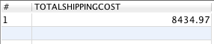

Problem 2:
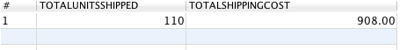

Problem 3:

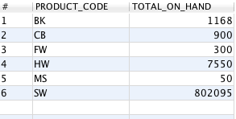

Problem 4:
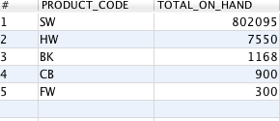

Problem 5:
// Verify in Problem 6

Problem 6:
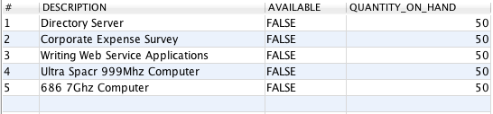

Problem 7:

// add to Verify #7
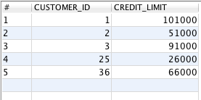

Problem 8:
