>> HW7q2

w=1.000000 stop at step 101

w=1.100000 stop at step 101

w=1.200000, stop at step 97

w=1.300000, stop at step 76

w=1.400000, stop at step 56

w=1.500000, stop at step 34

w=1.600000, stop at step 38

w=1.700000, stop at step 53

w=1.800000, stop at step 83

w=1.900000 stop at step 101

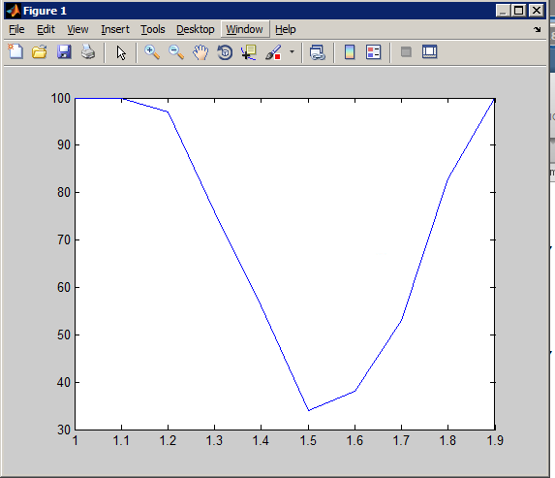

hw7p3-result

res =

1.0e+04 \*

0.143246152411155

0.288154956366622

0.436521775445709

0.591049546510523

0.753851737256760

0.928558777460369

1.118122243569174

0.734257286107643

0.363608301000164

n =

100

Comment: SOR converge faster