**How to Use this Template**

1. Make a copy [ File → Make a copy... ]
2. Rename this file: “**Capstone_Stage1**”
3. Replace the text in green

**Submission Instructions**

1. After you’ve completed all the sections, download this document as a PDF [ File → Download as PDF ]
2. Create a new GitHub repo for the capstone. Name it “**Capstone Project**”
3. Add this document to your repo. Make sure it’s named “**Capstone_Stage1.pdf**”

**GitHub Username**: jzhou23

FoodOrder

Description

App for customer order food, either take out or have the food in the restaurant.

Save time for waiting for food, use app instead of paper menu.

Intended User

Who is your intended user? (For example, is this an app for dog owners? Families? Students? Travelers?)

For both the customers and restaurants’ owners.

Features

List the main features of your app. For example:

* Using Firebase Auth and Firebase Database
* Customers can leave the comment for each food their ordered
* Owners can give the coupon for promotion

User Interface Mocks

These can be created by hand (take a photo of your drawings and insert them in this flow), or using a program like Photoshop or Balsamiq.

**Screen 1**

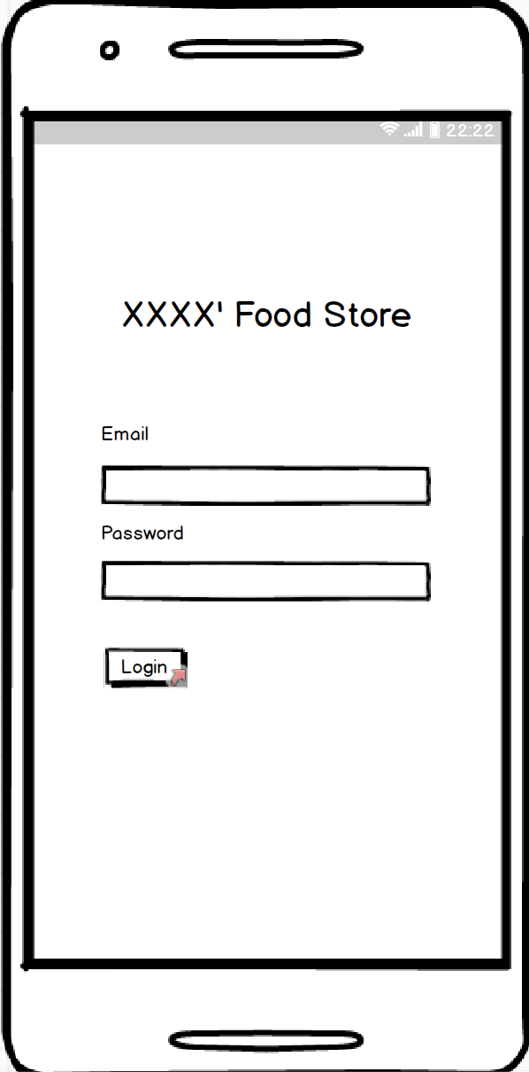

Owner’s log in page, I assume there are multi administrators and cooks for one restaurant

**Screen 2**

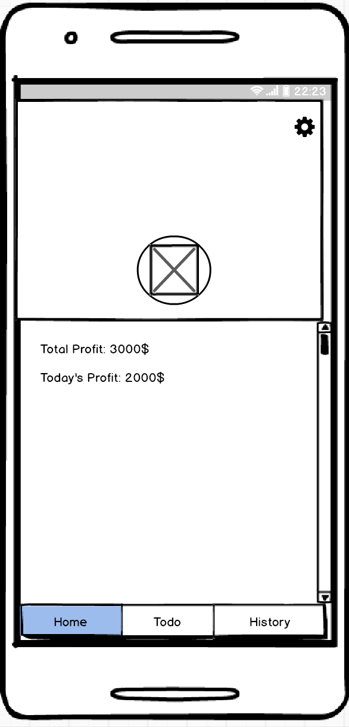

This is the home page in this app, display some summary information about daily profit and so on. Using Bottom Navigation Bar to navigate Home, Todo, History pages.

**Screen 3**

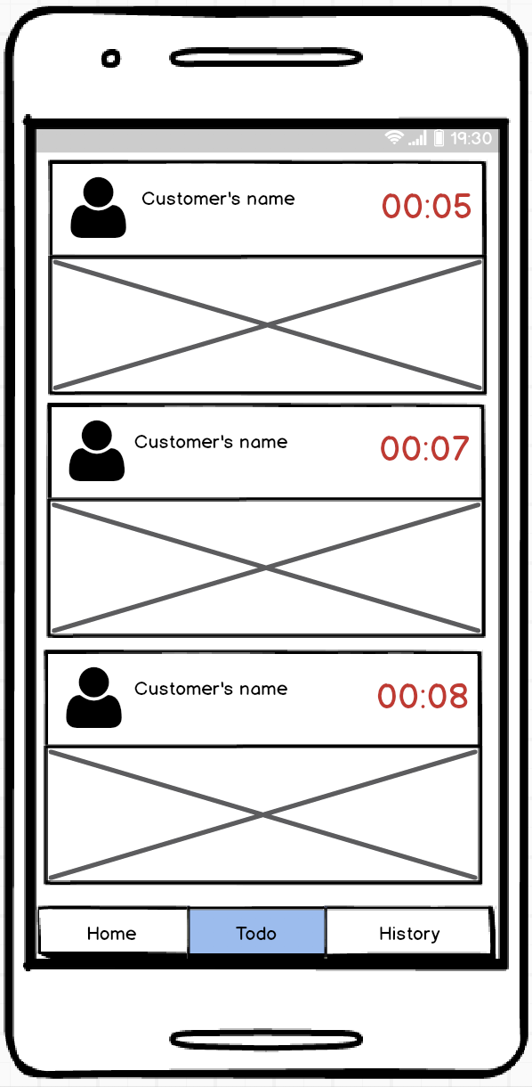

This is Todo page, When customer ordered some food, the user’s and order information will pop up. Cooks can click each item to prepare all the food customer ordered.

Two cooks cannot open one item.

**Screen 4**

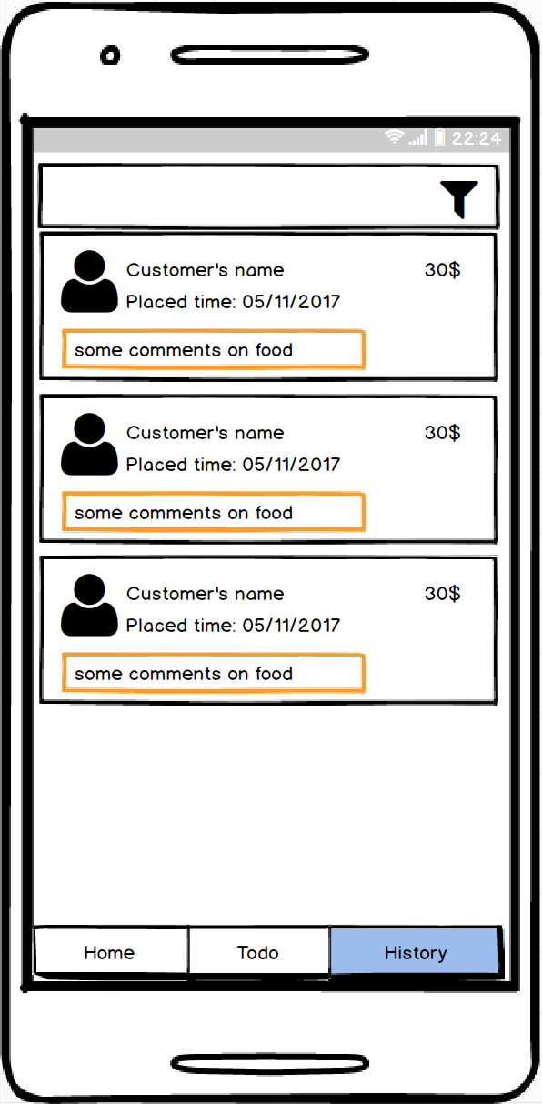

This is the History Page, shows all the orders he did and comments

**Screen 5**

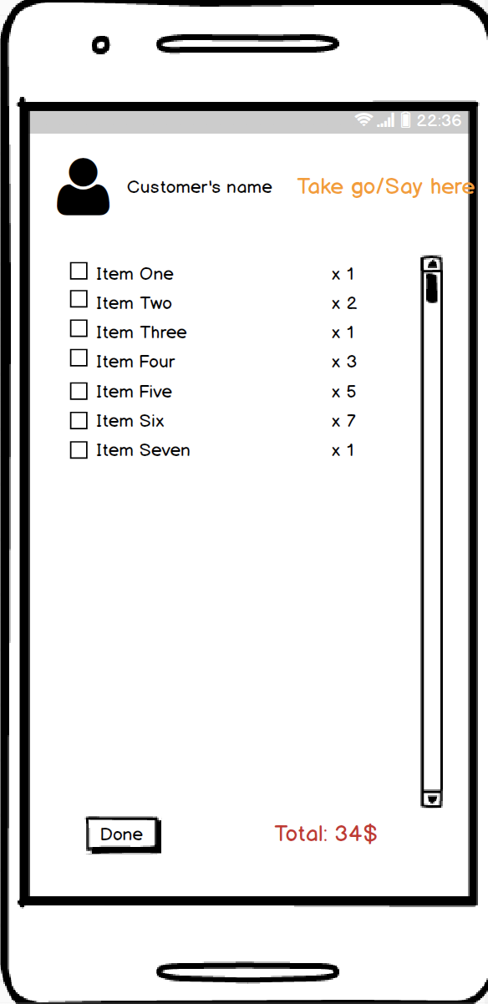

For order details. And this page should not call back until all the task is completed.

**Screen 6**

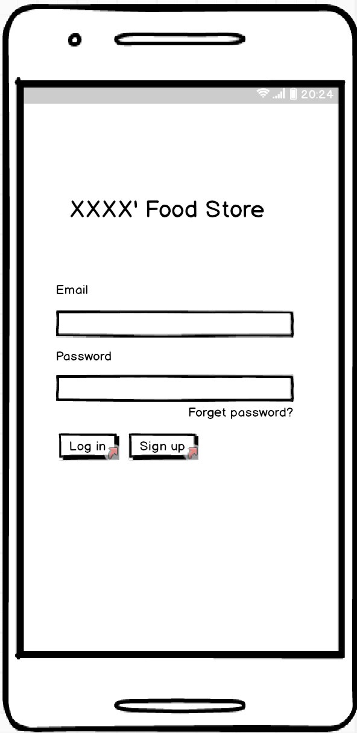

The log in and sign up page for customers.

**Screen 7**

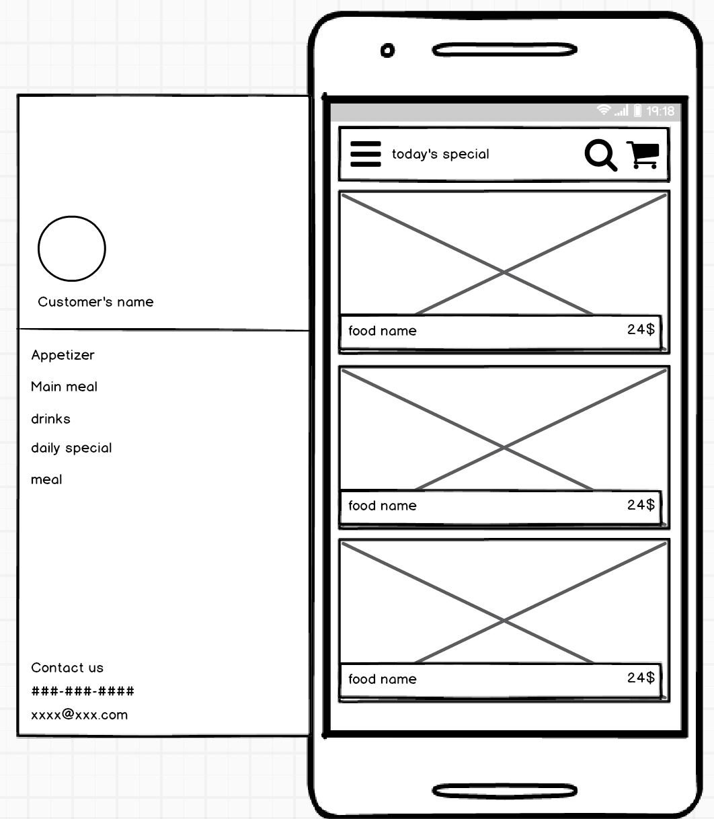

The main page for customers’ app, using navigation drawer to shows different menus.

**Screen 8**

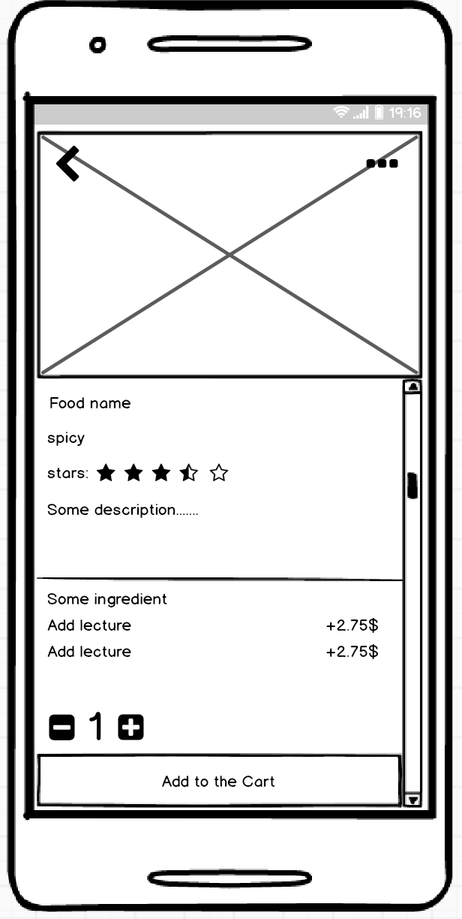

Detail page for each food.

**Screen 9**

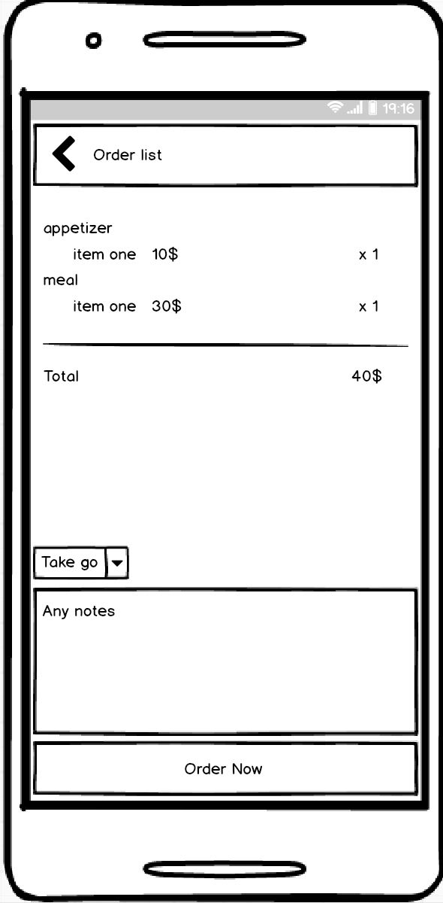

Shop Cart Page

**Screen 10**

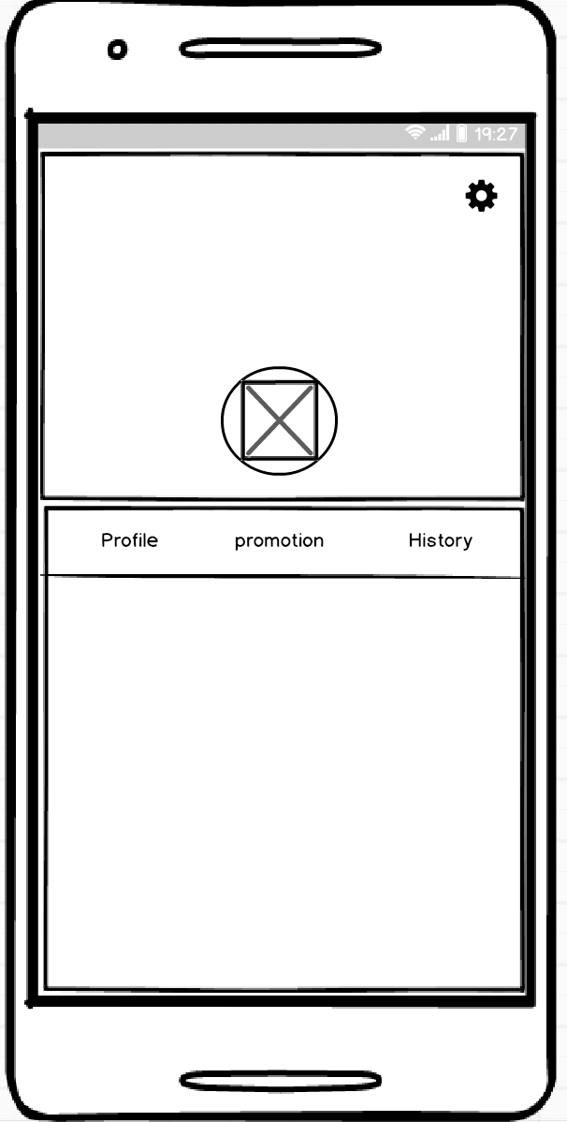

User’s profile page

**Screen 11:**

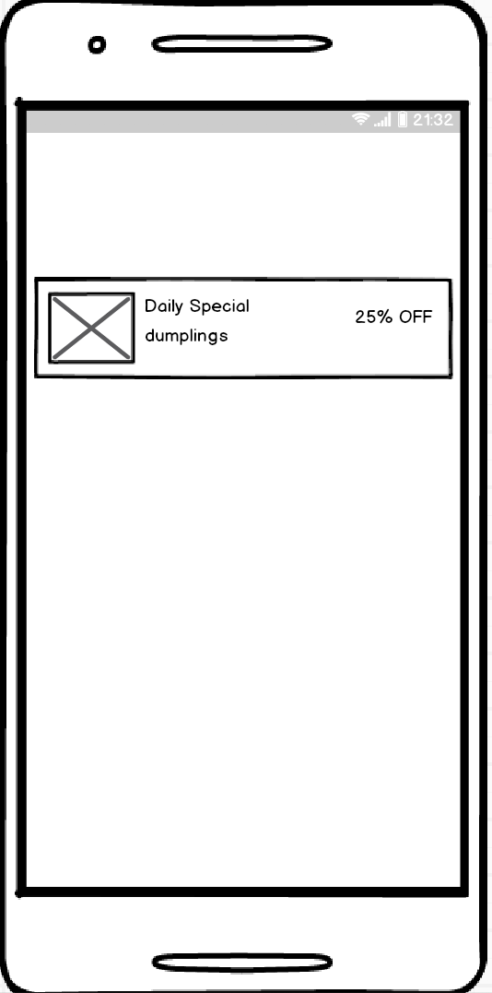

This Screen is about the widget of Customer’s App. However, personally I don’t like push the ad to the widget.

Key Considerations

**How will your app handle data persistence?**

I will build a Firebase Database to storage the menu and customers information.

Of course, build a Content Provider to store the data offline.

Using Sharedpreference to save person-preference.

**Describe any corner cases in the UX.**

For Owner’s app, cooks should not use back button to cancel an order

**Describe any libraries you’ll be using and share your reasoning for including them.**

Using Picasso to cache image.

Butterknife bind view, save time

Firebase to share menu and comments information

**Describe how you will implement Google Play Services.**

Firebase

Next Steps: Required Tasks

This is the section where you can take the main features of your app (declared above) and decompose them into tangible technical tasks that you can complete incrementally until you have a finished app.

**Task 1: Project Setup**

Brain storm.

Get the feedback from my friends, is this app is good enough?

**Task 2: Implement UI for Each Activity and Fragment**

Build all the UI for Activity and Fragment.

Use some navigation libraries to build each pattern.

Create different list item and adapter for different recyclerview

**Task 3: Set up Firebase Auth and Database**

Set up firebase Auth, set up the rules for customer and owners.

Collect Food image and information, and set up the Firebase database

As well as local database.

**Task 4: Implement Material Design**

Follow material design guide.

**Task 5: Test**

Test each part of the app is working well, debug.

Task 6: Loader Data

I will loader the data using loader and Firebase DataBase to move data to the page. Because I don’t use API to get data.

And use IntentService to search special food items. I’m not sure Firebase provide method for search. After all, I’ll find a way to search in the back thread to access the data.

Add as many tasks as you need to complete your app.

**Submission Instructions**

1. After you’ve completed all the sections, download this document as a PDF [ File → Download as PDF ]
2. Create a new GitHub repo for the capstone. Name it “**Capstone Project**”
3. Add this document to your repo. Make sure it’s named “**Capstone_Stage1.pdf**”