# Development Tools:

1. Eclipse: <http://www.eclipse.org/downloads/>

# Source Control:

1. Google code: Project location: <http://code.google.com/p/iano/>
2. **TortoiseSVN**: Client tool to access subversion repository. <http://tortoisesvn.net/downloads.html>

## Accessing google code for code check in and check out:

1. Download and install TortoiseSVN. Restart computer if needed.
2. Create a directory where you want the local copy of the project.
3. Right click on the directory and select "SVN Checkout" from the context menu. This will open the TortoiseSVN dialog to enter repository location.
4. In the "URL of repository" field, enter the repository location:

([**http**://iano.googlecode.com/svn/trunk/](http://iano.googlecode.com/svn/trunk/))

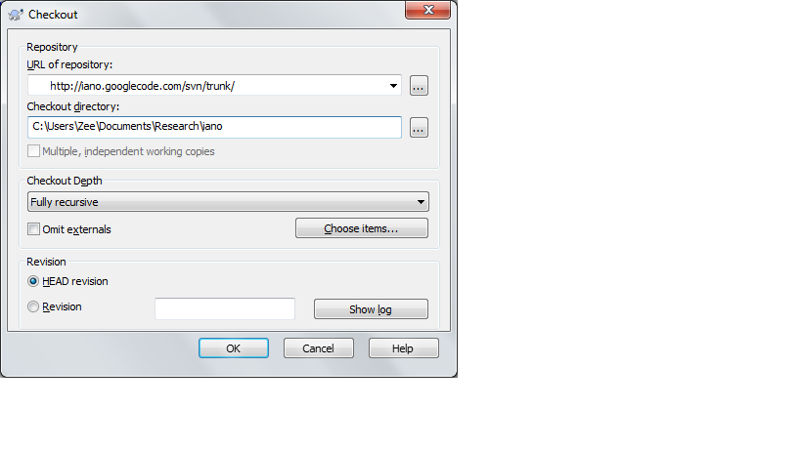

1. Click "OK". This will create the local copy of the project files.
2. To check in new codes after you have made changes, you can right click on the file or parent folder and select "SVN Commit". This will display the list of files that have been updated and new ones that are created in the selected folder. Select the files you want to commit, enter message for this commit and press "OK". You will be asked for username and password. Use your username (gmail address) and password (generated in google code). You can choose to save these credentials so that you don't have to enter them every time you check in.
3. To check out new codes, right click on the folder and select "SVN update"
4. If the same code has been modified by another contributor, a conflict will be reported . In that case, right click on the file and check for difference from the TortoiseSVN context menu and resolve the difference

# Tools and API Libraries

## ImageJ

<http://rsbweb.nih.gov/ij/>

<http://www.imagingbook.com/index.php?id=102>

## Fiji

<http://fiji.sc/wiki/index.php/Fiji>