Jingxia Zhu

IE 523

12/13/2018

Part 1:

This program is heavily based on Chap 9 and Chap 7 sample code.

As instructions, we need to attempt the problem using explicit and adjustment simulation. Explicit method is easy: we need to check whether each simulated path has touched the barrier or not. If the barrier is touched, the payoff should be 0. After we get the aggregate payoff for every trial, we discount back and divide by number of trials. I utilized my barrier_option function for reusability.

For adjustment simulation: As told in lecture, we need to first ignore the existence of barriers. It means that we just use R and SD measured in expiration time instead of small intervals as what we did in explicit method. Then, we multiply the probability (my prob function) to adjust the real payoff (i.e. option price) using the given closed-form formula.

Output:

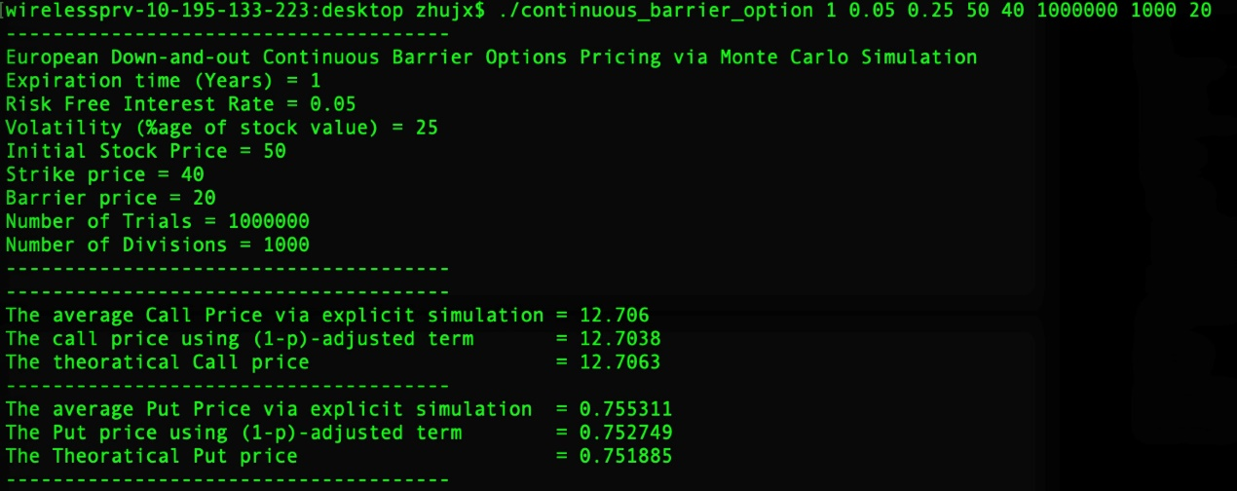

Part 2:

I would simply discuss my attempt at the Brownian bridge correction.

This time the prob adjustment is not as simple as something that can be directly calculated at T. We need to update by consecutive multiplication in our loop over our number of divisions . This is the only difference from what I did in Part 1.

Output:

