Jingxia Zhu(jingxia6)

9/9/2018

Github link: <https://github.com/jzhuuhzj/IE598_F18_HW2.git>

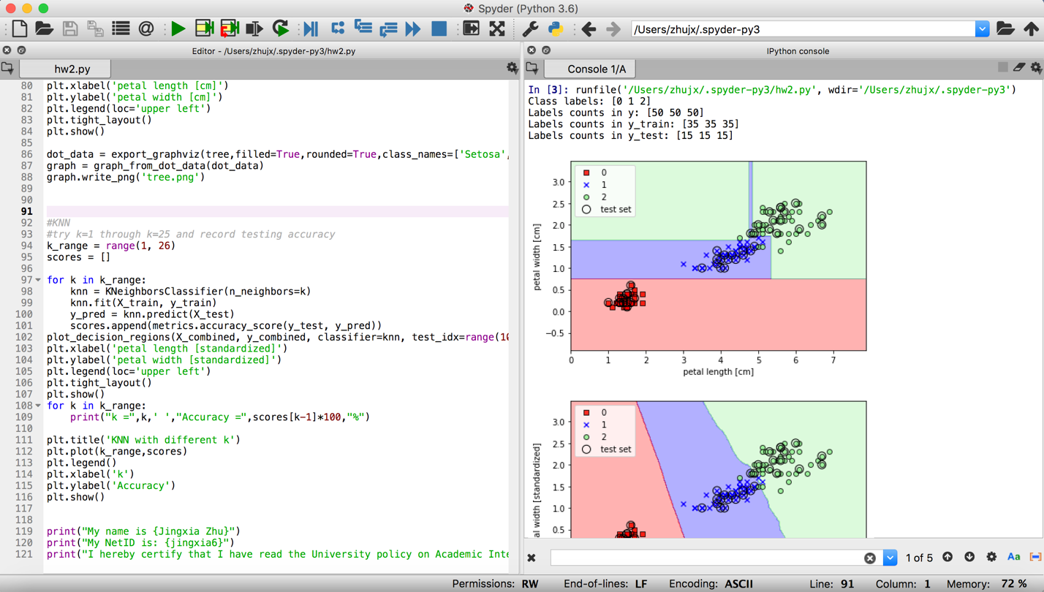

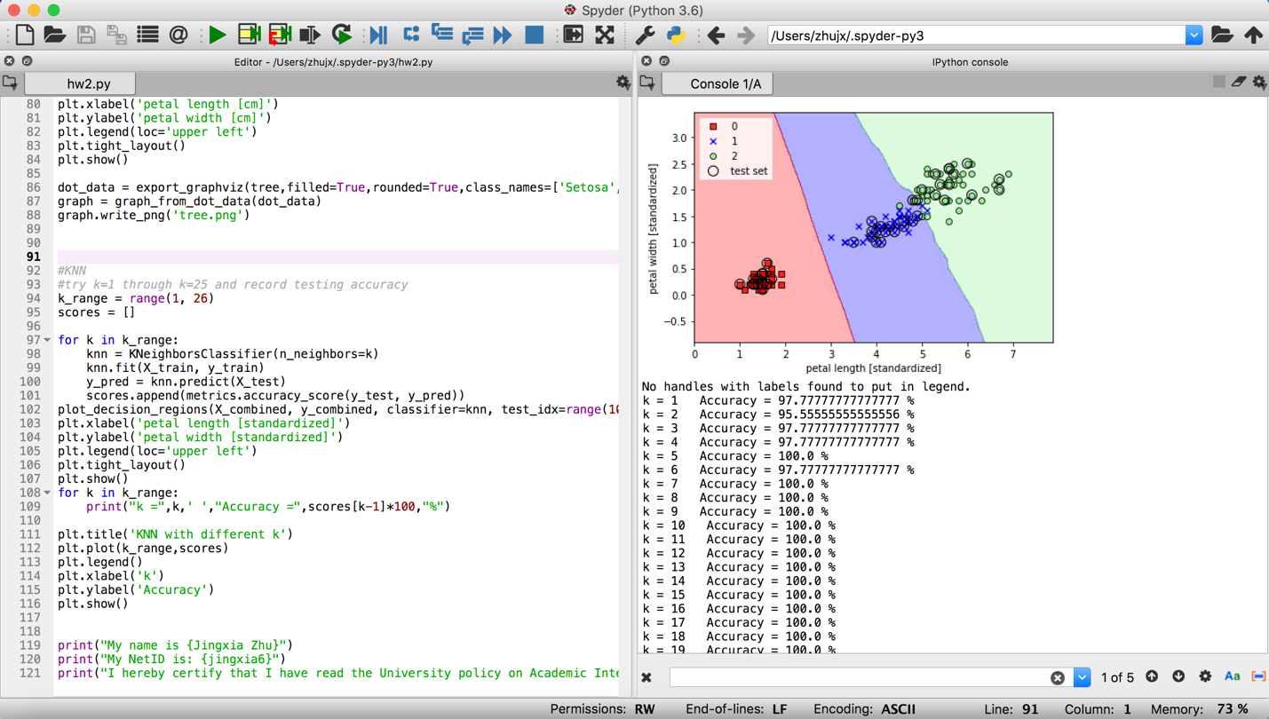

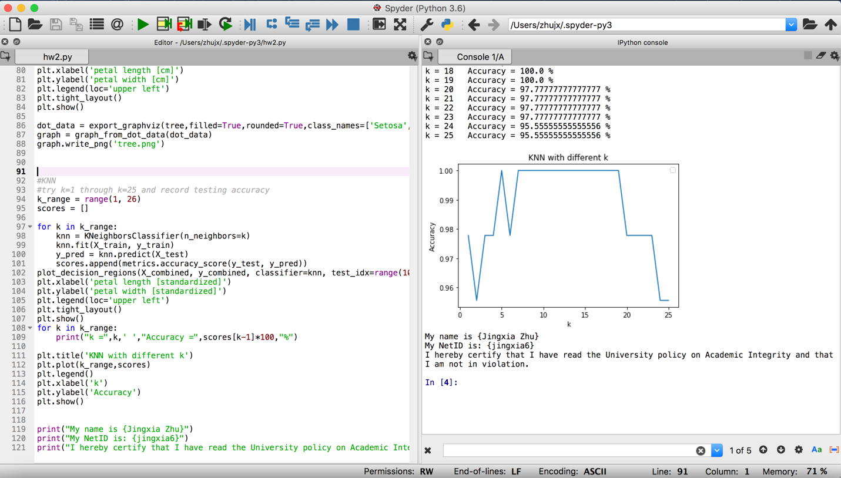

There are several ks have the accuracy of 100% but with the same level of accuracy; in order to avoid overfitting, we choose the smallest k as our best k.