2021 VCE Mathematical Methods 1 (NHT) examination report

Specific information
This report provides sample answers or an indication of what answers may have included. Unless otherwise stated, these are not intended to be exemplary or complete responses.

Question 1a.
The most efficient method is direct use of quotient rule.
$$\frac{2e^{2x}\left(2x+1\right)-2e^{2x}}{{(2x+1)}^{2}}=\frac{{4xe}^{2x}}{{(2x+1)}^{2}}$$
Alternatively, the combination of chain and product rule could be used.

Question 1b.
$f^{'}\left(x\right)=4\sin^{3}\left(2x\right)×2\cos\left(2x\right)=8\sin^{3}\left(2x\right)\cos\left(2x\right)$
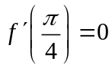

Question 2a.
$h^{'}\left(x\right)=3x^{2}\log_{e}\left(2x\right)+x^{3}×\frac{1}{x} (or ×\frac{2}{2x})$
This was a ‘show that’ question.

Question 2b.
$\int{\left(3x^{2}\log_{e}\left(2x\right)+x^{2}\right)dx=}x^{3}\log_{e}\left(2x\right)$
$y=x^{3}\log_{e}\left(2x\right)-\frac{x^{3}}{3}+c$
$$y\left(\frac{1}{2}\right)=-\frac{25}{24} =>c=-1$$
$∴y=x^{3}\log_{e}\left(2x\right)-\frac{x^{3}}{3}-1$

Question 3a.
$\operatorname{Pr}\left(win\right)=\frac{10}{100}=\frac{1}{10}$

Question 3b.
$$E\left(P\right)=\frac{1}{10}×\left(+5\right)+\frac{9}{10}×\left(-2\right)=-1.30$$
$Expected loss=\$1.30$

Question 3c.
$p=\frac{1}{10}, n=3$ $\operatorname{Pr}\left(X=2\right)=$ ³C₂ $({\frac{1}{10})}^{2}\left(\frac{9}{10}\right)=3×\frac{1}{100}×\frac{9}{10}=\frac{27}{1000}=0.027$

Question 4ai.
$$f\left(g\left(x\right)\right)=2x+5$$

Question 4aii.
$$f\left(g\left(-2\right)\right)=1$$
$∴(1,∞)$ = range

Question 4b.
$x=2e^{y}+1$
$f^{-1}\left(x\right)=\log_{e}(\frac{x-1}{2})$
$h\left(x\right)=\log_{e}\left(\frac{x-1}{2}\right)=g\left(x-c\right)+d=\log_{e}\left(x+2-c\right)+d$
$\log_{e}\left(\frac{x-1}{2}\right)=\log_{e}\left(x-1\right)-\log_{e}\left(2\right)=\log_{e}\left(x+2-3\right)-\log_{e}\left(2\right)$
$c=3, d=-\log_{e}(2)$ or $d= \log_{e}{(\frac{1}{2})}$

Question 5a.
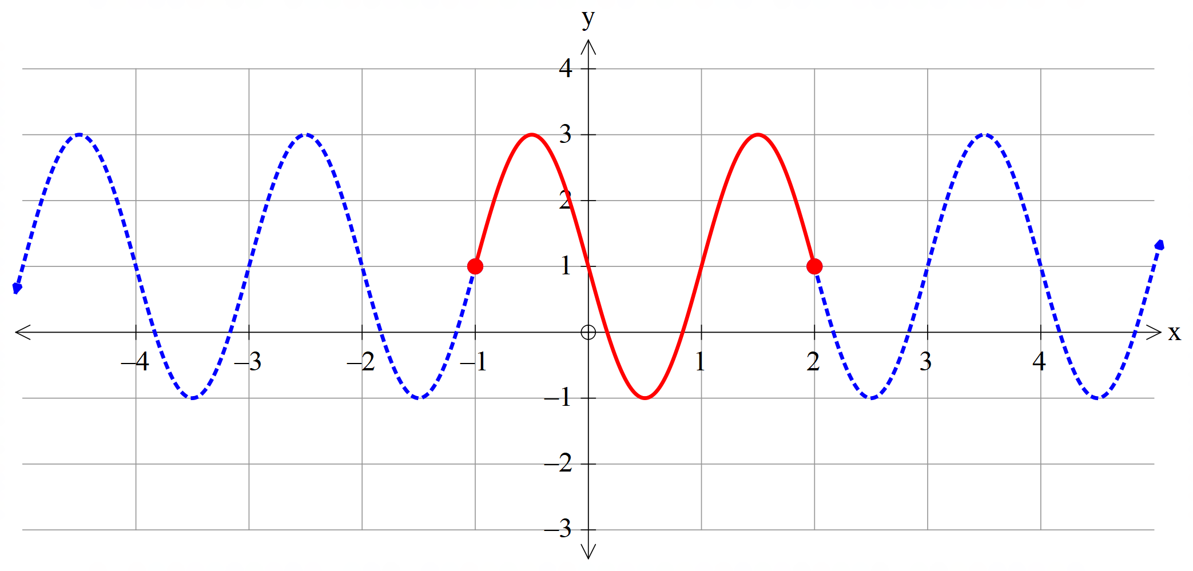
Note that endpoints are included.

Question 5b.
Solve $\sin\left(πx\right)=\frac{1}{2}$
$x=\frac{1}{6},\frac{5}{6}$

Question 5c.
$A=-\int_{\frac{1}{6}}^{\frac{5}{6}}{(1-2\sin\left(πx\right))dx}$
$A=-\left[x+\frac{2}{π}\cos\left(πx\right)\right]\begin{matrix}\frac{5}{6} \\ \frac{1}{6}\end{matrix}$
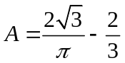

Question 6a.
$\operatorname{Pr}\left(A∩B\right)=\frac{2}{5}×\frac{2}{3}=\frac{4}{15}$
$\operatorname{Pr}\left(A'∩B\right)=\frac{1}{3}×\frac{1}{4}=\frac{1}{12}$
$\operatorname{Pr}\left(B\right)=\operatorname{Pr}\left(A∩B\right)+\operatorname{Pr}\left(A'∩B\right)=\frac{4}{15}+\frac{1}{12}=\frac{21}{60}=\frac{7}{20}$
A probability table or Venn Diagram was of most use.

Question 6b.
$\operatorname{Pr}\left(A'∪B'\right)=1-\frac{4}{15}=\frac{11}{15}$

Question 7a.
$$2a=q(2+a)$$
$a^{2}+2a-4=0$
$a=-1+\sqrt{5}$

Question 7b.
$Area=A=2a×q\left(2+a\right)=8a-2a^{3}$
$\frac{dA}{da}=8-6a^{2}=0$
Max when $a=\frac{2}{\sqrt{3}}$
$$A\left(\frac{2}{\sqrt{3}}\right)=\frac{4}{\sqrt{3}}×\frac{8}{3}=\frac{32\sqrt{3}}{9}$$
Many students forgot to find the maximum area.

Question 8a.
$f^{'}\left(x\right)=2-\frac{3}{2}\sqrt{x}=\frac{4-3\sqrt{x}}{2}$ $=2-\frac{3}{2}x^{\frac{1}{2}}$

Question 8b.
$$f^{'}\left(x\right)=2-\frac{3}{2}\sqrt{x}=-\frac{1}{2}$$
$$(\frac{25}{9}, \frac{25}{27})$$

Question 8c.
$$2x=2x-x^{\frac{3}{2}} =>x=0$$
Some students did not apply the null factor law appropriately.

Question 8d.
$f^{'}(x)=0$ when $x=\frac{16}{9}$
$$q∈(\frac{16}{27},\frac{4}{3})$$

Question 9a.
$$f^{'}\left(0\right)=f\left(0\right)(4-f\left(0\right))=1\left(4-1\right)=3$$

Question 9b.
$g=f(x)$ has zero stationary points, because:
$f'≠0$ for all x since $f'=0$ only when $f=0$ or 4.
But $Ran of f ∈\left(0,4\right)$

Question 9c.
The correct answer is (0,4].

