Mathematical Methods Exam 1 – MA112

2023 Assessment Guide

Marking Guide

Q# | Marks | Solutions | Mark allocation and notes
1a | 2 | $\frac{dy}{dx}=\frac{e^{x}∙\left(2x-1\right)-e^{x}(x^{2}-x)}{e^{2x}}$  $\frac{dy}{dx}=\frac{-x^{2}+3x-1}{e^{x}}$ or $\frac{-{(x}^{2}-3x+1)}{e^{x}}$ or $\left(-x^{2}+3x-1\right)e^{-x}$ | 1M– valid attempt to use quotient/product rule—‘3 or 4 relevant terms’ and each with e^x or e^(-x)—disregard use of brackets  1A – correct vinculum, other forms, if named then dy/dx= or f ’(x)=
1b | 2 | $f^{'}\left(x\right)=2\sin\left(x\right)e^{2x}+\cos\left(x\right)e^{2x}$  $f^{'}\left(\frac{π}{4}\right)=2\sin\left(\frac{π}{4}\right)e^{\frac{π}{2}}+\cos\left(\frac{π}{4}\right)e^{\frac{π}{2}}$  $f^{'}\left(\frac{π}{4}\right)=\sqrt{2}{e^{\frac{π}{2}}}+\frac{\sqrt{2}{e^{\frac{π}{2}}}}{2}= \frac{3\sqrt{2}e^{\frac{π}{2}}}{2} or \frac{3e^{\frac{π}{2}}}{\sqrt{2}}$  $f^{'}\left(\frac{π}{4}\right)=\frac{3\sqrt{2}e^{\frac{π}{2}}}{2}$ | 1M – valid attempt to use product rule, 2 terms (cos$±$sin, with e^(2x))  1A—any correct form, accept $e^{\frac{2π}{4}}$, if named f ’ or dy/dx only

Q# | Marks | Solutions | Mark allocation and notes
2 | 3 | $e^{2x}-4e^{x}-12=0$  $m^{2}-4m-12=0 where m=e^{x}$  $\left(m-6\right)\left(m+2\right)=0$  $m=6 or m=-2$  $e^{x}=6 or e^{x}=-2$  $∴ x=\log_{e}{6}$ | 1M -set up a quadratic = 0 and attempt to factorise/solve  1H- correct use of null factor law to solve their quadratic and give 1 or 2 answers as ‘m’ or $e^{x}=$  1A—only one, must be x=

Q# | Marks | Solutions | Mark allocation and notes
3a | 3 | 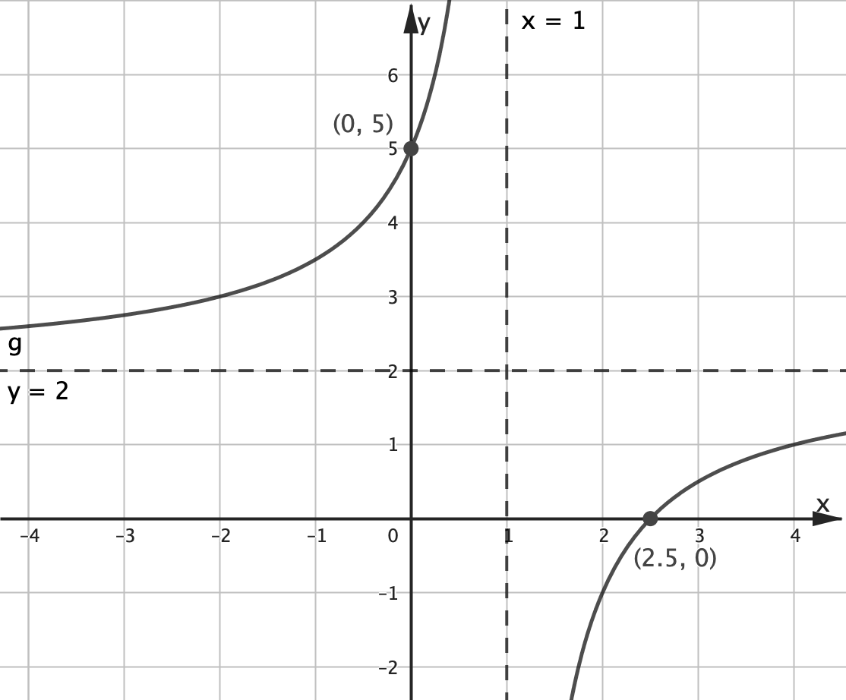 | 1M – hyperbola shape (even if in wrong aspect)  No flicks/turning points/crossings  1M asymptotes correctly positioned and labelled.  1M – intercepts correctly positioned and labelled.  Full marks if all correct and labelled (other grid points not considered)
3b | 1 | $1<x≤4 or (1, 4]$ | 1A
Q# | Marks | Solutions | Mark allocation and notes
4 | 2 | $f\left(1\right)=1+1=2$  $f\left(2\right)=2+\frac{1}{2}=\frac{5}{2}$  $f\left(3\right)=3+\frac{1}{3}=\frac{10}{3}$  Area  $\frac{3-1}{2×2}\left[2+2×\frac{5}{2}+\frac{10}{3}\right]$  $=\frac{1}{2}\left[\frac{6}{3}+\frac{15}{3}+\frac{10}{3}\right]$  $=\frac{31}{6}=\frac{62}{12}=5\frac{1}{6}$ | 1M –Area calculation with y values (y values can be incorrect). Correct use of formula sheet or 2 single trapeziums  1A, no units needed

Q# | Marks | Solutions | Mark allocation and notes
5a | 1 | $\frac{1}{2}$ | 1A
5b | 3 | Method 1  $$\int_{k}^{\frac{π}{2}}{\cos\left(x\right)}dx={\left[\sin\left(x\right)\right]}_{k}^{\frac{π}{2}}$$  $=\sin\left(\frac{π}{2}\right)-\sin\left(k\right)$  $$=1-\sin\left(k\right)$$  $$\frac{1}{2}=1-\sin\left(k\right)$$  $$\sin\left(k\right)=\frac{1}{2}$$  $k=\frac{-11π}{6}$ , $\frac{-7π}{6}$ , $\frac{π}{6}$ , $\frac{5π}{6}$  Method 2  Use graph or transformation between $sin⁡(x)$ and $cos⁡(x)$ to find where the area under $y=\sin\left(x\right)$ between $\left[-3π,2π\right]$ equals to area under the $y=cos⁡(x)$  $k=\frac{-11π}{6}$ , $\frac{-7π}{6}$ , $\frac{π}{6}$ , $\frac{5π}{6}$ | 1M –antidifferentiate to get $±$sin(x) and then substitute correct terminals  1H – single sin term  $$\sin\left(k\right)=1-their "\text{a}\text{"} \\ OR\sin\left(k\right)=\frac{1}{2}$$  1A – 4 correct values from correct working must be k=, not x=  1M – graph of sine and cosine showing area(s)  1M a graph over $\left[-3π,2π\right]$ showing 4 intercepts  1A – as above.

Q# | Marks | Solutions | Mark allocation and notes
6a | 1 | $\left(0.04+0.16\right)÷2=0.1$  $\hat{p}=0.1$ | 1A, not $\frac{0.2}{2}$, allow 0.10 & 10%
6b | 2 | $0.06=2×\sqrt{\frac{0.1×0.9}{n}}$, $0.03=\sqrt{\frac{0.1×0.9}{n}}$ ,  $$({0.03)}^{2}=\frac{0.1×0.9}{n}=\frac{9}{100n}$$  $$n=100$$ | 1H –set up a correct equation for $n$, using correct $\hat{p}, \text{or their} \hat{p}$ and consistent (1-$\hat{p})$, if 0<$\hat{p}$<1  1A
6c | 1 | Confidence interval width is halved  Or “reduced by a factor of 2”  Altered by factor of $\frac{1}{2}$ | 1A, just ½ ok  Essentially anything with ½

Q# | Marks | Solutions | Mark allocation and notes
7a | 1 | $\left[-1\right.,\left.∞\right)$ | 1A
7b | 2 | 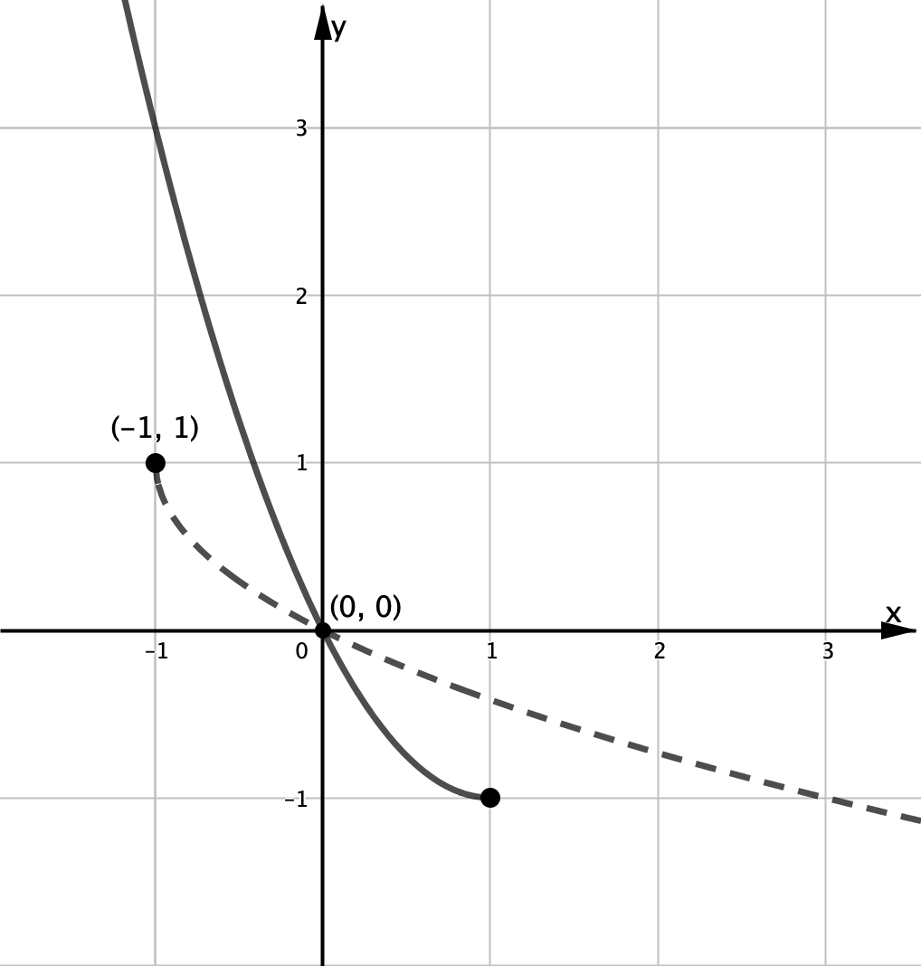 | 1M – shape, Negative arm of a square root function.  1A –closed dot at (-1,1) and passing through (0,0) and (3,-1).  Label (-1,1) & (0,0)
7c | 2 | In turning point form  $y=f\left(x\right)$  $y={\left(x-1\right)}^{2}-1$  Swap $x$ and $y$  $x={\left(y-1\right)}^{2}-1$  $x+1={\left(y-1\right)}^{2}$  $-\sqrt{x+1}=y-1$  $f^{-1}(x)=1-\sqrt{x+1}$ for $x∈\left[-1,\left.∞\right)\right.$ | 1A for correct inverse function, named as $f^{-1}\left(x\right) or f^{-1}, not y=$  1A correct domain,  $$-1≤x<∞, \text{or} x≥-1$$
7d | 2 | Method 1  $A=2\int_{0}^{1}{\left(-x-\left(x^{2}-2x\right)\right)dx}$  $A=2\int_{0}^{1}{\left(x-x^{2}\right)}dx$  $A=2{\left[\frac{1}{2}x^{2}-\frac{x^{3}}{3}\right]}_{0}^{1}$  $A=2\left(\frac{1}{2}-\frac{1}{3}-\left(0\right)\right)$  $A=\frac{1}{3}$  Method 2  $A=\int_{-1}^{0}{\left(-x-\left(1-\sqrt{x+1}\right)\right)dx}+\int_{0}^{1}{\left(-x-\left(x^{2}-2x\right)\right)dx}$  $A={\left[-\frac{x^{2}}{2}-x+\frac{2}{3}{\left(x+1\right)}^{\frac{3}{2}} \right]}_{-1}^{0}+{\left[\frac{1}{2}x^{2}-\frac{x^{3}}{3}\right]}_{0}^{1}$  $A=\left(0-0+\frac{2}{3}-\left(-\frac{1}{2}+1+0\right)\right)+\left(\frac{1}{2}-\frac{1}{3}-0\right)$  $A=\frac{1}{3}$  Method 3  Use of valid triangle  $$A=2\left(-\frac{1}{2}-\int_{0}^{1}{\left(x^{2}-2x\right)dx}\right) \\ A=2\left(-\frac{1}{2}-{\left[\frac{1}{3}x^{3}-x^{2}\right]}_{0}^{1}\right)$$  $$A=2\left(-\frac{1}{2}-\left[\frac{1}{3}-1\right]\right)$$  $A=\frac{1}{3}$ | Multiple methods  1H – set up an integral with correct terminals and have -x and $f$ or their $f^{-1}$present  Eventual 2× required  1A  1H – line 1 with correct endpoints for both integrals, their $f^{-1}$ ok  Note modulus version ok  1A  1H – set up an integral with correct terminals and have -x and $f$ or their $f^{-1}$present  Eventual 2× required  1A

Q# | Marks | Solutions | Mark allocation and notes
8a | 1 |  | 1M check all steps, must see a calculation step, must see dt  all t’s only  Not just sub and verify
  $\int_{0}^{4}{kt(16-t^{2})dt}=1$  $$k{\left[8t^{2}-\frac{t^{4}}{4}\right]}_{0}^{4}=1$$  $k\left(8×16-\frac{16×16}{4}\right)=1$  $64k=1$  $∴k=\frac{1}{64}$ | $\int_{0}^{4}{t(16-t^{2})dt}$  $$={\left[8t^{2}-\frac{t^{4}}{4}\right]}_{0}^{4}=\left(8×16-\frac{16×16}{4}\right)=64$$  $64k=1$  $∴k=\frac{1}{64}$
8b | 2 | $E\left(T\right)=\frac{1}{64}\int_{0}^{4}{\left(16t^{2}-t^{4}\right)dt}$  $=\frac{1}{64}{\left[\frac{16t^{3}}{3}-\frac{t^{5}}{5}\right]}_{0}^{4}$  $=\frac{1}{64}\left(\frac{1024}{3}-\frac{1024}{5}-0\right)$  $=\frac{1}{64}×\frac{2048}{15}$  $E\left(T\right)=\frac{64}{30}=\frac{32}{15}=2\frac{2}{15}$ | 1M – attempt to integrate $t∙f\left(t\right)$ with correct endpoints, must see evidence of $\frac{t^{3}}{3} and \frac{t^{5}}{5}$  1A all t’s only  (e.g. 2048/960)
8c | 3 | $\operatorname{Pr}\left(2<T<4|T>1\right)=\frac{Pr\left(2<T<4\right)}{Pr⁡(T>1)}$  $=\frac{\frac{1}{64}\int_{2}^{4}{\left(16t-t^{3}\right)}dt}{\frac{1}{64}\int_{1}^{4}{\left(16t-t^{3}\right)}dt}= \frac{\int_{2}^{4}{\left(16t-t^{3}\right)}dt}{\int_{1}^{4}{\left(16t-t^{3}\right)}dt}$  $=\frac{{\left[8t^{2}-\frac{t^{4}}{4}\right]}_{2}^{4}}{{\left[8t^{2}-\frac{t^{4}}{4}\right]}_{1}^{4}}$  $=\frac{\left(64-\left(32-4\right)\right)}{\left(64-\left(8-\frac{1}{4}\right)\right)}$  $=\frac{36}{\frac{225}{4}}$  $=\frac{144}{225}=\frac{16}{25}=0.64$  Can evaluate numerator and denominator separately and then have  $\operatorname{Pr}\left(T>2 | T>1\right)=\frac{\frac{9}{16}}{\frac{225}{256}}=\frac{9}{16}×\frac{256}{225}=\frac{16}{25}$  OR  **Can define a cumulative density function F(t)  $$F\left(t\right)=\operatorname{Pr}\left(0≤T≤t\right)=\int_{0}^{t}{\frac{1}{64}(16u}-u^{3})du+0=\frac{1}{64}{⟦8u^{2}-\frac{u^{4}}{4}⟧}_{0}^{t}=\frac{t^{3}}{8}-\frac{t^{4}}{256}$$  and get $\frac{1-F(2)}{1-F(1)}=\frac{1-\frac{7}{16}}{1-\frac{31}{256}}=\frac{9}{16}×\frac{256}{225}=\frac{16}{25}$ | 1M -identify conditional and write as calculus fraction, $f\left(t\right)$ (ok no substitution) --integrals for both conditionals (with correct endpoints), line 2 or 3  1M – correct antiderivative and valid attempt to substitute in both numerator and denominator  1A or equivalent  Accept if all t’s or all x’s  OR  1M for defining F(t) and writing as function in antiderivative form  1M for identifying conditional prob and substituting into F(t) for both numerator and denominator or separate terms  1A

Q# | Marks | Solutions | Mark allocation and notes
9a | 1 | $f\left(0\right)=a-{0\left(0-2\right)}^{2}=a-0=12, f\left(0\right)=a$  $∴a=12$  $g\left(1\right)=12×1+b×1^{2}=12+b=9$  $∴b=-3$ | 1M -must see evidence of calculation steps correctly leading to correct values.
9b | 2 | $f\left(x\right)=12-x{\left(x-2\right)}^{2}$  $=-x^{3}+4x^{2}-4x+12$  $f^{'}\left(x\right)=-\left(3x^{2}-8x+4\right)$  $f^{'}\left(2\right)=-(3{\left(2\right)}^{2}-8\left(2\right)+4)$  $=0$  Maxima from the graph, either use f or g  $f\left(2\right)=12-0=12$  $(2,12)$ | 1M – either substitute or solve approach  show that f’(2)=0 and g’(2)=0, or correctly solve both $f^{'}\left(x\right)=0 and g^{'}\left(x\right)=0 to get x=2$  must see equations for f’(x) and g’(x) or f’(x) and ‘parabola’ method for g.  1A – independent of 1M mark, coordinates  or x=2 & y=12  Not just f(2)=12
  $g\left(x\right)=12x-3x^{2}$  $g^{'}\left(x\right)=12-6x$  $g^{'}\left(2\right)=0$ | $$g\left(x\right)=12x-3x^{2}$$  $=-3x^{2}+12x$  Turning point at  $$x=\frac{-b}{2a}=\frac{-12}{-6}=2$$
9c | 3 | Area of triangle  $A\left(x\right)=\frac{1}{2}×x×(12x-3x^{2})$  $=6x^{2}-\frac{3}{2}x^{3}$  Maximum area at $A^{'}\left(x\right)=0$  $A^{'}\left(x\right)=12x-\frac{9}{2}x^{2}=\frac{1}{2}(24x-9x^{2})=0$  $3x\left(4-\frac{3}{2}x\right)=0$  $x=0$ (point $A$) , $x=\frac{24}{9}=\frac{8}{3}$  $A\left(\frac{8}{3}\right)=\frac{1}{2}×\frac{8}{3}×\left(12\left(\frac{8}{3}\right)-3{\left(\frac{8}{3}\right)}^{2}\right)$  $=\frac{4}{3}\left(32-\frac{64}{3}\right)$  $=\frac{1152}{81}=\frac{128}{9}$ | 1A – correct $A'(k$) or $A'(x$) and set equal zero, with consistent naming  1A $x=\frac{8}{3}$ or $k=\frac{8}{3}$  $$(or equivalent)$$  1A – units not required, but if stated must be correct

