2021 NHT VCE Physics written examination report

Specific information
This report provides sample answers or an indication of what answers may have included. Unless otherwise stated, these are not intended to be exemplary or complete responses.

Section A

Question 1
The correct response was A.
The current is parallel to the field. The formula $F=BIL$ only applies if the angle between the current and the field is 90˚. Students are not required to be able to find the force if the angle is between 0˚ and 90˚.

Question 2
The correct response was B.
Each +2Q charge exerts and equal attractive force on the -Q charge. The vector sum of these forces is straight down.

Question 3
The correct response was D.
$$F∆t=m∆v$$
$$F=\frac{m∆v}{∆t}$$
$$F=\frac{45×{10}^{-3}×41}{0.5×{10}^{-3}}$$
$$F=3.7 kN$$

Question 4
The correct response was D.
$$w=mg$$
$$w=60×9.8$$
$$w=588 N$$

Question 5
The correct response was B.
The period of the orbit is given by $T=\sqrt{\frac{4π^{2}r^{3}}{GM}}$.
The period is determined by the radius and the mass of the central body. It is independent of the mass of the satellite.

Question 6
The correct response was D.
$$V_{p-p}=2×V_{RMS}×\sqrt{2}$$
$$V_{p-p}=2×240×\sqrt{2}$$
$$V_{p-p}=680 V$$

Question 7
The correct response was B.
Power loss is proportional to $I^{2}$. Transformers allow power to be transmitted at high voltages and low currents.

Question 8
The correct response was C.
The halving of the period and the doubling of the voltage is consistent with doubling the speed of rotation according to the formula: $ε=\frac{ΔΦ}{Δt}$.

Question 9
The correct response was A.
The lower end of the solenoid is experiencing an increase in upwards flux. Lenz’s law states that the induced current will produce an increase in flux downwards. Using the right-hand grip rule the current will flow from right to left in the coils as viewed in the diagram. If the solenoid is viewed from above, the current will be flowing clockwise.

Question 10
The correct response was C.
The distance travelled is the horizontal velocity multiplied by the time of flight.
$$x=8×cos30×1$$
$$x=6.9 m$$

Question 11
The correct response was D.
If air resistance is taken into consideration, then there is both a sideways force (resistance) as well as a vertical force (gravitational). D is the only option that demonstrates both these forces.

Question 12
The correct response was D.
The maximum acceleration occurs where there is maximal force. This occurs at the bottom of the motion. All other options are false.

Question 13
The correct response was D.
The description of the clock as stationary indicated that it too is travelling at 0.943c ($γ=3.00$). The description of the time interval of 75.0 sec as a proper time indicates that the clock is operating as expected in its frame of reference. However, the clock is moving in Joanna’s frame of reference so she will observe dilated time on the clock.
$$t=t_{0}γ$$
$$t=75.0×3.00$$
$$t=225 sec$$

Question 14
The correct response was A.
Point P is a node. Nodes are the result of destructive interference.

Question 15
The correct response was A.
Polarisation is dependent on the orientation of the waves; hence, it supports the wave model of light.

Question 16
The correct response was B.
The spacing of the bands is given by the formula: $w=\frac{λL}{d}$.
Therefore, if lambda is decreased (green light has a shorter wavelength than red light) then the width, w, will also decrease.

Question 17
The correct response was B.
$$λ_{d}=\frac{h}{mv}$$
$$λ_{d}=\frac{6.63×{10}^{-34}}{1.67×{10}^{-27}×2.0×{10}^{3}}$$
$$λ_{d}=2.0×{10}^{-10} m$$

Question 18
The correct response was C.
C is the only option that is not a finding of the photoelectric effect experiment.

Question 19
The correct response was B.
The independent variable value is selected by the investigator. The dependent variable is measured by the investigator.

Question 20
The correct response was A.
$$E=mc^{2}$$
$$∆m=\frac{3.6×{10}^{-13}}{{\left(3×{10}^{8}\right)}^{2}}$$
$$∆m=4×{10}^{-30} kg$$
The final mass will be $M_{i}-4×{10}^{-30} kg$

Section B

Question 1a
The sphere will move up. The sphere is negatively charged, and the upper plate is positively charged.

Question 1b
$$F=\frac{qV}{d}$$
$$F=\frac{(2.7×{10}^{-6})×(15.5)}{2.0×{10}^{-3}}$$
$$F=0.021 N$$

Question 2a
$$qV=\frac{1}{2}mv^{2}$$
$$V=\frac{0.5×(9.1×{10}^{-31})×{\left(2.0×{10}^{7}\right)}^{2}}{1.6×{10}^{-19}}$$
$$V=1.1kV$$

Question 2b
The magnetic force acting on the electron is always perpendicular to the electrons velocity and has a constant magnitude.

Question 2c
$$Bqv=\frac{mv^{2}}{r}$$
$$r=\frac{9.1×{10}^{-31}×2.0×{10}^{7}}{1.6×{10}^{-19}×2.5×{10}^{-3}}$$
$$r=0.046 m$$

Question 3a
$$F=\frac{GMm}{r^{2}}$$
$$F=\frac{6.67×{10}^{-11}×5.98×{10}^{24}×7.35×{10}^{22}}{{\left(3.84×{10}^{8}\right)}^{2}}$$
$$F=1.99×{10}^{20} N$$

Question 3b
The orbital period will increase.
The ratio $\frac{R^{3}}{T^{2}}$ is constant for all satellites orbiting the earth.
As R increases, T will also increase.

Question 4a
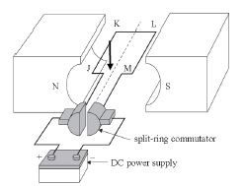
A downwards arrow as shown.

Question 4b
The role of the split ring commutator is to reverse the direction of the current every half turn to maintain a constant direction of rotation.

Question 5

Question 6a
The slip rings maintain a continuous electrical connection with the spinning loop and are used when an AC output is required.

Question 6b
$$Φ=BA$$
$$Φ=0.20×0.02×0.03$$
$$Φ=1.2×{10}^{-4} Wb$$

Question 6c
$$f=\frac{1}{T}$$
$$f=\frac{1}{0.2}$$
$$f=5 Hz$$

Question 6d

Question 7a
An ideal transformer is one where no power is lost, that is, P_{primary} = P_{secondary}.

Question 7b
$$\frac{N_{p}}{N_{s}}=\frac{V_{p}}{V_{s}}$$
$$\frac{N_{p}}{N_{s}}=\frac{240}{12}$$
$$\frac{N_{p}}{N_{s}}=\frac{20}{1}$$

Question 7c
$$P=\frac{V^{2}}{R}$$
$$P=\frac{{12}^{2}}{6}$$
$$P=24 W$$

Question 7d
$$R_{wire}=12×2×0.05=1.2 Ω$$
$$Total resistance=6+1.2=7.2 Ω$$
$$I=\frac{V}{R}=\frac{12}{7.2}=1.67 A$$
$$V_{globe}=1.67×6.0=10 V$$

Question 7e
There is less power delivered to Light 1 compared to Light 2.
Power is lost along the transmission lines.
The observed brightness is proportional to the delivered power.

Question 8a

Question 8b
$$F_{tow}=mg sinθ$$
$$F_{tow}=200×9.8×sin15$$
$$F_{tow}=507 N$$

Question 8c
$${GPE}_{gained}=mg∆h$$
$${GPE}_{gained}=950×9.8×100×sin15$$
$${GPE}_{gained}=241 kJ$$

Question 9a
Acceleration at W is greater than zero and less than 9.8 m s⁻².
Acceleration at X is zero.
Acceleration at Y is greater than zero and directed to the left.

Question 9b
$$mgh=\frac{1}{2}kx^{2}$$
$$5.0×9.8×h=0.5×100×{3.0}^{2}$$
$$h=9.2 m$$

Question 9c
$$\frac{1}{2}kx^{2}=\frac{1}{2}mv^{2}$$
$$0.5×100×3^{2}=0.5×5.0×v^{2}$$
$$v=13.4 m s^{-1}$$
$$p=mv$$
$$p=5.0×13.4$$
$$p=67 kg m s^{-1}$$

Question 9d
The momentum is transferred to the earth.

Question 10a
$$γ=\frac{1}{\sqrt{1-\frac{v^{2}}{c^{2}}}}$$
$$γ=\frac{1}{\sqrt{1-{0.984}^{2}}}$$
$$γ=5.61$$

Question 10b
$$t=\frac{d}{v}$$
$$t=\frac{4.37}{0.984}$$
$$t=4.44 y$$

Question 11a
$$T=\frac{1}{f}$$
$$T=\frac{1}{40}$$
$$T=25 msec$$

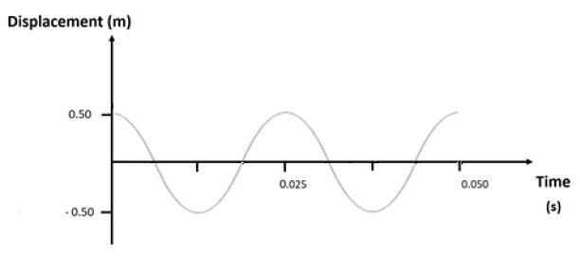
Question 11b

Question 12a
R2 must be half a wavelength (9.0 m) further from X than R1.
$$72+9=81 m$$

Question 12b
The observations are due to interference.
Destructive interference is occurring at X and constructive interference is occurring at Y.
Interference is a wave phenomenon.

Question 13a

Question 13b
$$θ_{c}=\sin^{-1}\left(\frac{n_{2}}{n_{1}}\right)$$
$$θ_{c}=\sin^{-1}\left(\frac{1.42}{1.56}\right)$$
$$θ_{c}=65.5˚$$
Refraction will occur is the incident angle is between 0˚ and 65.5˚

Question 14
Diffraction depends on the ratio: $\frac{λ}{w}$. If this ratio is close to 1 then diffraction is most obvious.
At 10,000 Hz, $\frac{λ}{w}=\frac{0.03}{0.8}=3.75×{10}^{-2}$ so diffraction is minimal.
At 100 Hz, $\frac{λ}{w}=\frac{3.34}{0.8}=4.18$ so diffraction is much more significant.

Question 15a
$$E=\frac{hc}{λ}$$
$$E=\frac{4.14×{10}^{-15}×3×{10}^{8}}{400×{10}^{-9}}$$
$$E=3.1 eV$$
This is below the work function so no photoelectrons will be emitted.

Question 15b
5.4 eV is greater than the work function so a photoelectron will be emitted with a kinetic energy of 0.5 eV.

Question 15c
The experiment supports the particle model of light.
The model suggests a threshold frequency and no electrons were emitted by the 400 nm light.
The model suggests that the energy of the photon is dependent on its frequency and the higher frequency light did produce photoelectrons.
Other findings of other photoelectric effect experiments, such as the absence of a time delay, are not supported by this particular experiment.

Question 16a
$$E=\frac{hc}{λ}$$
$$E=\frac{4.14×{10}^{-15}×3×{10}^{8}}{2.0×{10}^{-9}}$$
$$E=621 eV$$

Question 16b
Diffraction depends on the ratio: $\frac{λ}{w}$.
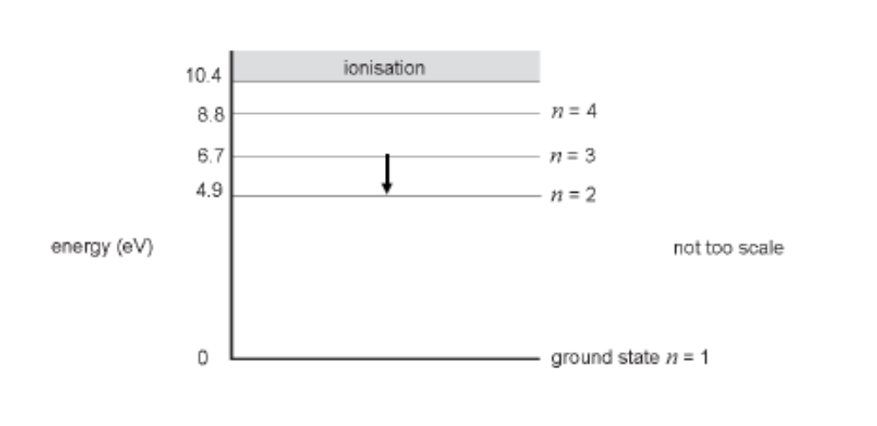
In this case the ratio is $\frac{2.0×{10}^{-9}}{5×{10}^{-8}}=4×{10}^{-2}$so little, if any, diffraction will be observed.

Question 17a
The diagram may have suggested to students that there is a discrete energy level at 10.4 eV with ionisation occurring beyond this point. While the intent of the question was that ionisation would occur at, or even slightly before, 10.4 eV and hence no electron transition down from this level would be possible, the assessment process favoured the students who may not have interpreted the diagram in that way.

Question 17b
$$∆E_{eV}=6.7 eV$$
$$∆E_{J}=6.7 ×1.6×{10}^{-19}$$
$$∆E_{J}=1.07×{10}^{-18} J$$

Question 17c
Nothing will happen.
2.1 eV is not enough energy to transition to any higher state.

Question 18a
$$F=m\frac{∆v}{∆t}$$
$$∆v=3.3-\left(-3.6\right)=6.9 m s^{-1}$$
$$F=50×{10}^{-3}×\frac{6.9}{40×{10}^{-3}}$$
$$F=8.6 N$$
The force acts upwards.

Question 18b
Some of the energy is converted to SPE in the ball.
The rest is lost as heat/sound.

Question 18c
The momentum is transferred to the earth.

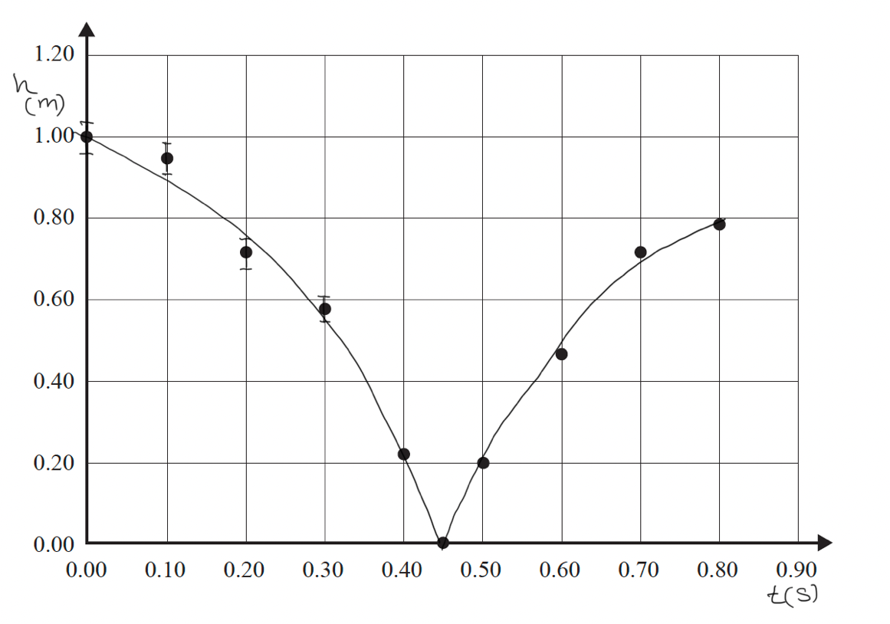
Question 18d

Question 18e
The shallowest gradient accepted used the last two data points prior to impact.
$$grad=\frac{rise}{run}$$
$$grad=\frac{0.22}{0.05}$$
$$grad=4.4 m s^{-1}$$
Steeper gradients (and, therefore, higher velocities) calculated from tangent lines drawn on the graph were also accepted provided the student clearly indicated how their calculation was done.

