2022 VCE Physics (NHT) external assessment report

Specific information
This report provides sample answers or an indication of what answers may have included. Unless otherwise stated, these are not intended to be exemplary or complete responses.

Section A – Multiple-choice questions
Question | Correct answer | Comments
1 | D | $$E=\frac{V}{d}$$  $$E=\frac{5.0×{10}^{3}}{10×{10}^{-3}}$$  $$E=5.0×{10}^{5}$$
2 | A | Right-hand slap rule.  Fingers N to S, thumb clockwise => Force is out of the page.
3 | D | $$g∝\frac{1}{R^{2}}$$  If R = 4R,  $$\frac{g}{16}$$
4 | C | Approximately 13 squares.  Each square is $1000×3×{10}^{6}=3×{10}^{9}J$.  Therefore, energy under the curve is approximately 4.0 x 10¹⁰ J.
5 | B/D | The question is unclear as to whether the transformer is a step-up or step-down. As a result, both the following solutions were accepted.  $$30.0 mA×350=1.1×{10}^{4} mA$$  $$30.0 mA÷350=0.086 mA$$
6 | C | The loop is going to experience a net increase of flux out of the page, on the outside compared to the inside, therefore the induced current will need to produce an increasing flux into the page on the outside compared to the inside. This will require an anticlockwise current, which will only flow momentarily.
7 | A | Using $\frac{1}{2}mv^{2}=Fd$ it can be shown that $F∝\frac{v^{2}}{d}$ for the same mass.  $$\frac{v^{2}}{d}=\frac{v^{2}}{d}$$  $$\frac{{60}^{2}}{18}=\frac{{40}^{2}}{d}$$  $$d=8m$$
8 | C | $$k=\frac{∆F}{∆x}$$  $$k=\frac{80}{0.5}$$  $$k=160 N m^{-1}$$
9 | A | $$∆x=30-20=10 cm$$  $10 cm ≈16N$ from graph  This implies a mass of 1.6 kg.
10 | A | The 4.25 Ly distance is the proper length measured from Earth in which neither the Earth nor the star is moving. As this length is moving in Ning’s frame of reference, it will appear contracted or less than 4.25 Ly.
11 | C | $$∆m=3×\left(6.645×{10}^{-27}\right)-1.993×{10}^{-26}$$  $$∆m=5×{10}^{-30}kg$$  $$E=mc^{2}$$  $$E=5×{10}^{-30}×{\left(3×{10}^{8}\right)}^{2}$$  $$E=4.5×{10}^{-13}J$$
12 | D | $$v=fλ$$  $$v=5.0×2.0$$  $$v=10 m s^{-1}$$
13 | C | $${sinθ}_{crit}=\frac{n_{2}}{n_{1}}$$  $${sinθ}_{crit}=\frac{1.33}{2.42}$$
14 | D | Following filter X, the vibration will be in one direction only. The direction will be horizontal.  Following filter Y, there will be no vibration at all. Filter Y only allows vertical vibrations through.
15 | B | The Doppler effect can be observed in all mechanical waves.
16 | A | If the intensity is increased, then the number of photons hitting the metal will increase, leading to more photoelectrons. Since the frequency of the photons has not changed, their energy has not changed and as a result the maximum kinetic energy of the photoelectrons will remain unchanged.
17 | B | The emission energies are 0.7eV, 1.9eV and 10.2eV.
18 | B | The word ‘laser’ is an acronym for ‘light amplification by stimulated emission of radiation’.
19 | C | Matter particles have deBroglie wavelengths related to their momentum by 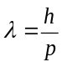.
20 | D | The inability to simultaneously know a particle’s position and its momentum is described by Heisenberg’s uncertainty principle.

Section B

Question 1a.
The principle is conservation of energy, where the work done on the charge by the field equals the change in kinetic energy of the particle.
$$qV=\frac{1}{2}mv^{2}$$
$$v=\sqrt{\frac{2qV}{m}}$$

Question 1b.
$$v=\sqrt{\frac{2qV}{m}}$$
$$v= \sqrt{\frac{2({1.6 x 10}^{-19 })(200)}{{9.1 x 10}^{-31 }}}$$
$$v=8.4×{10}^{6} m s^{-1}$$

Question 2a.
$$v=\sqrt{\frac{GM}{R}}$$
$$v=\sqrt{\frac{\left({6.67 x 10}^{-11 }\right){(5.7 x 10}^{26 })}{{1.2 x 10}^{9 }}}$$
$$v=5.6×{10}^{3} m s^{-1}$$

Question 2b.
Using $v=\sqrt{\frac{GM}{R}}$, when the radius (R) is smaller, then the orbital speed must be faster.

Question 2c.
$$\frac{GMm}{r^{2}}=\frac{4π^{2}rm}{T^{2}}$$
$$\frac{r^{3}}{T^{2}}=\frac{GM}{4π^{2}}=constant for all orbiting bodies.$$
$$\frac{{\left(1.2×{10}^{9}\right)}^{3}}{{16}^{2}}=\frac{{\left(5.3×{10}^{8}\right)}^{3}}{T^{2}}$$
$$T=4.6 days$$

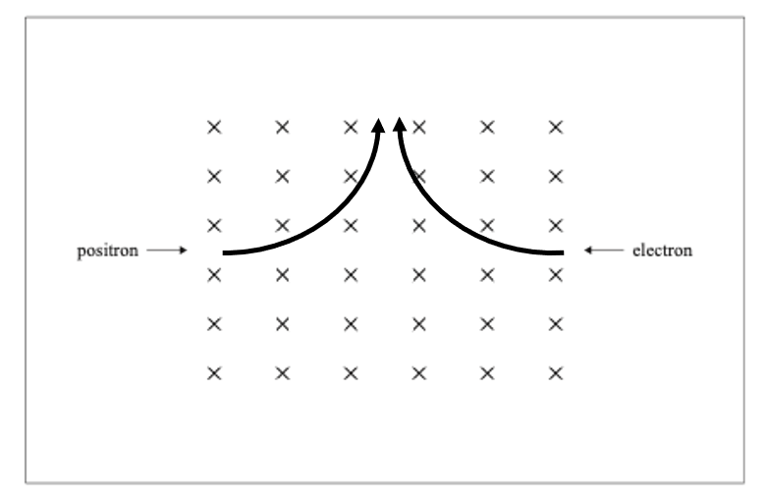
Question 3
Both arcs are circular and have the same radius.

Question 4a.
Clockwise

Question 4b.
One quarter turn:
$$t=0.25×\frac{1}{60}$$
$$t=0.0042 sec$$
Now area:
$$ε=nB\frac{ΔA}{Δt}$$
$$35×{10}^{-3}=200×5.0×{10}^{-3}×\frac{ΔA}{0.0042}$$
$$∆A=1.5×{10}^{-4} m^{2}$$

Question 4c.
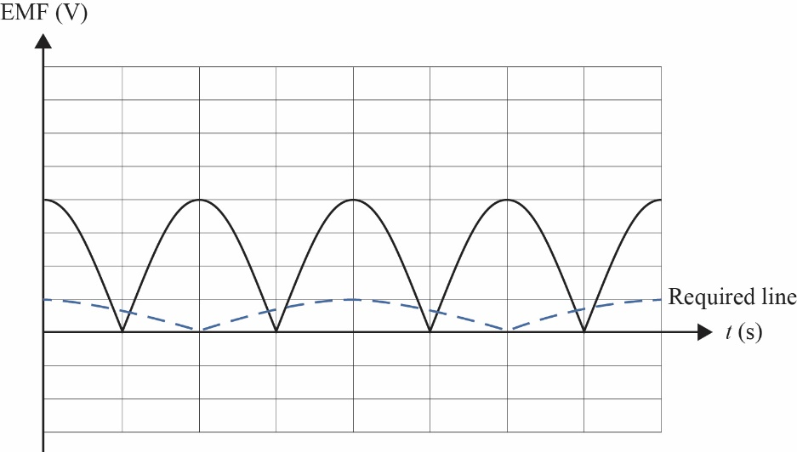
The VCAA is aware that the graph shows the EMF displayed on the CRO over two full turns. There was no evidence that students did not understand what was required.

Question 5
The loop experiences a change in flux due to the non-uniform field around the bar magnet. According to Faraday’s law, an EMF is induced where there is a change in flux over time.
i.e., $ε=-N\frac{ΔΦ}{Δt}$.
Students could also refer to Lenz’s law.

Question 6a.
$$\frac{N_{p}}{N_{s}}=\frac{V_{p}}{V_{s}}$$
$$\frac{N_{p}}{N_{s}}=\frac{240}{8}$$
$$\frac{N_{p}}{N_{s}}=30:1$$

Question 6b.
The VCAA is aware of the error in the wording for this question. The RMS current delivered by the power point while the battery is charging is given in the question stem as 0.35A. However, most students recognised that the question was asking them to calculate the RMS current delivered to the battery, which is calculated by:
$$\frac{Vp}{Vs}=\frac{Is}{Ip}$$
$$\frac{240}{8}=\frac{Is}{0.35}$$
$$Is=10.5A$$
Students were awarded full marks for either 0.35A or 10.5A.

Question 7a.
The height of the mass is $2.0 cos60=1.0 m$.
$$mgh=\frac{1}{2}mv^{2}$$
$$2.0×9.8×1.0=0.5×2.0×v^{2}$$
$$v=\sqrt{19.6}=4.4 m s^{-1}$$

Question 7b.
The mass will reach its maximum velocity at the bottom of the arc. At this point, the maximum amount of gravitational potential energy will have been converted to kinetic energy.

Question 7c.
The tension is greatest at the bottom of the arc where $T=mg+\frac{mv^{2}}{r}$.
$$T=2.0×9.8+ \frac{2.0×{4.4}^{2}}{2.0}$$
$$T=39 N$$

Question 8a.
$$a=\frac{GM}{r^{2}}$$
$$a=\frac{6.67×{10}^{-11}×5.98×{10}^{24}}{{\left(25×6.37×{10}^{6}\right)}^{2}}$$
$$a=1.6×{10}^{-2} m s^{-2}$$

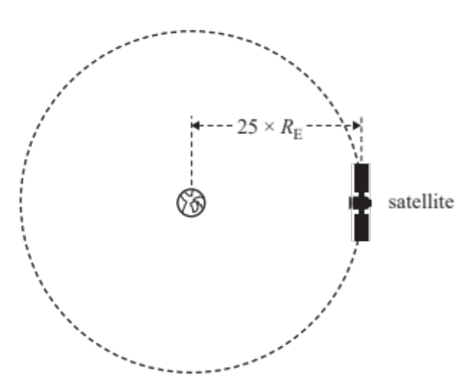
Question 8b.

Question 8c.
Magnitude of acceleration | Less than
Kinetic energy | Less than
Period | More than

Question 9a.
$$KE=\frac{1}{2}mv^{2}$$
$$KE=0.5×0.30×6^{2}$$
$$KE=5.4 J$$

Question 9b.
Find minimum velocity required to stay on track:
$$v_{min}=\sqrt{rg}$$
$$v_{min}=\sqrt{0.4×9.8}$$
$$v_{min}=1.98 m s^{-1}$$
Find KE at top of loop:
$${KE}_{B}={KE}_{A}-mgh$$
$${KE}_{B}=5.4-0.30×9.8×0.8$$
$${KE}_{B}=3.05 J$$
$$KE=\frac{1}{2}mv^{2}$$
Find velocity at top of loop:
$$3.05=0.5×0.3×v^{2}$$
$$v=4.5 m s^{-1}$$
As the velocity at B is greater than the minimum velocity required, the ball will stay on the track.
There were other alternative approaches that could be applied that were equally correct.

Question 10a.
Horizontal component of velocity: $v_{H}=7.0 cos50=4.5 m s^{-1}$.
$$t=\frac{d}{v}=\frac{3.2}{4.5}$$
$$t=0.71 sec$$

Question 10b.
Vertical component of velocity: $v_{H}=7.0 sin50=5.36 m s^{-1}$.
$$x=ut+ \frac{1}{2}at^{2}$$
$$x=\left(5.36×0.71\right)+(0.5×-9.8×{0.71}^{2})$$
$$x=1.34 m$$
Add launch height of 2.2 m.
The top of the basket is 1.34 + 2.2 = 3.5 m above the ground.

Question 11a.
$$t=t_{0}γ$$
$$t=2.3×3.2$$
$$t=7.4 μs$$

Question 11b.
The length would appear shorter due to length contraction.
$$L=\frac{L_{0}}{γ}$$
$$L=\frac{1.5}{3.2}=0.47 km \left(469 m\right)$$

Question 12a.
$$v=fλ$$
$$8.0=f×0.4$$
$$f=20 Hz$$

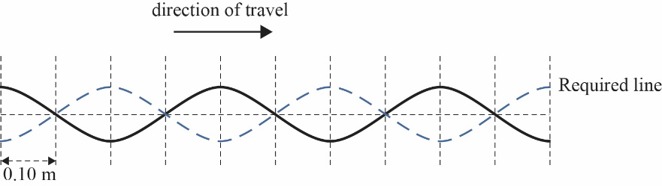
Question 12b.

$$v=\frac{∆x}{∆t}$$
$$∆x=8.0×\left(25×{10}^{-3}\right)$$
$$∆x=0.02 m$$
This means that all points on the wave move two segments to the right.

Question 12c.
Assuming that the velocity will remain the same, the wavelength will get shorter.

Question 13a.
$$c=fλ$$
$$3×{10}^{8}=12×{10}^{9}×λ$$
$$λ=0.025 m$$

Question 13b.
From the diagram, the path difference is $1λ$.
From Question 13a., we know $1λ=0.025 m$.

Question 13c.
The intensity will be a maximum, as the path difference is a whole multiple of the wavelength.

Question 13d.
If frequency halves, wavelength will double. This means that the top path is now $3λ$, while the bottom path is now $2.5λ$. As the path difference is now $0.5λ$, the intensity will be a minimum.

Question 14a.
As the light ray moves from a region of lower refractive index to one of higher refractive index, it will slow down.

Question 14b.
$θ_{i}$is the critical angle.
$$n_{1}sinθ_{1}=n_{2}sinθ_{2}$$
$$n_{1}sinθ_{c}=n_{2}$$
$$n_{1}=\frac{1}{\sin{41}}$$
$$n_{1}=1.52$$
This implies the glass is crown glass.
Students should avoid testing all combinations of the data provided against Snell’s law in the hope of finding a correct solution. This approach implies that the student does not understand the physics of the situation.
The VCAA is aware that it is not possible to project a laser into the glass block in such a way that it strikes the top interface at 41˚. This fact does not detract from the student’s ability to correctly answer the question.

Question 15a.
Intensity | No change
Frequency | Doubled
The VCAA is aware that increasing the frequency of the light source without increasing its power will lead to a reduction in the rate of photon production, ($E=hf$), and therefore there would be an expected reduction in photocurrent between the two frequencies. However, this question was written to assess the students’ understanding of the 1:1 relationship between incident photons and subsequent photoelectrons. It was not expected that students should take the physics of the photon production into consideration for this question.

Question 15b.
Intensity | Halved
Frequency | No change

Question 15c.
$$E=\frac{hc}{λ}$$
$$E=\frac{4.14×{10}^{-15}×3×{10}^{8}}{700×{10}^{-9}}$$
$$E=1.77 eV$$
As this is less than the work function, there will be no photoelectrons ejected.

Question 16a.
$$E=\frac{hc}{λ}$$
$$400=\frac{4.14×{10}^{-15}×3×{10}^{8}}{λ}$$
$$λ=3.11×{10}^{-9} m$$

Question 16b.
$$λ_{X-ray}=λ_{elec}$$
$$λ_{elec}=\frac{h}{mv}$$
$$3.11×{10}^{-9}=\frac{6.63×{10}^{-34}}{9.1×{10}^{-31}×v}$$
$$v=2.34×{10}^{5} m s^{-1}$$

Question 17
Photons with energies matching the transition energies between shells will be absorbed as the electrons are excited to higher energy states. These photons are missing from the spectrum.

Question 18
There were a number of situations that students could refer to. An example would be:
Electron diffraction. Classical physics predicts that electrons passing through a tiny aperture would continue to travel in straight lines. However, these electrons are observed to diffract according to their wave property.

Question 19a.
$$E_{max}=3.61 eV$$
$$E=hf$$
$$3.61=4.14×{10}^{-15}×f$$
$$f=8.7×{10}^{14} Hz$$

Question 19b.
Electrons exhibit a wave property.
Only orbits with circumferences that are a whole multiple of this wavelength will permit a standing wave to form.

Question 20a.
The independent variables are L and d.
The dependent variable is $∆x$.
The controlled variable is the wavelength of the laser.

Question 20b.
L (mm) | d (mm) | $\frac{L}{d}$ (no unit)  (x1000) | $∆x$ (mm)
1500 | 0.26 | 5.8 | 3.3
2500 | 0.26 | 9.6 | 5.5
3500 | 0.26 | 13 | 7.7
1500 | 0.16 | 9.4 | 4.9
2500 | 0.16 | 16 | 8.2
3500 | 0.16 | 22 | 12.3

Question 20c.

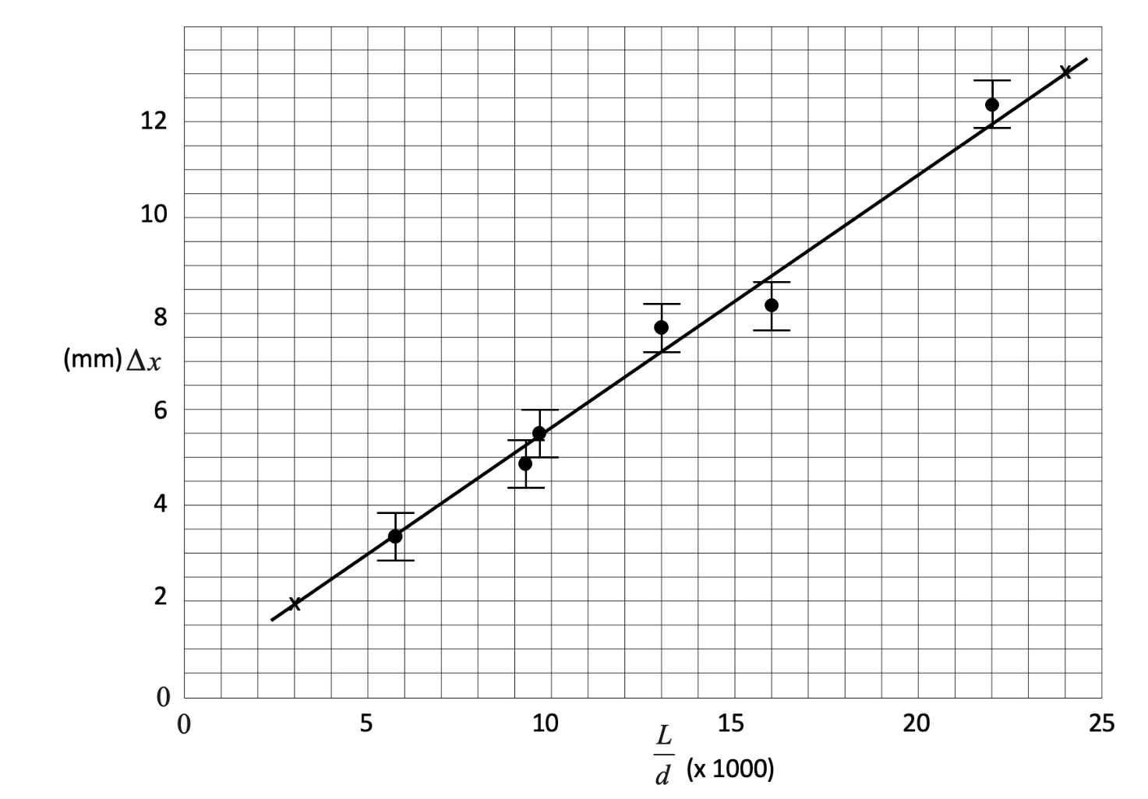
Question 20d.
$$Gradient=\frac{rise}{run}$$
$$Gradient=\frac{13-2}{(24-3)×1000}=\frac{11}{21000}$$
$$Gradient=5.2×{10}^{-4} mm$$
Students are reminded to use points on the line, not points from the table.

Question 20e.
Using $∆x=\frac{λL}{d} and y=mx$, if $∆x$ is plotted against $\frac{L}{d}$, then the gradient is $λ.$
Now $∆x$ is in mm and $\frac{L}{d}$ is in m, so the wavelength is the gradient / 1000.
$$λ=\frac{5.2×{10}^{-4}}{1000}$$
$$λ=5.2×{10}^{-7}m$$

