2023 VCE Physics (NHT) external assessment report

Specific information

Section A
Question | Correct answer | Comments
1 | C | Only C correctly shows field lines running from N to S.
2 | B | The field is non-uniform and directed outwards from the centre, indicating that it has to be an electric field.
3 | A | $$\frac{\frac{GMm}{r^{2}}}{\frac{GMm}{r^{2}}}=\frac{GMm}{{(5r)}^{2}}×\frac{r^{2}}{GMm}=\frac{1}{25}$$
4 | A | Only transverse waves can be polarised.
5 | B | $$\frac{I_{s}}{I_{p}}=\frac{N_{p}}{N_{s}}$$  If $I_{s}$ is to increase, then $N_{s}$ must decrease.
6 | C | $$V_{p}=V_{RMS}×\sqrt{2}$$  $$15.6×\sqrt{2}=22.1V$$  $$V_{p-p}=2×V_{p}$$  $$V_{p-p}=2×22.1=44.1$$
7 | C | The split ring commutator reverses the direction of the current every half turn to produce the DC output. Note DC refers only to direction of current flow and not magnitude.
8 | D | $$F=\frac{GMm}{r^{2}}=\frac{6.67×{10}^{-11}×5.68×{10}^{26}×1.08×{10}^{20}}{{\left(2.38×{10}^{8}\right)}^{2}}=7.2×{10}^{19}$$
9 | A | $$p_{A}=p_{B}$$  $$\left(1.0×0.80\right)=(2.5×v)$$  $$v=0.32 m s^{-1}$$
10 | C | $$E_{T}=\left(\frac{1}{2}mv^{2}\right)+\left(\frac{1}{2}mv^{2}\right)$$  $$E_{T}=\left(0.5×1.0×{1.0}^{2}\right)+\left(0.5×2.5×{0.4}^{2}\right)=0.7 J$$  $$SPE=\frac{1}{2}kx^{2}$$  $$0.7=0.5×k×{0.028}^{2}$$  $$k=1786 N m^{-1}$$
11 | D | A hypothesis is a possible explanation that needs to be tested by experimental evidence.
12 | A | The amplitude is the maximum deflection from the base line.
13 | B | When the wave is travelling through the block its speed decreases. This causes the wavelength to decrease while the frequency remains the same.
14 | D | 2.5 wavelengths in the 5.0 m string results in a wavelength of 2.0 m.
15 | B | $$E_{J}=0.12×\left(1.6×{10}^{-19}\right)=1.92×{10}^{-20} J$$
16 | C | $$λ_{d}=\frac{h}{mv}$$  $$v=\frac{6.63×{10}^{-34}}{\left(1.67×{10}^{-27}\right)×\left(5.00×{10}^{-9}\right)}$$  $$v=79.4 m s^{-1}$$
17 | C | An incandescent globe produces a continuous spectrum of visible light. An infra-red heat lamp will also produce a continuous spectrum but will not include the higher frequencies of visible light.
18 | A | If 300 nm is just able to release photoelectrons then increasing the wavelength will not produce any photoelectrons.
19 | D | 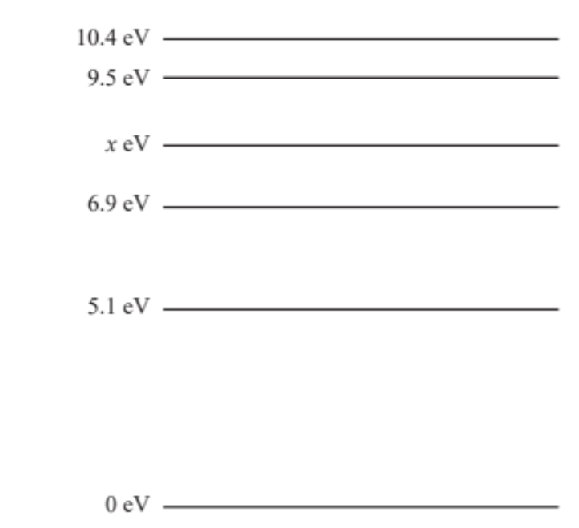  1.9 eV  1.0 eV  1.6 eV  8.5 eV
20 | B | $$E=mc^{2}$$  $$4.5×{10}^{-11}=(2m)×\left(9×{10}^{16}\right)$$  $$m=2.5×{10}^{-28} kg$$

Section B

Question 1
$$F=\frac{kq_{1}q_{2}}{r^{2}}$$
$$5.1×{10}^{-24}=\frac{(8.99×{10}^{9})×5q×q}{{\left(6.0×{10}^{-2}\right)}^{2}}$$
5q² = 2.04 × 10⁻³⁶
q = 6.39 × 10⁻¹⁹ C

Question 2
Ariel is correct.
The energy required to cross the gap is:
$$E=Vq=2000×1.5×{10}^{-8}$$
$$E=3×{10}^{-5} J$$
The particle only has 2.8 x 10⁻⁵ J so it will not reach the positively charged plate before it returns to the negative plate.

Question 3
Tube A.
The force between two conductors carrying currents in the opposite direction is repulsive. Tube B cannot move downwards due to the pegs but tube A can move upwards.

Question 4
Outcome 3.
$$Bqv=\frac{mv^{2}}{r}$$
$$v=\frac{2πr}{T}$$
$$Bq=\frac{m2πr}{T}×\frac{1}{r}$$
$$∴T=\frac{2πm}{Bq}$$
Since T is independent of v and both m and q are constant, both electrons will take the same time.

Question 5
$$\frac{{GM_{s}m}/{r_{s}^{2}}}{{GM_{e}m}/{r_{e}^{2}}}≡\frac{GM_{s}m}{r_{s}^{2}}×\frac{r_{e}^{2}}{GM_{e}m}=\frac{M_{s}}{r_{s}^{2}}×\frac{r_{e}^{2}}{M_{e}}=\frac{M_{s}}{M_{e}}×\frac{r_{e}^{2}}{r_{s}^{2}}$$
$$\frac{M_{s}}{M_{e}}×\frac{r_{e}^{2}}{r_{s}^{2}}=\frac{3.3×{10}^{5}}{1}×\frac{1}{{390}^{2}}=2.2$$

Question 6a.
$$a=\frac{Gm}{r^{2}}=\frac{\left(6.67×{10}^{-11}\right)×\left(5.98×{10}^{24}\right)}{{\left(6.37×{10}^{6}+5.00×{10}^{5}\right)}^{2}}$$
$$a=8.45 m s^{-2}$$
The acceleration is towards the centre of Earth.

Question 6b.
Area under graph (from 500 km to 1400 km) is:
$$Area=\frac{5050+3950}{2} × \left(1400-500\right)×{10}^{3}$$
Area = 4.05 × 10⁹ J
This could be done by counting squares but be careful to account for the fact that the y-axis does not go to zero.

Question 7a.
Anticlockwise

Question 7b.
$$F=nBIL$$
$$F=45×\left(80×{10}^{-3}\right)×3.2×\left(6.0×{10}^{-2}\right)$$
$$F=0.69 N$$

Question 8a.
$T=50×{10}^{-3}$ s
$$f=\frac{1}{T}=\frac{1}{50×{10}^{-3}}$$
$$f=20 Hz$$

Question 8b.
$$V_{RMS}=\frac{V_{p}}{\sqrt{2}}=\frac{4.30}{\sqrt{2}}$$
$$V_{RMS}=3.04 V$$

Question 8c.
Suggested change | emf  (increases, decreases or no effect)
Reduce the resistance of resistor R | no effect
Increase the strength of the permanent magnets | increases
Reduce the period of rotation of the coil to 60 m s | increases
Increase the number of turns of the rotating coil | increases

Question 9a.
$$P=\frac{V^{2}}{R}$$
$$2.60×{10}^{3}=\frac{V^{2}}{20}$$
$$V=228 V$$

Question 9b.
I in lines = I at hall
$$I_{hall}=\frac{V_{hall}}{R_{hall}}$$
$$I_{hall}=\frac{228}{20}=11.4 A$$
$$∴I_{line}=11.4 A$$

$$P_{loss}=4200-2600=1600 W$$
$$P_{loss}=I^{2}R$$
$$1600={11.4}^{2}×R$$

$$R=12.3 Ω$$

Question 9c.
1. Use transmission lines of lower resistance.
2. Use a step-up transformer at the generator end and a step-down transformer at the community hall end.

Question 10a.
Positive charge will flow towards E.

Question 10b.
$$ε=-N\frac{∆Φ}{∆t}= -NB\frac{∆A}{∆t}$$
Because the loop is travelling at constant speed, rate of change of area is constant, thus emf generated is constant.

Question 10c.
$$ε=-N\frac{∆Φ}{∆t}= -NB\frac{∆A}{∆t}$$
$$004=1×B×\frac{0.06×0.05}{0.025}$$
$$B=0.33 T$$

Question 11a.
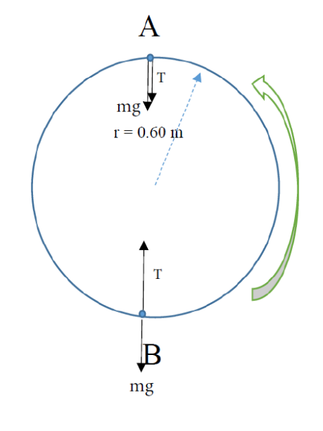

Question 11b.
$$T_{B}=F_{c}+mg=\frac{mv^{2}}{r}+mg$$
$$T_{B}=\frac{0.1×{3.0}^{2}}{0.6}-\frac{0.1×{3.0}^{2}}{0.6}+0.10×10$$
$$T_{B}=2.5 N$$

Question 11c.
Tension increases (at all points) as speed increases.
Fc constant at top and bottom.
Since $T_{B}=F_{c}+mg$ and $T_{A}=F_{c}-mg$, TB > TA (due to gravity).
Thus, the string is more likely to break at B.

Question 12a.
$$s=v_{h}×t=8.0×0.6$$
$$s=4.8 m$$

Question 12b.
$$v_{v}=a×t=10×0.3$$
$$v_{v}=3.0 m s^{-1}$$

Question 12c.
$$θ=\tan^{-1}\left(\frac{3.0}{8.0}\right)$$
$$θ=20.6°$$
$$v=\sqrt{{3.0}^{2}+{8.0}^{2}}$$
$$v=8.5 m s^{-1}$$

Question 12d.
One possible reason is air resistance.

Question 13a.
$$F=kx$$
$$\left(2.0×10\right)=k×1.0$$
$$k=20 N m^{-1}$$

Question 13b.
$$E_{s}=\frac{1}{2}kx^{2}=0.5×20×1^{2}$$
$$E_{s}=10.0 J$$
Position | h (m) | E_{g} (J) | $Δx$(m) | E_{s} (J)
P | 2.0 | 40.0 | 0 | 0
 | 1.5 | 30.0 | 0.5 | 2.5
Q | 1.0 | 20 | 1.0 | 10.0
 | 0.5 | 10.0 | 1.5 | 22.5
R | 0 | 0 | 2.0 | 40.0

No working was required for the values of 20 and 22.5.

Question 13c.
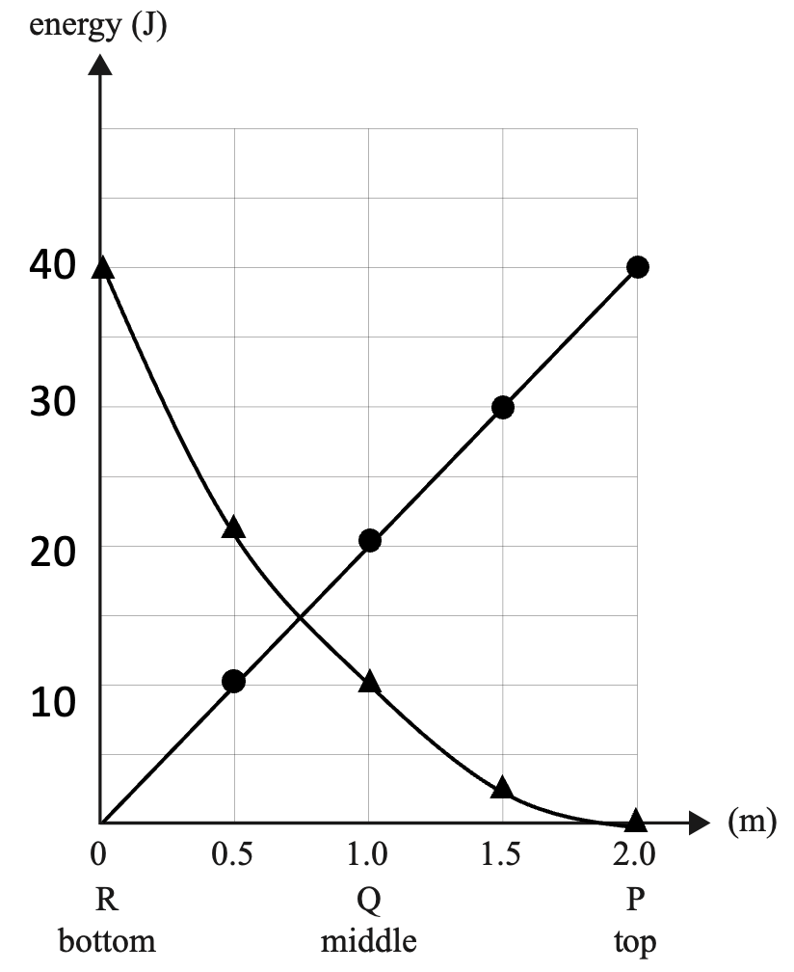

Question 13d.
Kinetic energy at middle point is 10 J (Total Energy – (E_{g} + E_{s} ))
$$KE=\frac{1}{2}mv^{2}$$
$$10=0.5×2.0×v^{2}$$
$$v=3.2 m s^{-1}$$

Question 13e.
The graphs plotted do not include the kinetic energy of the oscillating mass.
If the kinetic energy (E_{k}) of the oscillating mass had been included, E_{s}+ E_{g} + E_{k} would have added up to a constant value.

Question 14a.
3 × 10⁸ m s⁻¹ or c
The measured speed of light is the same for the spaceship and earth observer.

Question 14b.
$$L=\frac{L_{0}}{γ}$$
$$γ=\frac{1}{\sqrt{1-\frac{v^{2}}{c^{2}}}}=\frac{1}{\sqrt{1-{0.8}^{2}}}=1.67$$
$$L=\frac{71}{1.67}$$

$$L=43 m$$

Question 15a.
$$v=fλ$$
$$λ=\frac{360}{200}=1.8 m$$

Question 15b.
Volume depends on path difference between Nialle’s location and the speakers.
If the path difference is a whole multiple of the wavelength ($nλ$) then constructive interference will occur and the volume will be loud. If the path difference is a whole multiple of ($n-\frac{1}{2})λ$ then destructive interference will occur and the volume will be quiet.

Question 15c.
Since a standing wave is formed, the distance between nodes = λ/2 = 0.900 m.

Question 16
The reason why there is a difference in the sound is due to diffraction through the door opening. Longer wavelengths that approach the width of the door diffract more than shorter wavelengths, and so, the shorter wavelengths will sound softer relative to the longer wavelengths.

Question 17a.
$$n_{1}sinθ_{1}=n_{2}sinθ_{2}$$
$$1.00×sinθ_{1}=1.55sin31$$
$$θ_{1}=53.0°$$

Question 17b.
Ray strikes interface at 59° to normal (geometry) and this is the critical angle.
$${sinθ}_{c}=\frac{n_{clad}}{n_{core}}$$
$$sin59˚=\frac{n_{clad}}{1.55}$$
$$n_{clad}=1.33$$

Question 18a.
Band 3 is a point of destructive interference because the path difference of the light rays from the two slits is 3λ/2.

Question 18b.
$$∆x=\frac{λL}{d}=\frac{\left(600×{10}^{-9}\right)×1}{{10}^{-4}}$$
$$∆x=0.006 m=6.00 mm$$

Question 18c.
As RI increases, speed, and therefore wavelength, decrease.
$$\frac{v_{air}}{λ_{air}}=\frac{v_{liquid}}{λ_{liquid}}$$
$$\frac{3×{10}^{8}}{600×{10}^{-9}}=\frac{2.5×{10}^{8}}{λ_{liquid}}$$
$$λ_{liquid}=500 nm$$

$$w=\frac{λL}{d}=\frac{(500×{10}^{-9})(1)}{{10}^{-4}}$$
$$w=5.00 mm$$

Question 19a.
$$W=hf_{0}$$
$$4.30=4.14×{10}^{-15}×f_{0}$$
$$f_{0}=1.04×{10}^{15} Hz$$

Question 19b.
Sam’s idea is unlikely to produce more photoelectrons. It has already been stated that the threshold frequency is in the ultraviolet range. Red light has a lower frequency than ultraviolet light so no photoelectrons are expected to be released regardless of the brightness.

Question 20a.
$$λ=\frac{h}{p}=\frac{6.63×{10}^{-34}}{4.60×{10}^{-24}}$$
$$λ=1.44×{10}^{-10} m$$

Question 20b.
Electrons have wave-like properties.
Diffraction is a property of waves.
Salt crystals have a spacing that produces diffraction patterns with a beam of electrons.

Question 21.
Electrons have wave properties (λ = h/p).
In stable energy levels, the electrons will form standing waves in orbit around the nucleus such that 2πr = nλ.

