2026 VCE Physics (NHT) external assessment report
This report provides sample answers, or an indication of what answers may have included. Unless otherwise stated, these are not intended to be exemplary or complete responses.

Section A
Question | Correct answer | Comments
1 | A | Faster speed after the collision indicates that both kinetic energy and the magnitude of the momentum have increased.
2 | B | The normal force is $75×9.81≈736 N$, upwards.
3 | D | From $v^{2}=u^{2}+2as$, where $u=0, a=g, and s=h$, $v=\sqrt{2gh}$.
4 | C | For the car to remain in contact with the track at M, the F_{on car by track} must be equal to or greater than F_{g}. The net force on the car at M must, therefore, be F_{g} + F_{on car by track}.
5 | D | All masses attract in a gravitational field, but like magnetic poles and like charges repel.
6 | A | For Q1 to experience a force to the left, it must be repelled by Q2 indicating the charge on Q1 is negative.  The magnitude of the force is given by: $F=\frac{kq_{1}q_{2}}{r^{2}}$  $q_{1}=\frac{(1.5×{10}^{-3})×{0.72}^{2}}{(8.99×{10}^{9})×(-3.6×{10}^{-6})}=-2.4×{10}^{-8}$C
7 | A | Both the space station and the astronaut are in freefall. There is no normal force on the astronaut.
8 | D | $$F=nBIL$$  $$F=1×1.2×4.8×0.36$$  $$F=2.1N$$  Right-hand grip rule; fingers into the page, thumb to the left, palm indicates force is down the page.
9 | C | The only force on the proton is perpendicular to its velocity so its speed remains unchanged.
10 | B | The voltage across the input into the inverter will be the output from the photovoltaic panels, which is a constant voltage indicated by graph 1 since graph 2 is not an input option in any of the answers.  The role of the inverter is to convert DC power to AC power, which is graph 4 since graph 3 is not an output option in any of the answers.
11 | D | If the frequency is doubled, the period will be halved and the amplitude will be doubled.  If the slip rings are replaced with a split ring commutator, the output will be a rectified sine wave.
12 | D | $$I_{RMS}=\frac{P}{V_{RMS}}$$  $$I_{RMS}=\frac{57.5}{230}=0.25A$$  $$I_{p-p}=2\sqrt{2}×I_{RMS}$$  $$I_{p-p}=2\sqrt{2}×0.25=707 mA$$
13 | B | $Φ∝B$ so if B is halved, $Φ$ is halved.  $Φ∝r^{2}$ so if r is doubled, $Φ$ is quadrupled.  The combined effect is to double the flux.
14 | C | Electromagnetic radiation comprises both oscillating electric and magnetic fields arranged perpendicular to each other.
15 | B | The point X is the second dark band from the centre of the pattern. This indicates that the path difference is $\frac{3λ}{2}$ .
16 | B | $$E=hf$$  $$f=\frac{9.7}{4.14×{10}^{-15}}$$  $$f=2.3×{10}^{-15} Hz$$
17 | B | $$λ=\frac{h}{mv}$$  If m increases, wavelength will decrease. The result is that the neutron has a shorter wavelength.
18 | A | A traveller on spaceship P will measure proper length since spaceship P is stationary in their frame of reference. A traveller on spaceship Q will measure a contracted length since spaceship P is moving in their frame of reference.
19 | C | The measurements are all concordant within the given uncertainty.  The difference between these measurements and the known true value is greater than the uncertainty in the measurement.  This indicates a systematic error.
20 | A | The variable that is determined before the measurement is taken is the distance of the timekeeper from the start.  The variable that is measured is the time measured by the timekeeper.

Section B

Question 1a.
$$k=gradient=\frac{250}{0.05}$$
$$k=5.0×{10}^{3} N m^{-1}$$

Question 1b.
$$E_{s}=\frac{1}{2}kx^{2}$$
$$E_{s}=0.5×5.0×{10}^{3}×{0.05}^{2}$$
$$E_{s}=6.3 J$$
This question could also be answered by finding the area under the graph.

Question 1c.
The spring constant would need to be greater.
To balance the increased force due to gravity (mg), the spring constant must increase if the displacement is to remain the same.

Question 2a.
$$v=\frac{2πr}{T}=\frac{2π×0.70}{0.67}$$
$$v=6.6 m s^{-1}$$

Question 2bi.
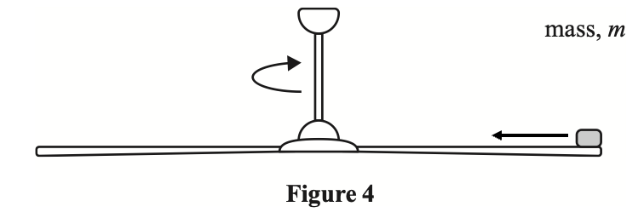

Question 2bii.
$$F=\frac{mv^{2}}{r}=\frac{4.0×{10}^{-3}×{6.6}^{2}}{0.70}$$

Question 2ci.
At a faster speed, the centripetal force required to keep the mass in a circular path will increase.
The friction force between the mass and the blade is not sufficient to provide the required centripetal force.

Question 2cii.
The mass will leave the blade in the direction of the tangent to the circular motion.
The mass will then follow a parabolic path as it falls to the floor.
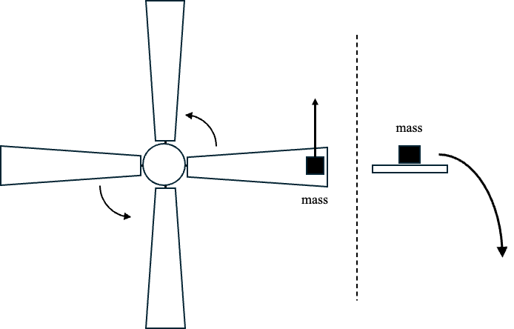

Question 3a.
The magnitude of the force of the car on the insect is equal to the magnitude of the force of the insect on the car.
This is an example of Newton’s third law.

Question 3b.
Two arguments were accepted.
The first was to state that Abbie is correct and that in a closed system the momentum remains constant as does the total energy; however, some of the kinetic energy would be converted to heat/sound.
The second was to state that both Abbie and James are incorrect. Abbie is incorrect about the energy remaining constant since the total energy of the car and insect will decrease. James is incorrect about the momentum not being conserved.

Question 4a.
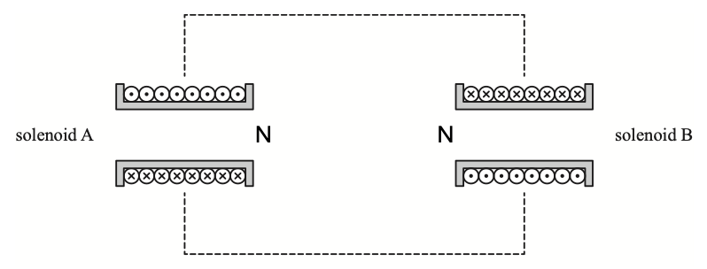

Question 4b.
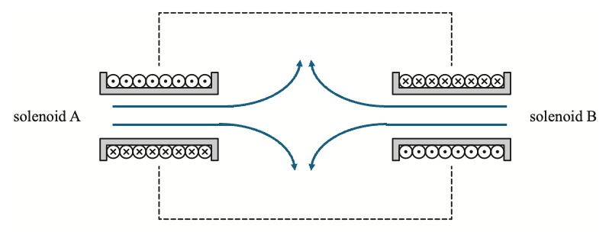

Question 5a.
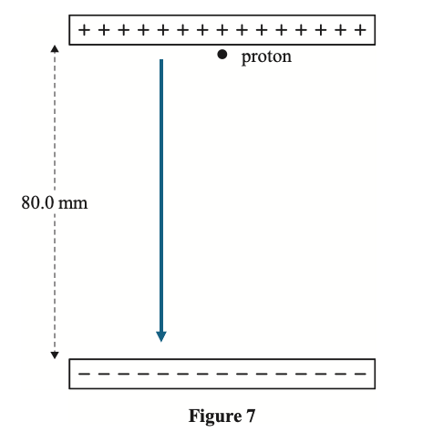

Question 5b.
$$F=Eq$$
$$F=1.60×{10}^{-19}×80×{10}^{-3}$$
$$F=2.4×{10}^{-15} N$$

Question 5c.
$$W=Fs$$
$$W=2.4×{10}^{-15}×80×{10}^{-3}$$
$$W=1.9×{10}^{-16} J$$
Other methods were also accepted.

Question 5d.
The change in electrical potential energy is dependent on charge and is independent of mass.
The alpha particle has twice the charge of the proton, so the change in electrical potential energy is doubled.

Question 6a.
$$g=\frac{GM}{r^{2}}$$
$$g=\frac{6.67×{10}^{-11}×7.35×{10}^{22}}{1.74×{10}^{6}+1.00×{10}^{6}}$$
$$g=0.653 m s^{-1}$$

Question 6b.
The area under the curve is approximately 50 squares.
One square equals $100 000×0.2=2×{10}^{4} J {kg}^{-1}$ .
Therefore, the total energy is $E=52×2×{10}^{4}×2=2.08×{10}^{6} J$ .
A range of the estimate of the number of squares was accepted.
Other methods for determining the area under the curve were accepted.

Question 6c.
The period will remain unchanged.
The period is determined by $T=\sqrt{\frac{4π^{2}r^{3}}{GM}}$, which is independent of the mass of the satellite.

Question 7a.
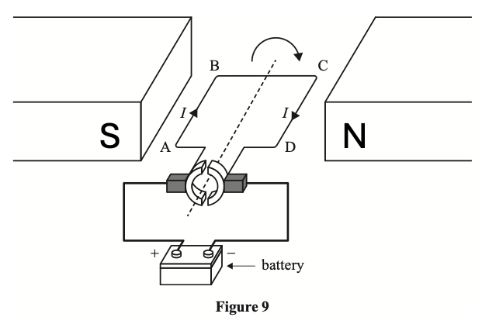
Applying the right-hand slap rule (or equivalent), the thumb points from A to B, the palm is upwards, and the fingers, therefore, point from right to left.
The loop is able to rotate continuously due to the split ring commutator. The split ring commutator reverses the direction of the current in the loop every half turn to maintain a clockwise torque.

Question 7b.
The loop is able to rotate continuously due to the split ring commutator. The split ring commutator reverses the direction of the current in the loop every half turn to maintain a clockwise torque.

Question 7c.
Jackie’s suggestion is correct.
The force on the current carrying wires is given by $F=nBIL$. If n is increased, the force will increase.

Question 8a.
The magnitude of the emf is given by:
$$ε=n\frac{∆Φ}{∆t}$$
$$ε=80×\frac{5.0×{10}^{-4}}{2.5×{10}^{-3}}$$
$$ε=16 V$$

Question 8b.
The dynamo is an example of an AC generator.
The alternating flux through the coil combined with the absence of a split ring commutator indicate that the output will be AC.

Question 9a.
The current through the lines is:
$$I=\frac{P_{inverter}}{V_{inverter}}=\frac{460}{230}=2 A$$
The voltage drop across the lines is:
$$V_{drop}=2×20=40 V$$
The voltage across the sign is:
$$V_{sign}=230-40=190 V$$

Question 9b.
Original power loss is:
$$P_{loss}=I^{2}R=2^{2}×20=80 W$$
Desired power loss is 20W.
Therefore, line current is:
$$20=I^{2}×20$$
$$⟹I=1 A$$
The winding ratio is:
$$\frac{N_{primary}}{N_{secondary}}=\frac{I_{secondary}}{I_{primary}}=\frac{1}{2}$$
The ratio is 1:2.

Question 10a.
The increase in current in solenoid 1 creates an increasing flux in solenoid 1.
This causes an increasing flux in solenoid 2.
The changing flux in solenoid 2 results in an induced emf and, therefore, a current in solenoid 2.

Question 10b.
The current in the resistor will flow from left to right.
Solenoid 2 is experiencing an increasing flux to the right.
The induced current will result in an induced flux to the left.
Using the right-hand grip rule (or equivalent), the current will flow from left to right through the resistor.

Question 10c.
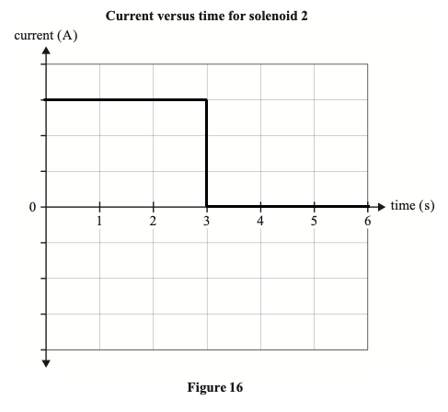
A negative initial voltage was also accepted.

Question 11a.
From the graph, the peak current is 2.8 A.
$$I_{RMS}=\frac{I_{P}}{\sqrt{2}}=\frac{2.8}{\sqrt{2}}=2.0 A$$

Question 11b.
The same brightness indicates that the power dissipated by the globe is still 6W.
$$V=\frac{P}{I}=\frac{6}{2}=3 V$$

Question 12a.
Einstein stated that the speed of light is the same for all observers.
The trackside observer will measure a longer distance for the photon.
The trackside observer will measure a dilated time for the path measured in the other observer’s frame of reference.

Question 12b.
$$γ=\frac{1}{\sqrt{1-\frac{v^{2}}{c^{2}}}}$$
$$γ=\frac{1}{\sqrt{1-{0.86}^{2}}}=1.96$$
$$t=γt_{0}=1.96×16×{10}^{-9}$$
$$t=31.4 ns$$

Question 13a.
$$p=\frac{h}{λ}=\frac{6.63×{10}^{-34}}{0.744×{10}^{-9}}$$
$$p=8.91×{10}^{-25} kg m s^{-1}$$

Question 13b.
Taking left as positive.
$$p_{f}=p_{i}$$
$$\left(9.11×{10}^{-31}×v_{electron}\right)-8.85×{10}^{-25}=8.91×{10}^{-25}$$
$$v_{electron}=1.95×{10}^{6} m s^{-1}$$

Question 14ai.
Planck’s constant is found from the gradient.
$$h=\frac{(2.6-0)}{(8-3)×{10}^{14}}$$
$$h=5.2×{10}^{-15} eV s$$

Question 14aii.
From the x-intercept.
$$f_{0}=3.0×{10}^{14} Hz$$

Question 14aiii.
From the y-intercept.
$$work function=1.6 eV$$

Question 14b.
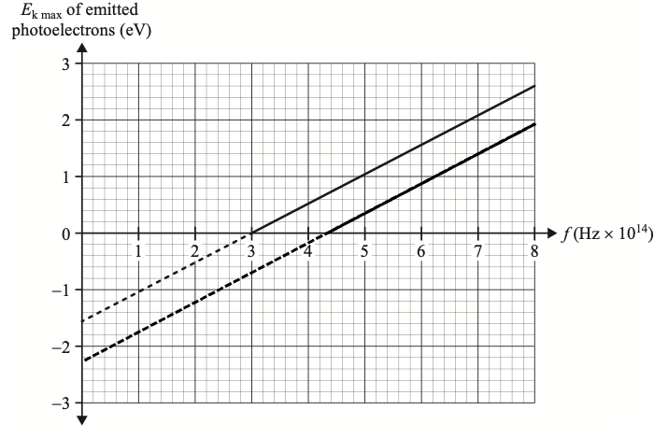

Question 15a.
$$E=\frac{hc}{λ}=\frac{4.14×{10}^{-15}×3.00×{10}^{8}}{500×{10}^{-9}}$$
$$E=2.48 eV$$

Question 15b.
The $\frac{λ}{w}$ ratio is:
$$\frac{λ}{w}=\frac{500×{10}^{-9}}{700×{10}^{-9}}=0.71$$
Diffraction is determined by the $\frac{λ}{w}$ ratio.
As the value for this ratio is less than 1.0, diffraction will be observed.

Question 16
Photons with energies that match the difference between electron energy levels in hydrogen can cause electrons to jump to higher energy levels. In doing so, they will be absorbed.
These absorbed photons are missing from the spectrum and give rise to the dark lines in the spectrum.

Question 17a.
The independent variable is the water depth, d.
The dependent variable is the range, R.
The controlled variables are either the water level in the tube or the size of the holes.

Question 17b.
For the range to be constant throughout the measurement, the height of the water column above it must be kept constant.
Clarifying that the water level in the tube is a controlled variable and, therefore, must be kept constant was also accepted.

Question 17c.
Repeating the measurements reduces the effect of random error.

Question 17d.
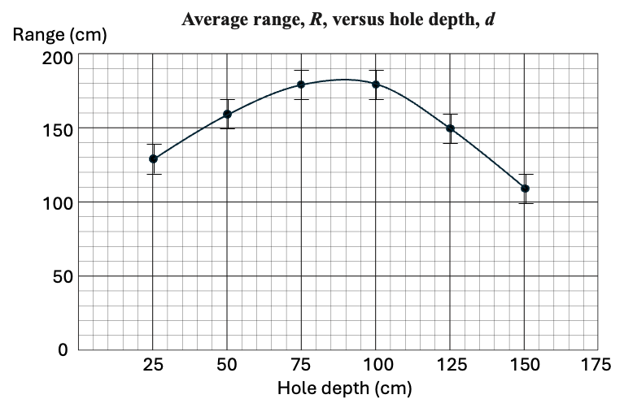

Question 17e.
From the graph.
The maximum range is ~182 cm.
The hole depth to achieve the maximum range is ~87.5 cm.

Question 17f.
No, the resistance forces cannot be ignored.
The theoretical range is significantly larger than the measured range.
The difference is outside the range of uncertainty in the measurement.

Question 17g.
While the bottom hole will have the greatest velocity, it will also have the shortest time before reaching the ground.
The range is proportional to the time it takes the water to reach the ground.

