_p

**TSX2StaMPS: Data preparation for StaMPS PSI processing of high-resolution TerraSAR-X data with SNAP**

# Table of Contents

Inhalt

Table of Contents 2

1 Introduction 3

2 Data download 4

3 Download and installation 4

4 Step by step 5

5 References 15

# Introduction

This tutorial represents the extension of the tutorials of the Research and User Support for Sentinel core products (RUS) service, which provides a free and open scalable platform in a powerful computing environment and hosts a suite of open-source toolboxes pre- installed on virtual machines, to handle and process data derived from the Copernicus Sentinel satellites constellation (Serco Italia SPA 2020).

Persistent Scatterer Interferometry (PSI) is a powerful advanced DInSAR technique able to measure and monitor displacements of the Earth’s surface over time with high accuracy (Serco Italia SPA 2020). Hooper et al. (2004) proposed a novel PS selection using phase characteristics, which is suitable to find low-amplitude natural targets with phase stability that cannot be identified by amplitude-based algorithms. This work originated one of the most widely used PSI software packages, StaMPS. 1

SNAP2StaMPS is a Python workflow developed by José Manuel Delgado Blasco and Michael Foumelis in collaboration with Prof. A. Hooper to automate the pre-processing of Sentinel-1 SLC data and their preparation for ingestion to StaMPS (Serco Italia SPA 2020). However, not only Sentinel-1 data could be processed within StaMPS, but other data like TerraSAR-X too. In this regard, the original SNAP2StaMPS package was modified in a new package called “TSX2StaMPS”, which focuses on the preprocessing of high-resolution TerraSAR-X data for the use in StaMPS. Since some of the processing steps and explanations contain parts of the SNAP2StaMPS package and tutorials, these abstracts are marked here with a red star (**\***) and refer to the following SNAP2StaMPS tutorial:

Serco Italia SPA (2020). *SNAP2StaMPS: Data preparation for StaMPS PSI processing with SNAP - Mexico City 2020 (version 1.1).* Retrieved from RUS Lectures at [https://rus-](https://rus-copernicus.eu/portal/the-rus-library/learn-by-yourself/) [copernicus.eu/portal/the-rus-library/learn-by-yourself/](https://rus-copernicus.eu/portal/the-rus-library/learn-by-yourself/)

# Data download

To download high-resolution TSX data, register as a new user at the EOWEB GeoPortal hosted by the German Aerospace Center (DLR): <https://eoweb.dlr.de/egp/>.

According to your user privileges, select the data (platform, start time, end time, geographical region) you want to download and put the selected scenes in the cart.

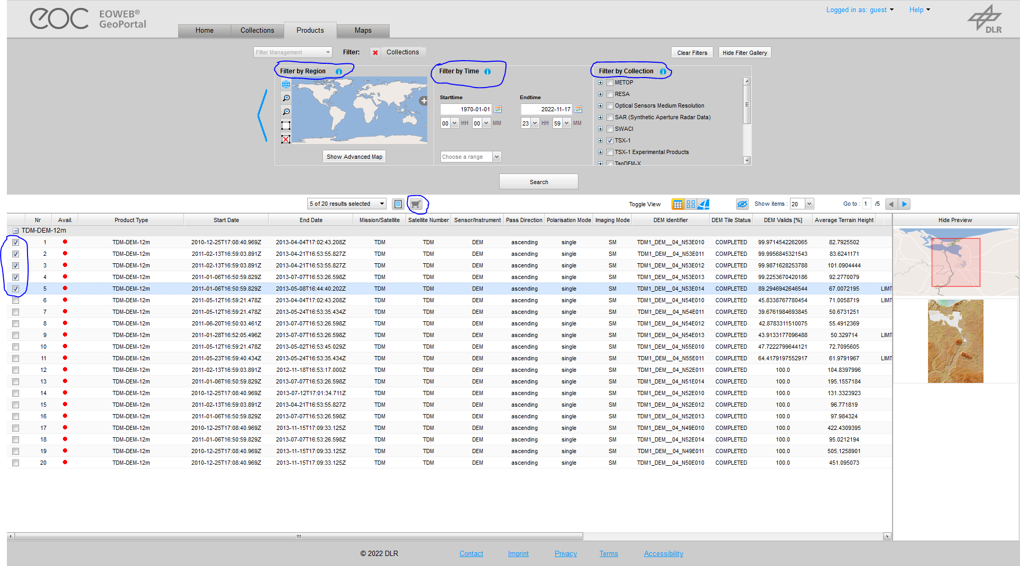

<https://eoweb.dlr.de/guestegp/main#mainWindowtabExplore>

After ordering the data, you can download the provided “.tar.gz” files by using FTPS. For further information see the following link for downloading data provided by DLR, e.g. via FileZilla: <https://eoweb.dlr.de/egp/docs/user/downloading_ordered_data.html>

# Download and installation

The TSX2StaMPS package can be downloaded via the following link on GitHub:

<https://github.com/jziemer1996/TSX2StaMPS.git>

To install the package, you only need to unzip the folder you downloaded from GitHub. Please note, that TSX2StaMPS is based on Python 3.9 and makes use of SNAP 9 functionality. So please make sure that your SNAP version is up to date, at least version 9.0.0. You don’t need to install any further Python library. However, make sure that your path variables are set accordingly if any further Python versions are installed on your machine. Therefore, just open the environmental variables window. Moreover, a python module called ***“pathlib”*** has to be installed manually, since it is not part of the default packages installed in Python. Therefore, in your command line type the following command: ***“pip install pathlib”.***

# Step by step

#### Package structure

The package is structured as followed:

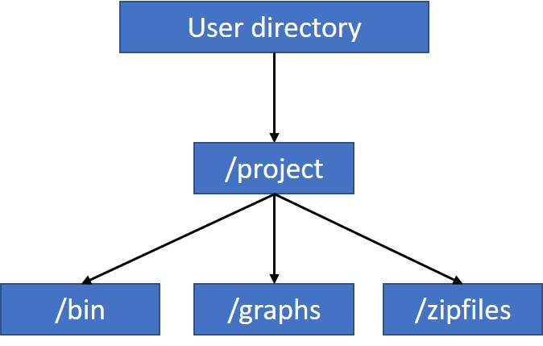

TSX2stamps consists of a project folder, in which three subdirectories can be found, ***“bin”***, ***“graphs”*** and ***“zipfiles”***. The downloaded TSX scenes can be downloaded and moved into the ***“zipfiles”*** directory. In the ***“bin”*** folder, you`ll find all processing steps provided as python scripts and a project.conf file, where all processing parameters can be defined by the user:

#### 1_unpack_sar_scenes.py

#### 2_slaves_prep.py

#### 3_subset_sar.py

#### 4_coreg_sar.py

#### 5_ifg_sar.py

#### 6_tsx_stamps_export.py

#### Project.conf

The python scripts can be executed via cmd or Windows Powershell. The 6_tsx_stamps_export.py script is the last step of the workflow and prepares the preprocessed data for ingestion in StaMPS. The scripts are based on SNAP graphs for the processing of the TSX scenes. These XML graphs are stored in the /graphs folder and are ordered according to the processing workflow:

* **3_TSX_Subset.xml**
* **4_DEM_Assisted_Coregistration.xml**
* **5_Interferogram_TopoPhase.xml**
* **6_TSX_Export.xml**

*The Following part is directly taken from the* [*SNAP2StaMPS - manual*](https://github.com/mdelgadoblasco/snap2stamps/blob/master/Manual/SNAP2StaMPS_User_Manual.pdf) *and StaMPS manual.****\****

StaMPS is compatible with the output generated by SNAP after the version 6.0. SNAP allows the user to define a series of xml files that contain user-defined processing workflow by using its Graph Builder. These files can be used to run SNAP processing in batch mode by using the GPT command (Graph Processing Tool).

[TSX2stamps](https://github.com/mdelgadoblasco/snap2stamps) contains a set of graphs, together with python wrappers that allow you to automatise the processing chain for single master interferograms compatible with StaMPS PSI.

#### Hardware requirements*

There are no specific hardware requirements but note that TerraSAR-X data are quite large, and their processing requires significant resources. For example, the interferogram generation step, which is the most computationally demanding will likely require a machine with a minimum of 16 GB RAM.

#### Master selection*

Before we start with the pre-processing of the data, we need to select an optimal master image. The master image is selected such that the distribution of the perpendicular baseline values is as low as possible as well as maximizing the (expected) stack coherence of the interferometric stack. Selection of the "optimal" master should lead to improved visual interpretation of the interferograms and assist quality assessment.

SNAP contains a tool to perform the optimal master selection for us while also providing the overview of the temporal and perpendicular baselines of all the products with respect to it.

Go to **Radar** → **Interferometric** → **InSAR Stack Overview** and click **Add Opened** to load all products (they will not be ordered by date, but it is not important). Then click **Overview**.

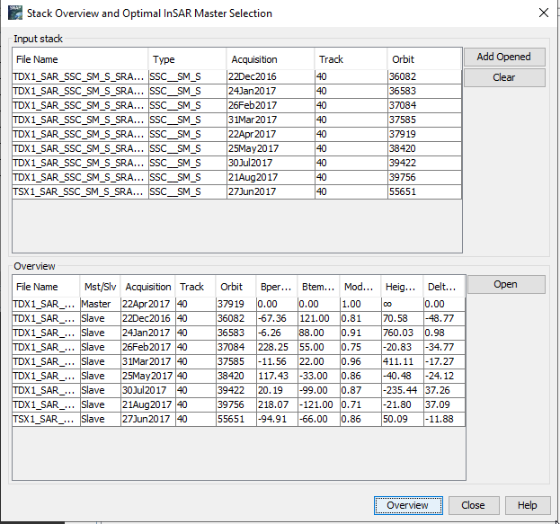

In the Mst/Slv column you can see, which TSX scene was selected as master. Please keep that scene in mind for later processing! Go to the /project directory and create a new folder called “master”.

#### TSX2StaMPS project configuration*

To run the next steps in a more automated mode the TSX2stamps package includes a ***project.conf*** file where all necessary user inputs are defined. Let’s now set it up.

You can find the file in the TSX2stamps **“bin”** folder and have to edit it according to your data and paths. Right-click ***project.conf*** and select ***Open in Mousepad.*** At this moment all the settings are empty.

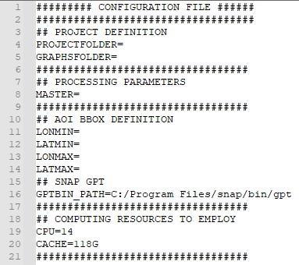

In the **PROJECT DEFINITION** section, we set the default project folder to the ***Processing*** folder and set the graphs folder to the TSX2stamps graph location.

#### PROJECTFOLDER=/…/Project

#### GRAPHSFOLDER=/…/Project/graphs

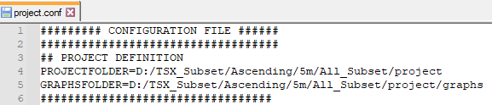



TIP: Your paths must not contain any spaces if they do, enclose them into quote marks “path”.

In the **PROCESSING PARAMETERS** section, specify the master folder. When finished with the subsetting of the TSX scenes, you can add your master .dim file in this line. For the moment, just leave it open.

#### MASTER=/…/Project/master

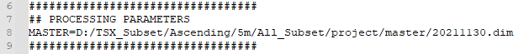

In the AOI BBOX DEFINITION you have to define a spatial subset. Therefore, four parameters, ***Latmin, Lonmin, Latmax*** and ***Lonmax*** have to be specified. The subset is based on geographical coordinates. To find out the extend of your subset, go to SNAP à **Graph Builder à Right click à Add à Raster à Subset.** There you can specify the extend of the SAR scene to be subsetted.

#### LONMIN (West longitude bound) = 7.403

#### LATMIN (North latitude bound) = 50.95

***LONMAX (East longitude bound) = 7.666***

***LATMAX (South latitude bound) = 51.24***

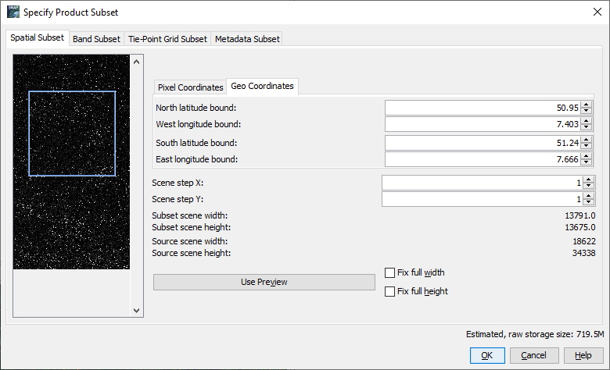

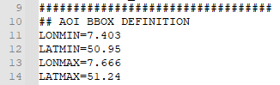



TIP: Be careful to copy minus signs correctly and remove all spaces.

In the SNAP GPT path, we need to point to the SNAP installation.

GPTBIN_PATH=***/…/snap/bin/gpt***



Finally, in the COMPUTING RESOURCES TO EMPLOY section, we can set the CPU number and Cache size to use (See  NOTE 4). This needs to be selected based on your VM/PC:

CPU=12 CACHE=32G

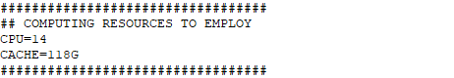

Now, go to **File** → **Save** and save the changes made to the ***project.conf*** file. We can now start with the automated processing using the python scripts.

#### Unpack TSX scenes

In the first step, the downloaded TSX scenes have to be unpacked in the /unzip folder. Finally, the unpacked scenes are moved to a newly created folder called ***“slaves”***, where further processing is done. The first step is executed using the *1_unpack_sar_scenes.py* script provided in the /bin folder. To execute the script, paste the following command in the terminal.

python2 1_unpack_sar_scenes.py project.conf

When the processing is completed, the bin path ending with $ will appear. Leave the terminal window open and check the ***“slaves”*** folder.

#### Slaves preparation*

In the next step, we need to divide the slave images into folders with the name corresponding to the acquisition date in format ***<yyyymmdd>***. This is necessary for the subsetting in step 3. To call the second python script paste the following command in the terminal.

python2 2_slaves_prep.py project.conf

Then press **ENTER** to run the command. *The processing will take few seconds depending on your VM (here: 16 cores; 128 GB RAM).*



TIP: **The TDX2stamps requires Python 2.7.** You can type “python -V” and “python2 -V” commands to your command line to find the associated version.

When the processing is completed, the bin path ending with $ will appear again. Leave the terminal window open and check, if the ***“slaves”*** folder contains a folder for each slave image.

#### /…/project/slaves

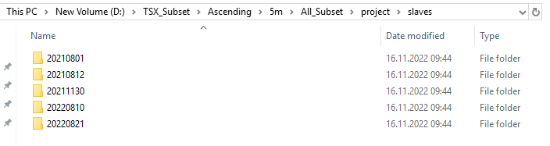

#### Subsetting

Next, you could create a subset of the downloaded TSX scenes. This is not mandatory, but is recommended, since it can significantly reduce the processing time of the following steps. Again, this step is run in the terminal window by using the *3_subset_sar.py* script which refers to the SNAP graph “3_TSX_Subset.xml” (predefined in the ***“graphs”*** folder). The python script will automate the processing by looping over the slave images and updating the input and output accordingly and then running the graph for each slave image. It will create a new folder named “subset” in the project directory, where all subsetted files are stored in format ***<yyyymmdd>***, with the extent specified in the AOI BBOX DEFINITION mentioned above.

Go back to the **terminal** window and run the following command.

python2 3_subset_sar.py project.conf

Then press **ENTER** to run the command. When the processing finishes successfully, something like the message below should appear. *The processing will take approximately 40 seconds per image depending on your subset and VM (here: 16 cores; 128 GB RAM).*

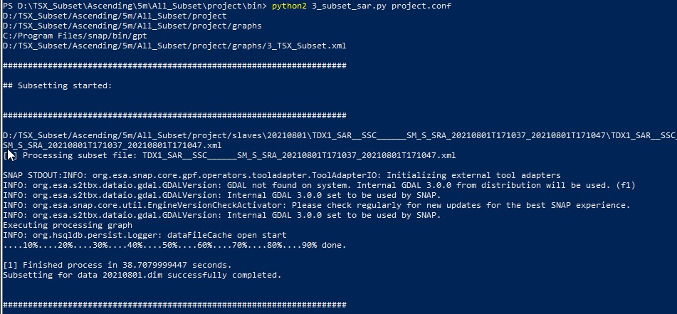

In the end of this process, don’t forget to move (not copy!) your master scene (see section 3.3) to the newly created folder called ***“master”*** (within the project folder). The correct folder content is important here, since each slave is coregistered with the master scene in the following step.

#### Master-slave coregistration*

In the next step we need to co-register each subsetted slave image with the master image. You can see the workflow below.

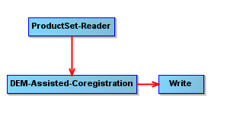

* + 1. DEM-Assisted-Coregistration

This operator co-registers two TSX products (master and slave) using a Digital Elevation Model (DEM) *(for further information see SNAP Help).* Note, that in this package, an external DEM is used as a default. To specify your DEM you want to use, open the “4_DEM_Assisted_Coregistration.xml” graph in the ***“graphs”*** folder, and paste the folder path, where the DEM is stored and the name of the DEM into line 11. However, you could use the DEMs provided via Auto Download in SNAP. If so, the XML graph needs to be adjusted accordingly (lines 9-11). The script will be executed by using the *4_coreg_sar.py* script within the bin folder.

* + 1. Run

Go back to the **terminal** window and run the following command. Note that this is one of the most time- demanding steps in the pre-processing chain. When the processing is completed, a new folder ***“coreg”*** is created in the ***Project*** folder. This folder contains the coregistered and debursted products.

python2 4_coreg_sar.py project.conf

Press **ENTER** to run the command. When the processing finishes successfully, something like the message below should appear. *The processing will take approximately 10 minutes per slave image depending on your subset and VM (here: 16 cores; 128 GB RAM).*

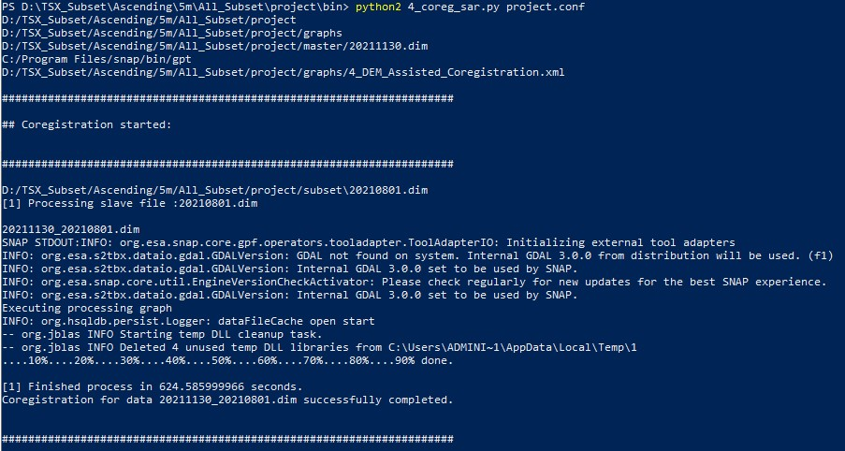

#### Interferogram generation*

Finally, interferograms have to be generated from the coregistered data pairs created in the previous step. This will be done by using the *5_ifg_sar.py* script in the bin folder, which corresponds to the “5_Interferogram_TopoPhase.xml” graph located in the graphs folder.

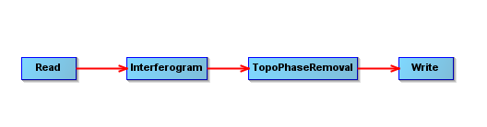

In the first step, the interferograms will be created using the files stored in the ***“coreg”*** folder. Finally, the topographic phase will be removed using the (external) DEM specified above. Again, you need to change the folder path and name of your DEM in line 42 of the “5_Interferogram_TopoPhase.xml” graph. As mentioned above, you don’t have to use your own DEM here, since a bunch of DEMs are provided via the Auto Download function in SNAP. If so, the XML graph needs to be adjusted accordingly (lines 41-42). When the processing is completed, a new folder ***“ifg”*** is created in the ***Project*** folder. This folder contains the interferogram with the topographic phase removed. The products in both folders are named ***<masterDate_slaveDate.dim.***

Go back to the **terminal** window and run the following command.

python2 5_ifg_sar.py project.conf

Then press **ENTER** to run the command. Leave the terminal window open. When the processing finishes successfully, something like the message below should appear. *The processing will take approximately 5 minutes per coregistered image-pair depending on your subset and VM (here: 16 cores; 128 GB RAM).*

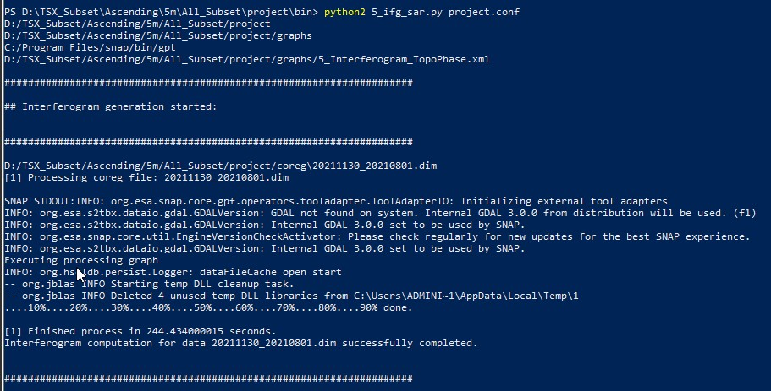

* + 1. Check the interferograms

Now, before the files are exported we need to test if all the interferograms have been correctly completed. Open SNAP graphical interface and load all the products:

#### /…/project/ifg/

Then open the ***“Phase_ifg_*****”*** band for each product. You do not need to open all at once as below, you merely need to check for empty interferograms.

In the image below you can see that all interferograms have been correctly created. If in your dataset you find an empty interferogram note the name and consequently remove the file from the ***“coreg”*** and ***“ifg”*** folders.

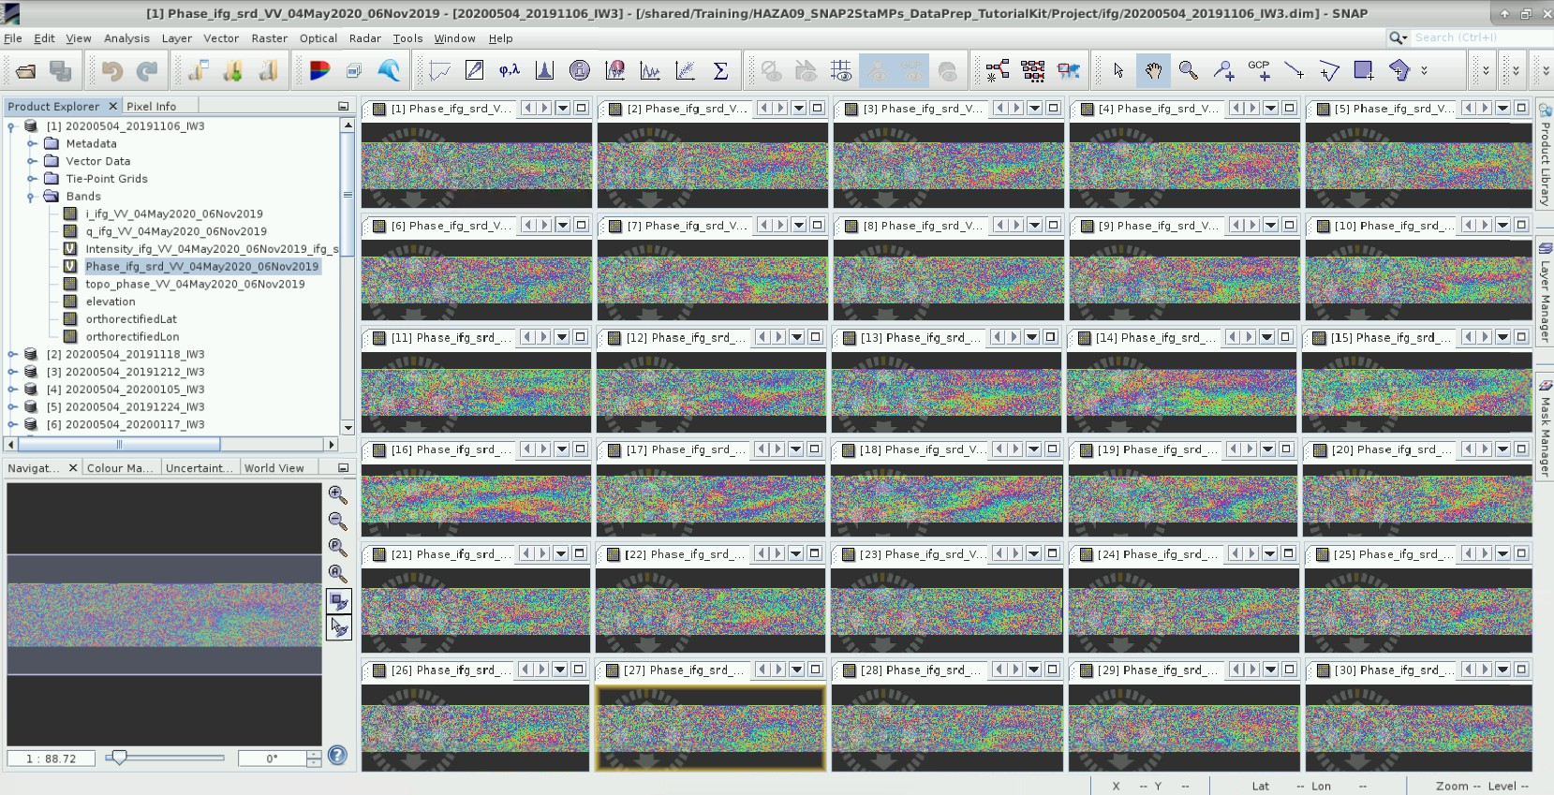

#### StaMPS export*

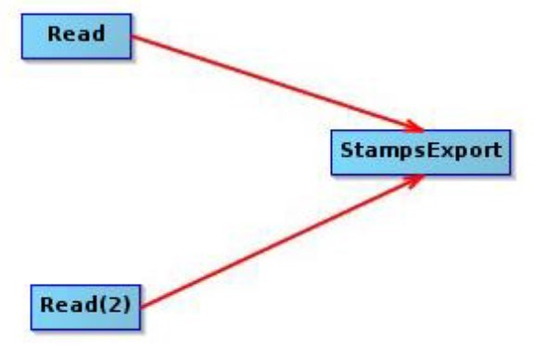

Now we need to prepare the data into a StaMPS compatible format. This is done by using a SNAP tool for StaMPS export.

The inputs are:

* the coregistered master-slave pair
* its corresponding interferogram with the elevation and orthorectified latitude and longitude bands

Go back to the **terminal** window and run the following command.

python2 6_tsx_stamps_export.py project.conf

Then press **ENTER** to run the command. When the processing finishes successfully, something like the message below should appear. *The processing will take again quite long time - approximately a 15 minutes per slave image depending on your VM (here: 16 cores; 128 GB RAM).*

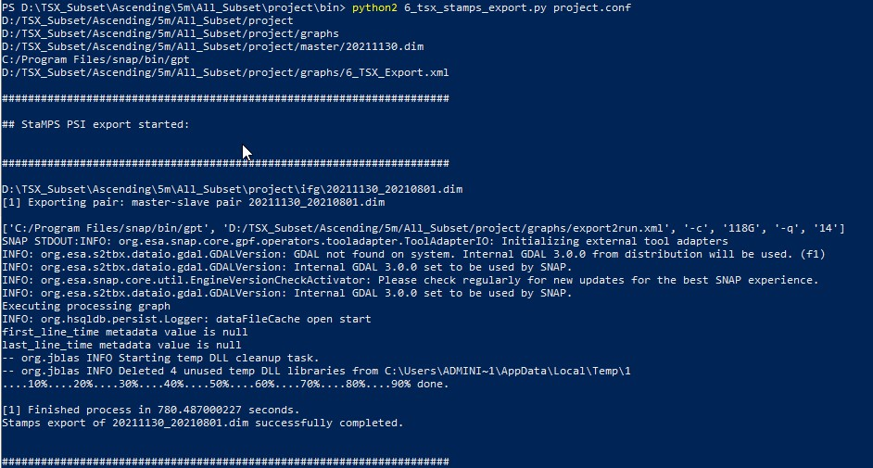

When the processing is completed, a new folder named ***“INSAR_<masterDate>”*** was created in the ***Project*** folder. It contains the final output structure - four folders: ***rslc***, ***diff0***, ***geo*** and ***dem***. When the processing was finished successfully, you can close your command line interface and start with StaMPS PSI processing.

# References

#### Software and Data download

**German Aerospace Center (2022).** EOWEB GeoPortal (EGP). <https://eoweb.dlr.de/egp/>

**SNAP2StaMPS Manual and download** - https://github.com/mdelgadoblasco/snap2stamps

[**StaMPS Manual**](https://homepages.see.leeds.ac.uk/~earahoo/stamps/StaMPS_Manual_v4.1b1.pdf)[**StaMPS Download**](https://github.com/dbekaert/StaMPS)

#### PSI resources

**Crosetto, M., Monserrat, O., Cuevas-González, M., Devanthéry, N., & Crippa, B. (2016). Persistent Scatterer Interferometry: A review***. ISPRS Journal of Photogrammetry and Remote Sensing*, 115, 78–89. <https://doi.org/10.1016/j.isprsjprs.2015.10.011>

**Delgado Blasco, J. M., Foumelis, M., Stewart, C., & Hooper, A. (2019). Measuring Urban Subsidence in the Rome Metropolitan Area (Italy) with Sentinel-1 SNAP-StaMPS Persistent Scatterer Interferometry**. *Remote Sensing*, 11(2), 129. <https://doi.org/10.3390/rs11020129>

**Jia, H., & Liu, L. (2016). A technical review on persistent scatterer interferometry**. *Journal of Modern Transportation*, 24(2), 153–158. <https://doi.org/10.1007/s40534-016-0108-4>

#### Tutorials

**GIS-Blog** - Matthias Schlögl – Using StaMPS/MTI for PSI Analysis (post series) - [https://www.gis-](https://www.gis-blog.com/stamps-1/) [blog.com/stamps-1/](https://www.gis-blog.com/stamps-1/)

1. **Hooper** – StaMPS Persistent Scatterer Exercise (2015) – ESA Land Training Course <http://seom.esa.int/landtraining2015/files/Day_4/D4P2a_LTC2015_Hooper.pdf>

**Serco Italia SPA (2020).** SNAP2StaMPS: Data preparation for StaMPS PSI processing with SNAP - Mexico City 2020 (version 1.1). Retrieved from RUS Lectures at <https://rus-copernicus.eu/portal/the-rus-library/learn-by-yourself/>