ZADATAK 3

After short google search, came to conclusion that this assignment is about Spectral bands .tiff image.
Spectral Bands: the spectral bands and indices serve as features for machine learning algorithms to build predictive models. These models help you classify land cover, vegetation health, water content, and more, based on the remote sensing data.
- Red, Green, Blue (RGB):
These represent the visible light bands in the electromagnetic spectrum. They measure how much light in the visible spectrum is reflected by the surface.

- NIR (Near-Infrared) measures light reflected in the near-infrared spectrum. Healthy vegetation reflects more NIR light, making it a key band for assessing plant health.
- NDVI (Normalized Difference Vegetation Index): (NIR - Red) / (NIR + Red) and is used to assess vegetation health. Values close to 1 indicate healthy, dense vegetation, while values close to 0 or negative values suggest bare soil or unhealthy plants.
- NDWI (Normalized Difference Water Index): (Green - NIR) / (Green + NIR). This index helps measure water content in vegetation or soil, with higher values indicating higher water content.
- MSAVI2 (Modified Soil-Adjusted Vegetation Index) modifies the NDVI formula to reduce the impact of soil brightness on vegetation measurements. Used for more accurate for assessing vegetation in areas with exposed soil.
- MTVI2 (Modified Triangular Vegetation Index): a complex index used to improve the detection of chlorophyll in vegetation and reduce the influence of atmospheric effects. Helps in estimating vegetation canopy structure and chlorophyll content.
- VARI (Visible Atmospherically Resistant Index): is a visible band index, calculated as (Green - Red) / (Green + Red – Blue). It's useful for assessing vegetation in areas where atmospheric effects are present, as it is more resistant to atmospheric disturbances.
- TGI (Triangular Greenness Index): another index related to the greenness and chlorophyll content of vegetation. It helps in estimating chlorophyll levels in vegetation.
Class Is This is the target variable, which probably indicates the type of surface or vegetation being observed (e.g., healthy vegetation, water bodies, soil, etc.).

-------------------------------------------------------------------------------------------------------------------------------

A_preprocessing
In the pre-processing stage, before any further work, it was necessary to investigate the type of data. The dataset consisted of 10 features, and it turned out that no information was missing. It can be concluded that there are approximately 48141 data records, with 6940 in Class 0, 25552 in Class 1, and 15650 in Class 2.
To gain an overview of each data column, I created histograms to visualize the distribution. All diagrams are stored in the output/data_distribution directory. After analysis, all the data appeared to be numerical (continuous), except for the output (Class), which leads us to the conclusion that this is a logistic classification problem. To solve this, there is a wide variety of possible models like Decision Tree, Random Forest, Gaussian Naive Bias, Support Vector Machine and k Nearest Neighbors algorithms.

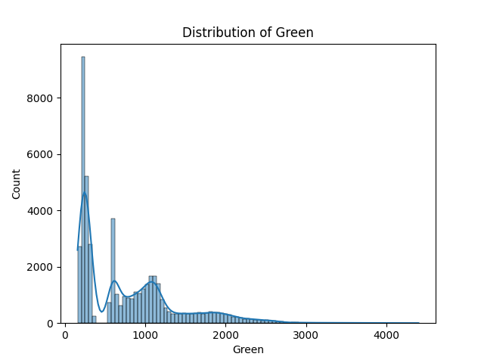

from output/data_distribution directory

The dataset was divided into three sets: training (70%), validation (15%), and test (15%).

-------------------------------------------------------------------------------------------------------------------------------

B1_preprocessing

Several models are constructed to see which will have the best performance result: Decision Tree, Random Forest, Gaussian Naive Bias, Support Vector Machine and k Nearest Neighbors algorithms.
Quite surprisingly, all models, using just a basic plug-and-play strategy approach, performed really well (>95%). However, fine-tuning was performed to see if further improvements were possible. Example of decision tree model confusion matrix is shown in figure

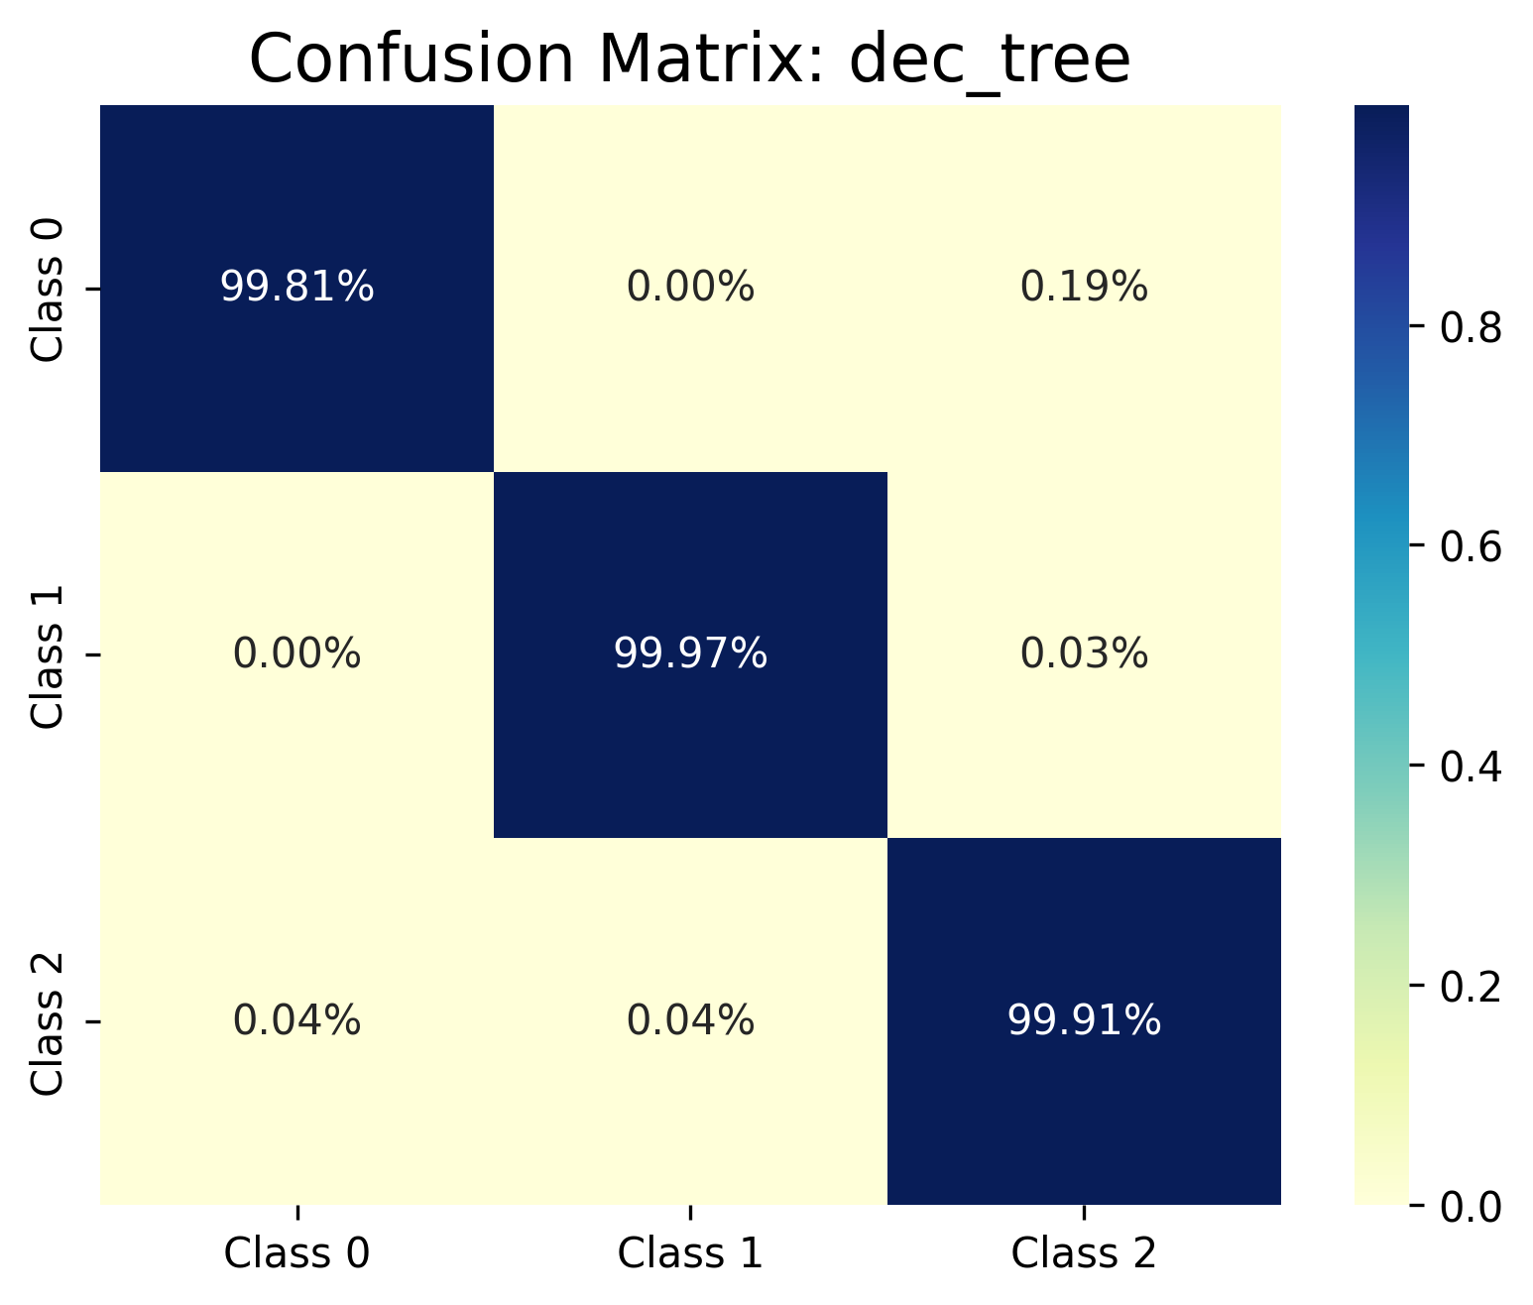

from zadatak_3/output/model_acc_valid

I measured the training time for all models using the training set, which comprised 70% of the data. The resulting times, though dependent on computational power, were as expected: The random forest model took the most time to train.

model | time [s]
Decision tree | 0.48
Random forest | 3.58
Gaussian_NB | 0.24
SVM | 0.8
kNN | 0.59

-------------------------------------------------------------------------------------------------------------------------------

B2_tuning_parameters

For the kNN and SVM algorithms, parameters needed to be fine tuned:
SVM: It is necessary to perform grid search over the C and gamma hyperparameters to obtain the optimal values. C - allowed classification error; inversely proportional strength of lambda regularization, C=1/lambda gamma - coef. kernels for rbf, poly and sigmoidal function. Because of number of data instances and already pretty good result, only c value was examined and rbf kernel function was chosen. After several analysis, c was chosen to be c=1e4
kNN had to be examines to find the optimal number of neighbors, and finally came up with 5 as the best solution with just a slightly differences in results.
In order to check all models performance, confusion tables were made for every model, stored in zadatak_3/output/model_acc_validation. It was not a supprise that Random Forest model had the best performance result, but had the largest training time as well.

In addition, csv file output/model_metrics.csv contains accuracy data such as: Accuracy, Precision, Recall, and F1 score.

-------------------------------------------------------------------------------------------------------------------------------

C_combined_model

In order to see if it was possible to achieve an even better result, I combined all the models and, for each data instance, I took the result that appeared most frequently across all the models.
However, the Random Forest algorithm had better accuracy than the combined model, which was a bit of a surprise. Random Forest appears to be the best model if time is not a decisive factor.
Confusion matrix for test data are stored in zadatak_3/output/model_acc_test. Combined model and Random Forst are shown in figures:
