**What is Tonglen?**

Tonglen is a Buddhist meditation practice that fosters the feeling of metta-bhava (loving-kindness), that aims at reversing the cycle of pleasure seeking and pain avoidance. The practice of Tonglen involves visualizations of “taking in pain” and “sending out healing”, in sync with in and out breaths.

How do we practice Tonglen?

Tonglen is practiced in 4 stages, beginning from the visualization of a Bodhichitta – which is the part of the “mind” associated with enlightenment and spiritual awakening. It is followed by the main Tonglen visualizations of colours, textures and synchronized breath. In this stage , the practitioner is asked to ““Breath in” feelings of heat, darkness, and heaviness—a sense of claustrophobia—and breathe out feelings of coolness, brightness, and light—a sense of freshness”. (Chödrön, 2022)

Breathe in completely, taking in negative energy through all the pores of your body. When you breathe out, radiate positive energy completely, through all the pores of your body.

During this stage, the practitioner must be conscious to sync the breath and visualizations.

**Purpose of this visualization**

Traditionally, the practice of Tonglen serves to heal another person to whom the out breath positivity is channelized. Although this is the central premise of the practice, one can also practice Tonglen to heal oneself. Here, the positive out breath is sent towards oneself, bolstering self-compassion and healing. Finally, the practice culminates by extending the breath-visualizations to more than one person- extending it to the world and its entire people. Tonglen can be practiced by extending compassion to all people, known or unknown to the practitioner, to whom one wants to send light.

**Tonglen in mobile/tablet– the Verse Project**

**Virtual** Reality has shown to be extremely effective in enhancing the effects of meditation. Studies by Anderson et al noted the various challenges that practioners faced during mindfulness. The study noted that the physical environment of the practitioner placed a great demand on the practitioner; the environmental variables such as noise, crowd, smells etc had an impact on the psychological state of the practioner and interfered with the practice of meditation. Virtual Reality environments effectively tackle the environmental disturbances by shifting attention away from the real-world environment and providing a facilitative environment for meditative practices. Such environments are controlled and can thus be designed to include variables in the environment that will enhance the desired result of the meditative practice.

Further there has been evidence to demonstrate that VR meditation applications do not generate any adverse effects.

Building on this evidence, we propose that the practice of Tonglen on VR can facilitate the practice, enhancing its positive effects of well-being and self-compassion in the practitioner. The VR environment will “provide a bounded scope for attention, availability of structured guidance along with the freedom to explore, and ability to utilize multiple attention anchors within the Virtual environment” **(Seabrook et al., 2020).**

**Tonglen – the Verse** introduces the ancient practice of Tonglen into a highly specialized immersive Virtual Environment. We at The Verse are integrating the soul of Tonglen in VR, to enhance the experience of the practitioner as well as facilitate its positive outcomes such as self-compassion and personal subjective well-being.

The practice of Tonglen operates on two central mechanics: the breath and visualizations. Both these components are consciously synchronized by the practitioner during the practice of Tonglen. During VR Tonglen, the visualizations are synchronized using a breath detector that identifies the breath and matches the visual output to the type of breath i.e in/out. Thus, the practitioner is allowed the cognitive space to focus solely on their breath, and experience the visualizations with each breath without meeting split attention demands.

[Birren (2006)](https://journals.sagepub.com/doi/full/10.1177/2158244014525423) studied to find that colours had an impact of various emotional factors. (Kurt & Osueke, 2014) demonstrated that brightness and saturation created “hard and “soft” feelings of anger or calmness.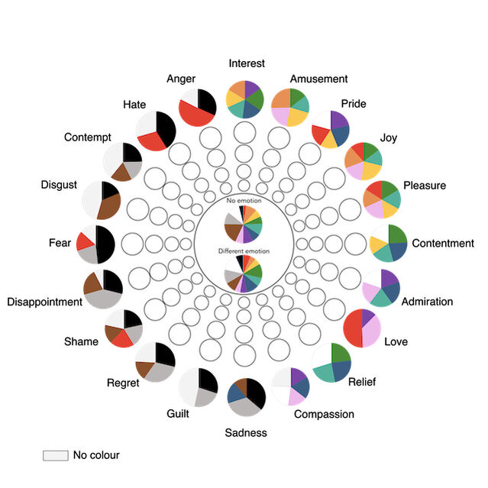

Red light has an exciting effect on the nervous system, especially the sympathetic branch of the autonomic nervous system. On the other hand, exposure to pure blue light has the opposite effect: lowering of the heart rate, respiration, and blood pressure with especial effect on the parasympathetic branch of the autonomic nervous system.

Questions for Daphna

**Ben:**

* **What variables should we measure? (Pre-post measurement).**
* **Do you think the breath is symbolic or has a physiologic impact?**

**Should we do a narrative or as a meditation experience taken into Mobile Mode. - Mechanic in a bigger game or standalone application –**

* To begin with , it is the best option to develop the game in a Mobile/Tablet version.

**What kind of Narrative should we weave for this game?**

* **Priming / Training componenent + Duration of Exercise– earlier stages of practice- how many cycles of the breath do we do?**

Imagine a game where you have to collect Roses in a free environment, as you make your way to a serene temple facing an expansive oasis. Each rose starts as a bud, as you inhale it withers but as you exhale it blooms. With every inhalation the rose bud becomes dark, gloomy, angry and sad depicted by colors of dark maroon, brown, black, and grey– colours associated with anger, sadness, fear and contempt.With every exhalation the bud begins to revive, fill itself with color, and bloom – depicted by colors of red, green and bright yellow- colours associated with emotions of joy, peace and warmth. Each rose blooms completely with one complete breathing exercise. Every successfully bloomed rose gets collected in a basket. Here, we weave priming components of the meditation into the Rose blooming cycles of breath. Every time a rose blooms with the users breathe, the environment around the user increases in luminance and brightness. Varying colors associated with positive emotion such as yellow, light blue etc are introduced into the environment with the complete blooming of each rose.

At the end of the rose garden trail , the user reaches a calm place where they can sit to meditate and send breath towards any person (here we allow the user to upload a picture of the person they want to send the healing breath to.) The practice of VR Tonglen ends here.

**How often this measurement is necessary? – For us to have significant data.**

* Daphna: Experiment with it.

**Do we call it Tonglen? – do we call it the practice of giving and taking?**

* Yes. Different people have employed different ways to practice Tonglen , thus there doesn’t have to be a specific narrative in order for it to be the accurate exercise. We can call it Tonglen.

**Narrative for Priming**

Imagine a game where you have to collect as many roses as possible. Each rose starts as a bud, and blooms with a breathing task. Each rose blooms in the span of one breathing exercise. As you walk along collecting roses, you bear hail, storm, snow, and blistering heat. Every time a rose blooms with your breath, the world around becomes more beautiful.