

SOPHGO

Precautions for PCBA SMT Manufacturing

Version: V1.0

Release date: 2023-12-15

© 2023 SOPHGO

Table of Contents

Contents 2

Precautions for Manufacturing 3

1.1 Materials 3

1.2 Stencils 3

1.3 PCB 3

1.4 Baking 4

1.5 Solder Pastes 4

1.6 Furnace Temperature Curve 5

1.7 PCBA Splitting 5

# Precautions for Manufacturing

## Materials

| **√** | **Items** | **Customer Confirmation (PASS/NO PASS)** | **Remarks** |
| --- | --- | --- | --- |
|  | Are items on the core bill of materials found on the list supplied by SOPHGO? |  |  |
|  | Are items on the bill of materials purchased through reputable sources? |  |  |
|  | Are items on the core bill of materials delivered with full packaging?  If delivered without full packaging, please double check if the silk-screen prints and solder balls are intact on all components and that there is no contamination. |  |  |

## Stencils

| **√** | **Items** | **Customer Confirmation (PASS/NO PASS)** | **Remarks** |
| --- | --- | --- | --- |
|  | The stencils are flat, without contamination, and with normal-sized apertures |  |  |
|  | The stencil has a thickness of 0.1mm |  |  |
|  | The stencil sizes comply with the requirements of the PCB manufacturer (different PCB manufacturers may specify different stencil sizes, and therefore they may not be universally compatible). |  |  |

## PCB

| **√** | **Items** | **Customer Confirmation (PASS/NO PASS)** | **Remarks** |
| --- | --- | --- | --- |
|  | The PCB manufacturer is a trusted partner with stable production output (please conduct small batch trial production if switched to a new supplier). |  |  |
|  | The PCB is fully tested and OK-ed by the manufacturer. |  |  |
|  | The PCB is packaged in a vacuum bag. |  |  |
|  | The opened PCB has no oxidation on the soldering pads (PCBs opened for more than 6 months should be discarded). |  |  |
|  | PCB surface has undergone gold immersion. |  |  |

## Baking

All BGA components such as the SoC and DDR flash chips should be baked.

All opened components or those whose humidity markers indicated moister should be baked before the SMT manufacturing process. Please refer to the line marked in red in Table 1-1 for parameters.

Table 1‑1 Baking Temperature and Time Table

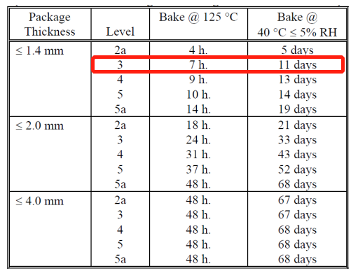

## Solder Pastes

| **√** | **Items** | **Customer Confirmation (PASS/NO PASS)** | **Notes** |
| --- | --- | --- | --- |
|  | The solder paste has been used in mass production. |  |  |
|  | The applied solder paste has even thickness and consistency. |  |  |
|  | The applied solder paste has a thickness of 0.1mm. |  |  |

## Furnace Temperature Curve

It is recommended to follow the manufacturers’ recommendations for furnace temperature curve. Please refer to the table below for potential adjustments.

|  |  |  |
| --- | --- | --- |
| **Furnace Temperature Curve** | **Peak IC Surface Temperature (°C)** | **Duration of Reflow Soldering (seconds)** |
| Reference: First View Technology Co., Ltd. | 248 | 80 |

## PCBA Splitting

After SMT manufacturing and cooling, when splitting the PCBs, please avoid applying pressure on the center of the boards to prevent damage!