**eMMCStress Testing**

**Test steps:**1. Place the supplied S30_power_loss.sh and yolo.tar.gz into the microSD card, insert and mount the card.

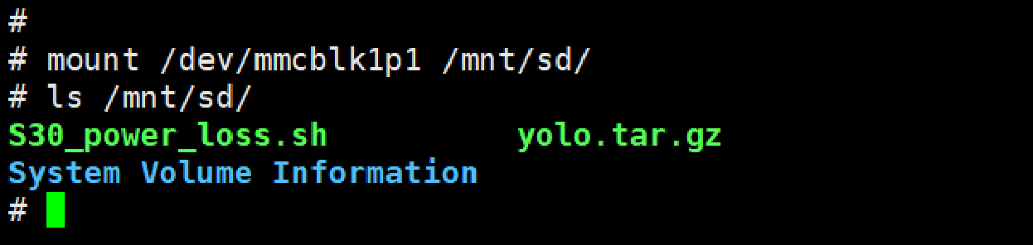

2. Copy S30_power_loss.sh into /mnt/system/etc/init.d/. The script will autorun on each boot.

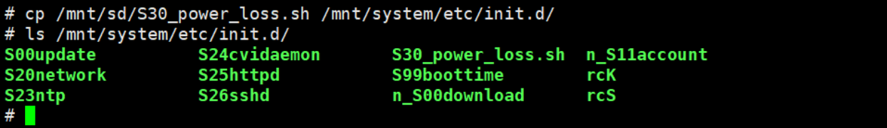

3. Put yolo.tar.gz into /mnt/data/test/ (you may compress your own yolo.tar.gz, with a size of approximately 100MB.

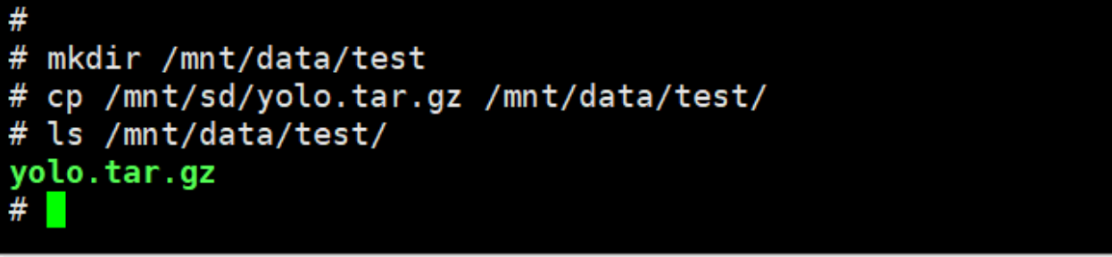

4. Power cycle the board, while the script copies and dd the file, power down the board (e.g., using a relay, On: 45s & Off: 5s)   
5. Review /mnt/data/yolo_diff.txt and see if the data differs. Run the command each time you power cycle the board. If the test passes, the log will print:

eg. Files yolo.tar.gz and /mnt/data/test/yolo.tar.gz are identical

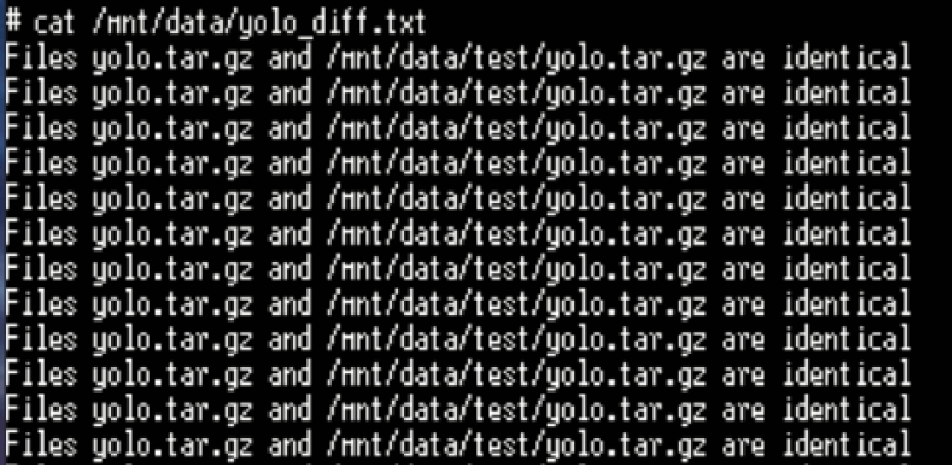

**Note:**   
1. Power cycle the board at least 2,500 times (checking /mnt/data/yolo_diff.txt for records) and see if the boot logs appear normal.