**SpinandStress Testing**

**Test steps:**

1.Read/Write Loads

1) Put the supplied testdd.sh in your microSD card, insert it, and mount it in the system.



2) Run testdd.sh.

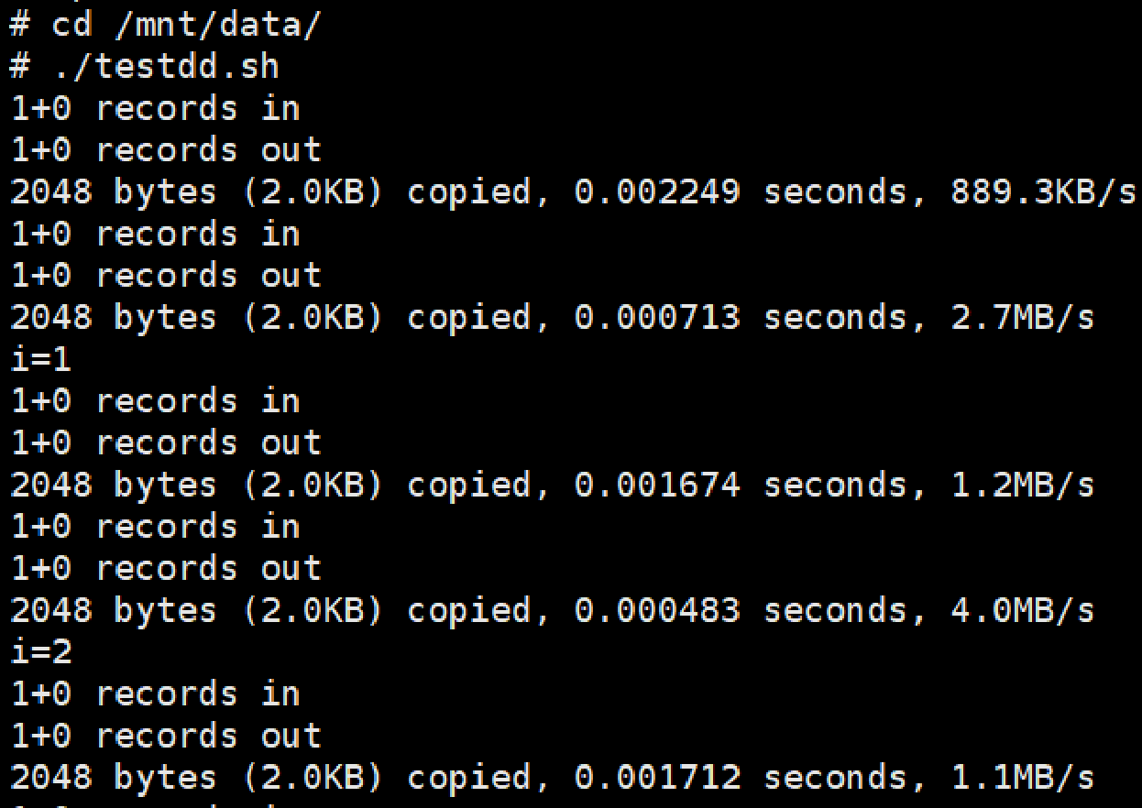

3) If the system, the reading and writing process during dd the file, and the boot log reboot appears normal, then the test can be considered successful.

2. Abrupt power loss during read/write process

1) Put the supplied testdd.sh into /mnt/system/etc/init.d/ and rename it as S30_Power_loss.sh. This script will autorun on each boot.



2) Whilst running dd on the supplied test.dd file, cut off the power to the board (e.g., using a relay, On: 45s & Off: 5s).

**Note：**   
1. Check if the boot log and dd process output appear normal during power up/down process.

2. This test should be repeated at least 2,500 times.