The correct workflow
The number in the filename is the Decimate(Modifier) ratio (or a target vert count), applied to sphere.obj before running the plugin:
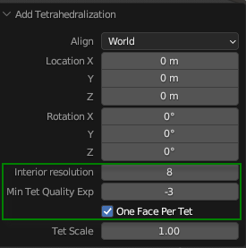
Crystal clear.
The filename number is the Decimate ratio × 100 (i.e., a percentage):
Filename | Decimate Ratio | Percentage
1.obj | 0.01 | 1%
5.obj | 0.05 | 5%
10.obj | 0.10 | 10%
50.obj | 0.50 | 50%
So the complete workflow is:
- Start with sphere.obj (2562 verts)
- Apply Decimate modifier at ratio = filename / 100
  - For 5.obj → ratio = 0.05
  - For 10.obj → ratio = 0.10 etc.
- Run the plugin with Interior Resolution = 8, One Face Per Tet ✅
