**All the screenshot is corresponding to use cases which are included in use case design document.**

- As a user, I want to change my password.

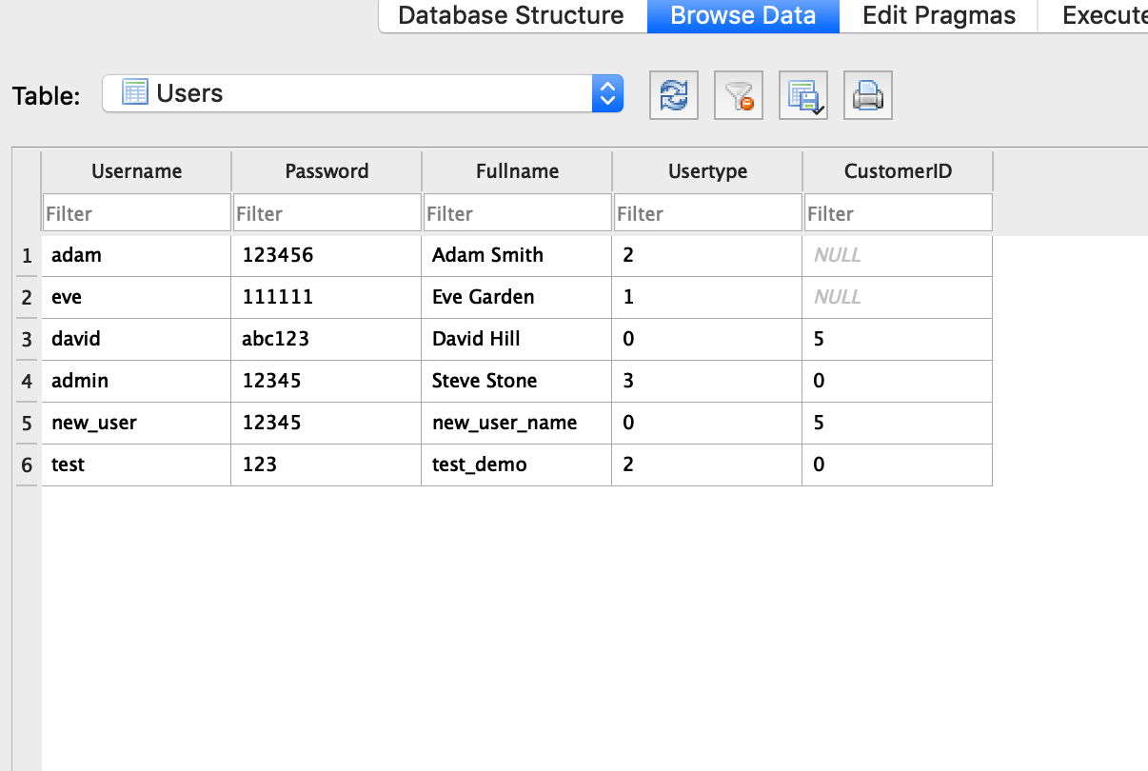  
- As an admin, I want to add a new user into the system.

  
- As an admin, I want to update the type/class of a user into the system (e.g., from cashier to manager).

  
- As a manager, I want to add a new product or update a current product in the system.

  
- As a manager, I want to view a summary report of sales from the system.

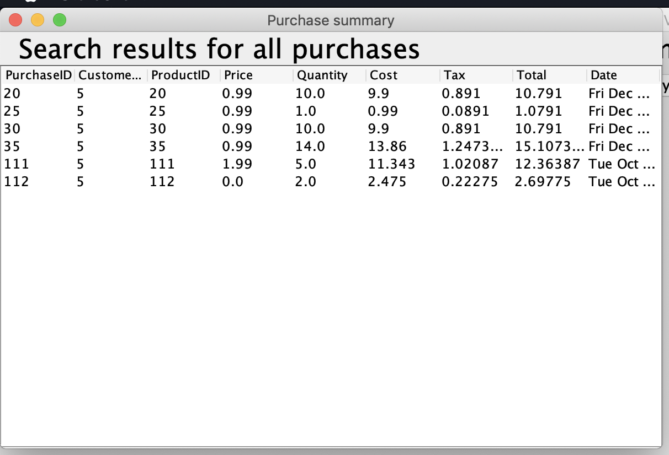  
- As a cashier, I want to add a new customer or update a current customer in the system.

  
- As a cashier, I want to add a new purchase or update a current purchase (only price and quantity) in the system.

  
- As a customer, I want to add a new purchase into the system.

  
- As a customer, I want to view my purchase history into the system.

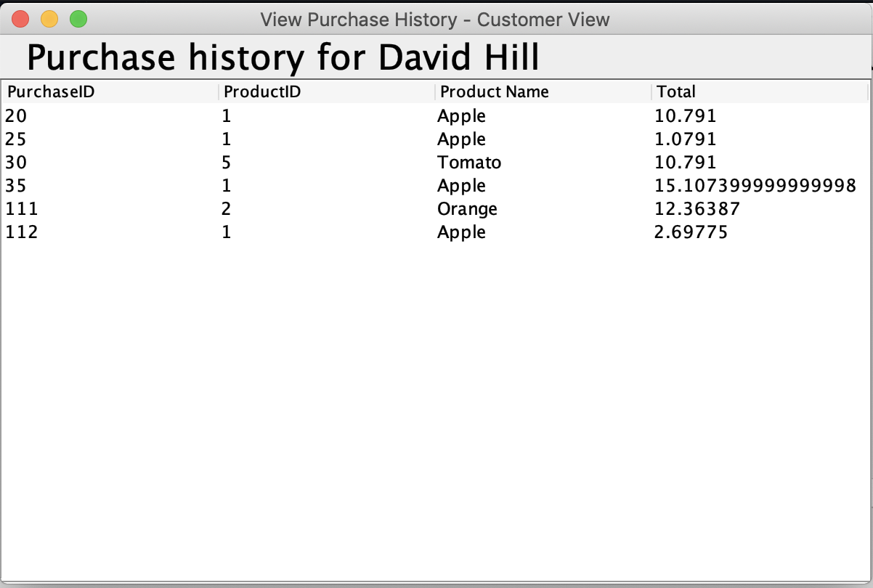  
- As a customer, I want to search for product information (based on name, price) in the system.

