1. User Interface

Different views: MainUI class

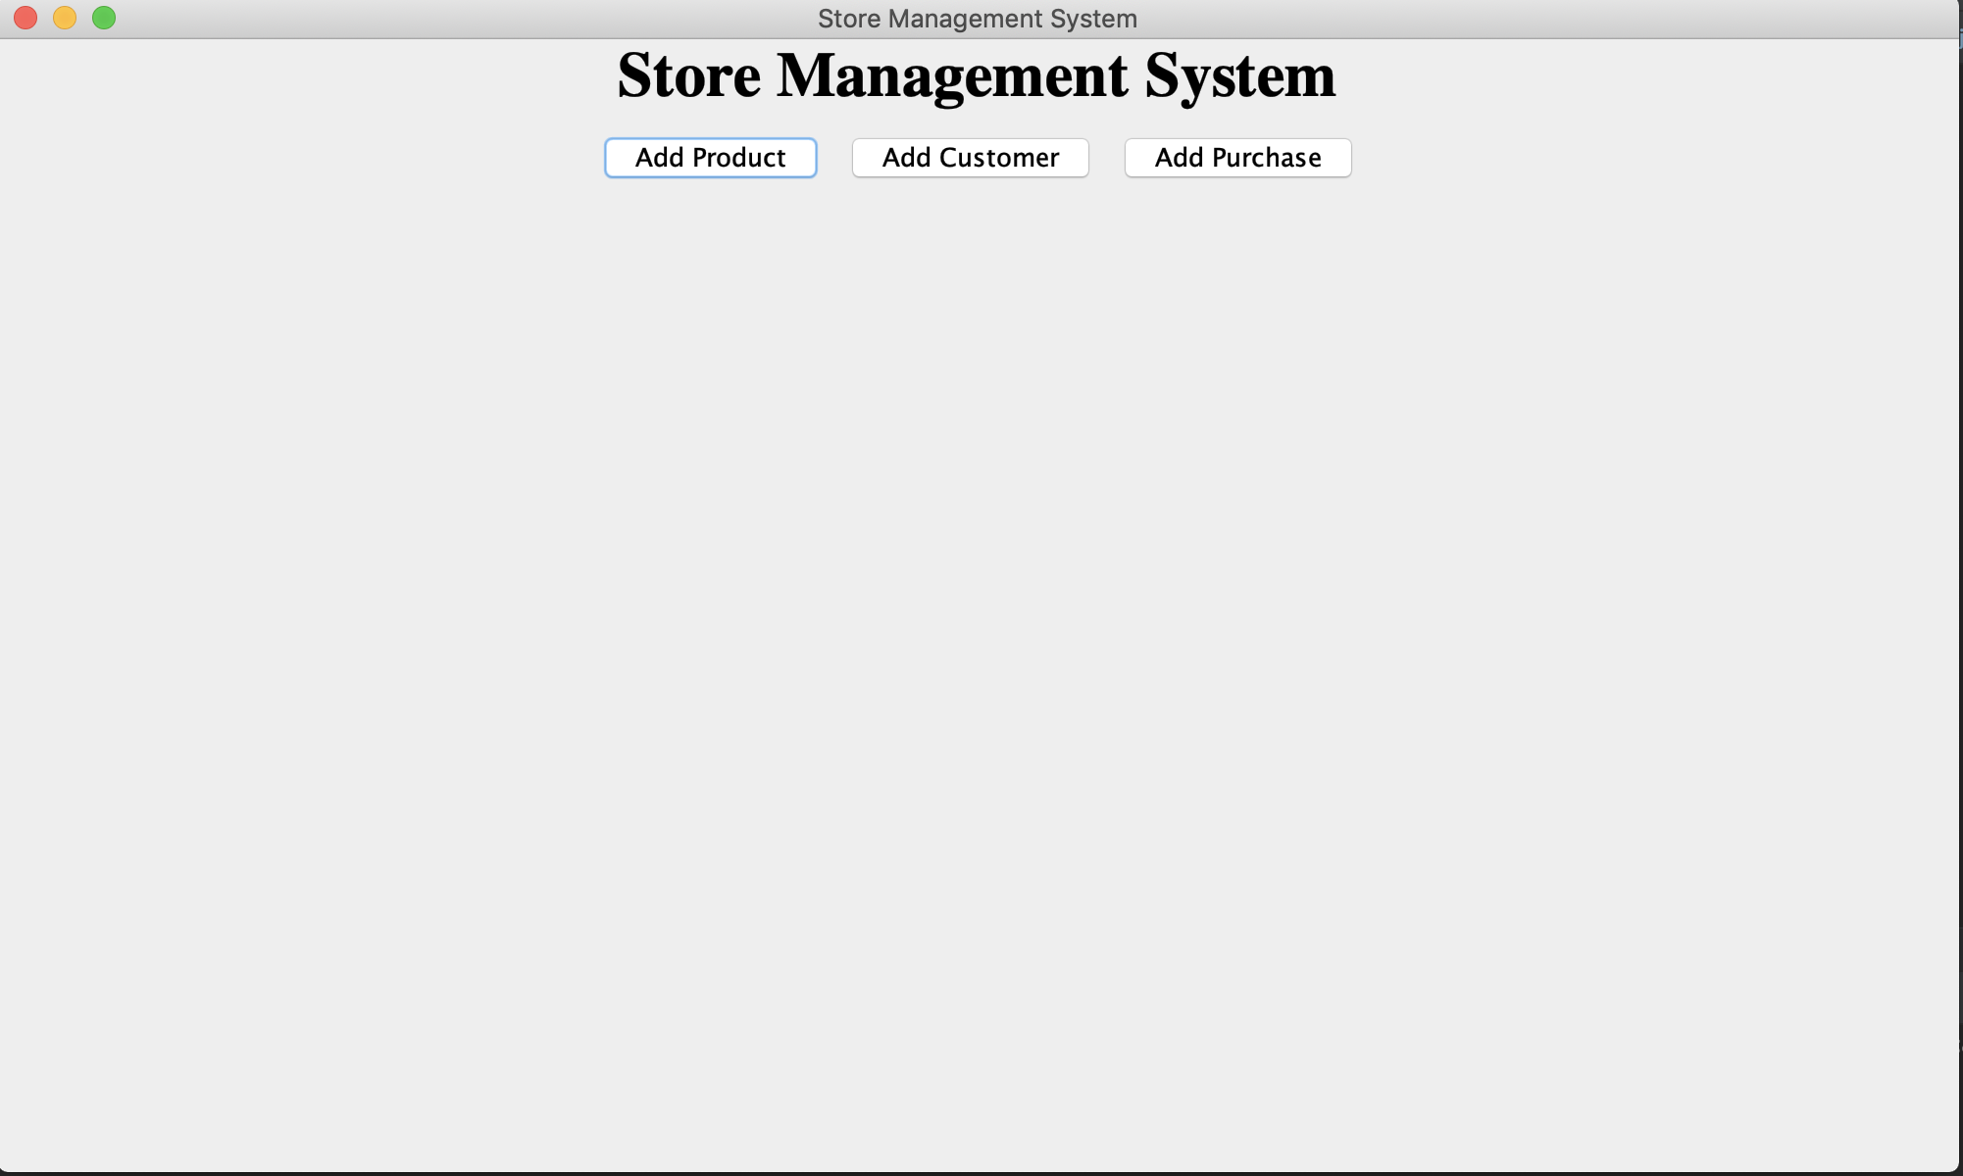

AddProductUI class

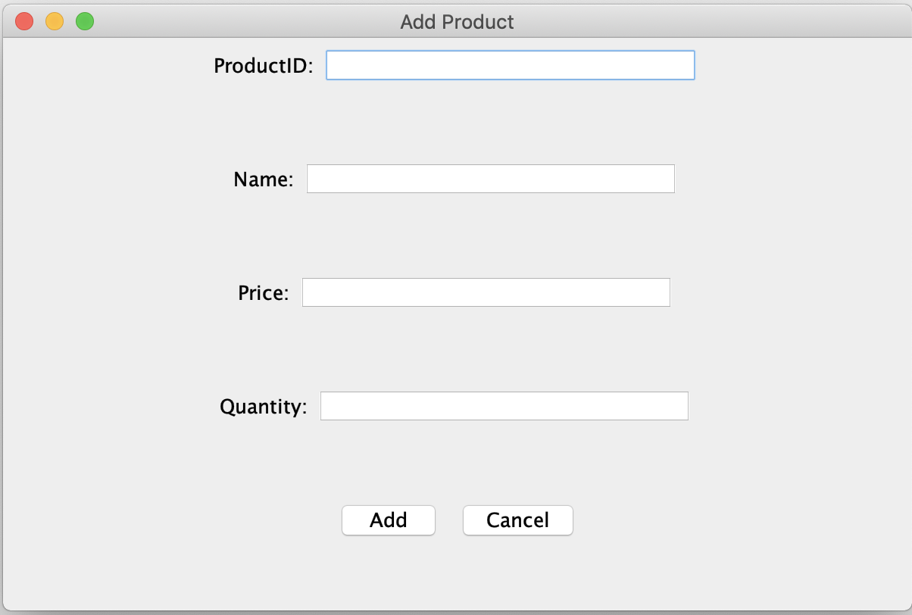

Add CustomerUI class

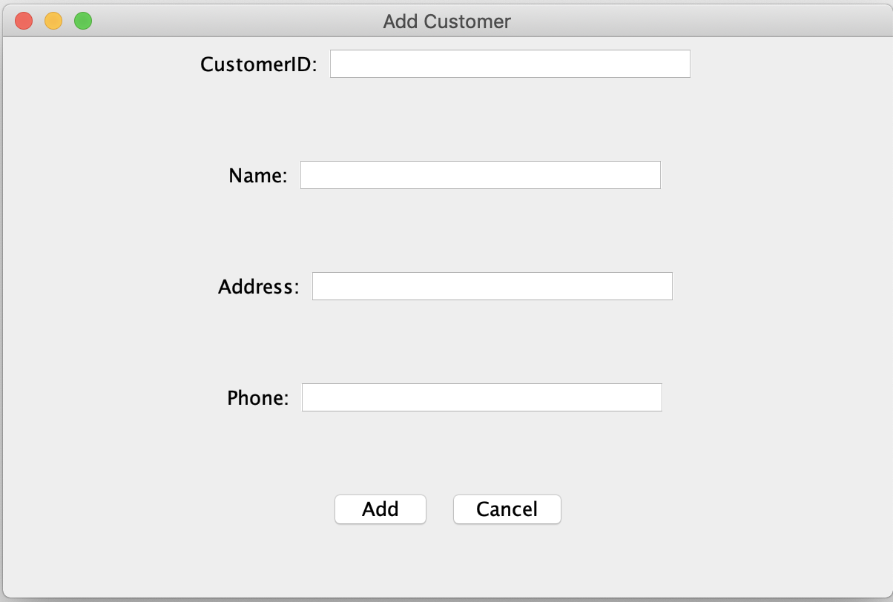

AddPurchaseUI class

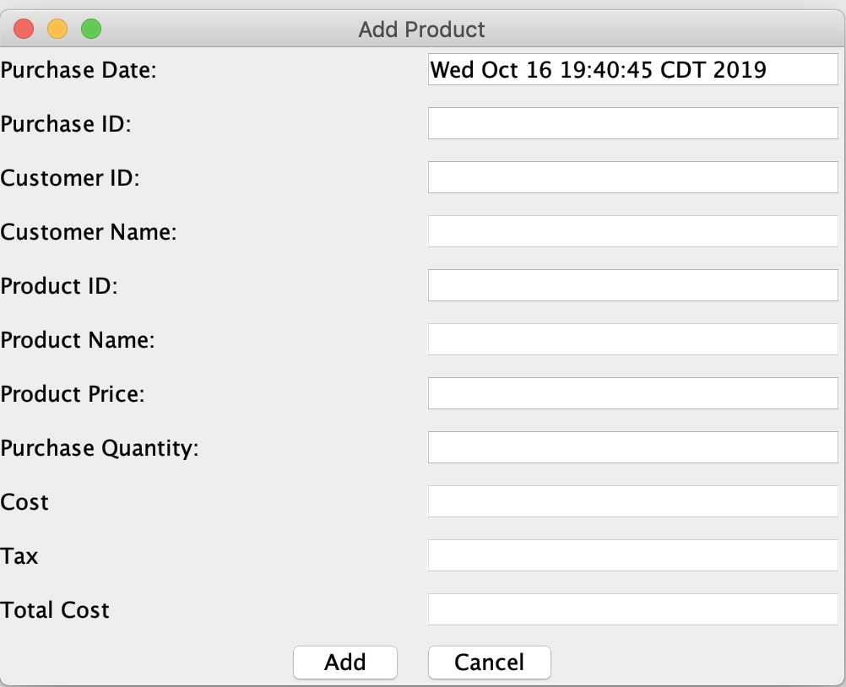

2. Business Logic

Data models for products, orders, customers

Class ProductModel: store a product object (in memory)

Class OrdersModel: store an order object (in memory)

Class CustomersModel: store a customer object (in memory)

Controllers for UI views

Class AddProductUI: contains interactions between system and user

Class AddPurchaseUI: contains interactions between system and user

Class AddCustomerUI: contains interactions between system and user

Main application (setup data access, create views)

Class StoreManager

Class APP

3. Data Access

Interface IDataAccess

SQLiteDataAdapter class: load/save products, customers, purchases data(implement the IDataAccess interface)

CachedDataAdapter class: load/save products, customers, purchases data in cache mode(implement the IDataAccess interface)