**The Ratio of Ferrous() and Ferric() Iron Prediction Using Iron L2,3 Edge and Convolutional Neural Network(CNN)**

Zhengran Ji and Huolin L. Xin*

Department of Physics and Astronomy, University of California, Irvine, CA 92697, United States

*Correspondence should be addressed to H.L.X. ([huolin.xin@uci.edu](mailto:huolin.xin@uci.edu))

**Abstract**

To understand the properties of the materials containing iron, determining the ratio of ferrous (Fe2+) and ferric iron (Fe3+) in mixed iron (Fe) is crucial. Electron energy loss spectroscopy (EELS) and soft X-ray absorption spectroscopy (XAS) are commonly used techniques to investigate Fe L2,3 edges for this purpose. However, it is still challenging to accurately decompose the Fe L2,3 edges until today. To address potential variations in instrumental resolution and energy axis offset between sessions, both EELS and XAS require reference spectra for Fe2+ and Fe3+ iron, ideally acquired on the same instrument/beamline and experimental session to be measured. Our previous research successfully applied a deep-learning neural network to decompose Mn L2,3 edges into Mn2+, Mn3+, and Mn4+ in both EELS and XAS without calibration and reference29. In this study, a similar approach was adopted for Fe L2,3 edges. A regression model was trained to predict the ratio of Fe2+ and Fe3+ iron in the mixed valence state Fe L2,3 edge. The research faced obstacles due to the scarcity of Fe L2,3 edges for training and validation, with most edges measured from Fe samples with oxidation states of 2+, 2.67+, and 3+. This could lead to overfitting and biased models if trained solely on these data. Additionally, the fine structure variations of the Fe edges were not evident as the iron oxidation states changed. To overcome these challenges, a synthesized method was developed, generating Fe L2,3 edge spectra with any Fe oxidation state between 2+ and 3+ from available Fe2+ and Fe3+ edges. This approach led to the creation of a comprehensive database containing 1.32 million spectra with ground truth values representing the percentage of Fe2+. The database included diverse data from both EELS and XAS spectra. Training on this large-scale database resulted in an impressive 91.06% accuracy on the validation dataset. The model's robustness was thoroughly tested against noise down to a signal-to-noise ratio of 5, and it exhibited an 82.14% accuracy when tested against experimental edges not used during synthesis. This research not only proves that the method from our previous research can be adopted to other transition metals, like Fe, but also serves as a valuable reference to synchrotron scientists and electron microscopists in the automated analysis of Fe L2,3 edge data.

**Introduction**

Electron energy loss spectroscopy(EELS19,20) and X-ray absorption spectroscopy(XAS21) are two methods that are utilized to examine the unoccupied electronic states, offering insight into the bonding characteristics of materials. The L2,3 edges are specifically employed to ascertain the oxidation state of transition metals21, 22, 23. These edges explore the vacant d orbitals, making the edge onset, fine structures, and shapes susceptible to the oxidation state of the d-block metal ions, particularly 3d transition metals like Mn, Fe, Ti, V, and Ni5, 23, 24, 25. For instance, the oxidation states of Fe ions in a material can be discerned using the near-edge fine structures in the Fe L2,3 edges, by breaking down the spectrum into a linear combination of Fe2+ and Fe3+reference spectra.

Though this breakdown may seem straightforward in theory, it is complicated in practice because the energy axis isn't always calibrated, and the instrument/beamline does not consistently possess the instrumental broadening. Without appropriate calibration, an energy offset exists between the experimental spectrum and the references, thereby obstructing accurate oxidation state breakdown. To circumvent this issue, standard reference samples like FeO and Fe2O3 must be measured within the same experimental session to prevent energy offsets and changes in instrumental broadening8, 26. However, even with this protocol, other factors such as temperature changes can cause an energy shift in the monochromator and hinder the proper energy axis calibration. Furthermore, if XAS measurements are taken hours apart, the obtained spectra could have a minor energy offset. In EELS, the energy offset can vary more quickly and unpredictably than in XAS. Typically, it is highly sensitive to the DC stray field, with external disturbances such as a passing truck or the movement of a nearby elevator potentially affecting the energy offset if the TEM isn't entirely shielded. While this issue has been partially addressed with the advent of dualEELS instruments, numerous single EELS instruments remain in active use, and all historic data were gathered without dualEELS correction. Additionally, the nonlinearity of the parallel EELS spectrometer presents a unique challenge in EELS as it's not only found in the dispersion device, the magnetic prism but also complexly exists in the magnification lenses, a set of quadrupoles. As a result, calibrating the energy onset of EELS edges is extraordinarily challenging unless rigorous protocols, as outlined by Tan et al8, are adhered to.

Another complicating factor is the variation in near-edge fine structures of EELS with sample thickness, attributed to plural scattering. As the sample thickness increases, signals near the edge onset undergo multiple scattering events, leading to higher energy losses. Consequently, this induces a distortion in the spectrum's shape8. For instance, in the case of the latter 3d transition metals' L2,3 edges, increasing sample thickness results in an elevated L2/L3 ratio, rendering the reference-free L2,3 ratio method inaccurate for EELS8. Additionally, in XAS, the background and near-edge structures may differ between the Total Electron Yield (TEY) and Partial Fluorescence Yield (PFY) modes. The TEY mode measures the total number of emitted electrons resulting from X-ray absorption, while the PFY mode measures the fluorescence emitted by the sample due to X-ray absorption. This disparity further undermines the reliability of the L2,3 ratio method. Moreover, when dealing with early 3d transition metals, the absence of established reference-free methods is due to the presence of the L2,3 anomaly, adding another layer of complexity to the analysis.

In both EELS and XAS spectroscopy, a noteworthy finding is that well-trained human operators can recognize spectral features and assign oxidation states to transition metal L2,3 edges. This observation suggests that employing deep learning could offer a promising solution to the L2,3 oxidation state decomposition challenge. Pate et al. in 2021 explored the use of deep learning for denoising high frame rate spectra27, while Chatzidakis and Botton in 2019 introduced the concept of translation-invariance for classifying EELS edges28. The latter researchers developed a convolutional neural network (CNN) for oxidation state classification and demonstrated that with translation-invariant training, the repositioning of the energy axis does not affect the classification of Mn 2+, 3+, and 4+ oxidation states. This significant finding highlights the analogy between spectral features and spatial features in images, indicating that a CNN can classify them regardless of their absolute energy positions in the spectrum. Furthermore, both Garvie et al. in 1998 and Van Aken et al. in 2002 explored the ratio of Fe2+ and Fe3+ in minerals in spectroscopy. However, none of the previous research applied deep learning method to investigate the ratio of Fe2+ and Fe3+ in Fe L2,3 edges.

In our previous research, we were successfully able to build a CNN to accurately decompose mixed-valence state Mn edges29. Mn edges serve as an excellent case study due to the distinctive variations in fine structures exhibited by the Mn L2,3 edge resulting from their three different oxidation states. These distinct oxidation states introduce significant differences in the electron energy loss spectra, making Mn oxides a valuable and informative subject for investigating and understanding the complexities of transition metal L2,3 edges in spectroscopic analyses. In this study, we were trying to apply the same method to Fe edges. However, the variation of the fine structure of Fe edges as Fe oxidation states change is not as obvious as Mn edges. Therefore, building a regression model to decompose the Fe2+ and Fe3+ mixed Fe edges remain challenging. Specifically, the model was not good at discriminating the Fe3+ and Fe2.67+(Fe3O4) edges due to the differences in near-edge fine structure are minor and unnoticeable.

To solve the issue, we synthesized our library, the training and validation data, from 34 reference spectra(13 Fe2+, 4 Fe2.67+, and 17 Fe3+). 4 Fe3O4(Fe 2.67+) spectra were introduced to make sure our data has enough Fe 2.67+ edge included. The library contains 1.32 million spectra with all Fe oxidation states included between 2+ to 3+ from both EELS and XAS. During the construction of the mixed oxidation state library, special attention was given to properly normalizing the Fe L2,3 edges. The library was curated to include experimental-like uncertainties, such as Gaussian and Lorentzian types of instrumental broadening, energy offset, detector noise, and plural scattering effect. After that, we built a CNN and trained it with the library. The model achieves 91.06% accuracy with robustness against the noise on the validation data. We also tested the model on testing data which are experimental spectra that were not used to synthesize the library. Our model was able to achieve 82.14% accuracy on the testing data and performed stably against the noise of SNR down to 5.

**Methods**

In this section, we will discuss the method utilized during the experiments. Figure 1 summarized the method section. Every part of the figure will be discussed in detail in the subsections.

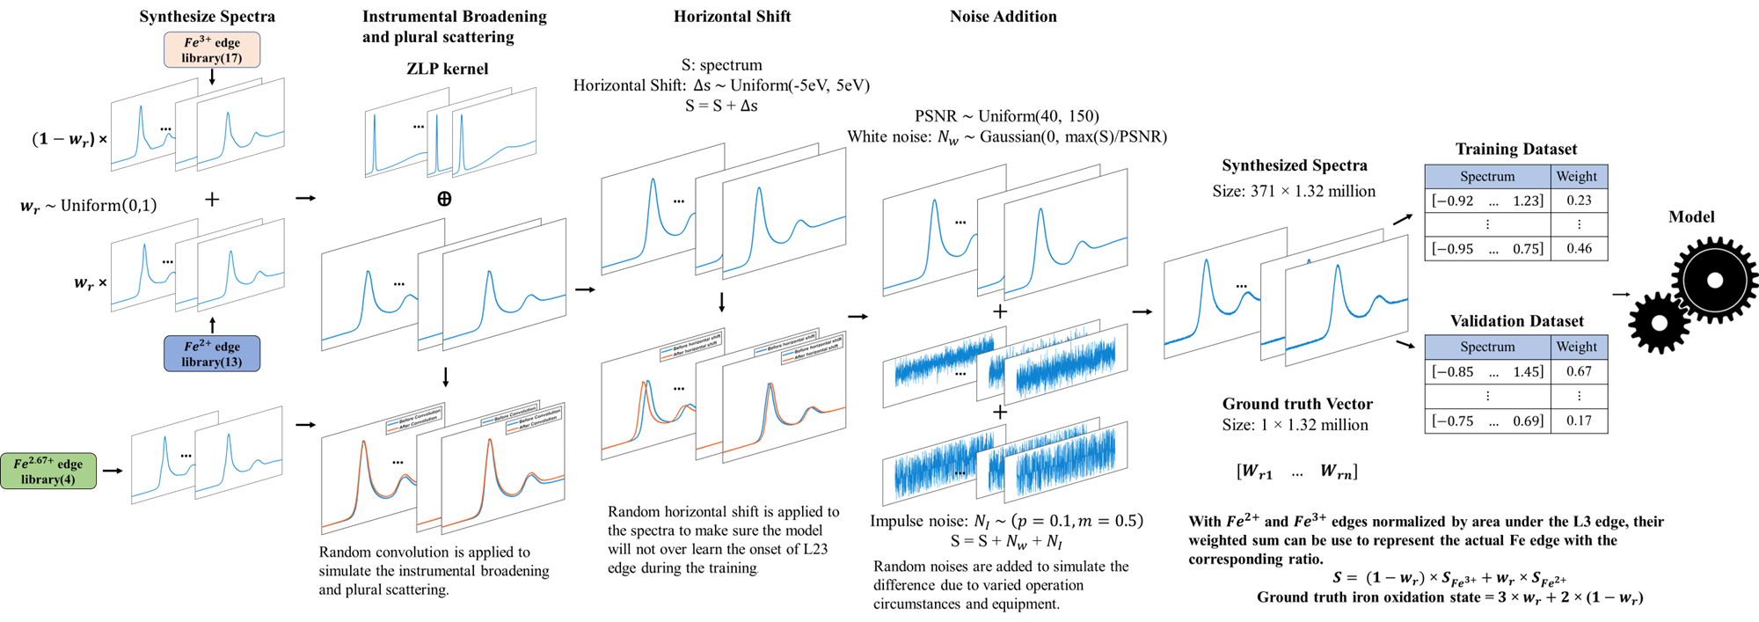

Figure 1 Process Image of Experiment Method

**Fe Reference Spectra Digitization**

We started with collecting reference Fe2+ and Fe3+ iron spectra from published literature. 13 spectra(9 EELS and 4 XAS), 4 spectra(3 EELS and 1 XAS on Fe3O4), and 17 spectra(12 EELS and 5 XAS) were found from 12 different literatures. Figure 2 presented all the reference spectra. Each subfigure represents the spectra from one piece of literature for Fe2+ and Fe3+ spectra, and its title specified which literature it is in the reference section.

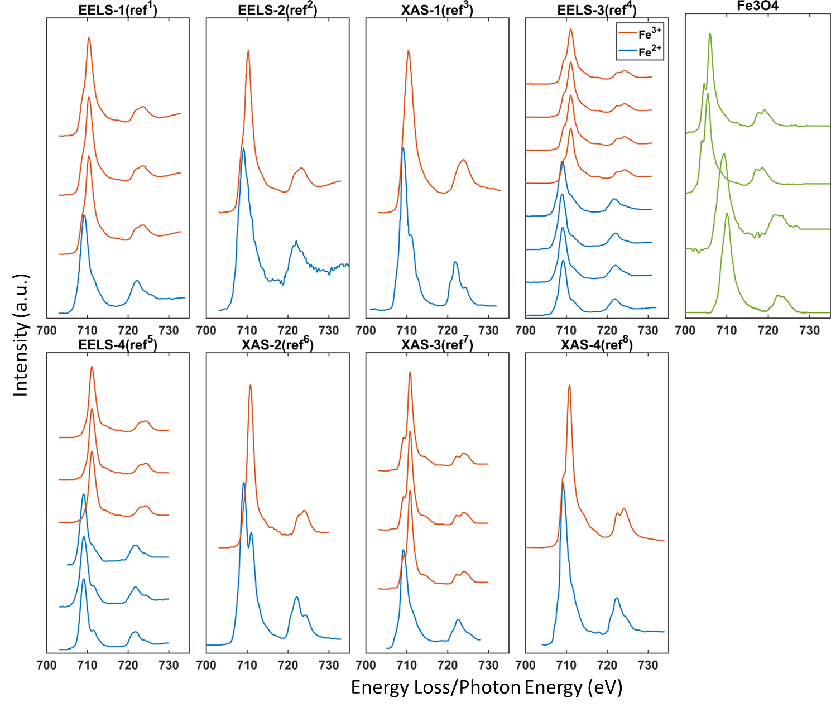

Figure 2 Fe Reference Spectra

We used the WebPlotDigitizer13, an online software, to digitize these spectra and saved them for later use. Since, the figures presented in the spectra in literature are high resolution and accurate, using WebPlotDigitizer is sufficient for the detail of the spectra. Table 1 summarized the compound tested to obtain these spectra. The variety of compound showed that our reference data can capture the varieties of Fe2+ and Fe3+ iron edge both from EELS and XAS.

|  |  |
| --- | --- |
| Oxidation state | Compound |
| 2+ | FeTiO31, FeO2,7,8, FeCl23, fayalite(Fe2SiO4) 4, ɣ-fayalite(Fe2SiO4) 4, wustite(Fe1-xO) 4, ilmenite(FeTiO3) 4, almandine5, hedenbergite5, hercynite5, Fe(II)–cysteine6, [FeCl4]2-7, [FeCl6]4-7 |
| 2.67+ | Fe3O49,10,11,12 |
| 3+ | Fe2O31, Fe2TiO51, Sr2Fe2O51, Fe2O32,3,4,7,8, jacobsite(MnFe2O4) 4, aegerine (NaFeSi2O6) 4, andradite(Ca3Fe2(SiO4)3) 4, orthoclase(KFeSi3O8) 5, brownmillerite(Ca2Fe2O5) 5, andradite5, Fe(III)–cysteine6, [FeCl4]-7, [FeCl6]3-7, |

Table 1 Source of Reference Fe L2,3 Spectra

After digitizing all the spectra, we took the range from 698eV to 735eV with an interval of 0.1eV (total 371 datapoints) for every spectrum. For the spectra with the missing data at the start or end of this range, we padded the start point value left and the endpoint value right.

**Normalization**

To effectively combine the spectra of Fe2+ and Fe3+ quantitatively, it is necessary to normalize them according to the correct ratio. This involves normalizing the Fe L3 edge based on the number of d-holes present. The Elemental Fe possesses an electron configuration of [Ar]3d6 4s2. Consequently, Fe2+ and Fe3+ exhibit electron configurations of [Ar]3d6 and [Ar]3d5. Since the d shell can accommodate 10 electrons, the number of d-holes left for Fe2+ and Fe3+ are 4 and 5, respectively. Thus, the area under the L3 peak and above the continuous background should be proportional to the respective d-hole numbers. We can model the continuous background under the L2,3 edge using two-step functions, where the step height follows a 1:2 population ratio. This ratio is based on the population of the filled 2p3/2 and 2p1/2 orbitals. By subtracting this background from the spectrum, we can calculate the d-hole area(Figure 3 right). Then normalize all the area for Fe2+ spectra to 4 and Fe3+ spectra to 5 to get the correct ratio.

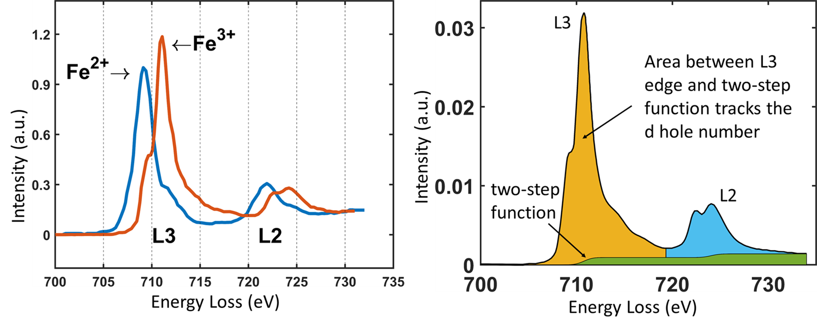

Figure 3 Left: Fe2+ and Fe3+ L2,3 Edges after Normalization. Right: D-hole Area under L3 Edge

**Synthesizing Training and Validation Spectra**

After normalizing the spectra, we can accurately combine the Fe2+ spectra() and Fe3+ spectra(to synthesize a new spectrum() whose iron oxidation state is between 2 and 3. is used to denote the percentage of Fe2+ in the synthesized spectrum(), and also was used as the ground truth value for the spectrum for model training later. Figure 4 demonstrated several synthesized spectra by this procedure.

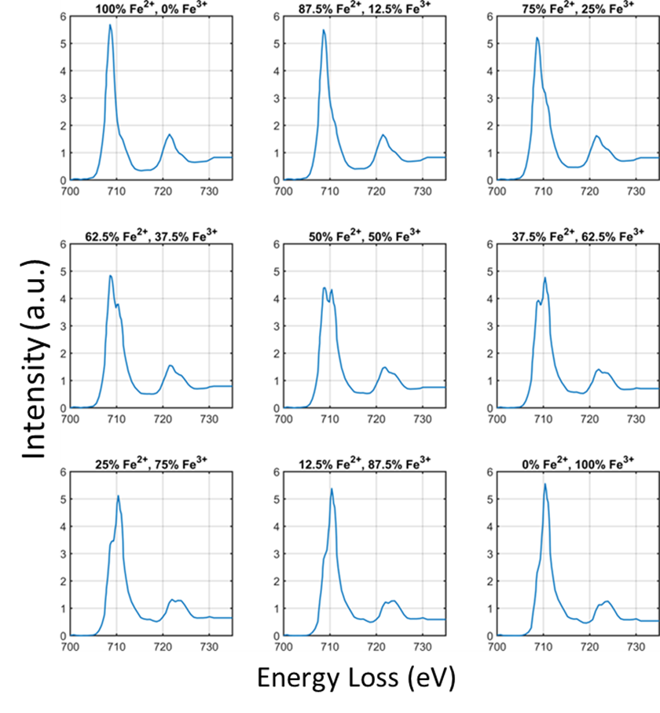We only added the iron spectra obtained from the same publication source to make sure that the two spectra added shared the same instrumental resolution. Following this rule and based on the reference spectra we had, there were 35 different combinations of Fe2+ and Fe3+ spectra among which 29 of them are EELS and 6 of them are XAS. For Fe2.67+ reference Spectra, we didn’t involve them in this process. They were directly passed to augmentation steps later.

Figure 4 Synthesized Spectra with Different Ratio of Fe2+ and Fe3+

Following this process, we generated 1.32(1.2 million were synthesized and 0.12 million were from Fe2.67+) million spectra. 1.1 million of them we used as training data and the rest 0.32 million as validation data.

**Instrument Broadening**

Two significant factors contribute to the widening of EELS spectra instrumentally. The first factor mainly stems from thermal broadening at the electron source and the first crossover results from the space-charge effect. Typically, this form of broadening is described by a Gaussian-type function. The second factor occurs at the detector, where the diffusion of light in the sinterlator and the optical coupler introduces a long-tail broadening effect that can be characterized by a Lorentzian function. In the case of XAS, comparable short-range and long-range broadening occurs due to the monochromator. Therefore, the instrumental point spread function(PSF(E)) can be modeled by the convolution of a Gaussian function with a Lorentzian function. E stands for the energy axis which, in our case, spread from -150eV to 150eV with an interval of 0.02eV. The full width at half maximum of the Lorentzian function() is denoted by *w* and the FWHM of the Gaussian function() is where is the standard deviation of the Gaussian distribution.

PSF(*E*, *w*, *σ*) = L(*E*,*w*) ⊗ G(*E*,*σ*)

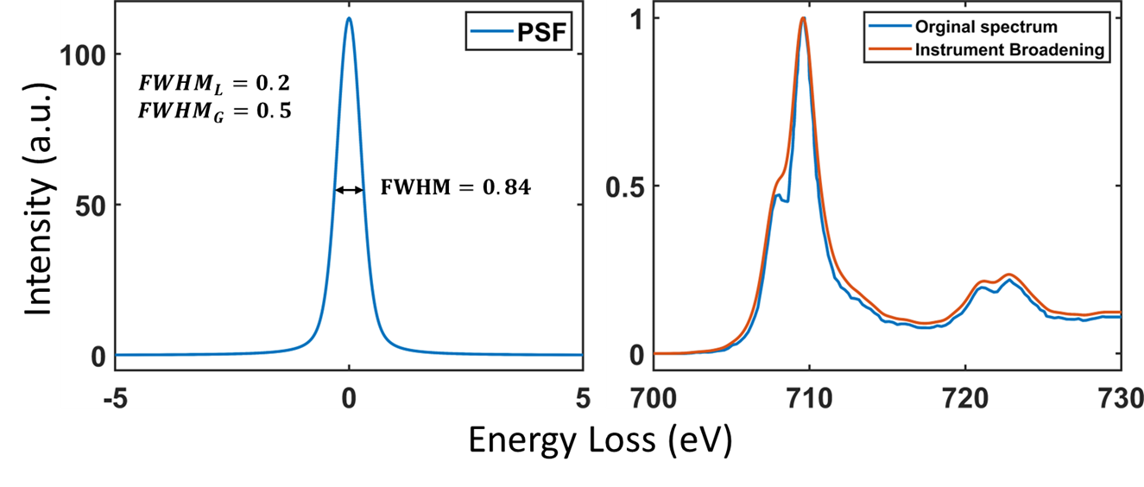After the convolution, the total FWHM is . Figure 5 is an example of the PSF and the instrumental broadening effect after applying it on a Fe2+ L2,3 edge.

Figure 5 Left: Example of PSF. Right: Instrument Broadening on Fe L2,3 edge

**Plural Scattering in EELS**

The plural scattering effect in EELS can be modeled as a function of the thickness of the sample , . Given the single scattering, the probability function is , and the differential equation that illustrates this effect is

Under ideal monochromatic conditions, when , the boundary condition is reached. In practice, we can use the PSF described in the last section as the initial energy profile since there is an energy spread in the incoming electron. Therefore,

After acquiring a numerical representation of , it becomes possible to computationally determine the spectral function, , for a specific thickness, . Figure 6 shows the plural scattering kernels as the normalized thickness(, is the inelastic mean free path) changes and its effect when convoluted with a Fe L2,3 edge.

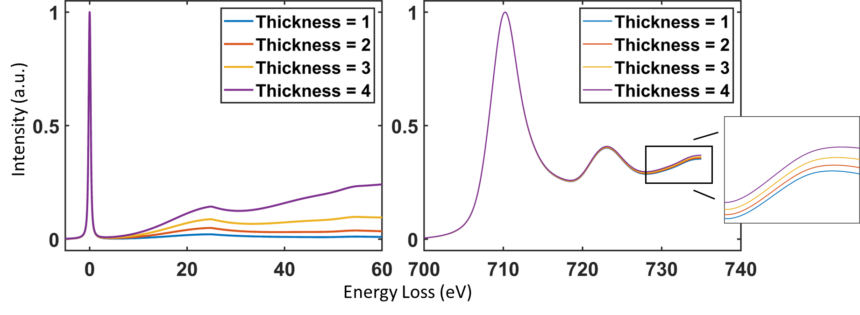

Figure 6 Left: ZLP Kernel with Different Thickness. Right: Fe L2,3 Edges with Plural Scattering Effect

**Horizontal Shift**

An inaccurate energy axis occurs both in EELS and XAS. To make sure our model takes this into account, we applied random horizontal shifts () in the range of -5eV to 5eV to all the synthesized spectra. Furthermore, with the horizontal shift added, the machine learning model will focus on learning the shape of the spectra instead of the energy onset of the L2,3 edges.

**Noise Addition**

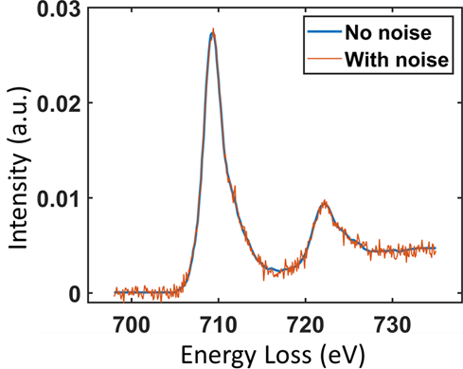To train a network that is noise-proof, we need to apply random noise to the spectra we created. We modeled the noise as Gaussian-type noise() with an impulse noise(). We only applied noise to 90% of the spectra to make sure our data is not too noisy. Figure 7 is an example of adding noise to a synthesized spectrum. The parameters of the two noises are defined as:

Figure 7 Example of Noise addition on Fe L2,3 Edge

magnitude = 0.5

**Neural Network Structure**

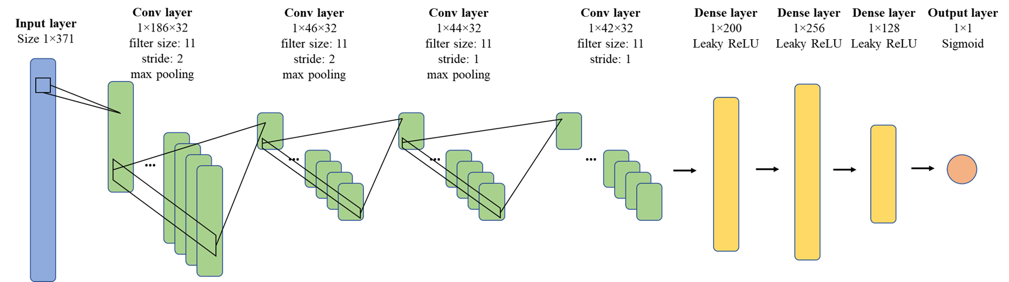We chose to use Convolutional Neural Network(CNN) for this task since its ability to extract features and its transformation-invariant property. Our model started with an input layer with a size of 371 to match the size of each spectrum. Then, there are four convolutional layers with filter size 11*1 and max pooling layer. After that, the features being extracted would be passed into the regression part of the network. The regression part consists of three fully-connected layers (dense layer). The output layer is a sigmoid layer with size 1. Since our goal was to predict , the percentage of Fe2+ in the synthesized spectra, the sigmoid layer can scale the output between 0 and 1. Figure 8 shows the structure of the neural network.

Figure 8 Structure of the Convolutional Neural Network

**Training and Validation**

We trained the model in MATLAB and used stochastic gradient descent with momentum as the optimizer. The model was trained for 2 epochs and since the model converged fast, we scheduled a learning rate drop every epoch. Table 2 provided the technical detail for model training.

|  |  |
| --- | --- |
| Parameter | Value |
| Framework | MATLAB |
| GPU | NVIDIA GeForce GTX 1080 Ti |
| Training time | 0.54 hour |
| Optimizer | Stochastic gradient descent with momentum(SDGM) |
| Loss function | Mean squared error Loss |
| Mini Batch Size | 200 |
| Learning Rate Drop Factor | 0.2 |
| Learning Rate Drop Period | 1 |
| Initial Learning Rate | 0.02 |
| Validation Frequency | 50 |
| Validation Patience | Inf |
| Max Epochs | 2 |

Table 2 Technical Detail of Model Training

Since it’s a regression model, we used rooted-mean-squared-error(RMSE) to track the performace of the model() during the training. The RMSE can be calculated as:

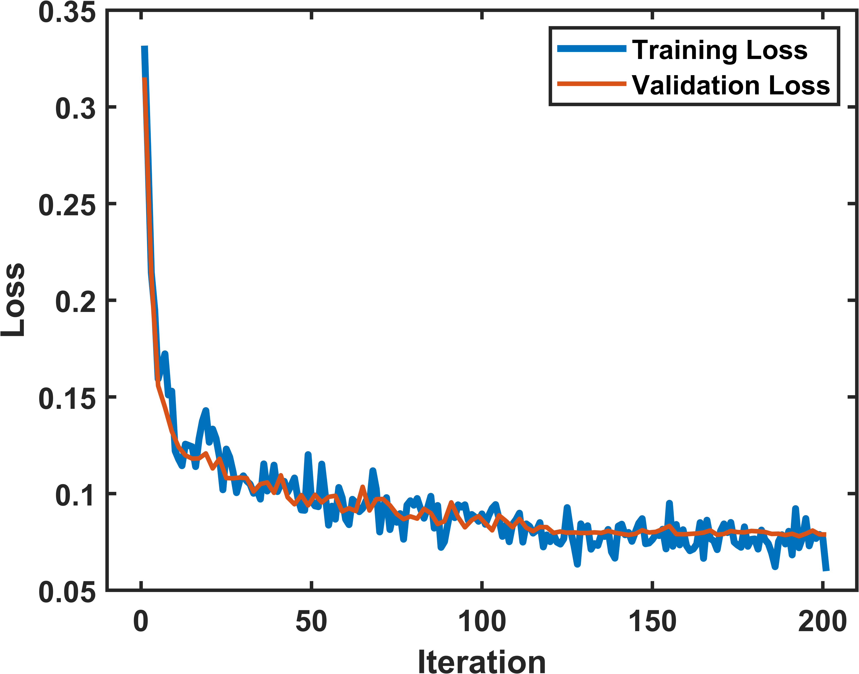Figure 9 is the plot of RMSE and loss for both training and validation. The final training RMSE of the model is 0.073 and the final validation RMSE of the model is 0.077. The final training loss of the model is 0.0024 and the final validation loss is 0.0033. Both validation RMSE and loss converged to a low number, so there was no overfitting during the training progress and the model fitted the data well.

Figure 9 Training and Validation RMSE Plot

**Result & discussion**

**Performance on Validation Data**

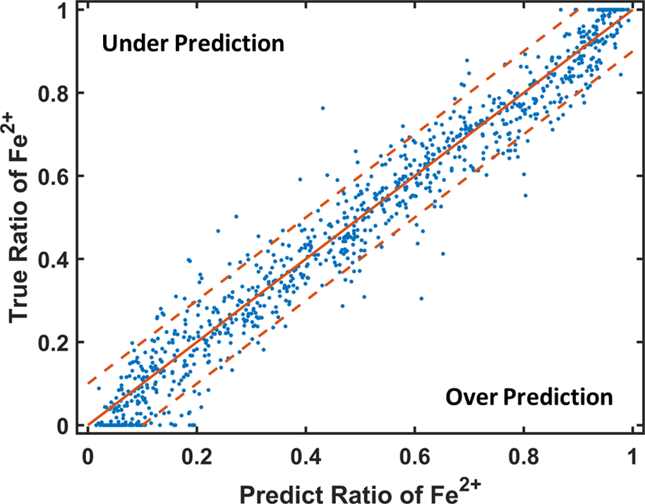The model we trained has a 91.06% accuracy on validation data. Figure 10 is a scatter plot of 1000 spectra randomly selected from validation data. The solid orange line is . The two dashed orange lines are and . The x-axis represents the model’s prediction of Fe2+ percentage in the spectra while the y-axis represents the true percentage. If the blue dots fell into the area enclosed by the two dash lines, the predictions on the spectra were considered accurate(the difference between the predicted oxidation state and the ground truth is between -0.1 and 0.1).

Figure 10 Scatter Plot on 1000 Validation Data

**Test against noise on validation data**

To make sure our model is robust enough against noise, we tested our model against different levels of noise on 1000 spectra. The level of noise is quantified by signal-to-noise ratio which is calculated as:

, where is the standard deviation of the noise.

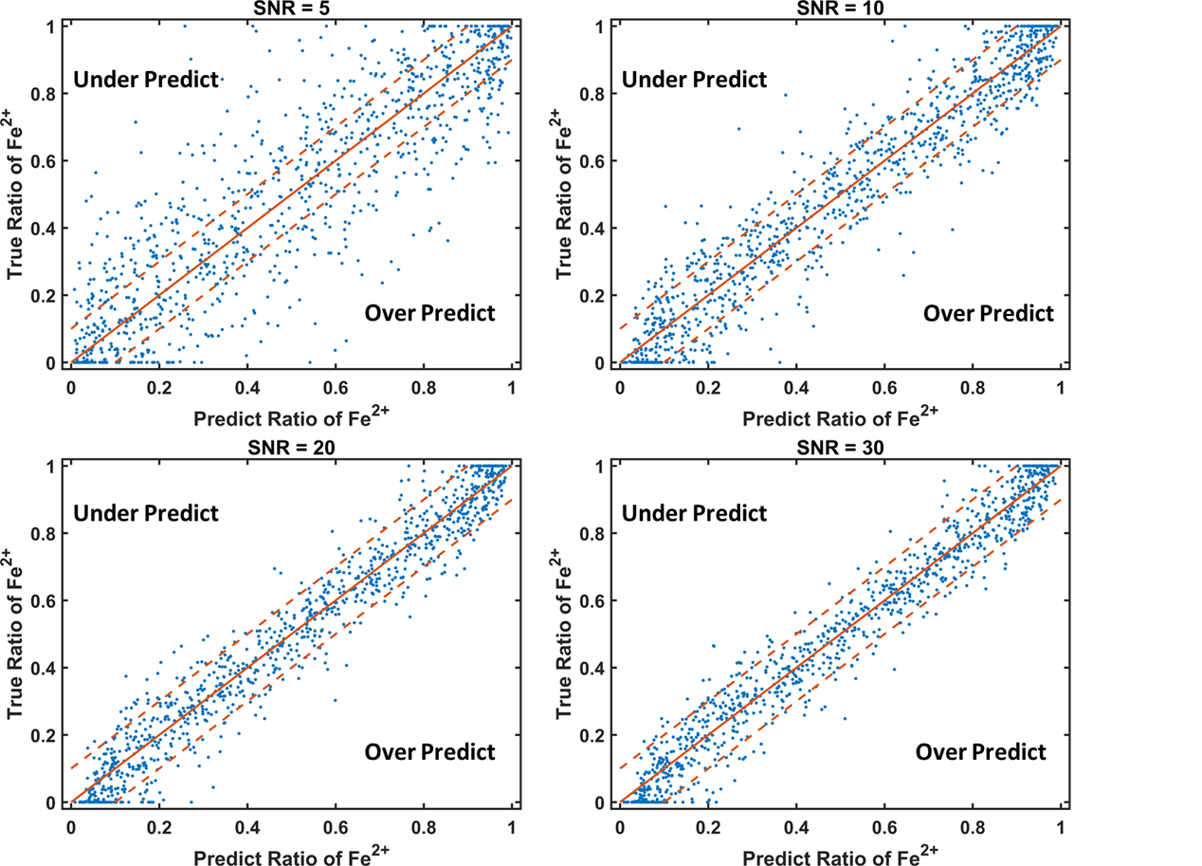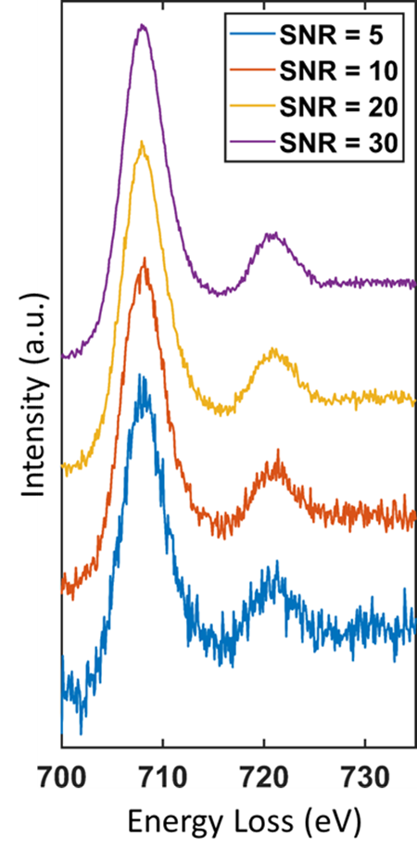In this test, we tested the model again same 1000 validation spectra with SNR = 5, 10, 20, and 30 respectively. Figure 11 shows a spectrum with each level of white noise and figure 12 is the performance of our model on the 1000 spectra with each level of noise.

Figure 12 Performance of the Model on Different Levels of Noise

Figure 11 Spectrum with Different Levels of Noise

**Performance on Testing Data**

Since we synthesized the validation data following the same process as synthesizing the training data, it is not enough just to test the model on validation data. We also tested our model on real experimental spectra that we didn’t digitize to synthesize the training and validation data. We called these spectra testing data. There are 28 spectra from different literature and online database. Our model performs stable on these spectra. Table 3 shows the materials of the spectra, the true percentage of , and the predicted percentage of from our model.

|  |  |  |
| --- | --- | --- |
| Material | Ground truth | Prediction |
| Fe2O39, 14, 15, 16, 17 | 0.0% | 12.32%, 16.53%, 0.04%, 16.98%, 5.85%, 4.86%, 2.47%, 3.57%, 3.69%, 26.7% |
| FeO(OH) 9 | 0.0% | 9.94%, 0.47%, 3.58%, 5.6% |
| Fe2TiO59 | 0.0% | 7.6% |
| LaFeO318 | 0.0% | 1.67% |
| amphibole LC35 | 25.0% | 30.71% |
| Fe3O49, 14, 15 | 33.3% | 31.14%%, 35.66%, 30.37%, 30.46% |
| amphibole SC15 | 48.0% | 38.32% |
| augite CVF15 | 62.0% | 81.18% |
| spinel KR355 | 79.0% | 86.71% |
| glass75 | 83.0% | 82.99% |
| FeCO39 | 100.0% | 99.35% |
| FeTiO39 | 100.0% | 94.82% |
| FeO14 | 100.0% | 97.8% |

Table 3 Model Performance of Testing Spectra

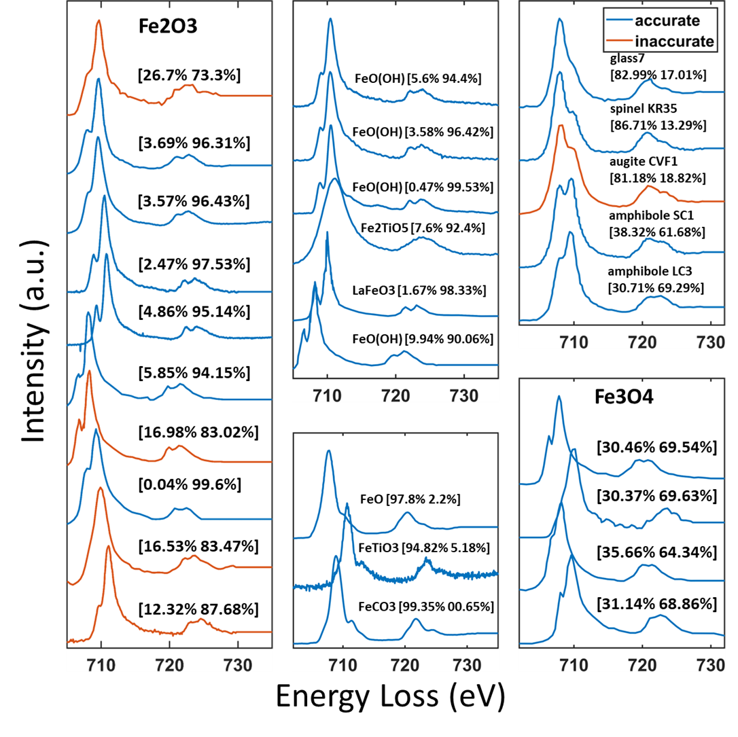Figure 13 shows all 28 testing spectra and the model’s predictions on them. 23 out of 28 spectra were considered accurately predicted using our model and the testing accuracy is 82.14%.

Figure 13 Testing Spectra

**Test against noise on testing data**

To further test our model, we added different levels of noise to the testing data and passed them into our model. The level of noise is quantified by SNR and we set SNR to be 5, 10, 20, and 30 respectively. Figure 14 shows some of the testing spectra with different levels of noise.

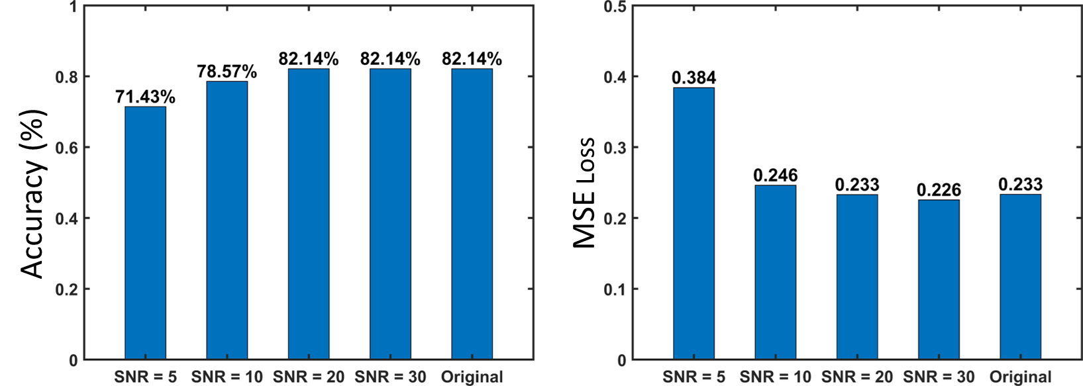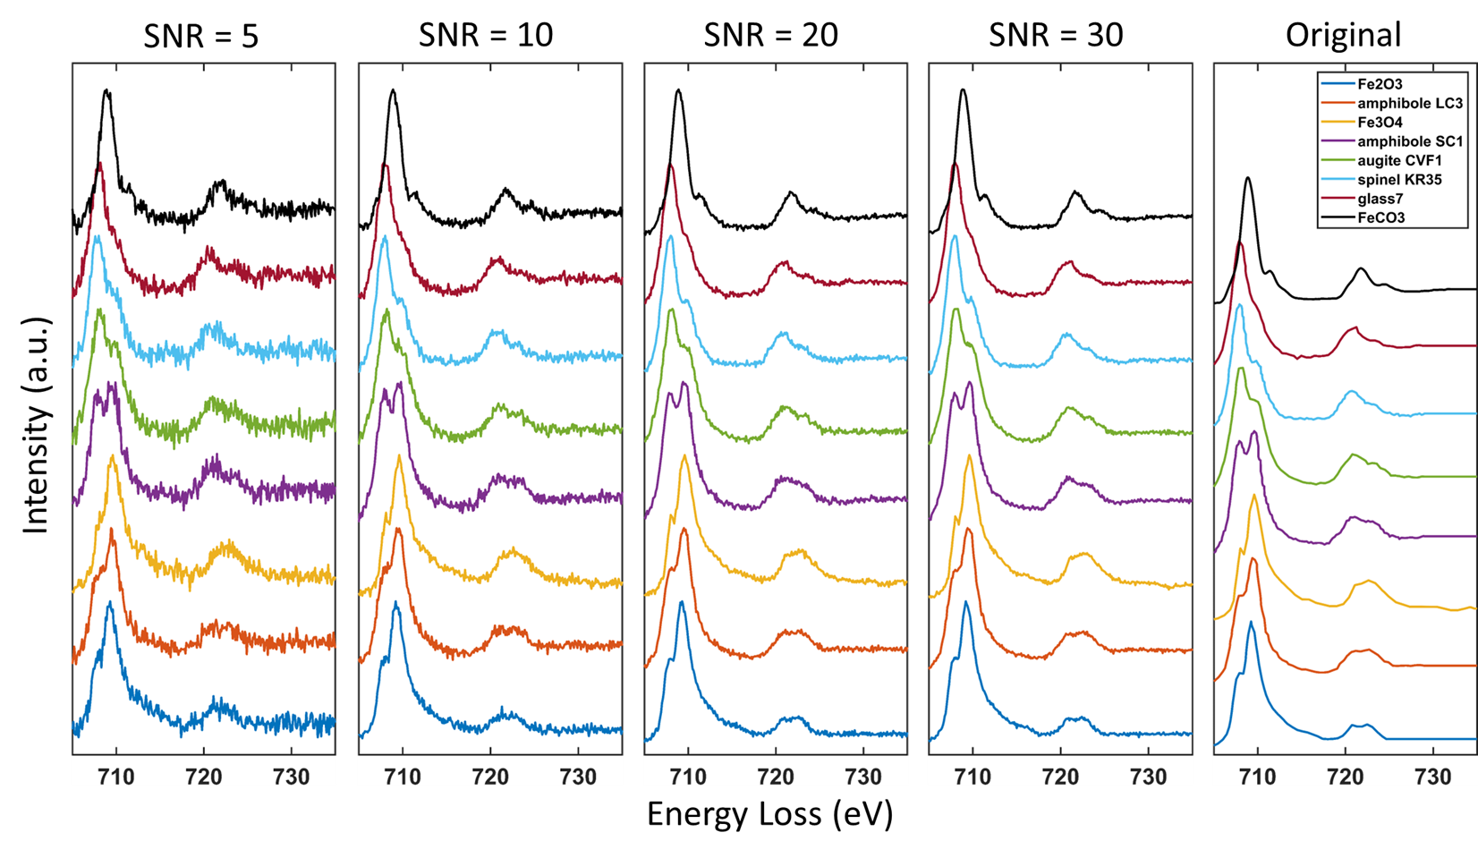The two bar plots show our model’s performance on testing data with different levels of noise. The two criteria we used are accuracy and MSE loss. The model consistently performs well until the SNR is reaching 5. This result is alien to the result we got from testing our model against noise on validation data. Based on the data, we can conclude our model is robust against noise on testing data.

Figure 15 Left: Bar Plot of Model Accuracy against Different Levels of Noise. Right: Bar Plot of MSE Loss against Different Levels of Noise

Figure 14 Testing Spectra with Different Levels of Noise

**Conclusion**

In this research, we proved the similar method we used on Mn L2,3 edges can be transfer to Fe L2,3 edge due to they are both transition metals with similar chemistry property. To create a physics-included and ground-truth labeled training dataset, a synthesized method was applied, considering plural scattering, instrumentation broadening, noise, and energy axis offset. This resulted in a database of 1.32 million spectra with labeled oxidation states, encompassing a wide variety of data, including EELS and XAS spectra. Training the convolutional neural network on this extensive dataset achieved 91.06% accuracy on the validation dataset and 82.14% on the testing dataset.The model's robustness was tested against noise (down to SNR of 5) and further validated using spectral data that were not part of the training. The results demonstrated high accuracy and sensitivity in decomposing different Fe valence state minerals confirming its quantitative correctness for real experimental data. This experiment concludes that the method we used in our previous research for Mn can be to transfer to Fe but with more Fe3O4 data added to the training and validation set due to the fine structure variation in Fe is not as obvious as Mn. The model not only proves to be a valuable asset for researchers and materials scientists but also provides skilled electron microscopists and synchrotron scientists with assistance in automating the analysis of Fe L2,3 edge data.

**Reference**

1. Mann, Dallas & Mordvinova, Natalia & Yannello, Vincent & ZIOUANI, Yasmine & González-Ballesteros, Noelia & Sousa, Juliana & Lebedev, Oleg & Kolen'ko, Yury V. & Shatruk, Michael. (2019). Electrocatalytic water oxidation over AlFe2B2. Chemical Science. 125. 10.1021/acs.jpcc.1c0234510. Doi: <https://doi.org/10.1039/c8sc04106g>.

2. Giménez-Marqués, Mónica & Bellido, Elena & Berthelot, Thomas & Simon-Yarza, Teresa & Hidalgo Crespo, Tania & Simón-Vázquez, Rosana & González-Fernández, Africa & Ávila, José & Asensio, Maria & Gref, Ruxandra & Couvreur, Patrick & Serre, Christian & Horcajada, Patricia. (2018). GraftFast Surface Engineering to Improve MOF Nanoparticles Furtiveness. Small. 125.10.1021/acs.jpcc.1c0234514. 1801900. Doi: <https://doi.org/10.1002/smll.201801900>.

3. Kowalska, Joanna K et al. “Iron L2,3-Edge X-ray Absorption and X-ray Magnetic Circular Dichroism Studies of Molecular Iron Complexes with Relevance to the FeMoco and FeVco Active Sites of Nitrogenase.” Inorganic chemistry vol. 56,14 (2017): 8147-8158. 125. 10.1021/acs.jpcc.1c02345 Doi: <https://doi.org/10.1021/acs.inorgchem.7b00852>.

4. Shibata, Goro & Won, Choongjae & Kim, Jaewook & Nonaka, Yosuke & Ikeda, Keisuke & Wan, Yuxuan & Suzuki, Masahiro & Koide, Tsuneharu & Tanaka, Arata & Cheong, Sang-Wook & Fujimori, A.. (2021). Large Orbital Magnetic Moment and Strong Perpendicular Magnetic Anisotropy in Heavily Intercalated Fe x TiS 2. The Journal of Physical Chemistry C. 125. Doi: <https://doi.org/10.1021/acs.jpcc.1c02345>.

5. Garvie, L., Buseck, P. Ratios of ferrous to ferric iron from nanometre-sized areas in minerals. Nature 396, 667–670 (1998). Doi: <https://doi.org/10.1038/25334>.

6. Van Aken, P., Liebscher, B. Quantification of ferrous/ferric ratios in minerals: new evaluation schemes of Fe L 23 electron energy-loss near-edge spectra. Phys Chem Min 29, 188–200 (2002). Doi: <https://doi.org/10.1007/s00269-001-0222-6>.

7. Bhattacharyya, Amrita & Stavitski, Eli & Dvorak, Joseph & Martínez, Carmen. (2013). Redox interactions between Fe and cysteine: Spectroscopic studies and multiplet calculations. Geochimica et Cosmochimica Acta. 122. 89-100. 125. 10.1021/acs.jpcc.1c0234514. 1801900. 10.1002/smll.201801900. Doi: <https://doi.org/10.1016/j.gca.2013.08.012>.

8. Tan, Haiyan & Verbeeck, Jo & Abakumov, Artem & van Tendeloo, Gustaaf. (2012). Oxidation state and chemical shift investigation in transition metal oxides by EELS. Ultramicroscopy. 116. 24-33. Doi: <https://doi.org/10.1016/j.ultramic.2012.03.002>.

9. EELS Data Base. <https://eelsdb.eu>.

10. Pool, Vanessa L. et al. “Site determination and magnetism of Mn doping in protein encapsulated iron oxide nanoparticles.” Journal of Applied Physics 107 (2010): n. pag. Doi: <https://doi.org/10.1063/1.3359431>.

11. Narayanan, Surya & Shahbazian-Yassar, Reza & Shokuhfar, Tolou. (2020). In-Situ Visualization of Ferritin Biomineralization via Graphene Liquid Cell-Transmission Electron Microscopy. ACS Biomaterials Science & Engineering. Doi: <https://doi.org/10.1021/acsbiomaterials.9b01889>.

12. Piquer, C. & Laguna-Marco, M. & Roca, Alejandro G. & Boada, Roberto & Guglieri, Clara & Chaboy, J.. (2014). Fe K-Edge X-ray Absorption Spectroscopy Study of Nanosized Nominal Magnetite. The Journal of Physical Chemistry C. 118. 1332–1346. Doi: <https://doi.org/10.1021/jp4104992>.

13. WebPlotDigitizer. <https://automeris.io/WebPlotDigitizer>.

14. Yokoyama, Takaomi & Takahashi, Hideyuki & Koshiya, Shogo & Murano, T. & Terauchi, Masami. (2022). Analytical technique for self-absorption structure of iron L-emission spectra obtained by soft X-ray emission spectrometer. Microscopy (Oxford, England). 71. Doi: <https://doi.org/10.1093/jmicro/dfac009>.

15. Filatova, E. & Egorova, Yulia & Galdina, Kristina & Scherb, Tobias & Schumacher, G. & Bouwmeester, Henny & Baumann, Stefan. (2017). Effect of Fe content on atomic and electronic structure of complex oxides Sr(Ti,Fe)O 3−δ. Solid State Ionics. 308. 27-33. Doi: <https://doi.org/10.1016/j.ssi.2017.05.016>.

16. de Smit, E., Swart, I., Creemer, J. et al. Nanoscale chemical imaging of a working catalyst by scanning transmission X-ray microscopy. Nature 456, 222–225 (2008). Doi: <https://doi.org/10.1038/nature07516>.

17. Leus, Karen & Folens, Karel & Nicomel, Nina Ricci & Perez, Jeffrey Paulo & Filippousi, Maria & Meledina, Maria & Dîrtu, Marinela & Turner, Stuart & Tendeloo, Gustaaf & Garcia, Yann & Du Laing, Gijs & Van Der Voort, Pascal. (2018). Removal of arsenic and mercury species from water by covalent triazine framework encapsulated γ-Fe2O3 nanoparticles. Journal of Hazardous Materials. 353. Doi: <https://doi.org/10.1016/j.jhazmat.2018.04.027>.

18. Magnetic Dichroism Spectroscopy and Microscopy. <https://www-ssrl.slac.stanford.edu/stohr/xmcd.htm>.

19. Egerton, Ray. (2009). Electron Energy Loss Spectroscopy in the TEM. REPORTS ON PROGRESS IN PHYSICS Rep. Prog. Phys. 72. 16502-25. Doi: <https://doi.org/10.1088/0034-4885/72/1/016502>.

20. Keast, V & Scott, AJ & Brydson, R & Williams, David & Bruley, John. (2001). Electron energy-loss near-edge structure - A tool for the investigation of electronic structure on the nanometre scale. Journal of microscopy. 203. 135-75. Doi: <https://doi.org/10.1046/j.1365-2818.2001.00898.x>.

21. Chen, Jingguang G.. “NEXAFS investigations of transition metal oxides, nitrides, carbides, sulfides and other interstitial compounds.” Surface Science Reports 30 (1998): 1-152. Doi: <https://doi.org/10.1016/S0167-5729(97)00011-3>.

22. Leapman, Richard & Grunes, and. (1982). Study of the L23 edges in the 3d transition metals and their oxides by electron-energy-loss spectroscopy with comparisons to theory. Phys. Rev. B. 26. Doi: <https://doi.org/10.1103/PhysRevB.26.614>.

23. Schmid, H & Mader, W. (2006). Oxidation States of Mn and Fe in Various Compound Oxide Systems. Micron (Oxford, England : 1993). 37. 426-32. Doi: [https://doi.org/10.1016/j.micron.2005.12.004](Doi:%20https://doi.org/10.1016/j.micron.2005.12.004).

24. Kourkoutis, L. & Xin, Huolin & Higuchi, Takuya & Hotta, Yasushi & Lee, June Hyuk & Hikita, Yasuyuki & Schlom, D. & Hwang, H. & Muller, D.. (2010). Atomic-resolution spectroscopic imaging of oxide interfaces. Philosophical Magazine - PHILOS MAG. 90. 4731-4749. Doi: <https://doi.org/10.1080/14786435.2010.518983>.

25. Kourkoutis, L. & Hotta, Yasushi & Susaki, Tomofumi & Hwang, H & Muller, D. (2007). Nanometer Scale Electronic Reconstruction at the Interface between LaVO 3 and LaVO 4. Physical review letters. 97. 256803. Doi: <https://doi.org/10.1103/PhysRevLett.97.256803>.

26. Laffont, Lydia & Gibot, P.. (2010). High resolution electron energy loss spectroscopy of manganese oxides: Application to Mn3O4 nanoparticles. Materials Characterization. 61. 1268-1273. Doi: <https://doi.org/10.1016/j.matchar.2010.09.001>.

27. Pate, C.M., Hart, J.L. & Taheri, M.L. RapidEELS: machine learning for denoising and classification in rapid acquisition electron energy loss spectroscopy. Sci Rep 11, 19515 (2021). Doi: <https://doi.org/10.1038/s41598-021-97668-8>.

28. Chatzidakis, M., Botton, G.A. Towards calibration-invariant spectroscopy using deep learning. Sci Rep 9, 2126 (2019). Doi: <https://doi.org/10.1038/s41598-019-38482-1>.

29. Xin, H.L., Ji, Z. & Hu, M. MnEdgeNet -- Accurate Decomposition of Mixed Oxidation States for Mn XAS and EELS L2,3 Edges without Reference and Calibration. Arvix (2023). Doi: <https://doi.org/10.48550/arXiv.2210.11657>.

**Acknowledgment**

This work is supported by the Office of Basic Energy Sciences of the U.S. Department of Energy, under award no. DE-SC0021204 and UCI UROP and SROP program.

**Author contribution**

HLX and ZJ conceived the idea. All authors designed and carried out the experiments. ZJ and HLX wrote the manuscript.

**Competing interests**

The authors declare no competing interests.

**Data availability**

Data and code are available from the corresponding author upon request.