**Gmail Tutorial**

Gmail is a free email account provide by Google. In this tutorial, we will talk about the basic operations in Gmail and focused how to send and receive emails in Gmail.

**Overall:**

1. **Send Email**
2. **Receive Email**
3. **Conclusion**

**Sending Email**

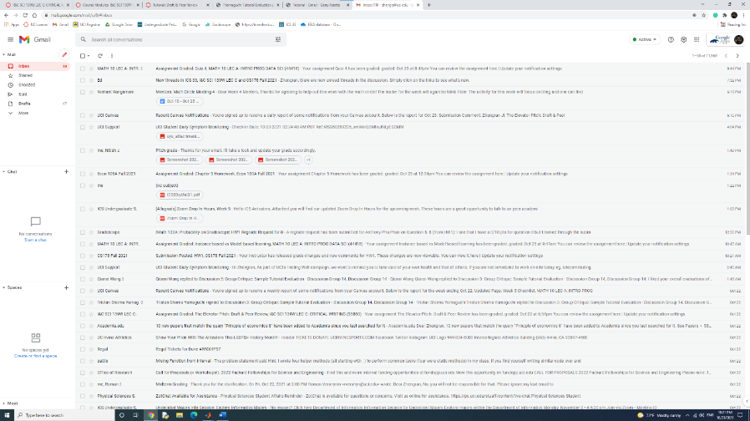The first part of this tutorial will focus on teaching the user how to send emails in Gmail website.

1. **Create a new message**

When we first log in the Gmail main page, we will see the button with a pen label on it. Click that button, you will see a window pop out with ‘new message’ at the top left.

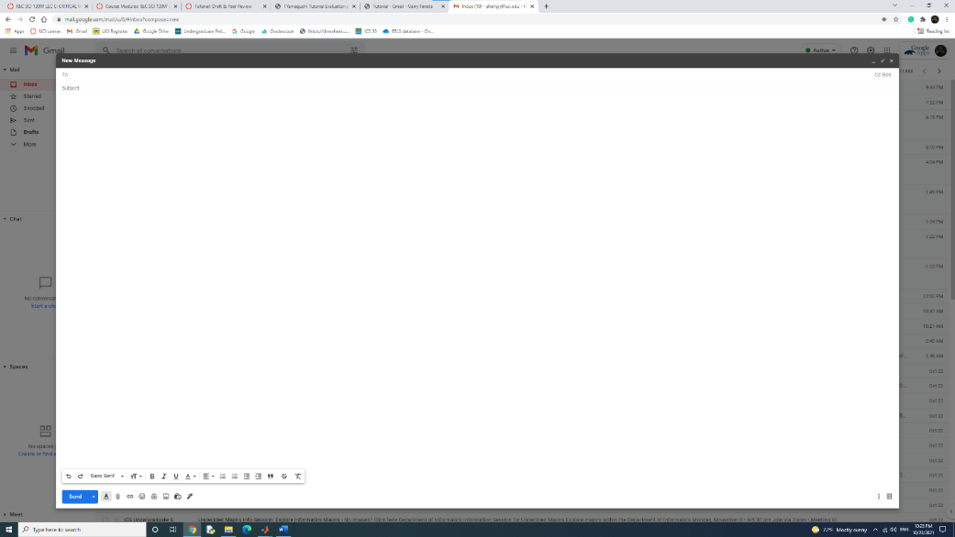

1. **Enter receiver**

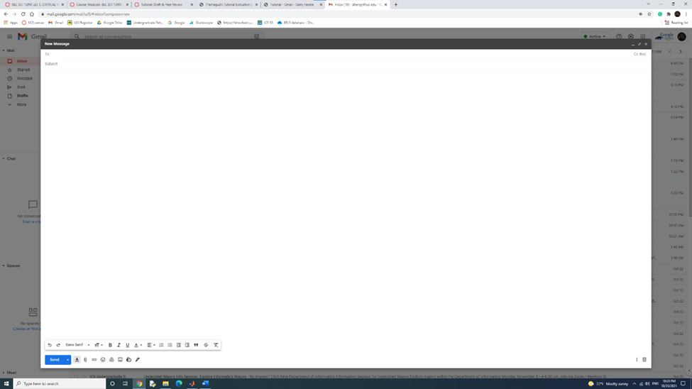 Click the first line of that window which has ‘To’ at the left, and enter a valid email address. If you have contact with the email address before, there will be a prompt window that you can choose the email address in that.

1. **Choose cc or bcc (optional)**

Notice, on the right of the first line, there are two options, ‘cc’ and ‘bcc’. When you click each option, there will be a new line pop out on which you can enter email address. The different between cc and bcc is that cc is public and bcc is private.

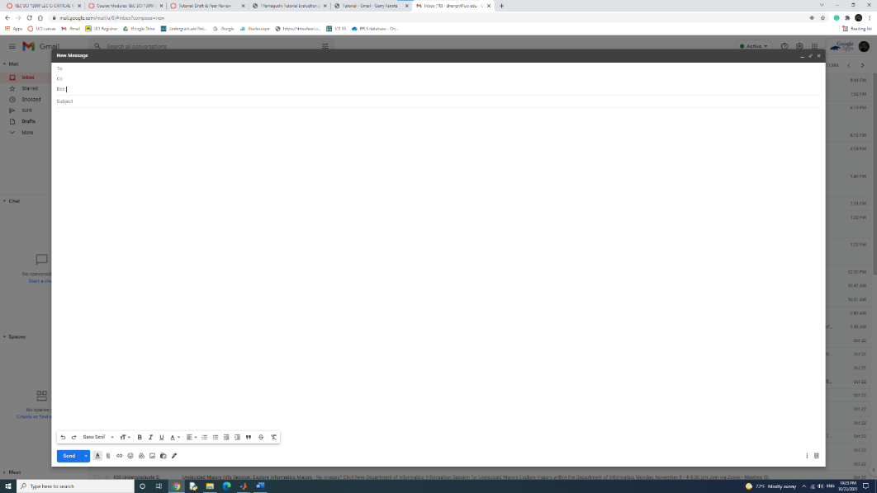

1. **Subject (Optional)**

After that, click the line start with ‘subject’, and enter the subject you want. If you do enter anything, the email will be sent as NO Subject.

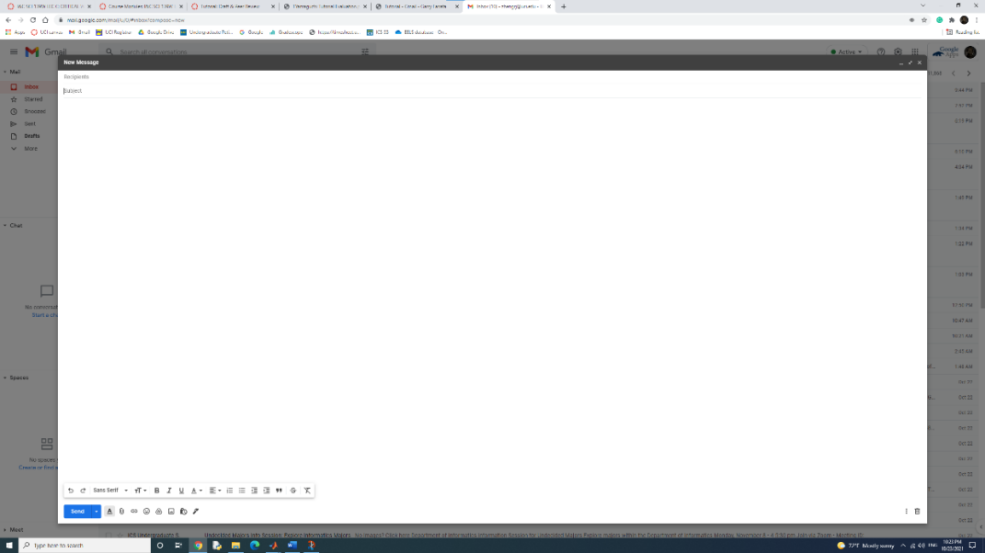

1. **Write the message**

At the blank under, enter the message as you want. At the bottom, there is a bar with several options on it. Of which, you can use to change the font, size or the text, or attach files to the email.

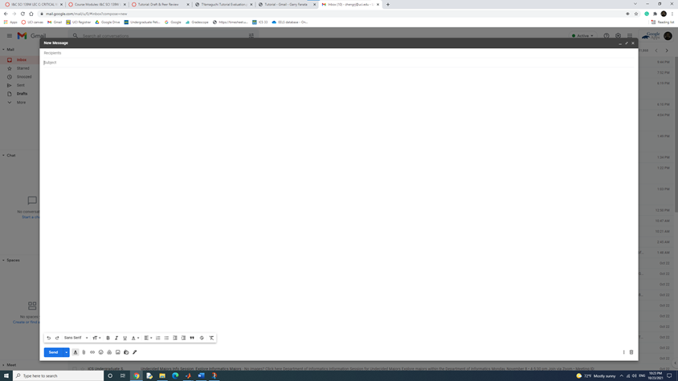

1. **Send the email**

After editing the message, click the blue button with the label send at the left down corn of the window to send the email.

**Receiving Email**

This part will focus on teaching you all the features that Gmail has regarding the email in the inbox.

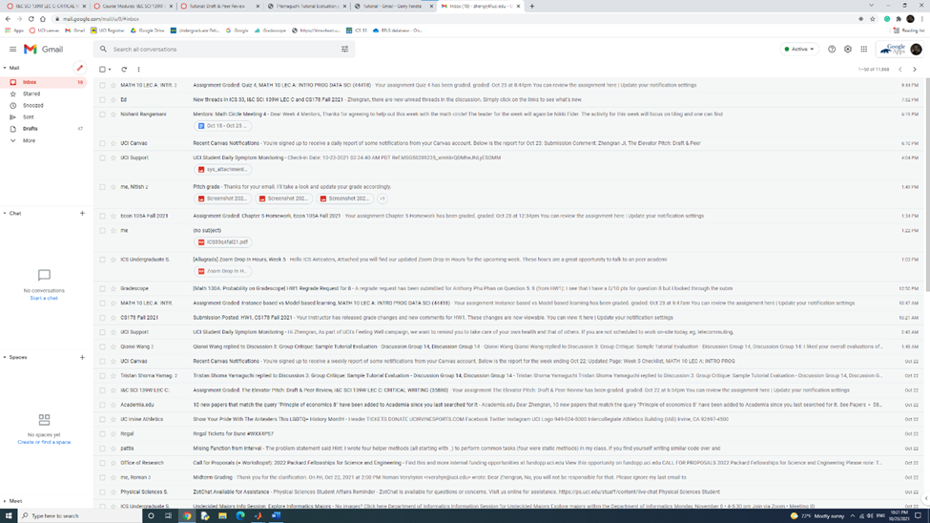

1. **Read an email**

When logging into the Gmail web app, you will automatically get access to the inbox page. You can see every email info in the inbox with the sender and the subject listed chronologically. Click the email to get access to it.

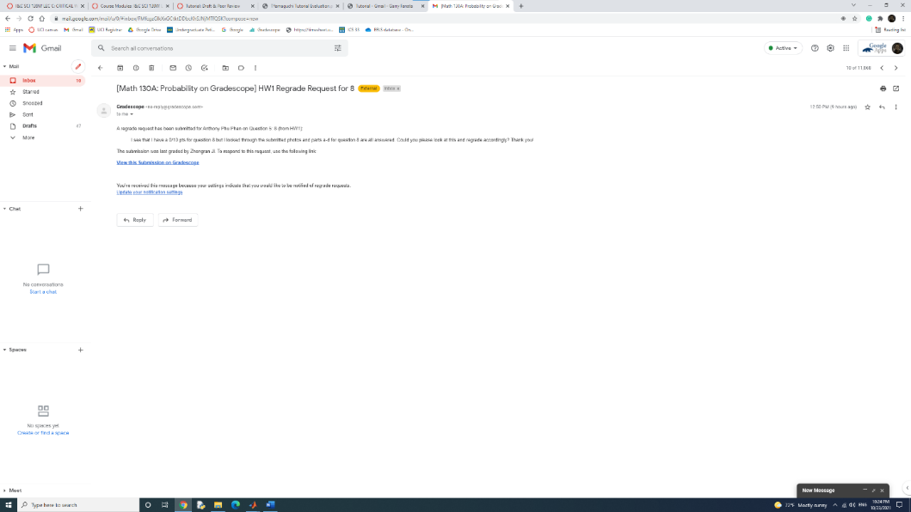

1. **Reply to an email**

At the bottom of the email, there is button with the label ‘reply’. By clicking to the button, the message window will pop out where you can reply to this email.

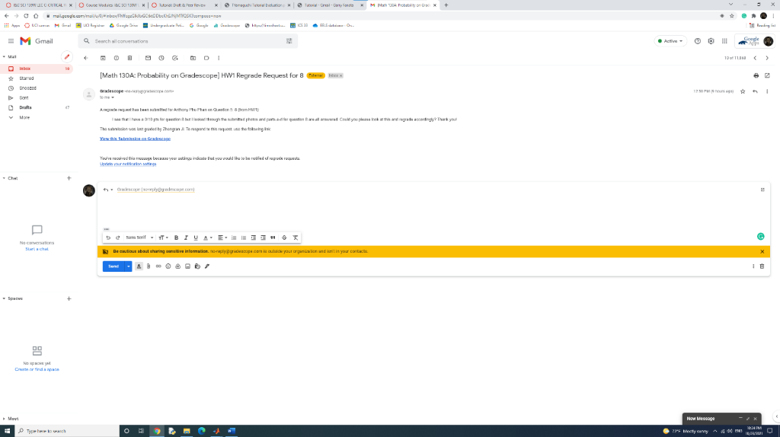

1. **Forward an email**

At the bottom of email, there is a button with the label ‘forward’. By clicking to the button, the message window will pop out where you can choose the email address to forward the email.

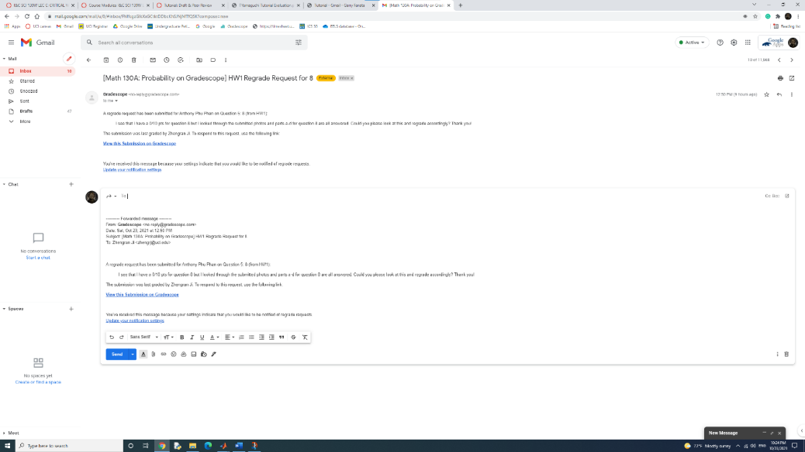

1. **Other options**

On the top of each email, there is bar with serval options such as archive, delete, and report spam.

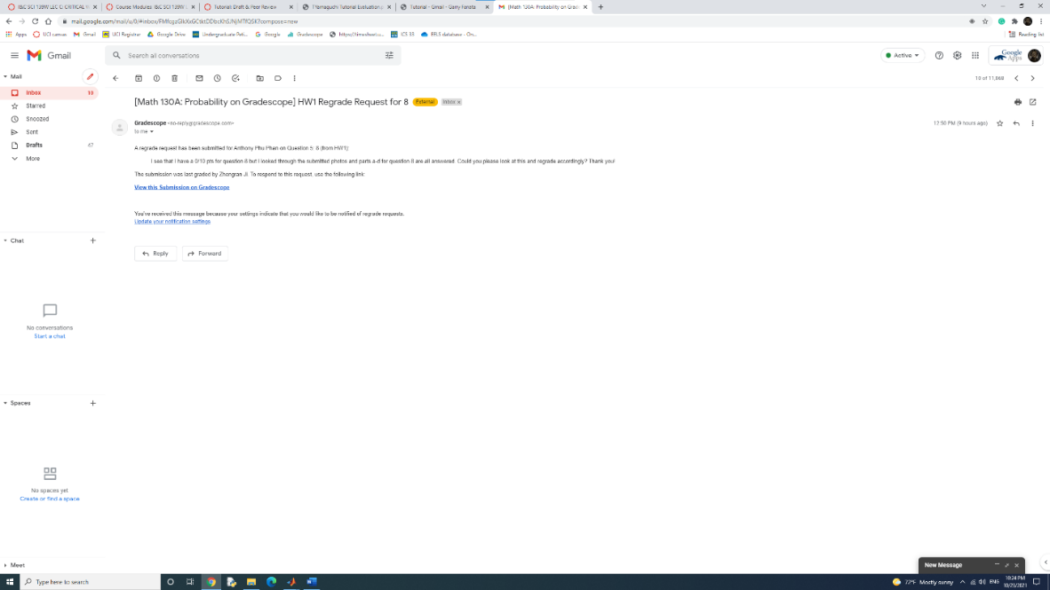

**Conclusion**

As reading the tutorial, you are expected to understand how to send and check received emails in Gmail.