The simple shapes of Amanita spores are influenced by complex ecological, phylogenetic, and biophysical variables.

Authors: Jason Raiti¹, Corbin Bryan¹, Sydney Berkeley¹, Carrie Chapek¹, Jacob J. Golan¹, Carsen Grote², Ricardo Kriebel³, Sheldon Stajkovic¹, Yen-Wen Wang⁴, Anne Pringle^{1,5}

ORDID iDs:
Jason Raiti: 0009-0006-5092-1969
Corbin Bryan: 0009-0006-8075-9018
Sydney Berkeley: 0009-0004-4357-5004
Carrie Chapek: Not available.
Jacob J. Golan: 0000-0002-9127-1329
Carsen Grote: 0009-0003-6870-9390
Ricardo Kriebel: 0000-0002-1138-7533
Sheldon Stajkovic: 0009-0006-6022-3662
Yen-Wen Wang: 0000-0002-6851-1646
Anne Pringle: 0000-0002-1526-6739

¹ Department of Botany, University of Wisconsin-Madison
² Department of Mathematics, University of Wisconsin-Madison
³ Department of Botany, California Academy of Sciences
⁴ Department of Biostatistics, Yale University
⁵ Department of Bacteriology, University of Wisconsin-Madison

Keywords: Basidiospore; spore shape; morphometrics; climate; trait ecology; dispersal; Amanita; mushroom; Stokes flow

AI Statement: The authors used the generative artificial intelligence tools Grammarly, ChatGPT, and Gemini to assist with editing and improving the clarity and readability of the manuscript. These tools were not used to generate research data, interpret results, or formulate scientific conclusions. All text was reviewed and revised by the authors, and we take full responsibility for the content of the manuscript.

ABSTRACT
Spores are essential to fungal reproduction and dispersal, but why spores are shaped as they are remains poorly understood. Using morphometric data from 1,041 spore outlines representing 211 species, we plotted the evolution of spore shape across the fungal genus Amanita. We quantified spore shape and volume with elliptic Fourier analysis and principal component decomposition. Shapes and volumes were then integrated with multi-locus phylogenetic reconstructions and matched to climatic variables derived from global climate databases. Most variation in spore shape (84.6%) is explained by a single principal component representing whether a spore is globose (round) or elongate. Elongate spores are typically small, and larger spores are rarely elongated. After accounting for phylogenetic history, trophic mode (whether a species is ectomycorrhizal or not) explains little about spore shape. Instead, trait mapping revealed the repeated evolution of similar morphologies across distinct lineages within the genus, regardless of trophic mode. While trophic mode did not explain spore shape, elongate spores were more likely to be found in wet and temperate habitats, suggesting a climatic influence on the evolution of spore elongation. A model suggests shape may also reflect selection imposed by climate on dispersal physics, including shape-dependent terminal velocity under low–Reynolds number flow. Our findings imply the morphology of Amanita spores is shaped not by how a fungus eats but by the environmental and biophysical constraints influencing dispersal.

INTRODUCTION
Fungal spores are a universal trait of fungi (Weber and Hess 1976) and the primary agents of dispersal, and yet the evolutionary and ecological forces shaping their morphology remain poorly understood. Spores vary enormously in size, ornamentation, and shape across the fungal tree of life, even by an order of magnitude within a single genus (e.g., Alternaria alternata and A. solani (Golan et. al. 2023)). Spores may be smooth and spherical (e.g., Penicillium spp.), or elaborately ornamented (e.g., Russula and Laccaria spp.), or take forms as unusual as the tetraradiate or boomerang-shaped spores of aquatic “Ingoldian fungi” (Golan and Pringle 2017).
Variation in spore morphology has historically been used as a tool to identify and name species (Bas 1969) and it continues to be used by taxonomists because it is an accessible and relatively low cost trait to measure (Ordynets et al. 2021). The staggering morphological diversity of spores suggests natural selection and diversification as evolutionary drivers of spore geometry. However, hypotheses linking spore morphology to ecology, phylogenetic history, and dispersal biophysics remain contested (Pringle et al. 2015).
In fact, spore size and shape have been proposed to reflect a sometimes conflicting array of influences (FIG. 1).
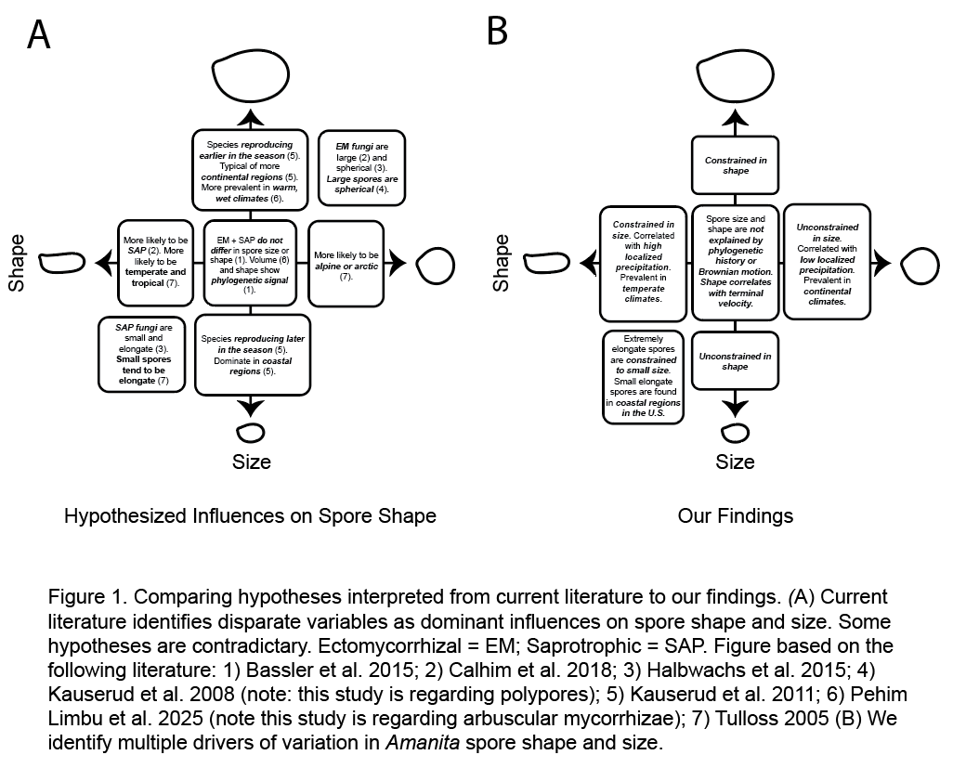
Comparative work shows trophic mode (whether a species is symbiotic, a decomposer, or something else) can strongly correlate with both size and shape: ectomycorrhizal taxa may produce larger, more globose spores while saprotrophs may tend toward smaller, narrower spores (Calhim et al. 2018). Other studies highlight close links between resource availability (as measured by net primary productivity in local habitats), sporocarp size, and spore size; when more resources are available, sporocarps are larger in both polypores and agarics, and species with larger fruit bodies and more resources tend to produce larger spores (Kauserud et al. 2008; Bässler et al. 2015). Climate and phenology may also influence spore morphology: species reproducing early in the season or occupying continental, drier habitats may bear larger spores with lower surface-area-to-volume ratios, potentially enhancing resistance to desiccation (Kauserud et al. 2011). Substrate specialization can also drive differences in spore shape, and wood-decaying saprotrophs may be more likely to evolve elongate or curved spores as compared to litter and herb-stem decayers. The pattern suggests the deposition mechanics of spores onto different surfaces (or how spores land) influences morphology (Calhim et al. 2018). In addition, broader life-history trade-offs analogous to r/K selection (Bässler et al. 2016) or natural selection for a greater number of spores (Iapichino et al. 2021) may influence reproductive traits. The production of many small spores is consistent with r-selection for high propagule output, whereas production of fewer, larger spores is consistent with K-selection for greater per-spore investment. For example, Laccaria tortilis has spores 12.8 µm in diameter and <10,000 spores per mm² of gill, whereas Clitocybe globispora has spores 4.3 µm in diameter and >50,000 spores per mm² (Halbwachs 2018). In general, larger sporocarps produce more spores, consistent with the “maximal packing” of reproductive propagules into reproductive structures (Iapichino et al. 2021). Biophysical constraints may also influence spore shape, as larger spores may be more spherical if selection for water conservation favors a lower surface-area-to-volume ratio (Kauserud et al. 2008).
Together, these hypotheses suggest spore morphology emerges from the interplay of ecological niche, the architecture of sporocarps and spores, natural selection for dispersal and establishment, and inherited developmental constraints (FIG. 1). As a result, spore traits may not reflect any single selective force, but rather the cumulative outcome of evolution acting across multiple stages of the reproductive cycle, from release and transport to deposition and germination.
However, inferences frequently rely on broad comparisons across multiple genera, often ignoring the shared evolutionary history which may also drive morphology. While trophic mode and climate are consistently identified as major correlates of spore traits, both trophic mode and spore traits are constrained by phylogeny (Bässler et al. 2015; Pehim Limbu et al. 2025). Spore traits may be adaptations, or they may be phylogenetic artifacts; it can be difficult to distinguish adaptive evolution from features emerging as byproducts of other evolutionary forces (e.g. spandrels sensu Gould and Lewontin 1979). The lack of targeted and phylogenetically explicit analyses using quantitative shape data for many closely related species is a limitation. To date, no study has tested how spore traits are influenced by trophic mode, climate, and phylogeny across a large, globally distributed and monophyletic clade. Moreover, most research to date has relied on length-to-width ratios or qualitative descriptors (e.g. “globose”, “allantoid”, “elongate”). Morphometrics is the quantitative analysis of biological form, and it uses mathematical descriptions to compare structures. Morphometrics is a tool we can use to quantify the full geometry of spores.
The mushroom-forming genus Amanita provides an ideal system for using morphometrics to test the multiple hypotheses used to explain spore morphology. The genus was formally named in Lamarck and Poiret’s Encylopédie méthodique: botanique in 1783 (vol. 1, pg. 111), and Amanita species remain among the most iconic of fungi. The genus is monophyletic, species-rich, globally distributed, and unusually well documented, with detailed type descriptions, micrographs, and natural history available for hundreds of taxa (e.g., Tulloss & Yang 2017; Kuo 2017). Although the genus is predominantly ectomycorrhizal, Amanita also includes decomposer lineages as well as the enigmatic A. inopinata group, whose trophic mode remains uncertain (Wolfe et al. 2012). Symbiosis evolved a single time within the genus, and available data allow for explicit comparisons of spore morphology across an ecological transition. Furthermore, the recent availability of multilocus phylogenies and genome-scale phylogenomic resources (Wolfe et al. 2012; Cui et al. 2018) enables a phylogenetically rigorous assessment (Pringle et al. 2015).
Because trophic mode and climatic variables are consistently identified as major correlates of spore traits and can be quantified across large taxonomic datasets, we explored three hypotheses testable through publicly available data: spore morphology differs between trophic modes, spore morphology covaries with precipitation, and spore morphology differs among climate zones.
However, the physical context in which dispersal occurs may also influence spore traits (Golan and Pringle 2017). For wind-dispersed fungal spores, motion through air is controlled by viscous drag, and not inertia; this low-Reynolds-number regime is commonly described as Stokes flow (Fischer et al. 2010). In Stokes flow, aerodynamic resistance is sensitive to particle size and for non-spherical bodies, it can also depend on shape and orientation (Roper et al. 2008). Mushroom caps trap thin boundary layers of still air around them and their evaporative cooling can generate convective airflows to carry spores outward and upward, even in the absence of external winds (Dressaire et al. 2016). As spores disperse, slight differences in settling velocity or trajectory may alter whether a spore deposits rapidly or encounters other, local winds to travel further afield. Whether a spore is elongate or globose may affect its aerodynamics and dispersal trajectory (Ingold 1965).
Keeping the physics of spore dispersal in mind, we explore five questions using the genus Amanita as a model: (1) What are the major axes of spore shape variation within the genus? (2) Do ectomycorrhizal, decomposer, or putatively transitional lineages exhibit distinct spore shapes once phylogenetic relationships are taken into account? (3) Does the climate in which mushrooms grow influence spore morphology? (4) How often have particular spore shapes evolved within the genus, and is there evidence of convergent evolution? (5) Do the different shapes of spores influence their initial dispersal away from a mushroom and into air?

MATERIALS AND METHODS
Building a spore trait database.—
Compiling spore data from taxonomic literature.
Project data and methods are publicly available through a GitHub repository associated with the publication: https://github.com/jzraiti/Spore-Shape-Amanita.
First, we compiled spore data from species descriptions available on Amanitaceae.org (Tulloss 2025), an online monograph (Kuo 2025), and the following publications: Bas 1969, Bojantchev et al. 2011, Bojantchev and Davis 2013, Cho et al. 2015, Cripps et al. 2017, Davison et al. 2015, Deng et al. 2014, Deng et al. 2016, Endo et al. 2016, Endo et al. 2017, Hosen et al. 2015, Liu et al. 2017, Menolli, Capelari, et al. 2009, Menolli, Asai, et al. 2009, Miller Jr. 1991, Miller 1992, Oda et al. 2000, Oda et al. 2001, Oda, Tanaka, et al. 2002a, Oda, Tanaka, et al. 2002b, Oda, Yamazaki, et al. 2002, Pérez-Silva and Alfonso 1983, Singh and Kaur 2016, Takahashi 2004, Tang et al. 2015, Tang et al. 2017, Thongbai et al. 2016, Vargas et al. 2017, Yang et al. 2001, Wartchow and Maia 2007, Wartchow et al. 2009, Wartchow and Gamboa 2012, Wartchow et al. 2013, Wartchow et al. 2015, Wartchow 2016, and Wartchow and Cortez 2016. Spore data consisted of collection location, date, and collector; habitat description; spore drawings or photographs; and minimum, maximum, and mean length and width measurements (µm).
Creating morphometric descriptors.
We digitally traced the outlines of 1,041 spores from published drawings and micrographs representing 211 species (FIG. 2), including 208 species of Amanita as well as three close relatives (Pluteus cervinus; Pluteus petasatus; Zhuliangomyces illinitus). Digitized spore outlines were analyzed using the R package momocs, implemented in R 4.5.1 (R Core Team 2025), a toolkit for the quantitative analysis of biological shapes based on outline coordinates (Bonhomme et al. 2017). Outlines were first standardized so that differences in the scale, orientation (the direction of the protruding hilar appendix), and rotation (the angle of the hilar appendix) did not influence comparisons. Each outline was subsequently converted into a series of 120 coordinate points. Converted outlines were analyzed using elliptic Fourier descriptors (EFDs) (Kuhl and Giardina 1982), a method to convert complex outlines into numerical values. Next, we used the numerical shape descriptors and a principal components analysis (PCA) to summarize the main axes of shape variation across species.
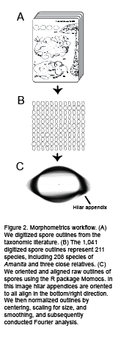

Digitizing shape requires a normalized two-dimensional outline. To account for the three-dimensionality of spores, we also estimated spore volume using the ellipsoid spheroid formula (Hopkins and Bennett 2023; Kauserud et al. 2011; Bässler et al. 2015) and spore lengths and widths.
We retrieved daily temperature and precipitation data for collection localities around the date of collection from NOAA databases, including the NOWData portal (NOAA National Weather Service 2025) and the Climate Data Online database (NOAA National Centers for Environmental Information 2025). Records were extracted from the weather stations closest to each locality. For United States localities, data were primarily obtained from the NOWData database, but missing records and international records were retrieved from the Climate Data Online dataset. From these records, we calculated cumulative precipitation for the 30 days preceding the collection date, a proxy for local moisture. We filtered the precipitation data to exclude extreme rainfall events (>150% average annual rainfall) and so eliminated 3 data points corresponding to A. virginioides, A. smithiana, and A. chatamagotake.
We assigned each collection locality to its Köppen–Geiger climate zone using a 1-km resolution global raster dataset (Beck et al. 2018) because this dataset provides standardized climate classifications based on long-term temperature and precipitation patterns. For climate analyses incorporating phylogeny, we included only species for which both phylogenetic and morphometric data were available. Because most of these species were from the continental United States, climate zones in this analysis were simplified and binned into the two climate categories most common in the United States: “continental” and “temperate”.
Ultimately, our dataset consists of 1,041 digitized spore outlines representing 211 species. The variables we subsequently analyzed include species identity, morphometric traits (PC1 of shape and estimated spore volume), collection locality and date, associated climatic variables, and trophic mode.

Phylogeny species tree. —
We reconstructed phylogenetic relationships among our Amanita species using publicly available sequences from the National Center for Biotechnology Institute’s (NCBI’s) GenBank (Supplemental Table 1). Our phylogeny is based on seven loci chosen because they have been used in previous studies (Wolfe et al. 2012; Cui et al. 2018) and they are readily available: nuclear small subunit (18S SSU; model: TIM2+F+I+G4), mitochondrial small subunit (mtSSU; model: GTR+F+I+G4), mitochondrial large subunit (mtLSU; model: TVM+F+R3), nuclear large subunit (LSU; model: GTR+F+I+R5), internal transcribed spacer (ITS; model: TPM3u+F+I+G4), translation elongation factor 1-alpha (TEF1; model: TIM2e+R4), and RNA polymerase subunit (RPB2; model: K2P+I+R3). Species lacking coverage for more than 4 loci were excluded from analysis. Ultimately, we assembled a multilocus dataset for 132 of our 211 species, including 129 Amanita species and our three outgroups. Sequences were aligned with mafft 7, and we selected optimal alignment algorithms using the “--auto” flag (Katoh and Standley 2013). Data were trimmed with trimal 1.4 (Capella-Gutiérrez et al. 2009). Gene trees were inferred with iq-tree 2 using models selected by modelfinder (Minh et al. 2020). Gene trees were then used to infer a species tree with astral (Zhang et al. 2025).
The 129 Amanita species encompass 111 ectomycorrhizal species, 8 decomposer species, and 3 species clustered within a clade defined by A. inopinata. Phylogenetic analyses place these three species near the transition between decomposer and ectomycorrhizal Amanita, but whether they are decomposers or ectomycorrhizal, or live using elements of both strategies, remains unclear (Redhead et al. 2016; Wolfe et al. 2012). In later trophic mode analyses, we take an agnostic approach and simply define the categories as ectomycorrhizal, saprotrophic, or as the “A. inopinata” clade or group.
We also constructed a species tree using Amanita and Volvariella volvacea genome assemblies available from NCBI GenBank and JGI MycoCosm. The V. volvacea genome serves as an outgroup. Genome completeness was assessed with busco 3.0.2 using the agaricales_odb10 dataset (Simão et al. 2015; Waterhouse et al. 2018). Orthologs present in at least half of the 17 sampled taxa were retained for gene-tree inference. Individual orthologs were aligned with mafft 7.525 using its automatic algorithm selection, and gene trees were inferred with iq-tree 2.4.0 with modelfinder. The resulting 3,373 gene trees were used to infer a species tree with astral 4. To quantify concordance and conflict among loci at each internode, the inferred species tree was annotated with lossless internode certainty (ICA) values calculated in raxml-hpc 8.2.12 (Stamatakis 2014). Lossless ICA compares the frequency of the reference bipartition at a given branch to the frequencies of all conflicting bipartitions observed across the gene trees while accounting for missing gene trees; higher values indicate greater concordance among loci, whereas values near zero or below zero indicate substantial discordance.

Mapping morphometric traits. —
We tested three hypotheses found in literature (e.g., Calhim et al. 2018; Halbwachs et al. 2015; Kauserud et al. 2011) (FIG. 1) and defined by us a priori: spore morphology differs among trophic modes (ectomycorrhizal versus saprotrophic versus the “A. inopinata” group), covaries with precipitation, and covaries with different climate zones.
We first mapped morphometric traits, namely principal component 1 and spore volume, onto our seven-locus phylogeny to assess how these traits changed across our trees and where shifts in morphology occurred within the trees. We tested for phylogenetic signal, defined as the tendency for closely related species to resemble one another in trait values because of their shared evolutionary history, using Blomberg’s K (Blomberg et al. 2003) and Pagel’s λ (Pagel 1999). Blomberg’s K measures the extent to which trait similarity among related species matches the expectation under Brownian motion, whereas Pagel’s λ estimates the strength of phylogenetic covariance in the data.
Our trophic mode analysis considered three groups (SUPP. FIG. 1, SUPP. FIG 2.): ectomycorrhizal, saprotrophic, and unknown (the “A. inopinata” group). We tested for differences in spore shape among trophic modes using phylogenetic ANOVA (Adams and Collyer 2018; Revell and Harmon 2022) as implemented in the phytools package (Revell 2024). In this analysis, trait values are simulated along the phylogeny under a Brownian motion model of evolution, testing if PC1 is significantly different between trophic mode groups when accounting for the expected covariance among species due to shared ancestry.
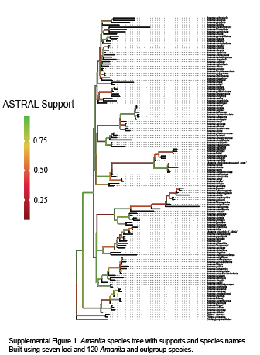
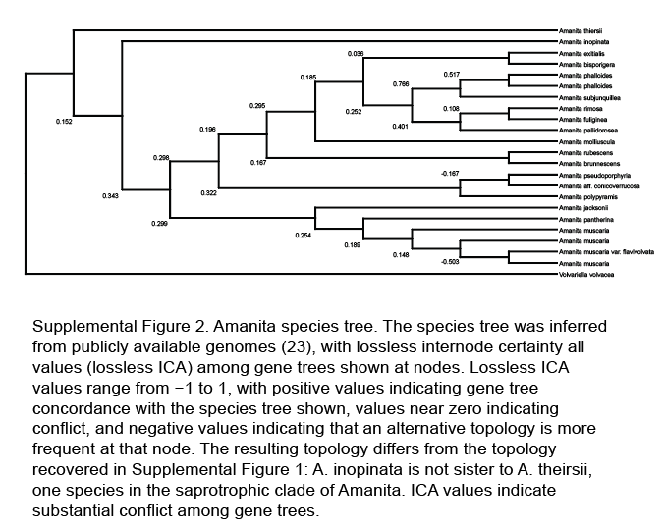
Our precipitation and climate zone analyses used phylogenetic generalized least squares (PGLS) to test related hypotheses: whether spore shape (PC1) and estimated spore volume were associated with either the 30-day precipitation preceding collection and/or climate zone. For each of the two traits (shape and volume), we fit three candidate models representing different hypotheses: (1) precipitation alone explains the trait, (2) climate group alone explains the trait, and (3) precipitation plus climate group explains the trait. Models were compared using Akaike’s Information Criterion corrected for small sample size (AICc), and models with ΔAICc < 2 were considered equivalently supported. For each trait, we extracted the best-supported of the three models, inspected parameter estimates and significance, and estimated Pagel’s λ by maximum likelihood to quantify phylogenetic signal in the residuals (variance not explained by our models).

Modeling spores in Stokes flow. —
To evaluate the potential aerodynamic consequences of different spore morphologies, we estimated a dimensionless proxy for terminal settling velocity for each species’ spores using a Stokes flow model for a prolate spheroid (Supplemental Text 1). In brief: spore length and width measurements were used to approximate spores as prolate spheroids, and terminal velocity was calculated assuming the orientation that maximizes drag (i.e., with the long axis parallel to the ground, or “broadside” orientation (Tulloss 2005)). Under the low Reynolds number regimes typical of microscopic particles in air, viscous drag causes settling velocity to scale with particle size and shape. Because our objective was comparing across species, and not estimating absolute settling speeds, we omitted physical constants shared across taxa from our calculation: gravitational acceleration, air viscosity, and density contrasts between spores and air. Resulting velocity estimates were normalized by dividing each species’ value by the across-species mean, yielding a dimensionless metric of relative settling velocity (mean = 1.0). The metric facilitates comparisons among species while removing any dependence on unknown or constant physical parameters.
We visualized the distribution of normalized terminal velocities across species using a histogram and explored its relationship with spore shape variation using principal component 1 (PC1). We evaluated the relationship using a least-squares linear regression of species mean PC1 against normalized terminal velocity. Pearson’s correlation coefficient (r) and the coefficient of determination (r²) were used to summarize effect size.
Real spores may depart from our model’s assumptions because of their irregular shapes, variable settling orientations, turbulence, or boundary layer dynamics. Our metric should be conservatively interpreted as a comparative index of relative settling potential rather than a physical estimate of absolute aerodynamic performance.

RESULTS

Spore morphospace is dominated by a single elongate–globose axis. —
Across Amanita, most interspecific diversity in the shape of spores was explained by a single principal component. PC1 captured 84.6% of the total variation in the shape of their outlines and described a continuum from elongate to globose morphologies (FIG. 3). Negative PC1 scores correspond to more elongate spores and positive scores to more globose spores. PC1 was significantly but modestly correlated with estimated spore volume (r = 0.31, r² = 0.10; p < 0.001). Elongate spores occurred only among the smaller-volume species in our dataset while large spores appear constrained to a more globose shape, but small spores appear to be both elongate and globose (FIG. 3). The four taxa with the lowest PC1 score (i.e. the most “elongate” taxa: A. alliacea, A. roanokensis, A. inodora, and A. rhoadsii) are not monophyletic and all of them are found in the coastal regions of the southern and eastern United States.

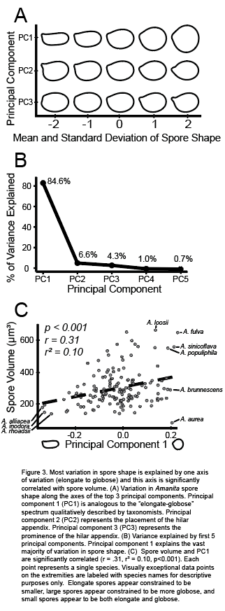

Trophic mode explains little variation in spore shape and volume. —
If evolutionary history is ignored, the ectomycorrhizal (EM) taxa show a modest tendency toward more elongate spores relative to saprotrophic and the “A. inopinata” clades, but the difference is minimal and not significant (FIG. 4; p > 0.05). After accounting for the shared evolutionary history of the species, trophic mode explained little to none of the variation in PC1: a phylogenetic ANOVA detected no significant difference among groups. Estimated spore volume also did not differ detectably among trophic groups before or after accounting for phylogenetic relationships (p > 0.05).

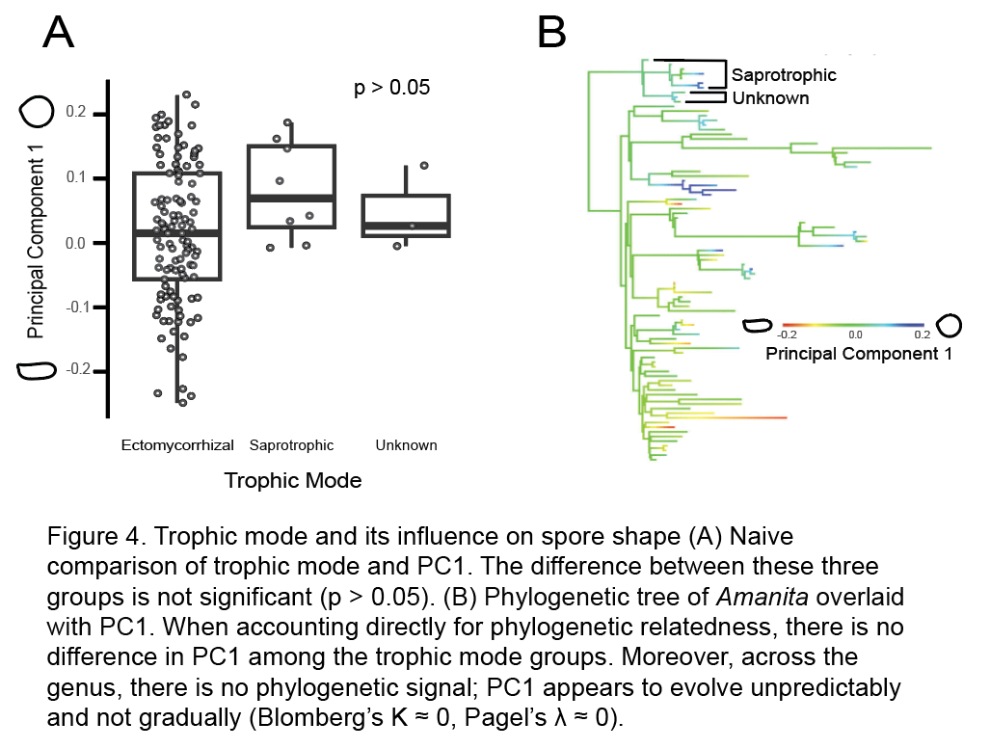

Associations between shape and climate persist when shared evolutionary history is taken into account; volume appears unaffected by climate. —
While trophic mode explained little of the variation in PC1, we found that PC1 varied significantly with climatic context (FIG. 5). In the full environmental dataset, mean PC1 was associated with both 30-day precipitation prior to collection (r = -0.37, r² = 0.14, p < 0.01) and Köppen climate group (p < 0.05). Species from wetter habitats and from temperate climate groups tended to have lower PC1 values, corresponding to more elongate spores, while species from drier habitats and from continental climate groups tended to have higher PC1 values, corresponding to more globose spores.

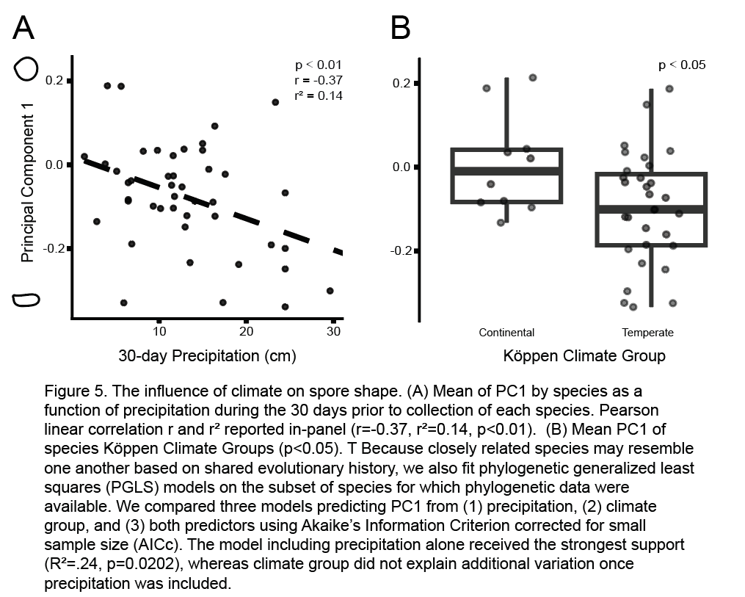

Because precipitation and Köppen climate groups summarize overlapping aspects of different environments’ rainfall patterns, we compared phylogenetic generalized least squares (PGLS) models including each predictor separately and together on the subset of taxa for which phylogenetic data were available. However, each data set only partially overlapped resulting in a reduced sample size (n = 22). Within this model set, precipitation was the best-supported predictor of PC1. In the top-ranked model, PC1 decreased with increasing precipitation, and the model explained approximately 24% of interspecific variation in PC1. PC1 decreased with increasing 30-day precipitation (β = −0.022; SE = 0.009; t₂₀ = −2.52; r² = 0.24; p < 0.05). The model including both precipitation and Köppen climate group was less supported than the precipitation-only model, and the climate-group-only model was weaker still. Thus, while both precipitation and climate group were associated with PC1 in the larger non-phylogenetic dataset, phylogenetically informed model comparisons supported the precipitation model most strongly among the candidate models. By contrast, no climate predictor was statistically supported for estimated volume (all p > 0.05).

PC1 is not phylogenetically conserved. —
PC1 shows effectively no phylogenetic signal overall (N = 129; Blomberg’s K ≈ 0; Pagel’s λ ≈ 0). Closely related species are not more similar in PC1 than expected by chance, suggesting spore shape is a labile trait and evolves frequently among different values of PC1. A visual inspection of the trait plotted across a phylogeny of the Amanita (FIG. 4B) supports this finding, for example, strongly globose shapes have evolved repeatedly among different clades. Spore volume likewise shows no phylogenetic signal (N = 87; Blomberg’s K ≈ 0; Pagel’s λ ≈ 0). Neither trait appears phylogenetically conserved and variation in the traits does not track shared ancestry.

PC1 covaries with a Stokes terminal velocity. —
To understand how shape may be influenced by the physics of initial dispersal away from a mushroom, we estimated a relative proxy for terminal velocity and tested whether the elongate–globose axis of spore shape corresponds to differences in settling after release. In our approach, terminal velocity is the steady speed reached by spores in Stokes flow regimes in free fall through still air. The resulting proxy was roughly normally distributed across species and spanned an approximately threefold range (FIG. 6). Species’ PC1 scores are associated with normalized terminal velocity (r = 0.38, r² = 0.14 , p < 0.05): more elongate spores tend to display lower terminal velocities while more globose spores tend to display higher terminal velocities. Our result is consistent with shape-related differences in drag during the initial phase of dispersal, after release. However, because elongate spores in Stokes flow may also settle at an angle and exhibit lateral drift, depending on their orientations, our analysis should be interpreted with caution. It is based on a comparative index and we are not providing estimates of real-world settling speeds.

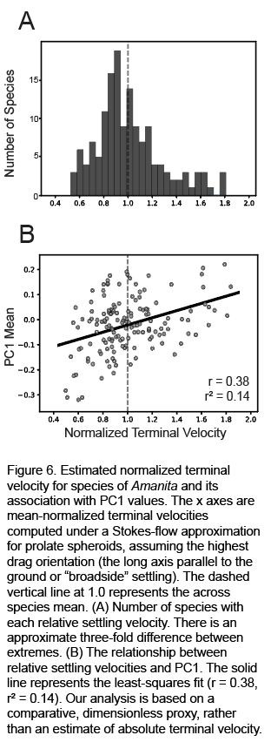

DISCUSSION
The shapes of Amanita spores are simple but the influences on shape are complex.—
Across the genus Amanita, variation in spore outlines was dominated by a single elongate–globose axis (PC1, FIG. 3). In other words, the primary morphometric signal corresponds to a shape spectrum already familiar to taxonomists, rather than to an abstract statistical axis disconnected from morphological descriptions.
Although the spores occupy a simple morphospace, the influences on shape appear to be complex and likely act across release, transport, deposition, and germination (Pringle et al. 2015; Aguilar-Trigueros et al. 2015). Ectomycorrhizal species outnumber decomposer or other species, and the imbalance limits our comparisons among groups. Nonetheless, an initial signal of trophic mode disappeared when the phylogenetic relatedness of species was taken into account. Local climate correlated with shape, even in a phylogenetically explicit analysis, and shape is also related to the physics of how spores move through air. In general, shape appears to evolve rapidly, and there is no evidence of phylogenetic conservation.
Unlike spore shape, estimated spore volume was associated with neither trophic mode nor climate after accounting for phylogeny, suggesting the broader links between spore volume and natural history found in other fungal genera do not translate directly to Amanita fungi (Kauserud et al. 2011; Calhim et al. 2018).
The elongate-globose axis of spore shape (PC1) is related to estimated spore volume, but the relationship is asymmetric: smaller spores take either elongate or globose shapes, but larger spores are rarely elongate (FIG. 3). The pattern is broadly consistent with earlier comparative work in other fungal groups, also showing larger spores tend to be more spherical (Kauserud et al. 2008. No species in our dataset combined a large estimated volume with a strongly elongate shape. This result is also consistent with observations of undescribed Amanita species (Tulloss 2005). Several explanations are plausible, including developmental or geometric constraints, desiccation related surface-area-to-volume trade-offs, and/or constraints associated with ballistospore launch itself (Kauserud et al. 2008; Halbwachs 2018; Fischer et al. 2010). If proposed constraints are important, we hypothesize ecological forces on spore shape evolution in Amanita may be acting within a limited region of morphospace, rather than across all theoretically possible shapes.

Spore shape was not detectably associated with trophic mode.—
Broad comparative studies across many genera of fungi often recover associations between trophic mode and spore traits. For example, Calhim et al. (2018) found ectomycorrhizal fungal spores to be more frequently ornamented, larger, and often more globose than saprotrophic spores, whereas Halbwachs et al. (2015) found ectomycorrhizal agaric spores to have thinner walls and more frequent ornamentation when compared to saprotrophic agaric spores. However, within Amanita, trophic mode did not explain spore shape (FIG. 4). Yet, trophic mode may still be relevant to spore evolution. Our analyses focus on spore silhouette and size, and not ornamentation, surface chemistry, or any other spore feature. Perhaps these other traits map more strongly onto trophic strategy than shape or size (Halbwachs et al. 2015; Calhim et al. 2018).

Amanita inopinata deserves closer study.—
Interpretation of any analysis involving trophic mode in Amanita is also complicated by our limited knowledge of the ecology of species in the A. inopinata clade. We treated the clade as its own group because how it obtains carbon remains unresolved, and in fact, the topology of one of our phylogenies (based on genomes, SUPP. FIG. 2) suggests the clade may be transitional (Looney et al. 2022). The data complicate the distinction between Amanita and the proposed genus Saproamanita (Tulloss et al. 2016; Redhead et al. 2016). Resolving the natural history of fungi in the A. inopinata clade would enable a clearer study of the impacts of trophic mode on Amanita morphology and inform a fuller understanding of the genus as a whole.

Spore shape is correlated with climate.—
Among the ecological variables we tested, precipitation emerged as the strongest predictor of spore shape (PC1), with higher precipitation preceding collection tending to correlate with more elongate spores (FIG. 5). This association persisted after shared evolutionary history was considered. However, we think precipitation itself is unlikely to be driving spore shape. Instead, the availability of water as reflected in not only rain, but also ambient humidity and near soil surface moisture may be relevant. While our 30-day precipitation window only measured precipitation, the Köppen climate groups would consider many other features of local environments as well as precipitation. We hypothesize climate more broadly as a central influence on spore shape, and supporting our hypothesis, the most elongate taxa in our dataset cluster in the coastal southeastern and eastern United States. Tulloss (2005) recorded similar observations on temperate and tropical Amanita and also speculated shape was related to the influence of climatic variables.
In analyses encompassing other fungi, Kauserud et al. (2011) also suggest water balance optimization as the functional link between climate and spore morphology, observing that Norwegian coastal fungi have smaller spores than inland species, perhaps because of a relaxed constraint on water storage in more humid, coastal environments. Although we found structuring in shape rather than size, perhaps dry conditions disfavor elongated spores because elongation increases the surface-area-to-volume ratio and wetter conditions relax this constraint (Kauserud et al. 2008).
This mechanism may also contribute to the asymmetric relationship between size and shape in Amanita, in which small-spored species span much of the elongate–globose axis whereas larger spores are predominantly globose (FIG. 3C). Because both small size and elongation increase surface area relative to volume, small, elongate spores should face the strongest potential water-balance constraint and may therefore be viable across a narrower range of environmental conditions. Wetter environments may relax this constraint and permit both elongate and globose forms among small spores. Direct measurements of local humidity, spore water loss, and post-release behavior will be needed to distinguish among these hypotheses.

Shape is a labile trait in the genus Amanita.—
Similar shapes appear repeatedly and independently across the phylogeny of Amanita (FIG. 4B), and PC1 showed essentially no phylogenetic signal. The pattern is consistent with recurrent natural selection on shape and not phylogenetic conservatism (Halbwachs et al. 2015).
A recent study of arbuscular mycorrhizal (AM) fungi provides a useful contrast to our data. Pehim Limbu et al. (2025) found broad associations between AM fungal spore volume and shape, and climate, and they also reported moderate phylogenetic conservatism for volume but not shape. Among the Amanita, shape rather than volume was associated with climate, and neither shape nor volume was phylogenetically conserved. The contrasting patterns suggest different lineages of fungi may evolve different solutions to the multiple pressures of climate, development, and biophysics.

Spore shape and dispersal biophysics.—
Spore shape may be especially consequential during the earliest stages of dispersal, when spores must first escape the weak local airflows immediately surrounding a sporocarp before broader atmospheric transport becomes relevant. Even modest differences in drag or settling behavior likely have biologically meaningful effects (Ingold 1965). Our simplified settling model yielded an approximately threefold range in relative terminal-velocity estimates, and estimates correlate with the elongate-globose axis represented by PC1 (FIG. 6). The correlation provides a plausible functional link between spore shape variation and the physics of early dispersal. In addition to changing relative settling speed, elongated spores may also differ from more globose spores in how they orient during descent, potentially altering their trajectories and introducing a lateral component to their movement under simplified conditions (Supplemental Text 1).
Our model is a deliberate simplification, and real spores depart from idealized spheroids because their movement may depend on orientation, ornamentation, turbulence, boundary-layer dynamics, and hygroscopic effects (Dressaire et al. 2016; Golan and Pringle 2017; Calhim et al. 2018; Reponen et al. 1996; Hassett et al. 2015). Nevertheless, simplified aerodynamic models can help to isolate the potential contribution of shape when its effects on aerodynamic behavior and deposition are difficult to measure experimentally (Hussein et al. 2013). Our model does not identify which feature(s) of the dispersal mechanism are influenced by shape, but it supports a conclusion that shape variation in Amanita has consequences for spore dispersal.

Conclusion.—
The shapes of Amanita spores are simple, but the influences on shape are not (FIG. 7). The dominant elongate–globose axis is poorly explained by trophic mode, shows little phylogenetic constraint, and is associated with climate; it appears to influence the movements of spores dispersing away from mushrooms. Spore shape is therefore not only a taxonomic character, but also a labile functional trait shaped by ecological, physical, and likely yet unmeasured forces.

DATA AVAILABILITY STATEMENT
Alignments available here: https://github.com/jzraiti/Spore_Shape_Alignments.git
ACKNOWLEDGMENTS
Special thanks to the University of Wisconsin-Madison. In particular, the Botany department for providing teaching experience, funding, and community and the Pringle lab for mentorship and companionship.

LITERATURE CITED

Adams DC, Collyer ML. 2018. Phylogenetic ANOVA: Group‐clade aggregation, biological challenges, and a refined permutation procedure. Evolution. 72(6):1204–1215. https://doi.org/10.1111/evo.13492
Aguilar-Trigueros CA et al. 2015. Branching out: Towards a trait-based understanding of fungal ecology. Fungal Biology Reviews. 29(1):34–41. https://doi.org/10.1016/j.fbr.2015.03.001
Amanitaceae. 2017. http://tullabs.com/amanita/
Bässler C et al. 2015. Ectomycorrhizal fungi have larger fruit bodies than saprotrophic fungi. Fungal Ecology. 17:205–212. https://doi.org/10.1016/j.funeco.2014.06.005
Bässler C et al. 2016. Mean reproductive traits of fungal assemblages are correlated with resource availability. Ecology and Evolution. 6(2):582–592. https://doi.org/10.1002/ece3.1911
Beck HE et al. 2018. Present and future Köppen-Geiger climate classification maps at 1-km resolution. Sci Data. 5(1):180214. https://doi.org/10.1038/sdata.2018.214
Blomberg SP, Garland T, Ives AR. 2003. TESTING FOR PHYLOGENETIC SIGNAL IN COMPARATIVE DATA: BEHAVIORAL TRAITS ARE MORE LABILE. Evol. 57(4):717. https://doi.org/10.1554/0014-3820(2003)057%255B0717:TFPSIC%255D2.0.CO;2
Bojantchev D, Davis RM. 2013. Amanita augusta, a new species from California and the Pacific Northwest. North American Fungi. 8(0):1. https://doi.org/10.2509/naf2013.008.005
Bojantchev D, Pennycook SR, Davis RM. 2011. Amanita vernicoccora sp. nov. —the vernal fruiting “coccora” from California. mycotaxon. 117(1):485–497. https://doi.org/10.5248/117.485
Calhim S et al. 2018. Fungal spore diversity reflects substrate-specific deposition challenges. Sci Rep. 8(1):5356. https://doi.org/10.1038/s41598-018-23292-8
Cho HJ et al. 2015. Four New Species of Amanita in Inje County, Korea. Mycobiology. 43(4):408–414. https://doi.org/10.5941/MYCO.2015.43.4.408
Cripps CL, Lindgren JE, Barge EG. 2017. Amanita alpinicola sp. nov., associated with Pinus albicaulis, a western 5-needle pine. mycotaxon. 132(3):665–676. https://doi.org/10.5248/132.665
Cui Y-Y et al. 2018. The family Amanitaceae: molecular phylogeny, higher-rank taxonomy and the species in China. Fungal Diversity. 91(1):5–230. https://doi.org/10.1007/s13225-018-0405-9
Davison EM et al. 2015. Amanita drummondii and A. quenda (Basidiomycota), two new species from Western Australia, and an expanded description of A. walpolei. Nuytsia. 25(Volume 25, 10 Mar 2015):1–13. https://doi.org/10.58828/nuy00738
Deng W, Li T, Hosen MdI. 2016. Amanita rufobrunnescens, a new species of Amanita section Amidella from South China. Phytotaxa. 243(2) [accessed 2026 July 16]. https://phytotaxa.mapress.com/pt/article/view/phytotaxa.243.2.4. https://doi.org/10.11646/phytotaxa.243.2.4
Deng W-Q, Li T-H, Li P, Yang ZL. 2014. A new species of Amanita section Lepidella from South China. Mycol Progress. 13(2):211–217. https://doi.org/10.1007/s11557-013-0906-6
Dressaire E, Yamada L, Song B, Roper M. 2016. Mushrooms use convectively created airflows to disperse their spores. Proc Natl Acad Sci USA. 113(11):2833–2838. https://doi.org/10.1073/pnas.1509612113
Endo N et al. 2016. Taxonomic consideration of the Japanese red-cap Caesar’s mushroom based on morphological and phylogenetic analyses. Mycoscience. 57(3):200–207. https://doi.org/10.1016/j.myc.2016.01.005
Endo N et al. 2017. Reevaluation of Japanese Amanita section Caesareae species with yellow and brown pileus with descriptions of Amanita kitamagotake and A. chatamagotake spp. nov. Mycoscience. 58(6):457–471. https://doi.org/10.1016/j.myc.2017.06.009
Fischer MWF et al. 2010. Solving the aerodynamics of fungal flight: how air viscosity slows spore motion. Fungal Biology. 114(11–12):943–948. https://doi.org/10.1016/j.funbio.2010.09.003
Golan JJ et al. 2023. Differences in spore size and atmospheric survival shape stark contrasts in the dispersal dynamics of two closely related fungal pathogens. Fungal Ecology. 66:101298. https://doi.org/10.1016/j.funeco.2023.101298
Golan JJ, Pringle A. 2017. Long-Distance Dispersal of Fungi Heitman J, Crous PW, editors. Microbiol Spectr. 5(4):5.4.03. https://doi.org/10.1128/microbiolspec.FUNK-0047-2016
Halbwachs H, Brandl R, Bässler C. 2015. Spore wall traits of ectomycorrhizal and saprotrophic agarics may mirror their distinct lifestyles. Fungal Ecology. 17:197–204. https://doi.org/10.1016/j.funeco.2014.10.003
Hassett MO, Fischer MWF, Money NP. 2015. Mushrooms as Rainmakers: How Spores Act as Nuclei for Raindrops Gladfelter AS, editor. PLoS ONE. 10(10):e0140407. https://doi.org/10.1371/journal.pone.0140407
Hopkins JR, Bennett AE. 2023. Spore traits mediate disturbance effects on arbuscular mycorrhizal fungal community composition and mutualisms. Ecology. 104(5):e4016. https://doi.org/10.1002/ecy.4016
Hosen MdI, Li T-H, Deng W-Q. 2015. Amanita cinereovelata, a new species of Amanita section Lepidella from Bangladesh. Mycol Progress. 14(6):35. https://doi.org/10.1007/s11557-015-1058-7
Kauserud H et al. 2011. Mushroom’s spore size and time of fruiting are strongly related: is moisture important? Biol Lett. 7(2):273–276. https://doi.org/10.1098/rsbl.2010.0820
Kuhl FP, Giardina CR. 1982. Elliptic Fourier features of a closed contour. Computer Graphics and Image Processing. 18(3):236–258. https://doi.org/10.1016/0146-664X(82)90034-X
Kuo M. 2025. [accessed 2025 Dec 23]. https://www.mushroomexpert.com/index.html
Liu F et al. 2017. Asymmetric drop coalescence launches fungal ballistospores with directionality. J R Soc Interface. 14(132):20170083. https://doi.org/10.1098/rsif.2017.0083
Looney B et al. 2022. Evolutionary transition to the ectomycorrhizal habit in the genomes of a hyperdiverse lineage of mushroom‐forming fungi. New Phytologist. 233(5):2294–2309. https://doi.org/10.1111/nph.17892
Menolli N, Asai T, Capelari M. 2009. <I>Amanita coacta</I> (<I>Amanitaceae</I>, <I>Agaricales</I>) with a key to <I>Amanita</I> species occurring in Brazil. Mycotaxon. 107(1):419–430. https://doi.org/10.5248/107.419
Menolli N, Capelari M, Baseia IG. 2009. Amanita viscidolutea , a new species from Brazil with a key to Central and South American species of Amanita section Amanita. Mycologia. 101(3):395–400. https://doi.org/10.3852/07-079
Miller Jr. OK. 1991. New species of Amanita from Western Australia. Can J Bot. 69(12):2692–2703. https://doi.org/10.1139/b91-338
Miller OK. 1992. Three New Species of Amanita from Western Australia. Mycologia. 84(5):679–686. https://doi.org/10.1080/00275514.1992.12026193
Minh BQ et al. 2020. IQ-TREE 2: New Models and Efficient Methods for Phylogenetic Inference in the Genomic Era Teeling E, editor. Molecular Biology and Evolution. 37(5):1530–1534. https://doi.org/10.1093/molbev/msaa015
Oda T, Yamazaki T, et al. 2002. Amanita ibotengutake sp. nov., a poisonous fungus from Japan. Mycol Progress. 1(4):355–365. https://doi.org/10.1007/s11557-006-0032-9
Oda T, Tanaka C, Tsuda M. 2000. Amanita sinensis, new to Japan and Nepal. Mycoscience. 41(4):403–405. https://doi.org/10.1007/BF02463955
Oda T, Tanaka C, Tsuda M. 2001. Amanita imazekii —a new species in Amanita section Caesareae. Mycologia. 93(6):1231–1234. https://doi.org/10.1080/00275514.2001.12063257
Oda T, Tanaka C, Tsuda M. 2002a. Amanita concentrica : a new species in Amanita section Amanita from Japan. Mycoscience. 43(1):81–83. https://doi.org/10.1007/s102670200013
Oda T, Tanaka C, Tsuda M. 2002b. Two new species of Amanita from Japan. Mycoscience. 43(4):351–355. https://doi.org/10.1007/S102670200051
Ordynets A, Keßler S, Langer E. 2021. Geometric morphometric analysis of spore shapes improves identification of fungi. PLOS ONE. 16(8):e0250477. https://doi.org/10.1371/journal.pone.0250477
Pagel M. 1999. Inferring the historical patterns of biological evolution. Nature. 401(6756):877–884. https://doi.org/10.1038/44766
Pehim Limbu S et al. 2025. Climate-linked biogeography of mycorrhizal fungal spore traits. Proc Natl Acad Sci USA. 122(29):e2505059122. https://doi.org/10.1073/pnas.2505059122
Pérez-Silva E, Alfonso RMaA. 1983. Chromatographic and Taxonomic Evaluation of Amanita Citrina (Agaricales). Mycologia. 75(6):1030–1035. https://doi.org/10.1080/00275514.1983.12023789
Redhead SA, Vizzini A, Drehmel DC, Contu M. 2016. Saproamanita, a new name for both Lepidella E.-J. Gilbert and Aspidella E.-J. Gilbert (Amaniteae, Amanitaceae). IMA Fungus. 7(1):119–129. https://doi.org/10.5598/imafungus.2016.07.01.07
Reponen T et al. 1996. Effect of relative humidity on the aerodynamic diameter and respiratory deposition of fungal spores. Atmospheric Environment. 30(23):3967–3974. https://doi.org/10.1016/1352-2310(96)00128-8
Revell LJ. 2024. phytools 2.0: an updated R ecosystem for phylogenetic comparative methods (and other things). PeerJ. 12:e16505. https://doi.org/10.7717/peerj.16505
Takahashi H. 2004. Two new species of Agaricales from southwestern islands of Japan. Mycoscience. 45(6):372–376. https://doi.org/10.1007/S10267-004-0199-3
Tang LP et al. 2015. Taxonomy and phylogenetic position of species of Amanita sect. Vaginatae s.l. from tropical Africa. Mycol Progress. 14(6):39. https://doi.org/10.1007/s11557-015-1061-z
Tang L-P et al. 2017. Notes on Amanita section Caesareae from Malaysia. Mycologia. 109(4):557–567. https://doi.org/10.1080/00275514.2017.1394789
Thongbai B et al. 2016. A new species and four new records of Amanita (Amanitaceae; Basidiomycota) from Northern Thailand. Phytotaxa. 286(4) [accessed 2026 July 16]. https://phytotaxa.mapress.com/pt/article/view/phytotaxa.286.4.1. https://doi.org/10.11646/phytotaxa.286.4.1
Tulloss RE. 2005. Amanita - distribution in the Americas with comparison to eastern and southern Asia and notes on spore character variation with latitude and ecology. Mycotaxon. 93:189–231. https://doi.org/10.5962/p.414578
Vargas N et al. 2019. In Colombia the Eurasian fungus Amanita muscaria is expanding its range into native, tropical Quercus humboldtii forests. Mycologia. 111(5):758–771. https://doi.org/10.1080/00275514.2019.1636608
Wartchow F. 2015. Amanita psammolimbata, a new species from Northeastern Brazilian sand dunes. Mycosphere. 6(3):260–265. https://doi.org/10.5943/mycosphere/6/3/3
Wartchow F. 2016. Amanita viridissima (Amanitaceae, Basidiomycota), a striking new species from highlands of the semiarid region of Bahia, Brazil. Plecevo. 149(2):241–248. https://doi.org/10.5091/plecevo.2016.1198
Wartchow F, Maia LC, Cavalcanti MADQ. 2013. Taxonomic studies of Amanita muscaria (L.) Lam (Amanitaceae, Agaricomycetes) and its infraspecific taxa in Brazil. Acta Bot Bras. 27(1):31–39. https://doi.org/10.1590/S0102-33062013000100005
Waterhouse RM et al. 2018. BUSCO Applications from Quality Assessments to Gene Prediction and Phylogenomics. Molecular Biology and Evolution. 35(3):543–548. https://doi.org/10.1093/molbev/msx319
Wolfe BE, Tulloss RE, Pringle A. 2012. The Irreversible Loss of a Decomposition Pathway Marks the Single Origin of an Ectomycorrhizal Symbiosis Litvintseva AP, editor. PLoS ONE. 7(7):e39597. https://doi.org/10.1371/journal.pone.0039597
Zhang C, Nielsen R, Mirarab S. 2025. ASTER: A Package for Large-Scale Phylogenomic Reconstructions Ouangraoua A, editor. Molecular Biology and Evolution. 42(8):msaf172. https://doi.org/10.1093/molbev/msaf172

LEGENDS and FOOTNOTES

