TSLA
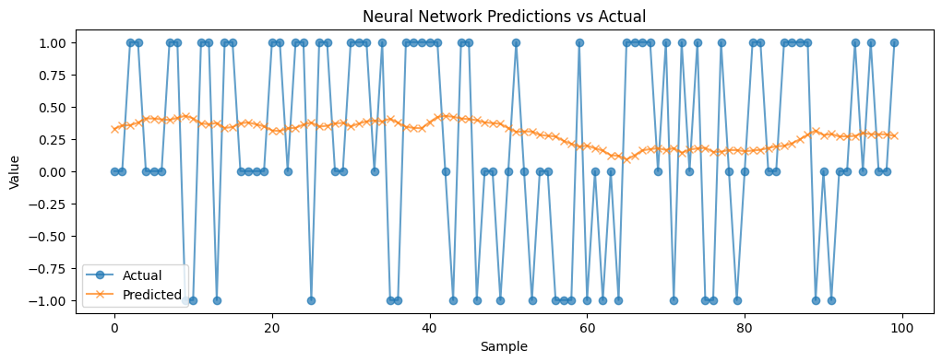
Validation score: 0.903584
Train R² Score: 0.9064
Test R² Score: 0.9023

Determining how user sentiment from social media platforms like StockTwits can help predict stock prices

Associated With
Dr. Mansi Bhavsar

