https://archive.ics.uci.edu/ml/datasets/Epileptic+Seizure+Recognition

EEG is most often used to diagnose epilepsy, which causes abnormalities in EEG readings. [1]

In this report the aim is to build a model to classify EEG readings into

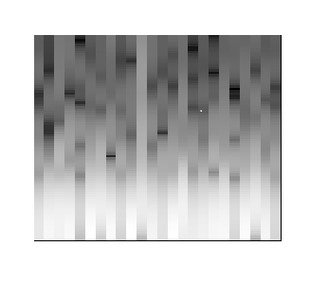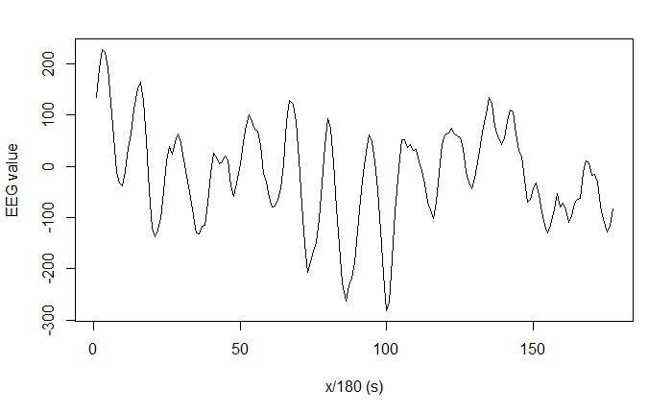Converting signal window to Spectrogram

Entire dataset is beyond c

Unable to use full dataset.



As 11,500 : 9.7gb for image vector.

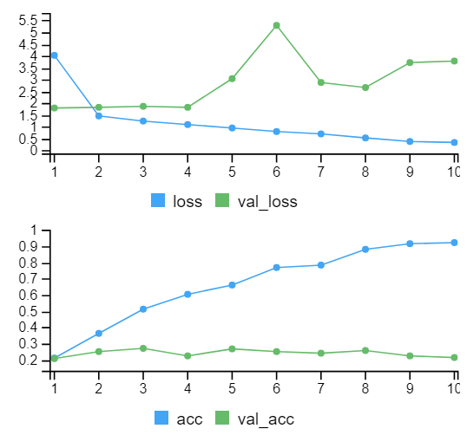250 1.7gb for image vector

Using keras seeding makes it very slow, (disabled GPU, CPU parallelism)

Had to shrink img size to 100x100 to fit

Initial Findings from Inception v3 transfer learning

Test Accuracy: 18.4%

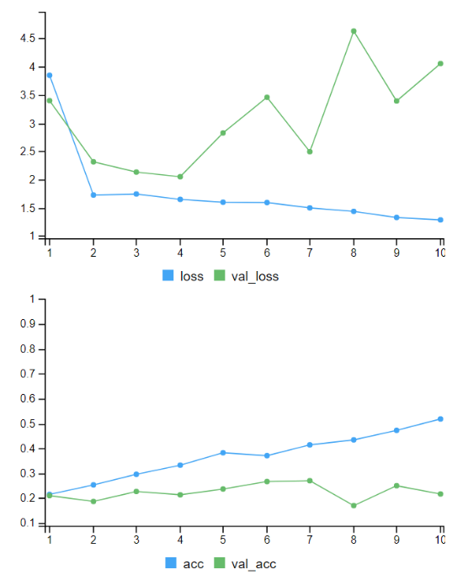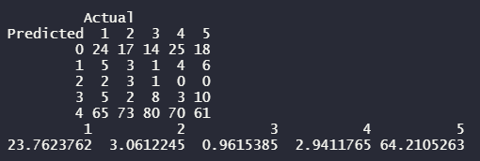

Rmsprop

Pooling instead of flatten

Test Accuracy: 20.4%

Rmsprop

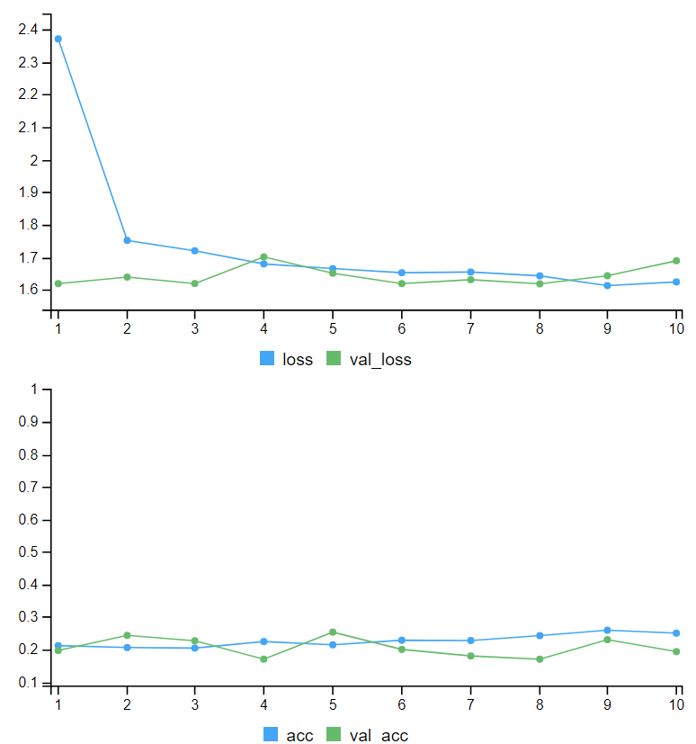3 dropout layers

3 relu layers

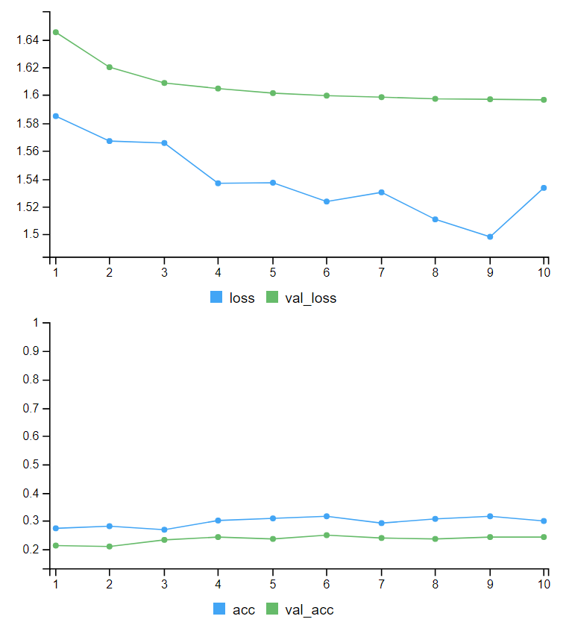Test Accuracy: 21.8%

3 drop out layers

3 relu layers

2 incpetions blocks unfrozen