训练记录：

|  |  |  |  |  |  |  |  |  |
| --- | --- | --- | --- | --- | --- | --- | --- | --- |
| 训练开始时间 | 网络 | 图片数量 | 迭代次数 | 学习率 | 最终AP | 其他 | 占用内存 | 备注  编号/gpu/时间/PID |
| 07.12 | VGG16 | 9k | 140k | 0.001 | 0.874 |  | 7G |  |
| 07.13 | VGG16 | 9k | 200k | 0.001 | 0.872 | 16to4 |  |  |
| 07.14 | VGG16 | 9k | 200k | 0.003 | 0.869 | 16to4 |  | 0711/3/ |
| 07.15 | VGG16 | 9k | 140k | 0.01 | NAN |  |  | 0711/1/ 16:03 |
| 07.15 | VGG16 | 9k | 140k | 0.001 | ZeroDivisionError | 图像翻转 |  | 0711/1/16:36/6042 |
| 07.18 | VGG16 | 100k | 140k | 0.001 | 0.792 |  |  | 2_0720/1/18:50/12906 |
| 07.18 | VGG16 | 109k | 140k | 0.001 | ZeroDivisionError |  |  | 2_0721/3/19:12/20923 |
|  |  |  |  |  |  |  |  |  |
| 07.12 | ZF | 9k | 140k | 0.00001 | 0.721 |  | 2G |  |
| 07.13 | ZF | 9k | 140k | 0.00001 | 0.715 | 16to4 |  |  |
| 07.14 | ZF | 9k | 200k | 0.001 | 0.860 | 16to4 |  |  |
| 07.14 | ZF | 9k | 200k | 0.001 | 0.857 |  |  |  |
| 07.14 | ZF | 9k | 200k | 0.003 | 0.868 |  |  |  |
|  | ZF | 9k | 200k | 0.01 | 未跑 |  |  |  |
|  | ZF | 9k | 200k | 0.03 | 未跑 |  |  |  |
| 07.18 | ZF | 100k | 10k | 0.001 | 0.6384 |  |  |  |
| 07.18 | ZF | 100k | 140k | 0.001 | 0.764 |  |  | 2_0718/2/18:00/6852 |
| 07.18 | ZF | 109k | 140k | 0.001 | ZeroDivisionError |  |  | 2_0719/3/19:22/15875 |
| 07.20 | ZF | 100k | 80k | 0.001 | 等待 | Finetuning  From 9k |  | 2_0718/0/10:20/29640 |
| 07.20 | ZF | 9k | 80k | 0.001 | 等待 | Finetuning  From 100k |  | 0715/0/10:30/31630 |
| 07.20 | ZF | 109k | 140k | 0.001 | ZeroDivisionError | 原始imdb.py |  | 2_0719/0/12:35/10025 |
| 07.20 | ZF | 109k | 140k | 0.001 | 等待 | 原始layer.py |  | 2_0721/0/12:49/13328 |
| 07.20 | ZF | 109k | 140k | 0.001 | 等待 | 均为最初版本 |  | py109k/0/16:47/31541 |
|  |  |  |  |  |  |  |  |  |
|  |  |  |  |  |  |  |  |  |
| 07.14 | VGG_m_1024 | 9k | 200k | 0.001 | 0.859 |  | 2G |  |
| 07.14 | VGG_m_1024 | 9k | 200k | 0.001 | 0.862 | 16to4 |  |  |
|  | VGG_m_1024 | 9k | 200k | 0.01 | 未跑 |  |  |  |
|  | VGG_m_1024 | 9k | 200k | 0.03 | 未跑 |  |  |  |
|  |  |  |  |  |  |  |  |  |

16to4 表示这两个地方做修改。(16 🡪 4)





参考：

If I wana detect small object, which args should I modify? <https://github.com/rbgirshick/py-faster-rcnn/issues/586>

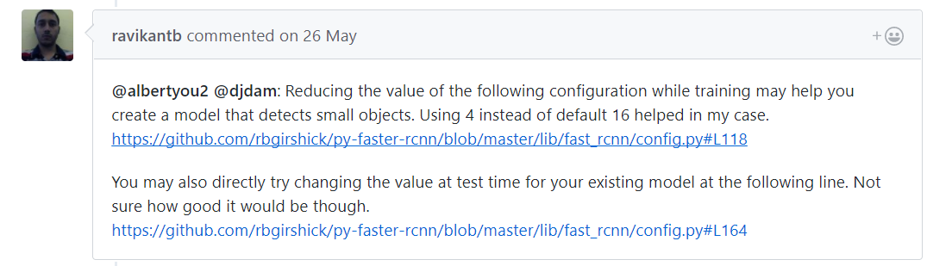

1. $FRCNN/lib/fast_rcnn/config.py RPN_MIN_SIZE 16 or 4
2. $FRCNN/lib/fast_rcnn/config.py 图像翻转
3. $FRCNN /models/pascal_voc/ZF/faster_rcnn_end2end/solve.prototxt learn_rate
4. $FRCNN / experiments/scripts/faster_rcnn_end2end.sh max_iters
5. Rm *.pyc && cache;

最初版本：

Imdb.py 未加边界处理

Config.py 图像翻转打开

Layer.py 未加奇数图片处理代码

Pascal_voc.py 未将原来的“-1”去掉

第二类图像处理（草地为背景）

4段视频 10万图片 其中大约1/3包含人体小目标

正在生成位置信息，进行数据整理。

再加入一判断，判断object的framespan范围，若满足该区间则进入。

object_framespan = object(cnt_object).ATTRIBUTE.framespan;

object_framespan_split = regexp(object_framespan,' ','split');

[object_framespan_split_length, object_framespan_split_length_temp] = size(object_framespan_split);

for cnt_object_framespan_split = 1:1:object_framespan_split_length_temp

object_frame_total = regexp(char(object_framespan_split(cnt_object_framespan_split)),':','split');

object_frame_total_min = str2num(char(object_frame_total(1)));

object_frame_total_max = str2num(char(object_frame_total(2)));

if cnt_frame_total >= object_frame_total_min && cnt_frame_total <= object_frame_total_max