# *ValueError: total size of new array must be unchanged*

Traceback (most recent call last):

File "/usr/lib/python2.7/multiprocessing/process.py", line 258, in _bootstrap

self.run()

File "/usr/lib/python2.7/multiprocessing/process.py", line 114, in run

self._target(*self._args, **self._kwargs)

File "./tools/train_faster_rcnn_alt_opt.py", line 195, in train_fast_rcnn

max_iters=max_iters)

File "/home/tzn/py-faster-rcnn/tools/../lib/fast_rcnn/train.py", line 157, in train_net

pretrained_model=pretrained_model)

File "/home/tzn/py-faster-rcnn/tools/../lib/fast_rcnn/train.py", line 53, in __init__

self.solver.net.layers[0].set_roidb(roidb)

File "/home/tzn/py-faster-rcnn/tools/../lib/roi_data_layer/layer.py", line 68, in set_roidb

self._shuffle_roidb_inds()

File "/home/tzn/py-faster-rcnn/tools/../lib/roi_data_layer/layer.py", line 35, in _shuffle_roidb_inds

inds = np.reshape(inds, (-1, 2))

File "/usr/local/lib/python2.7/dist-packages/numpy/core/fromnumeric.py", line 225, in reshape

return reshape(newshape, order=order)

ValueError: total size of new array must be unchanged

总图片数为奇数

# *ZeroDivisionError: integer division or modulo by zero*

Traceback (most recent call last):

File "/usr/lib/python2.7/multiprocessing/process.py", line 258, in _bootstrap

self.run()

File "/usr/lib/python2.7/multiprocessing/process.py", line 114, in run

self._target(*self._args, **self._kwargs)

File "./tools/train_faster_rcnn_alt_opt.py", line 129, in train_rpn

max_iters=max_iters)

File "/home/tzn/py-faster-rcnn/tools/../lib/fast_rcnn/train.py", line 160, in train_net

model_paths = sw.train_model(max_iters)

File "/home/tzn/py-faster-rcnn/tools/../lib/fast_rcnn/train.py", line 101, in train_model

self.solver.step(1)

File "/home/tzn/py-faster-rcnn/tools/../lib/roi_data_layer/layer.py", line 155, in forward

blobs = self._get_next_minibatch()

File "/home/tzn/py-faster-rcnn/tools/../lib/roi_data_layer/layer.py", line 74, in _get_next_minibatch

return get_minibatch(minibatch_db, self._num_classes)

File "/home/tzn/py-faster-rcnn/tools/../lib/roi_data_layer/minibatch.py", line 22, in get_minibatch

assert(cfg.TRAIN.BATCH_SIZE % num_images == 0), \

ZeroDivisionError: integer division or modulo by zero

Xml文件内部有无效信息

# *IndexError: list index out of range*

Traceback (most recent call last):

File "/usr/lib/python2.7/multiprocessing/process.py", line 258, in _bootstrap

self.run()

File "/usr/lib/python2.7/multiprocessing/process.py", line 114, in run

self._target(*self._args, **self._kwargs)

File "./tools/train_faster_rcnn_alt_opt.py", line 122, in train_rpn

roidb, imdb = get_roidb(imdb_name)

File "./tools/train_faster_rcnn_alt_opt.py", line 67, in get_roidb

roidb = get_training_roidb(imdb)

File "/home/tzn/py-faster-rcnn/tools/../lib/fast_rcnn/train.py", line 122, in get_training_roidb

rdl_roidb.prepare_roidb(imdb)

File "/home/tzn/py-faster-rcnn/tools/../lib/roi_data_layer/roidb.py", line 27, in prepare_roidb

roidb[i]['image'] = imdb.image_path_at(i)

IndexError: list index out of range

未删除之前的缓存文件和output文件夹

# *KeyError: 'max_overlaps'*

Traceback (most recent call last):

File "/usr/lib/python2.7/multiprocessing/process.py", line 258, in _bootstrap

self.run()

File "/usr/lib/python2.7/multiprocessing/process.py", line 114, in run

self._target(*self._args, **self._kwargs)

File "./tools/train_faster_rcnn_alt_opt.py", line 129, in train_rpn

max_iters=max_iters)

File "/home/tzn/py-faster-rcnn/tools/../lib/fast_rcnn/train.py", line 155, in train_net

roidb = filter_roidb(roidb)

File "/home/tzn/py-faster-rcnn/tools/../lib/fast_rcnn/train.py", line 145, in filter_roidb

filtered_roidb = [entry for entry in roidb if is_valid(entry)]

File "/home/tzn/py-faster-rcnn/tools/../lib/fast_rcnn/train.py", line 134, in is_valid

overlaps = entry['max_overlaps']

KeyError: 'max_overlaps'

未删除之前的缓存文件和output文件夹

# *bbox_loss = nan*

I0707 22:07:04.039875 10616 solver.cpp:229] Iteration 700, loss = nan

I0707 22:07:04.039930 10616 solver.cpp:245] Train net output #0: bbox_loss = nan (* 1 = nan loss)

I0707 22:07:04.039937 10616 solver.cpp:245] Train net output #1: cls_loss = 0.108777 (* 1 = 0.108777 loss)

学习率比较高（尝试降低学习率未果）

减小bndbox大小（Height,Width * 3/4）🡪 8k4k8k4k 🡪 可以

# *TypeError: 'numpy.float64' object cannot be interpreted as an index*

Process Process-3:

Traceback (most recent call last):

File "/usr/lib/python2.7/multiprocessing/process.py", line 258, in _bootstrap

self.run()

File "/usr/lib/python2.7/multiprocessing/process.py", line 114, in run

self._target(*self._args, **self._kwargs)

File "./tools/train_faster_rcnn_alt_opt.py", line 195, in train_fast_rcnn

max_iters=max_iters)

File "/home/tzn/Github/py-faster-rcnn/tools/../lib/fast_rcnn/train.py", line 160, in train_net

model_paths = sw.train_model(max_iters)

File "/home/tzn/Github/py-faster-rcnn/tools/../lib/fast_rcnn/train.py", line 101, in train_model

self.solver.step(1)

File "/home/tzn/Github/py-faster-rcnn/tools/../lib/roi_data_layer/layer.py", line 155, in forward

blobs = self._get_next_minibatch()

File "/home/tzn/Github/py-faster-rcnn/tools/../lib/roi_data_layer/layer.py", line 74, in _get_next_minibatch

return get_minibatch(minibatch_db, self._num_classes)

File "/home/tzn/Github/py-faster-rcnn/tools/../lib/roi_data_layer/minibatch.py", line 55, in get_minibatch

num_classes)

File "/home/tzn/Github/py-faster-rcnn/tools/../lib/roi_data_layer/minibatch.py", line 100, in _sample_rois

fg_inds, size=fg_rois_per_this_image, replace=False)

File "mtrand.pyx", line 1176, in mtrand.RandomState.choice (numpy/random/mtrand/mtrand.c:18822)

TypeError: 'numpy.float64' object cannot be interpreted as an index

Numpy版本太高

# *KeyError: 'actions1_000009'*

Evaluating detections

Writing person VOC results file

VOC07 metric? Yes

Traceback (most recent call last):

File "./tools/test_net.py", line 90, in <module>

test_net(net, imdb, max_per_image=args.max_per_image, vis=args.vis)

File "/home/tzn/Github/py-faster-rcnn/tools/../lib/fast_rcnn/test.py", line 295, in test_net

imdb.evaluate_detections(all_boxes, output_dir)

File "/home/tzn/Github/py-faster-rcnn/tools/../lib/datasets/pascal_voc.py", line 322, in evaluate_detections

self._do_python_eval(output_dir)

File "/home/tzn/Github/py-faster-rcnn/tools/../lib/datasets/pascal_voc.py", line 285, in _do_python_eval

use_07_metric=use_07_metric)

File "/home/tzn/Github/py-faster-rcnn/tools/../lib/datasets/voc_eval.py", line 126, in voc_eval

R = [obj for obj in recs[imagename] if obj['name'] == classname]

KeyError: 'actions1_000009'

解决方法: 删除data/VOCdekit2007下的annotations_cache文件夹

迭代次数较少时（actions1 的 512张图片）

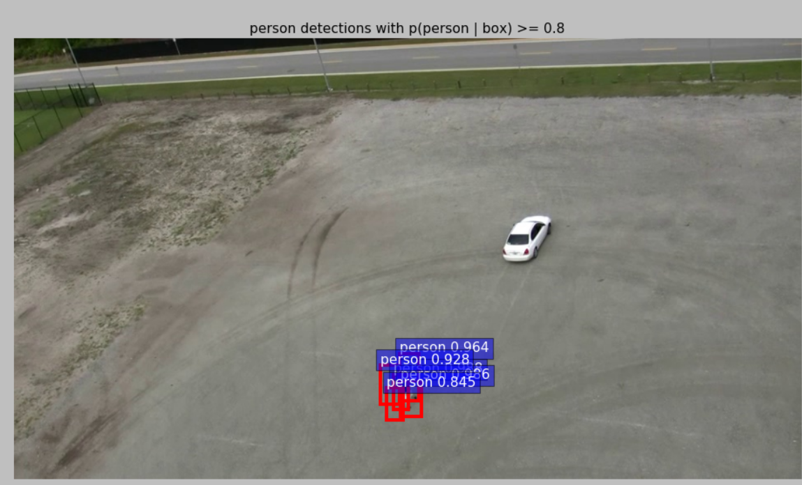

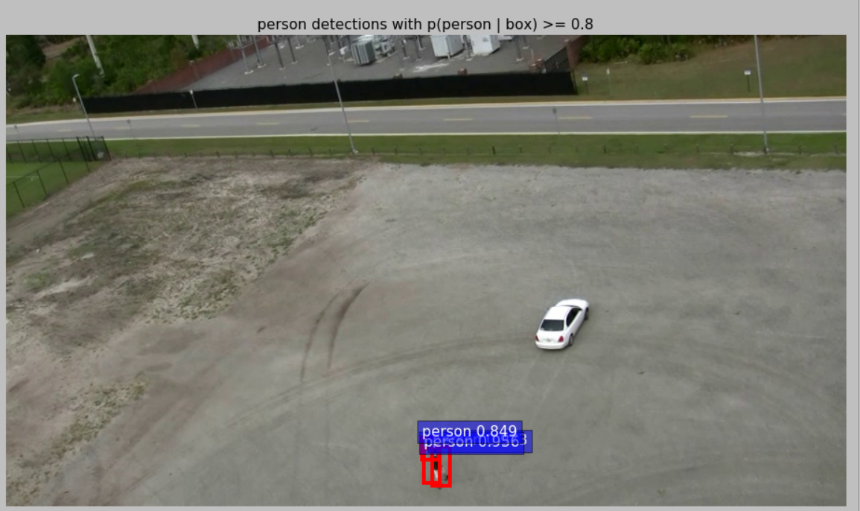

迭代次数加大后

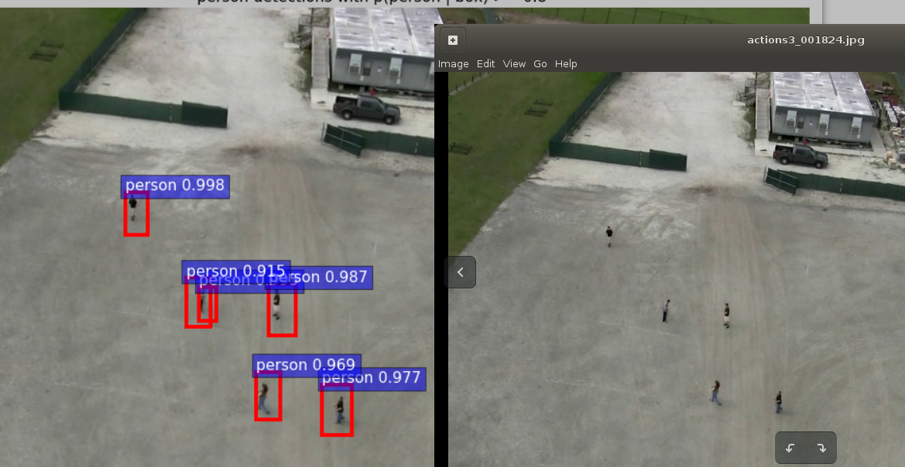

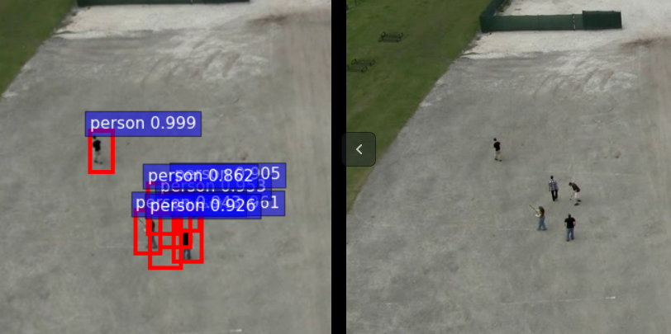

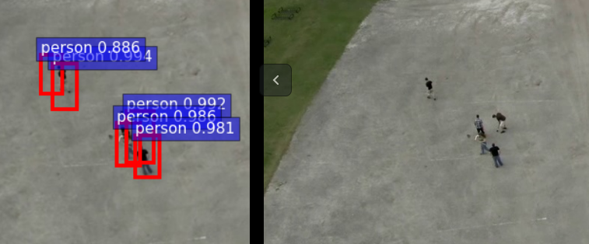

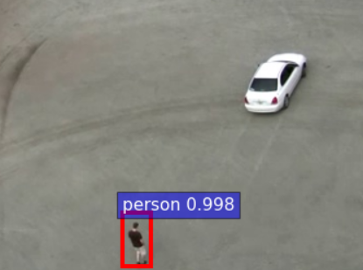

# *RuntimeWarning: invalid value encountered in greater_equal*

I0715 16:03:06.364894 2342 sgd_solver.cpp:106] Iteration 0, lr = 0.01

/home1/tzn/01_FasterRCNN/py-faster-rcnn_20170711/tools/../lib/fast_rcnn/bbox_transform.py:48: RuntimeWarning: overflow encountered in exp

pred_w = np.exp(dw) * widths[:, np.newaxis]

/home1/tzn/01_FasterRCNN/py-faster-rcnn_20170711/tools/../lib/fast_rcnn/bbox_transform.py:48: RuntimeWarning: overflow encountered in multiply

pred_w = np.exp(dw) * widths[:, np.newaxis]

/home1/tzn/01_FasterRCNN/py-faster-rcnn_20170711/tools/../lib/fast_rcnn/bbox_transform.py:49: RuntimeWarning: overflow encountered in exp

pred_h = np.exp(dh) * heights[:, np.newaxis]

/home1/tzn/01_FasterRCNN/py-faster-rcnn_20170711/tools/../lib/fast_rcnn/bbox_transform.py:49: RuntimeWarning: overflow encountered in multiply

pred_h = np.exp(dh) * heights[:, np.newaxis]

/home1/tzn/01_FasterRCNN/py-faster-rcnn_20170711/tools/../lib/rpn/proposal_layer.py:175:

RuntimeWarning: invalid value encountered in greater_equal

keep = np.where((ws >= min_size) & (hs >= min_size))[0]

解决方法: 降低学习率

***Check failed: error == cudaSuccess (77 vs. 0)***

F0718 17:57:00.090955 3050 math_functions.cu:79] Check failed: error == cudaSuccess (77 vs. 0) an illegal memory access was encountered

*** Check failure stack trace: ***

./experiments/scripts/faster_rcnn_end2end.sh: line 57: 3050 Aborted (core dumped) ./tools/train_net.py --gpu ${GPU_ID} --solver models/${PT_DIR}/${NET}/faster_rcnn_end2end/solver.prototxt --weights data/imagenet_models/${NET}.v2.caffemodel --imdb ${TRAIN_IMDB} --iters ${ITERS} --cfg experiments/cfgs/faster_rcnn_end2end.yml ${EXTRA_ARGS}

解决办法：检查内存使用情况。