**Memorandum**

“不论是在投资收益很好还是很坏的时候，你都应该始终坚持一种正确的投资策略，只有这样才能使长期投资回报最大化。”正如彼得·林奇所说，构建良好的量化投资策略是投资波动性资产取得长期收益的重要方式之一。本文主要阐述基于LSTM- GA模型的货币量化投资策略模型的构建过程，以及利用模型来进行5年的比特币与黄金资产模拟投资，最后得出较为可观的收益，给投资者提出合理的建议。

“Investing without research is like playing stud poker and never looking at the cards.”, As Peter Lynch said, building a good quantitative trading strategy is one of the important ways to invest in volatile assets for long-term returns. This paper mainly expounds the construction process of the quantitative trading strategy model based on the LSTM-GA model, and uses the model to conduct a 5-year simulated investment in Bitcoin and gold assets, and finally obtains a relatively considerable income, and puts forward reasonable suggestions to investors.

首先叙述模型的基本原理，我们分两步来构建模型。第一步，构建比特币与黄金价值预测模型。通过比较传统方法如GM以及ARIMA算法的预测效果与以长短期记忆模型（LSTM）为代表的深度学习模型的预测效果，得到LSTM模型预测结果在预测集上均方误差最小，即其拟合效果最好，其部分拟合结果如下图所示：

First of all, the basic principles of the model are described, and we build the model in two steps. The first step is to build a Bitcoin and gold value prediction model. By comparing the prediction effect of traditional methods such as GM and ARIMA algorithms with the prediction effect of the deep learning model represented by the long short-term memory model (LSTM), it is obtained that the prediction result of the LSTM model has the smallest mean square error on the prediction set and has the best fit. Some of the fitting results are shown in the following figure:

第二步，进行单日决策模型构建。首先，以包括均线移动策略在内的方向性趋势策略为主，结合波动率特征的策略思想，创造性地提出“闸门“思想，阐述策略的交易思路；其次，从数据获取及交易信号构建、交易信号权值求解、波动率指标构建等方面构建策略框架；最后通过对交易”闸门“开关的智能化控制，实现交易策略的每日更新。

The second step is to build a single-day decision model. Firstly, focusing on directional trend strategies including moving average strategies, combined with the strategy ideas of volatility characteristics, creatively put forward the idea of "gate", and expounded the trading ideas of the strategy; secondly, from data acquisition and trading signal construction, trading signal weight solution, volatility indicator construction, etc. Finally, through the intelligent control of the transaction "gate" switch, the daily update of the trading strategy is realized.

对于交易信号的构建，综合考虑比特币与黄金当天价格，第二天预测价格，涨跌天数，市场波动等因素，并定义哑变量进行量化。利用遗传算法求解各交易信号权值，综合得出交易意愿值。同时定义一个智能化“闸门“，其作用为控制交易次数，实现收益最大化。若交易意愿低于一定值，则本回合不进行交易；若交易意愿极高达到门限值，则买入尽可能多的货币。若交易意愿处于其中，则按照一定比率购买货币。同时，交易佣金越高，则降低开闸频率。

For the construction of trading signals, factors such as the price of Bitcoin and gold on the day, the predicted price of the next day, the number of days of ups and downs, and market fluctuations are comprehensively considered, and dummy variables are defined for quantification. The genetic algorithm is used to solve the weights of each trading signal, and the trading willingness value is obtained comprehensively. At the same time, an intelligent "gate" is defined, whose function is to control the number of transactions and maximize revenue. If the willingness to trade is lower than a certain value, the round will not be traded; if the willingness to trade is extremely high and reaches the threshold, buy as much currency as possible. If the willingness to trade is between the two, the currency is purchased according to a certain ratio. At the same time, the higher the transaction commission, the lower the frequency of gate opening.

最后，我们搭建了如下智能投资交易平台：

Finally, we built the following intelligent investment trading platform:

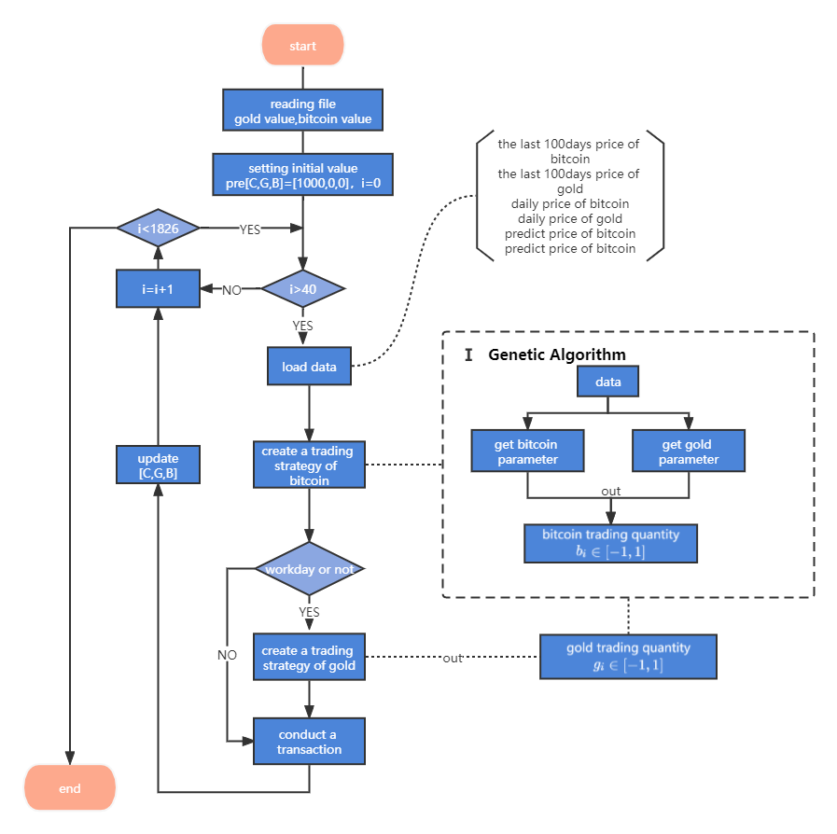

用户只需输入比特币与黄金过去一段时间的价格，初始资产持有量，以及风险偏好类型，平台就可进行自动投资。平台每一天都根据其前100天比特币与黄金的价格、持有量以及之后的预测价格给出是否买卖比特币或黄金以及买卖的量，最终获得较为理想的长期收益。

Users only need to enter the price of bitcoin and gold in the past period, the initial asset holdings, and the type of risk appetite, and the platform can automatically invest. Every day, the platform gives whether to buy or sell Bitcoin or gold and the amount of buying and selling according to the price of Bitcoin and gold in the first 100 days, the holding amount and the predicted price after that, and finally obtain a relatively ideal long-term income.

在量化投资策略模型的构建过程中，我们专注微观调整，对许多细节做出了精确的控制。如每日定投1%，来保持投资的稳健性；设置flag函数，来确保投资者新入场与抛空货币后，新的可买点来临时，及时将大量本金投入市场，赚取更大收益；利用遗传算法求解交易信号的权值，进而量化交易意愿；创新性提出“闸门“思想，智能化控制开放时机，交易意愿持高时必不放闸，交易意愿较低时及时关闸，同时利用其控制交易次数，来减少佣金造成的成本损失。同时结合灰色预测模型，深度学习模型进行宏观调控，确保得到最优收益。本策略模型相比普通激进型或稳健型投资，年化收益最高可达原投资组合的5倍左右。

During the construction of the quantitative trading strategy model, we focus on micro-adjustments and have precise control over many details. For example, set a daily investment of 1% to maintain the stability of the investment; set the flag function to ensure that after investors enter the market and short-sell the currency, when a new buying point arrives, a large amount of principal will be put into the market in time to earn more Profits; use genetic algorithm to solve the weight of trading signals, and then quantify the willingness to trade; innovatively propose the idea of "gate", intelligently control the opening timing, the gate will not be released when the willingness to trade is high, and the gate will be closed in time when the willingness to trade is low, At the same time, it uses it to control the number of transactions to reduce the cost loss caused by commissions. Combined with the gray prediction model, the deep learning model conducts macro-control to ensure optimal returns. Compared with ordinary aggressive or prudent investments, this strategy model can achieve a maximum annualized return of about 5 times that of the original investment portfolio.