CMPUT 291 – MINI PROJECT 2

Group Members:
Kalvin Eng and Steven Chang

Lab Session: D06

Did not collaborate with anyone
USER GUIDE
Phase 1 - Parsing data
1. Open a terminal to the directory where all the files for the program are stored including a text file of your data
2. Enter "cat your_file.txt | python3 data_parser.py" into the terminal where “your_file.txt” is the name of your data text file you want to search through

Phase 2 - Building index files
1. In the terminal while in the same directory, enter “source dbload.sh”

Phase 3 - Searching through the data
1. In the terminal while in the same directory, enter “python3 search.py” to start the program
2. Input query when prompted and press enter to search for your criteria
3. Enter another query or press enter to quit program

Possible Query Specifications For Narrower Searching:
Query Example | Description
term(s) | Search for term(s) in product titles, review summaries, or review texts
r:term | Search for term in review summaries or review texts only
p:term | Search for term in product titles only
term% | Search for partial matching strings that begin with term in all product titles, review summaries, or review texts
rscore > number | Search for all reviews that have a review score greater than the number.  Can search for less than by using '<' instead.
Term rscore > number | Search for all reviews that have term in product titles, review summaries, or review texts, AND also have a rscore greater than number
rdate > date pprice < bigger_number pprice > smaller_number term | Search for term in product titles, review summaries, or review texts that have a review date greater than date (format is YYYY/MM/DD), and the price of the product being reviewed is within the range of smaller_number and bigger_number
r:term rdate < date | Search for term in review summaries or review texts that also have a review date less than date (format is YYYY/MM/DD)
p:term pprice> smaller_number pprice < bigger_number | Search for all reviews that have term in product titles, and the product being reviewed has a price in the range smaller_number and bigger_number
Range Searches | Range searches possible for pprice, rdate, and rscore.

Description of Queries
For a simple explanation: Given the user input the program will first create a list of all the possible IDs that are valid based off the term searches first (I.e r:term, term, term%).
After a list of all possible review IDs are made, it is then passed into the “filtering” process where valid review IDs from the first part are checked against off the user's number searches (I.e rscore, pprice, rdate) if any. The review IDs that result from this process are the valid IDs based off the user's input.

For a more detailed explanation: the query to evaluate term searches checks each entered term and sets the a cursor to the beginning of the first index where it appears by using set_range flag. If it is a matching term search it will store the valid ID and move the cursor to the next item. Because the indexes of pterms and rterms are b+ trees, the cursor only moves until the term being checked from the index file doesn't match the given term. Because of this partial matching searching is also supported as all the terms are stored in order and once the index term doesn't start with the given term then all possible review IDs have been found.
In summary, a cursor is moved to the index where the term matches and will move to the next index and store the IDs until the index term does not match the given term – then it will move to the next given term if there are any left and repeat the searching process. The output from this query are valid IDs stored in a set termResults.
With a list of possible review IDs they will be checked against range searches in the order of rscore, rdate, and then pprice if they were specified by the user.
Because rscore is stored as a b+ tree in rs.idx, a cursor is moved to the first index that has the score specified by the user. Then it saves all the IDs that have a score greater, or less than, or both if the user wanted range search between two numbers. The output of this query is a set scoreResults. The two sets termResults and scoreResults are intersected, and results stored into scoreResults.
The IDs in scoreResults are now “filtered” through ranges specified by rdate and pprice if given.
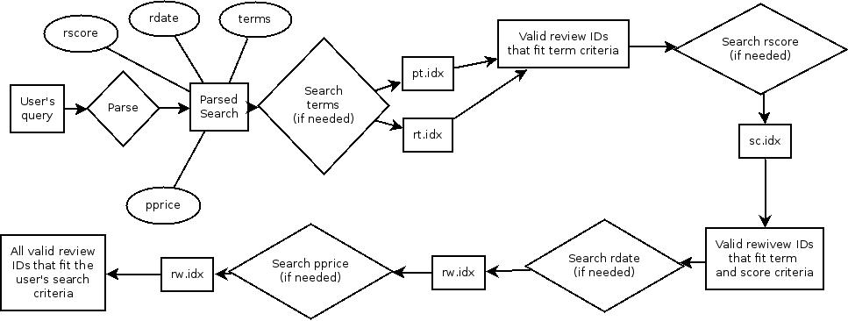
Because rdate and pprice are only found in rw.idx and that is sorted by hash index employing the techniques used in term searching and rscore is not efficient. To avoid unnecessary searches, a cursor moves to each review ID in scoreResults, gets the review from the rw.idx file and extracts the date. This is different than how searching was done previously in the term section as it only checks the potential valid IDs from scoreResults at this point instead of getting all the valid IDs from the database of reviews – thus minimizing searching. This is also done for pprice searching. Now. if the date of the review is valid given the rdate criteria given by the user the ID is stored into a dateResults set. Then the previous scoreResults and dateResults sets are intersected, and results stored into dateResults. The same process is done with the IDs in dateResults checking any given pprice criteria by the user; the results are stored in the priceResults set. Finally, dateResults is intersected with priceResults and results stored in finalResults. FinalResults contains all the review IDs that are valid based off the user's entered criteria. Here is a flowchart describing the processes and how IDs are initially gathered and gradually “filtered” out for the final set of valid IDs.
Testing Strategy
1a. Using the smallest data set available:
1b. Testing term searching first (term, term%, r:term, p:term ) by using a simple 1 condition query until IDs returned matches the IDs we got manually by looking through the text files.
1c. Testing range searching by adding a range condition to the query previously until IDs returned matches the IDs we got manually by looking through the text files.
1d. Testing more complicated query that has more than 1 term and range conditions at once until IDs returned matches the IDs we got manually by looking through the text files.
2. Load a larger data set (1k), repeat the tests above.
3. Testing all the example queries from the spec page and comparing total number (and IDs if manageable) of results with the total number of results reported by other groups on the forums.

Group Work Breakdown
Kalvin Eng:
- Phase 1 (including testing) ~5 hours
- Phase 2 (including testing) ~5 hours
- Testing phase 3 ~ 1 hours
Steven Chang:
- Phase 3 (including testing) ~ 10 hours
- Documentation/report ~ 2 hours

Methods of commutation:
- GitHub to host code
- Peer to Peer communication and when testing

ASSUMPTIONS
- every query has at least one condition on an indexed column
- when a price is unknown, it is listed with a string “unknown” in the price section of the review

