Low Level Design Template

DMT/AD06/TMP

Project Code
Project Name

Prepared/Modified by | Role | Date of Preparation
Reviewed by | Role | Date of Review
Approved by | Role | Date of Approval
Circulation List |  | Version Number of the template:1.0
Version Number | <version No >

Table of Contents

1. Description Of The Unit 3
2. References 4
3. Dependencies / Assumptions 5
4. Class Diagrams 6
5. Sequence Diagrams 7
6. Design Components 8
6.1 List Of UI Components 8
6.2 List Of Design Classes 8
7. Re-Usable Routines/Components 9
8. Messages 10
9. Configuration Files 11
10. Crud Matrix Table 12
11. Data Mapping Matrix 13
12. Action Flow Matrix 14
13. Stored Procedures 15
14. Program Specification / Pseudo Code 16
REVISION HISTORY OF THE WORK PRODUCT 17

Description Of The Unit
- After user placed order, the search operation should be performed by the Admin.
- Searching should be based on order id, item name and purchase date.
- The data should be stored/retrieved using an xml file.
- After parsing the xml file, the data should be stored in the database.
- The Admin should be able to update the order details.

Software Requirements
- Java 1.8
- Mongo DB
- Spring Boot
- Angular6

References

- https://www.javatpoint.com/jaxb-tutorial

- https://examples.javacodegeeks.com/core-java/xml/parsers/documentbuilderfactory/modify-xml-file-in-java-using-dom-parser-example/

- https://stackoverflow.com/questions/16610607/store-xml-data-in-a-mongodb-collection

Dependencies / Assumptions
<describe dependencies and assumptions that are relevant to coding of the unit. Mention the dependencies and assumptions related to FDA regulatory requirements >

Class Diagrams

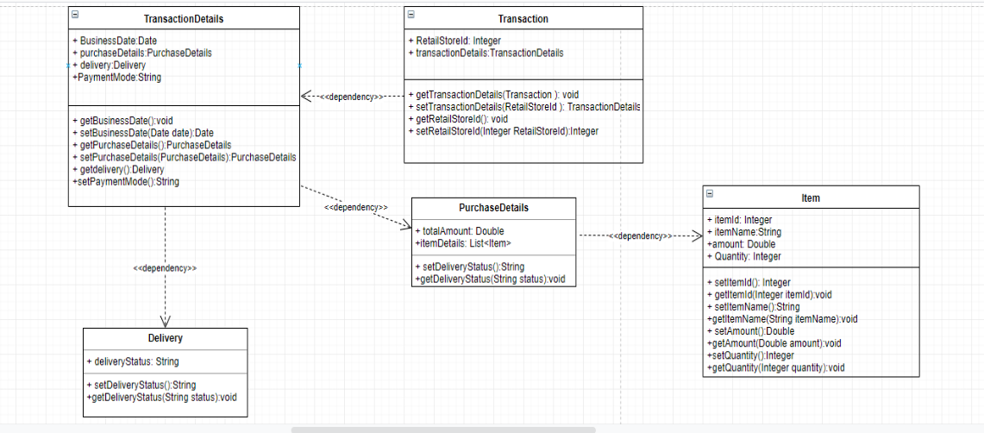

Sequence Diagrams

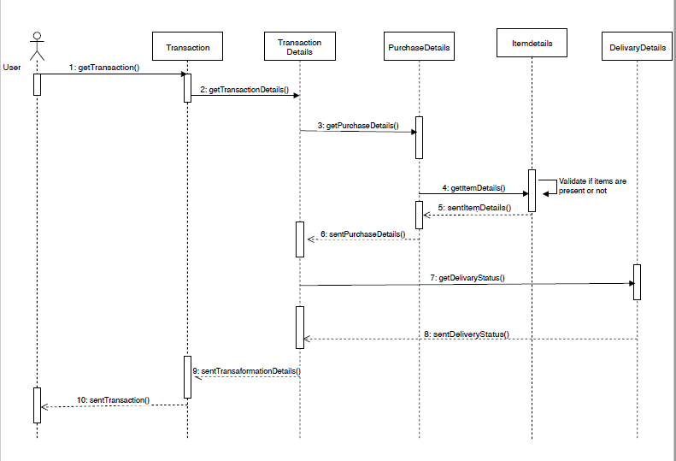
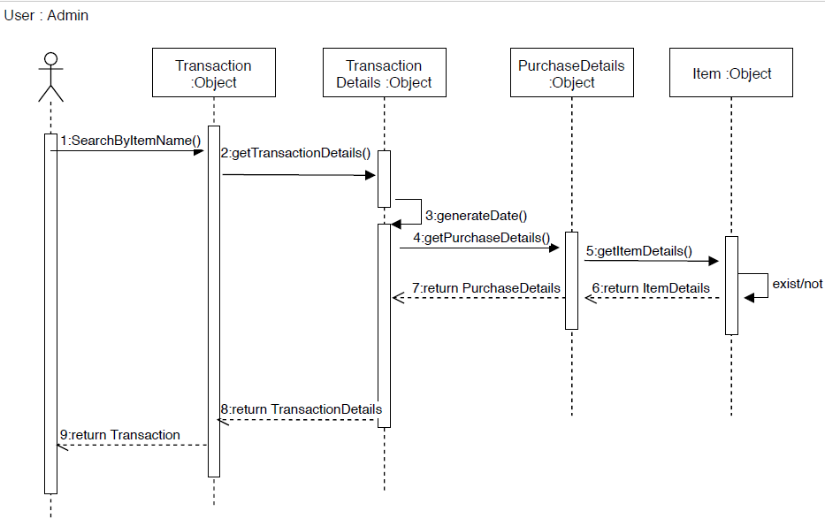

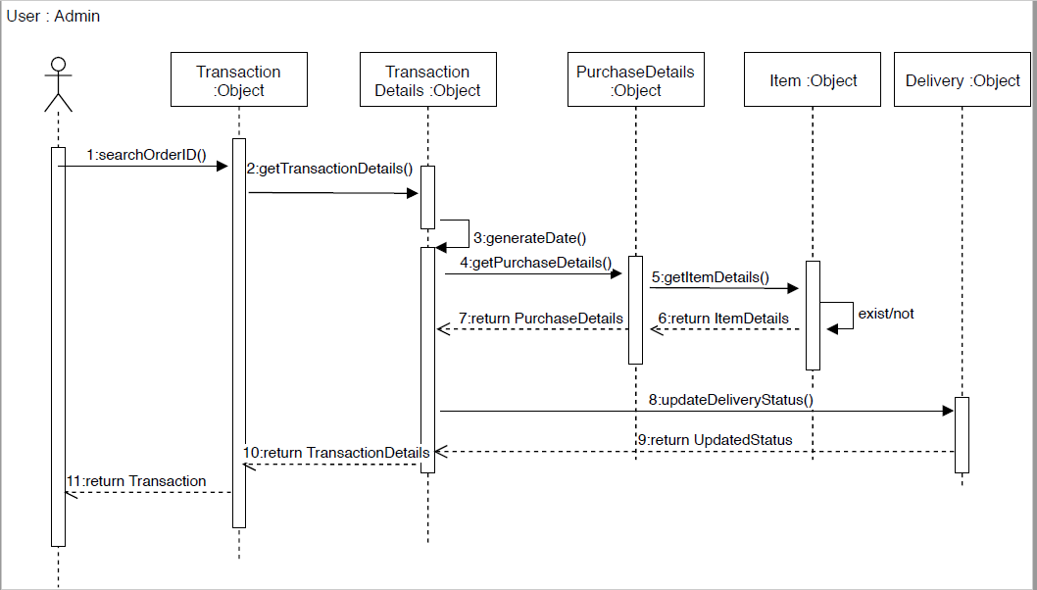

Design Components

List Of UI Components

1.Search Component

a.Search by orderId
b.Search by itemname

List Of Design Classes

1.Transaction
2.Transaction details
3.Purchase Details
4.Item
5.Delivery
6.Validate xml

Re-Usable Routines/Components
<provide references to the re-usable routines, copybooks and templates used by the unit>

Messages
<describe what are relevant messages which has to be displayed in this program unit>

#. | Type | Message Text
1. | <Warning/Information/Validation/Error>

Configuration Files
<< Provide complete list of configuration files that will be required during deployment of the application. This list will comprise of all the XML files, resource files packaged within application deployment>>

File Name | Path | Description

Crud Matrix Table

# | Table Name | Create | Read | Update | Delete

Data Mapping Matrix
<identify data-mapping matrix pertinent to screen or report data items. Provide details of the base table or column, screen item name, length, calculations and validations.>

Action Flow Matrix
<identify the action flow matrix detailing all actions and triggers associated with the unit. Provide details of processing and the enabled conditions>

Stored Procedures
<describe what are Stored Procedures Pertaining to this program unit >

# | Stored Procedure Name  (with Description) | Input/Out Parameters | Type | Size
1.

Program Specification / Pseudo Code
<specify processing details of the unit >

REVISION HISTORY OF THE WORK PRODUCT
<to be maintained by projects>

# | Date | Version # | Section Changed | Details of changes made | Approved By
1
2

