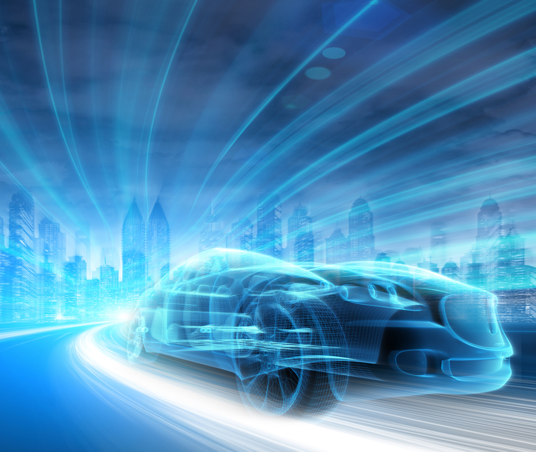

|  |
| --- |
| Dynamic Design |
|  |
| February 9  Automotive Door Control System Design  Khaled Ibrahim Abdulaziz |

# 1.ECU1

## **1.1 State Machine for Components**

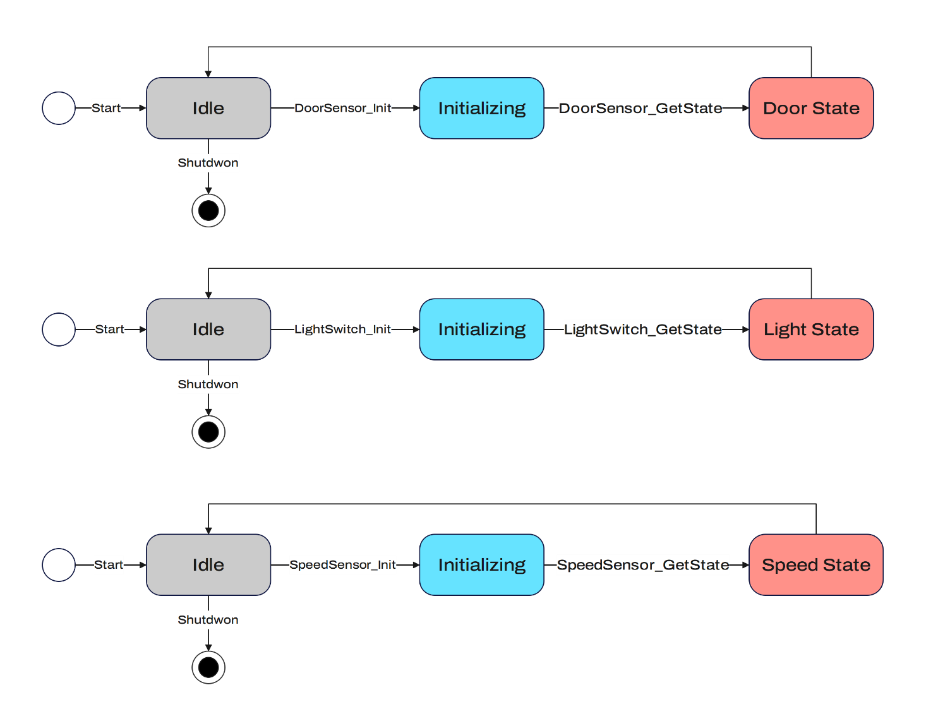

## **1.2 State Machine for Operation**

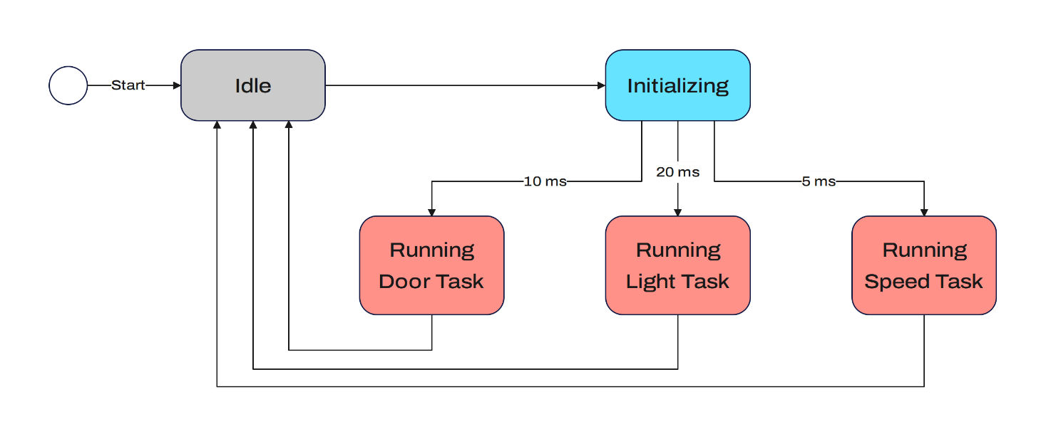

## **1.3 Sequence Diagram**

­­­­­­­­­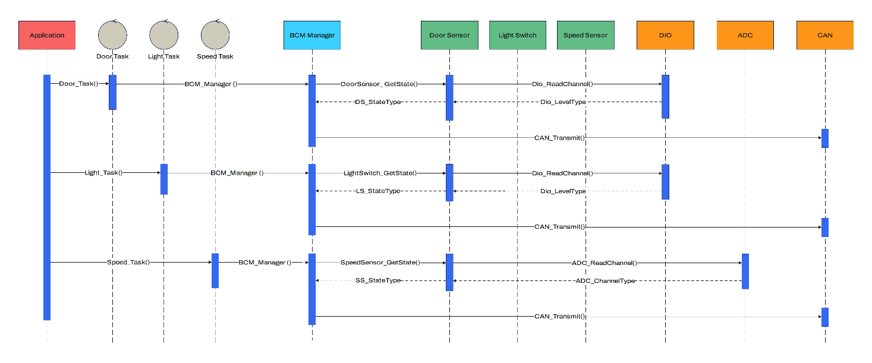

## **1.4 CPU Load**

*Assume that execution time of each time = 1 ms*

|  |  |  |  |
| --- | --- | --- | --- |
| **Task Name** | **Periodicity (ms)** | **Execution Time (ms)** | **Occurrence** |
| **Door Task** | 10 | 1 | 2 |
| **Light Task** | 20 | 1 | 1 |
| **Speed Task** | 5 | 1 | 4 |

Hyper period (H) = LCM = 20 ms

CPU Load = Sum(E) / H = (1 x 2 + 1 x 1 + 1 x 4) / 20 = 0.35

# 2.ECU2

## **2.1 State Machine for Components**

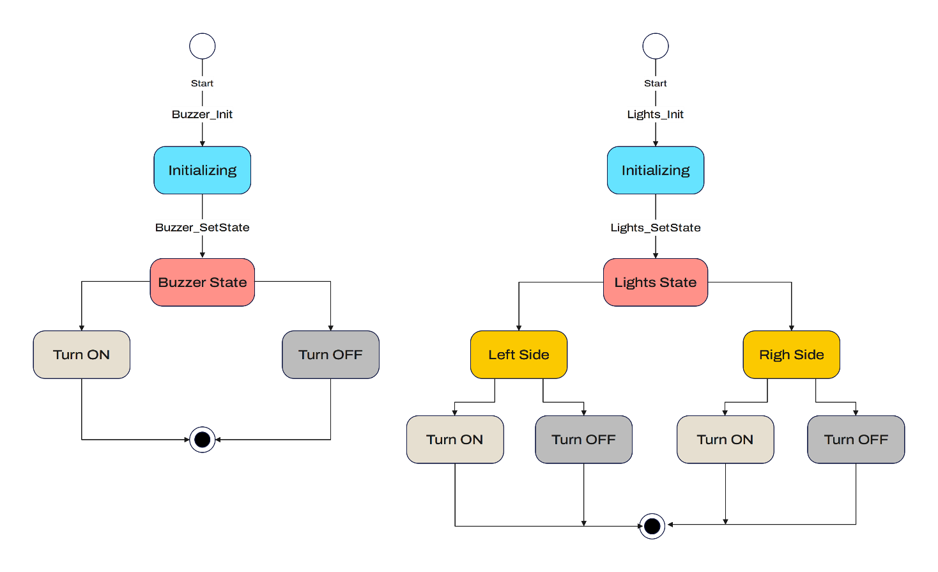2.2 State Machine for Operation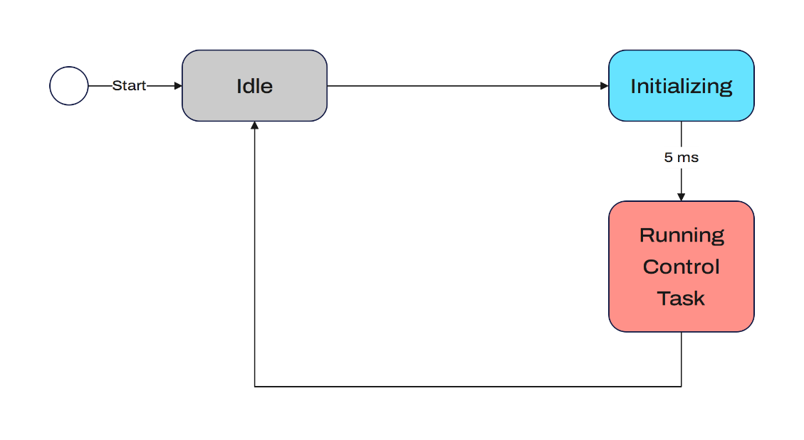

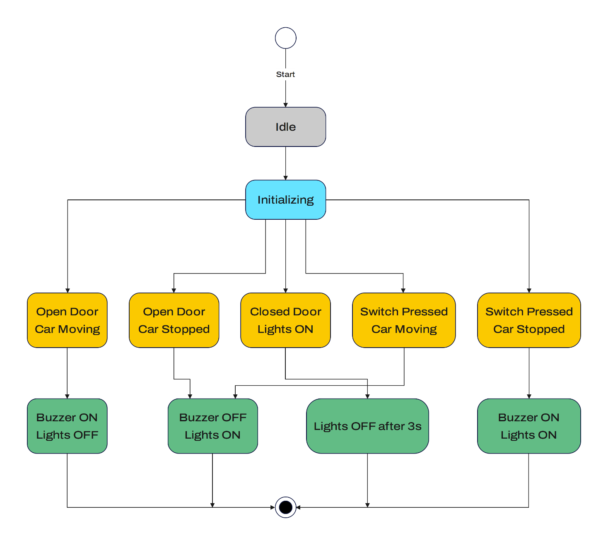

## **2.3 Sequence Diagram**

­­­­­­­­­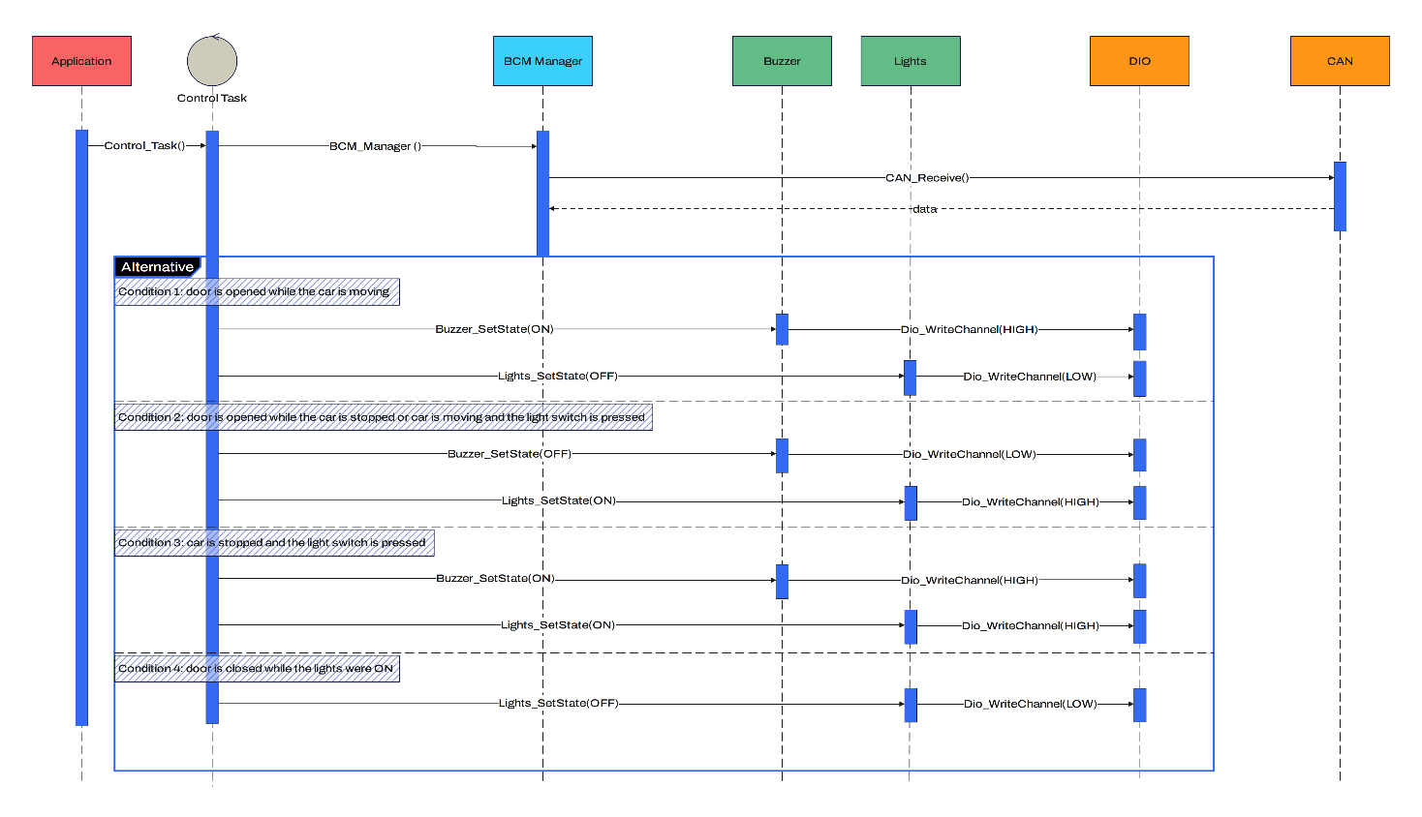

## **2.4 CPU Load**

*Assume that execution time of each time = 1 ms*

|  |  |  |  |
| --- | --- | --- | --- |
| **Task Name** | **Periodicity (ms)** | **Execution Time (ms)** | **Occurrence** |
| **Control Task** | 5 | 1 | 1 |

Hyper period (H) = LCM = 5 ms

CPU Load = Sum(E) / H = (1 x 1) / 5 = 0.2

# 3. BUS Load

*CAN frame has about 125 bits, assuming we're using 500 kbit/s.*

Time to transfer 1 bit Time = 1/bitrate = (1/500*1000) = 2 µs

Time to transfer 1 frame = 2 * 125 = 250 µs

1 frame / 20 ms -> 50 frames every 1000 ms, 1 frame / 10 ms -> 100 frames every 1000 ms, 1 frame / 5 ms -> 200 frames every 1000 ms

Total of frames per 1 second = 350 frames

Total time on Bus = total frames * time for frame = 350 * 0.25 = 87.5 ms

Bus Load = (87.5 / 1000) * 100= 8.75%