Palawan State University

Tiniguiban Heights, Puerto Princesa

BRGY. SAN MANUEL CALAMITY RESCUE SYSTEM

Karylle S. Aquino

BS-Information Technology B3

Gantt Chart

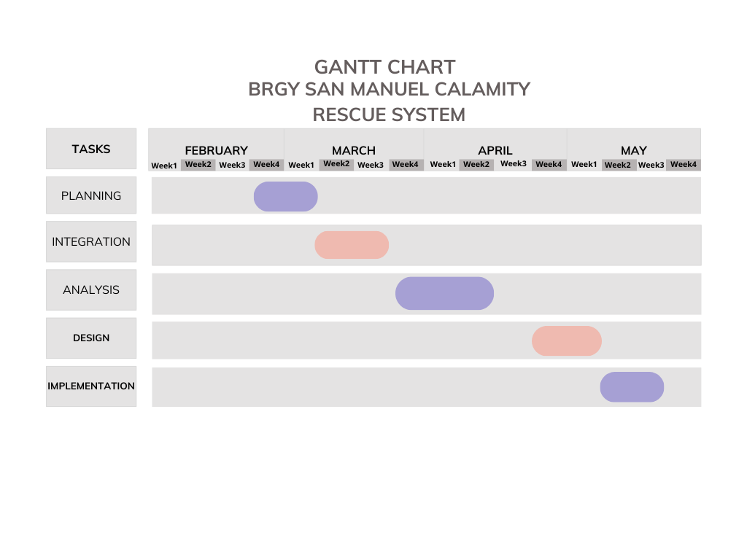

Fishbone Diagram

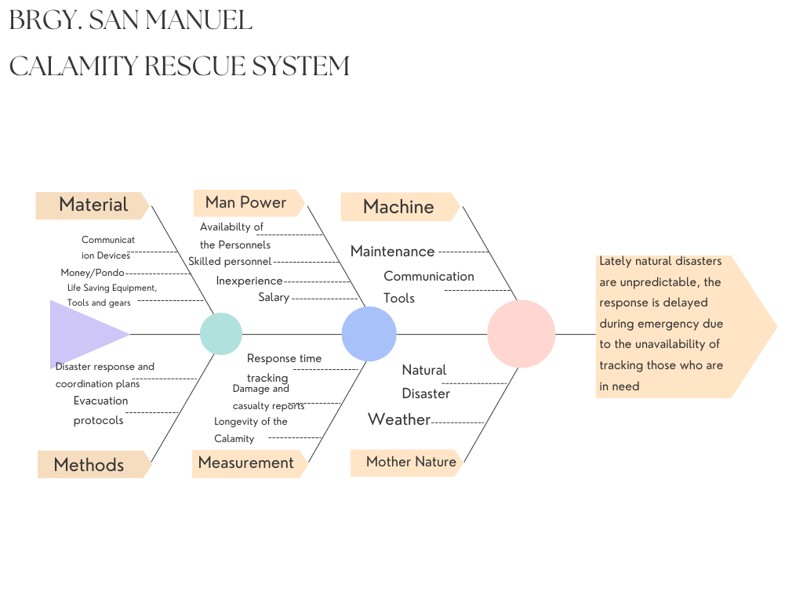

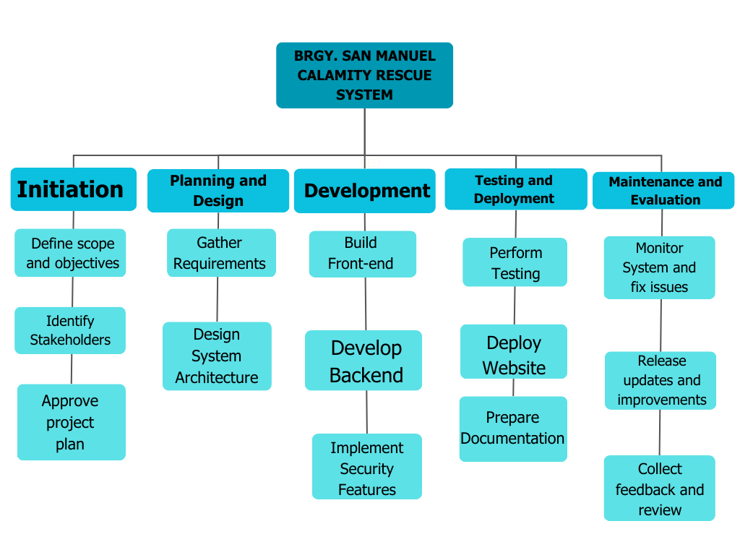Work Breakdown Structure

Cost Benefit Analysis

Costs

|  |  |
| --- | --- |
|  | Estimated Cost |
| Making the System | 100,000 |
| Rescue Tools | 90,000 |
| Training Volunteers | 30,000 |
| Maintenance | 20,000 |
| Internet Service | 10,000 |

Total Starting Cost: ₱250,000  
Yearly Cost After: ₱30,000

Benefits

|  |  |  |
| --- | --- | --- |
|  | Estimated Benefits | Why its needed |
| Less Damage to Properties | 200,000 | Early warning or faster response can protect homes |
| Fewer Emergency Payouts | 75,000 | Reduces Financial Burden in LGUs |
| Easier to Organize rescue | 50,000 | Organized rescue makes the work better |
| Save Lives | Priceless | Faster response saves people |

Total Benefits per Year: Around ₱325,000+

Comparing Cost and Benefits

Cost to start: ₱250,000

Money spent each year: ₱30,000

Money and value saved each year: ₱325,000+

Gantt Chart

Data Flow Diagram

