
TECHNICAL DESIGN REPORT
Design and Development of Chain Drive System
for Formula Student Electric Vehicle
with Weight Optimization of the Driven Sprocket using Topology Optimization
Prepared by | K Aravindhan
Team | IITG Racing – Formula Bharat
Sub-system | Powertrain – Tractive

Table of Contents
Table of Contents 2
1. Introduction 3
2. Powertrain Design Requirements and Vehicle Parameters 3
2.1 Design Goals 3
2.2 Vehicle Parameters 3
3. Track Analysis and Energy Requirement Estimation 4
3.1 Endurance Track Details 4
3.2 Energy Requirement Estimation 5
4. Gear Ratio Selection – Lap Time Simulation 5
5. Chain Drive System Design 6
5.1 Component Overview 6
5.2 Driver and Driven Sprocket Specification 6
6. Driven Sprocket – Material Selection and Topology Optimization 7
6.1 Material Selection 7
6.2 Topology Optimization Methodology 7
7. Finite Element Analysis and Structural Validation 8
7.1 Static Structural Analysis Setup 8
7.2 Static Structural Results 8
7.3 Optimization Convergence 8
7.4 Weight Reduction Results 9
8. Final Design Summary 11
9. Conclusion 11

(In Word, right-click the table above and choose "Update Field" to populate page numbers if it appears empty.)

1. Introduction
Formula Bharat is India's flagship Formula Student-style design competition, in which student teams design, build, and race a single-seater electric or combustion race car against a common technical rulebook. As part of the IITG Racing team's electric vehicle program, the powertrain sub-system is responsible for delivering motor torque to the rear wheels in a manner that satisfies the vehicle's acceleration and top-speed targets while remaining as light and reliable as possible.
This report documents the design and development of the chain drive system used to transmit power from the motor to the rear axle, covering the selection of the final drive (gear) ratio, the sizing of the driver and driven sprockets, and the choice of chain. Particular emphasis is placed on the driven sprocket, the heaviest rotating component in the drivetrain, whose mass was reduced through finite element analysis (FEA) based topology optimization. The methodology, simulation setup, and results of this weight-reduction exercise are presented in detail, along with the final optimized geometry.
The chain drive design process followed in this report proceeds through the following stages:
- Definition of vehicle parameters and performance targets
- Track-based energy requirement estimation
- Lap-time simulation based final drive ratio selection
- Sizing of the driver and driven sprockets and chain selection
- Material selection and topology optimization of the driven sprocket
- Finite element validation of the optimized design

2. Powertrain Design Requirements and Vehicle Parameters

2.1 Design Goals
The chain drive and overall powertrain were designed to meet the following vehicle-level performance targets:
- Acceleration: 0 to 100 km/h in 3–5 seconds
- Maximum speed: 110–125 km/h
These targets, combined with the longitudinal load equation below, were used to size the motor, the final drive ratio, and consequently the chain drive components.
Force on car = m·a + ½·Cd·ρ·A·v² + Cr·W·cosθ + W·sinθ

2.2 Vehicle Parameters
The principal vehicle parameters used in the longitudinal performance and energy calculations are summarized in Table 1.
Table 1: Vehicle parameters used for powertrain sizing
Vehicle Parameter | Value
Mass of the vehicle (m) | 305 kg
Drag coefficient (Cd) | 1.187
Density of air (ρ) | 1.125 kg/m³
Road frictional resistance coefficient (Cr) | 0.015
Slope angle (θ) | 0°
Wheel diameter | 45.72 cm (18″)
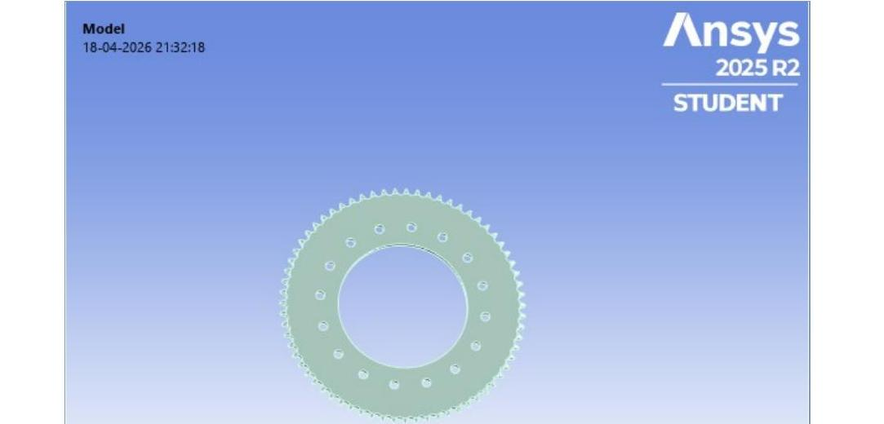
Figure 1: Imported solid model of the driven sprocket prior to weight reduction

3. Track Analysis and Energy Requirement Estimation

3.1 Endurance Track Details
The endurance track used for simulation was laid out in accordance with the guidelines of the Formula Bharat Rulebook. It consists of three straights — two of 50 m length and one of 40 m — two hairpin turns with an inner radius of 4 m, and a number of decreasing-radius corners. This track geometry forms the basis for the lap-time simulation used to size the final drive ratio (Section 4) and to estimate the energy consumed per lap.
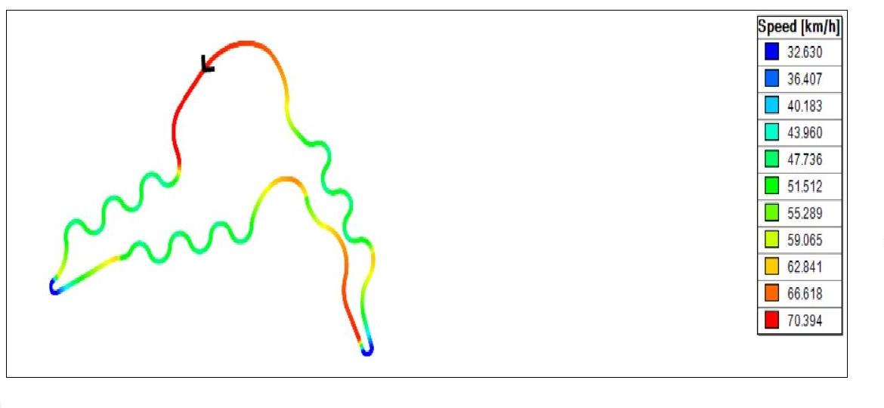
Figure 2: Simulated speed distribution along the endurance track (km/h)

3.2 Energy Requirement Estimation
The energy required to complete the endurance event was estimated using the following procedure:
- Obtain velocity–acceleration data from the lap-time simulation and calculate the acceleration force, Fma = mass of vehicle × longitudinal acceleration
- Calculate the net force, Fnet = Fma + aerodynamic downforce-related drag + rolling resistance
- Calculate the instantaneous power required, Power = Fnet × velocity, and find the average power over the lap
- Multiply the average power by the lap time to obtain the total energy required per lap
Based on these calculations, the energy requirement is:
• Energy for one lap: 0.135024 kWh
• Energy for 22 laps (full endurance event): 2.97 kWh

4. Gear Ratio Selection – Lap Time Simulation
OptimumLap simulation software was used to determine the final drive ratio that minimizes lap time on the endurance track described in Section 3.1. A sweep of final drive ratios from 1.0 to 10.0 was simulated, and the resulting lap time was recorded for each ratio.
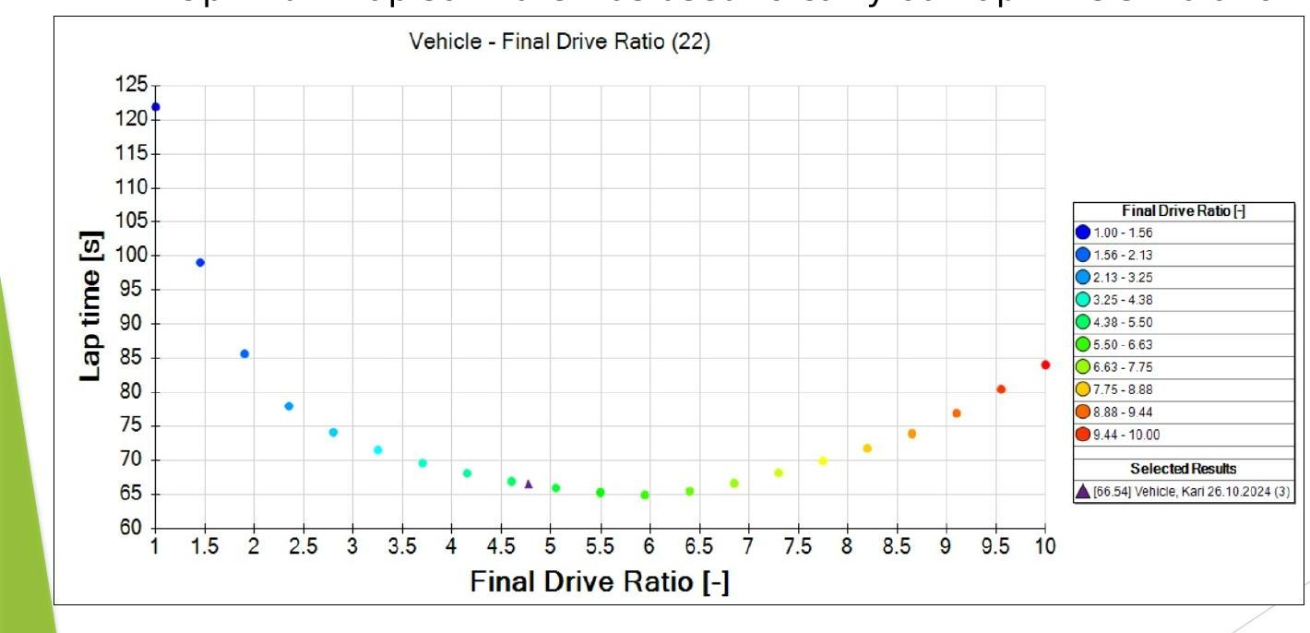
Figure 3: Lap time versus final drive ratio from OptimumLap simulation
From the lap time versus final drive ratio graph, the minimum lap time was found to occur over a final drive ratio range of 4.5 to 6.5. Because a larger final drive ratio reduces the maximum speed achievable on the straights, a final drive ratio of 4.77 was selected as the best compromise — this resulted in the desired maximum speed of approximately 70 km/h and a simulated lap time of 66.54 s.

5. Chain Drive System Design

5.1 Component Overview
The chain drive transmits torque from the EMRAX 208 motor (controlled by a Unitek Bamocar D3 motor controller) to the rear axle through a driver sprocket mounted on the motor shaft and a driven sprocket mounted on the rear axle. Figure 4 shows the assembled chain drive system with all components labelled.
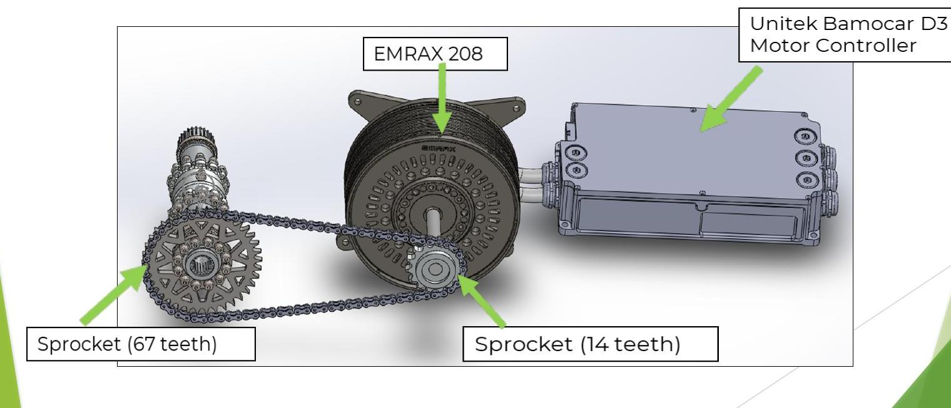
Figure 4: Chain drive system assembly: motor, motor controller, driver sprocket, chain, and driven sprocket

5.2 Driver and Driven Sprocket Specification
To realize the selected final drive ratio of 4.77, the driver (front) sprocket was specified with 14 teeth and the driven (rear) sprocket with 67 teeth, giving an actual ratio of 67/14 = 4.79, closely matching the target. A 06B1 simplex roller chain (3/8″ pitch, per ISO/BS 06B-1) was selected to suit this sprocket combination and the torque levels in the system.
The driver sprocket experiences high, concentrated contact stresses at its teeth on account of its small pitch circle diameter, and was therefore specified in 201 annealed stainless steel, a material with a high yield point well suited to sustaining this tooth loading. The driven sprocket, being significantly larger in diameter, contributes a much greater share of the rotating unsprung mass of the drivetrain; for this component, material and geometric efficiency were prioritized, as discussed in Section 6.
Table 2: Chain drive system specification summary
Parameter | Value
Final drive ratio | 4.77 (target); 4.79 (actual)
Driver sprocket teeth | 14
Driven sprocket teeth | 67
Chain | 06B1 simplex roller chain
Driver sprocket material | 201 annealed stainless steel
Driven sprocket material | 7075-T6 aluminium alloy

6. Driven Sprocket – Material Selection and Topology Optimization

6.1 Material Selection
The driven sprocket is specified in 7075-T6 aluminium alloy, a high-strength, lightweight alloy with excellent fatigue resistance, widely used in motorsport for rotating and unsprung components. Using aluminium in place of steel for this large-diameter component gives a substantial baseline weight saving; topology optimization was then used to remove further unnecessary material from the web of the sprocket without compromising structural integrity.

6.2 Topology Optimization Methodology
A topology optimization study was set up in Ansys Mechanical to identify load paths within the driven sprocket and to systematically remove low-utilization material from its web. The optimization region was defined over the full sprocket body, with the tooth profile, bore, and bolt-circle faces (443 faces in total) set as an exclusion region so that these functional surfaces remained unmodified. Because the sprocket geometry and bolt pattern are repetitive about its axis, the optimization exploited an 8-sector cyclic symmetry about the global X-axis, substantially reducing computation while preserving the rotational pattern visible in the final result.
The optimization was formulated as follows:
- Optimization type: Topology Optimization – Mixable Density
- Objective: Minimize compliance (i.e., maximize stiffness for the given load case)
- Response constraint: Mass, with percent to retain set to 60% of the original mass
- Maximum iterations: 500; convergence accuracy: 0.1%

7. Finite Element Analysis and Structural Validation

7.1 Static Structural Analysis Setup
Prior to optimization, a static structural analysis was carried out in Ansys Mechanical to characterize the baseline stress and deformation state of the driven sprocket under load. The imported solid body (volume 1.138 × 10⁻⁴ m³, baseline mass 0.893 kg) was meshed with 55,086 nodes and 29,110 elements. The bolt-circle region of the sprocket was fixed, and a ramped fixed-support moment of 667.8 N·m — corresponding to the peak torque transmitted through the chain at maximum motor torque — was applied at the outer profile to represent the worst-case dynamic loading condition.
The material properties used for this baseline FEA were those of Structural Steel (Young's modulus 200 GPa, Poisson's ratio 0.3, tensile yield strength 250 MPa, density 7850 kg/m³), as assigned in the simulation file. This is noted explicitly because it differs from the 7075-T6 aluminium specified for the manufactured part (Section 6.1); the steel properties served to validate the load path and optimization methodology, and it is recommended that a confirmatory run with aluminium 7075-T6 properties be carried out before final sign-off, since aluminium's lower modulus and yield strength will change the absolute stress and deflection margins.

7.2 Static Structural Results
Under the applied moment, the analysis returned the following results:
Table 3: Static structural analysis results (baseline, Structural Steel properties)
Result | Value
Maximum equivalent (von Mises) stress | 79.16 MPa
Average equivalent stress | 5.51 MPa
Minimum equivalent stress | 0.72 kPa
Maximum total deformation | 1.09 × 10⁻² mm
Average total deformation | 4.08 × 10⁻³ mm
Resulting factor of safety (vs. 250 MPa yield) | ≈ 3.16
The factor of safety of approximately 3.16 against the steel yield strength indicated significant margin in the original solid geometry, confirming that material could be removed from low-stress regions of the web without risking the structural integrity of the part — providing the justification for proceeding with topology optimization.

7.3 Optimization Convergence
The optimization was solved using the Mechanical APDL solver (elapsed solve time of 1 minute 15 seconds) and converged after 23 iterations, comfortably within the 500-iteration limit. Figure 6 shows the combined objective (compliance) convergence history, and Figure 7 shows the mass response convergence, both of which settle to a stable value well before the iteration limit, indicating a well-posed and converged optimization.
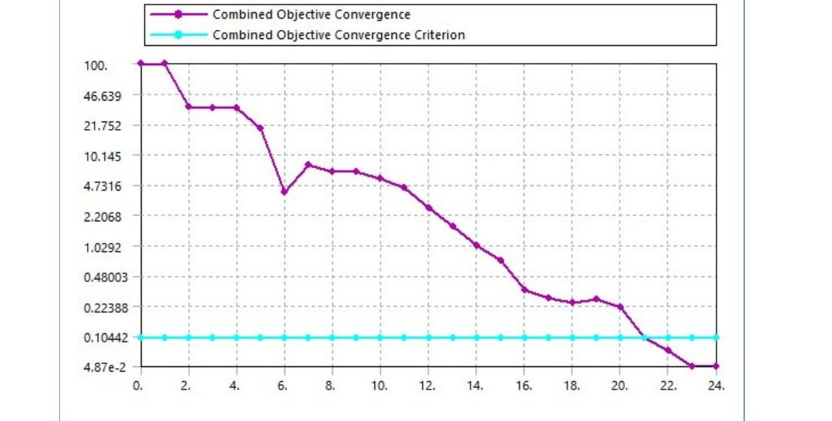
Figure 6: Combined objective (compliance) convergence history
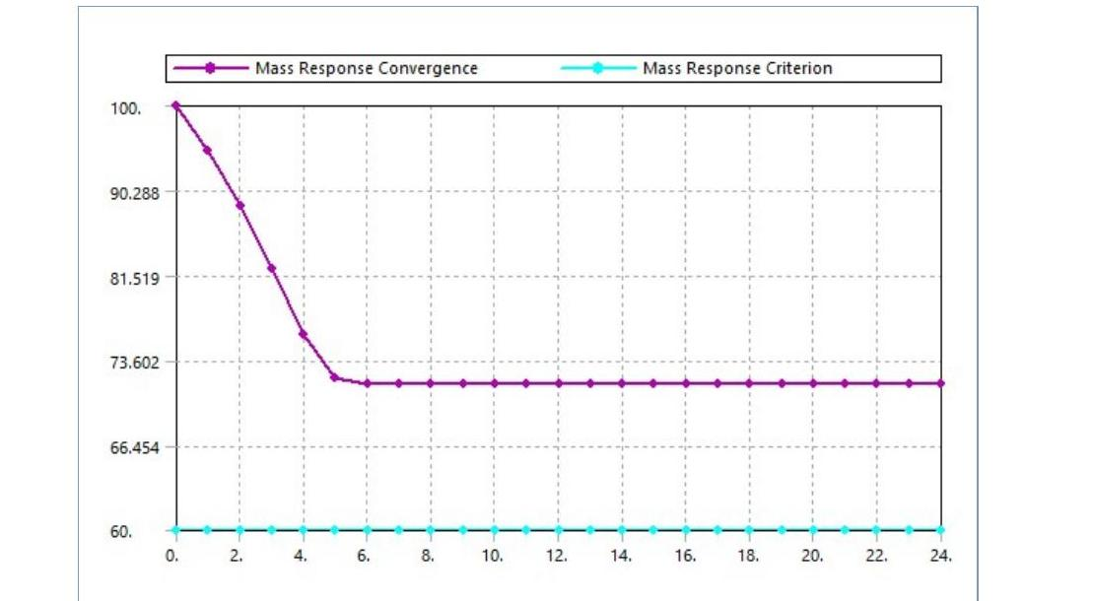
Figure 7: Mass response convergence history

7.4 Weight Reduction Results
The converged topology density solution (iteration 23) identifies, for every location in the design space, a normalized density between 0 (remove) and 1 (keep), using a retained-material threshold of 0.5. Figure 8 shows this density result mapped onto the driven sprocket, with red regions indicating material recommended for removal (density 0.0–0.4), tan regions marginal (0.4–0.6), and grey regions to be retained (0.6–1.0).
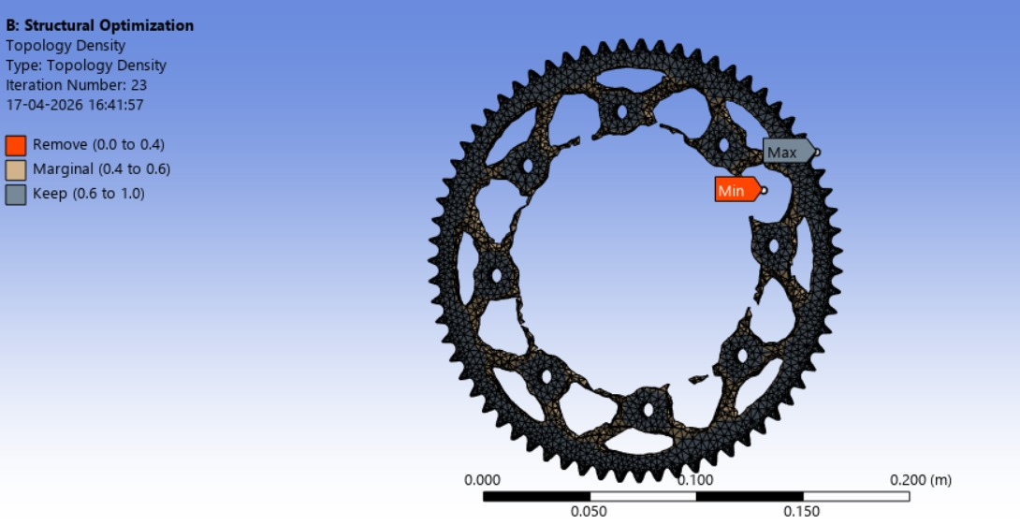
Figure 8: Topology density result for the driven sprocket at iteration 23 (Remove / Marginal / Keep)
The resulting mass and volume reduction achieved is summarized in Table 4. The final retained volume closely matches the 60% mass-retention constraint imposed on the optimization, confirming good convergence between the solver's result and the design intent.
Table 4: Topology optimization weight reduction summary (Iteration 23)
Quantity | Value
Original volume | 1.138 × 10⁻⁴ m³
Final volume | 6.716 × 10⁻⁵ m³
Volume retained | 59.01% of original
Original mass | 0.893 kg
Final mass | 0.527 kg
Mass retained | 59.01% of original
Net mass saving | ≈ 0.366 kg (≈ 41% reduction)
Average retained density | 0.640
Translating the topology density map into a manufacturable geometry produced the final optimized driven sprocket shown in Figure 9. The characteristic web cut-outs follow the load paths identified by the optimizer while preserving the tooth profile, bore, and bolt-circle as solid, functional features.
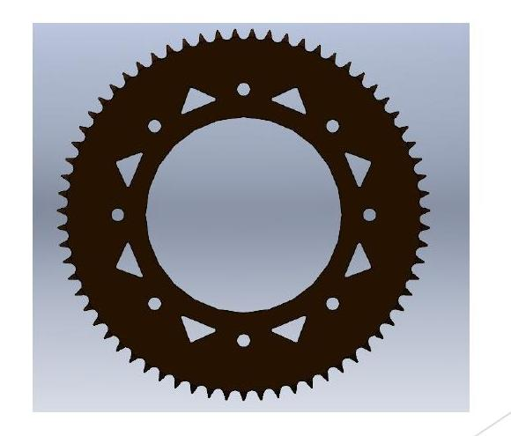
Figure 9: Final optimized driven sprocket geometry after topology-optimization-guided material removal

8. Final Design Summary
The key outcomes of the chain drive design and driven sprocket weight optimization are consolidated in Table 5.
Table 5: Chain drive system – final design summary
Parameter | Final Value
Final drive ratio | 4.77 (target) / 4.79 (actual)
Driver sprocket | 14 teeth, 201 annealed stainless steel
Driven sprocket | 67 teeth, 7075-T6 aluminium alloy
Chain | 06B1 simplex roller chain
Simulated top speed | ≈ 70 km/h
Simulated lap time | 66.54 s
Energy per lap / 22-lap endurance | 0.135 kWh / 2.97 kWh
Driven sprocket mass (before → after optimization) | 0.893 kg → 0.527 kg (–41%)
Baseline factor of safety (steel properties) | ≈ 3.16

9. Conclusion
A complete chain drive system was designed for the IITG Racing Formula Student electric vehicle, beginning from vehicle-level performance targets and track-based lap-time simulation, through to detailed component sizing and FEA-driven weight optimization of the driven sprocket. A final drive ratio of 4.77 (14T driver / 67T driven sprocket, 06B1 chain) was selected, meeting the target top speed of approximately 70 km/h with a simulated lap time of 66.54 s and a 22-lap energy requirement of 2.97 kWh.
Topology optimization of the driven sprocket, validated by static structural FEA, enabled a mass reduction of approximately 41% (0.893 kg to 0.527 kg) while retaining a healthy structural margin in the baseline analysis. As the part is manufactured in 7075-T6 aluminium rather than the structural steel used for the baseline FEA, it is recommended that the final geometry be re-verified with aluminium material properties, along with fatigue and chain-wear life checks, before the design is released for manufacture.

