

IITG Racing
Virtual EV Challenge — Team Report
Conducted by
IPG Automotive and Bosch

Submitted by
K Aravindhan · Ryan Sequeira · Bedabrat Barma · Ronak · Aayush Kumar

Mentored by
Mohammed Mosaddique Nawaz
Professor, Department of Electrical & Electronics Engineering, IIT Guwahati
Submission Date: 17 August 2025

1. FMU Details
The Functional Mock-up Unit (FMU) was generated using MATLAB Simulink's FMI Export Toolbox, compliant with FMI 2.0 for Co-Simulation.

1.1 Parameters Used in the FMU

Parameter | Symbol | Value | Units
Air Density | ρ (rho) | 1.225 | kg/m³
Drivetrain Efficiency | η (eta) | 0.90 | —
Gravitational Acceleration | g | 9.81 | m/s²
Frontal Area | A | 2.48 | m²
Vehicle Mass | m | 1,400 | kg
Rolling Resistance Coefficient | Cᵣᵣ | 0.01 | —
Drag Coefficient | Cₙ | 0.31 | —
Maximum Vehicle Speed | vₘₐˣ | 16.667 | m/s
Gear Ratio | G | 6 | —

2. Phase 1 — Optimal Speed and Motor Force Modelling

2.1 Optimal Speed Model
The Simulink model computes the optimal vehicle speed (V_opt) to maximise energy efficiency over the route. The governing equation is:

V_opt = √{ [(E/d)·η − Cᵣᵣ·m·g] / (0.5·ρ·Cₙ·A) } … (1)
V_opt is constrained not to exceed the maximum vehicle speed of 16.667 m/s.

2.2 Motor Force Model
The motor force required to maintain the target speed is calculated as:

Fₘₒₜₒᵣ = Cᵣᵣ·m·g + ½·ρ·Cₙ·A·v²ₐᶜₜ + m·a … (2)

2.3 Simulink Model — Block Diagram

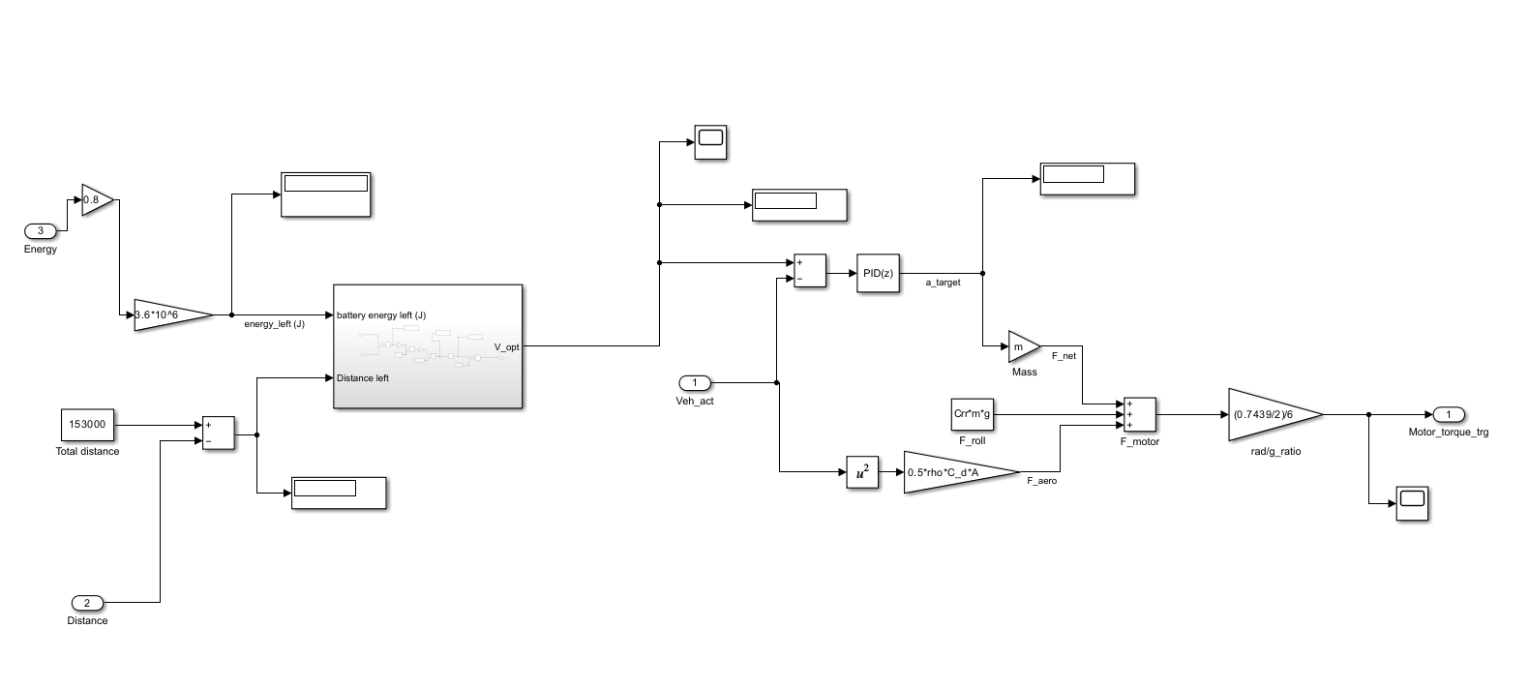
Figure 1: MATLAB Simulink FMU block diagram

2.4 Optimum Velocity Subsystem
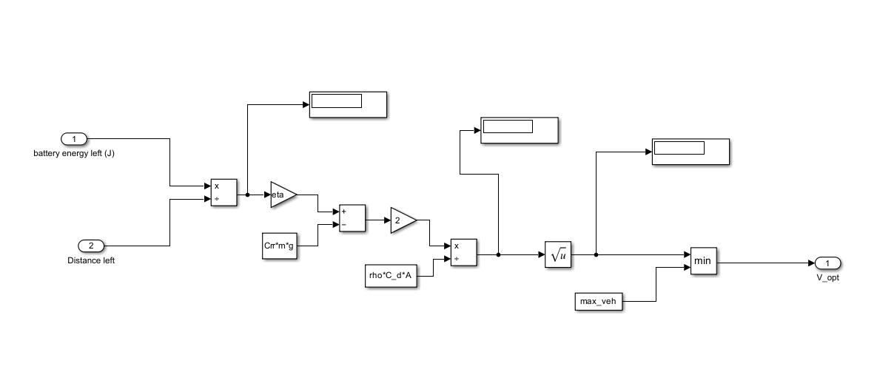
Figure 2: Optimum velocity subsystem in Simulink

2.5 Simulation Summary
Total distance covered: 153 km Elapsed time: 9,612.2 s (2.67 hours) Residual SoC: 19%

2.6 Velocity vs. Time
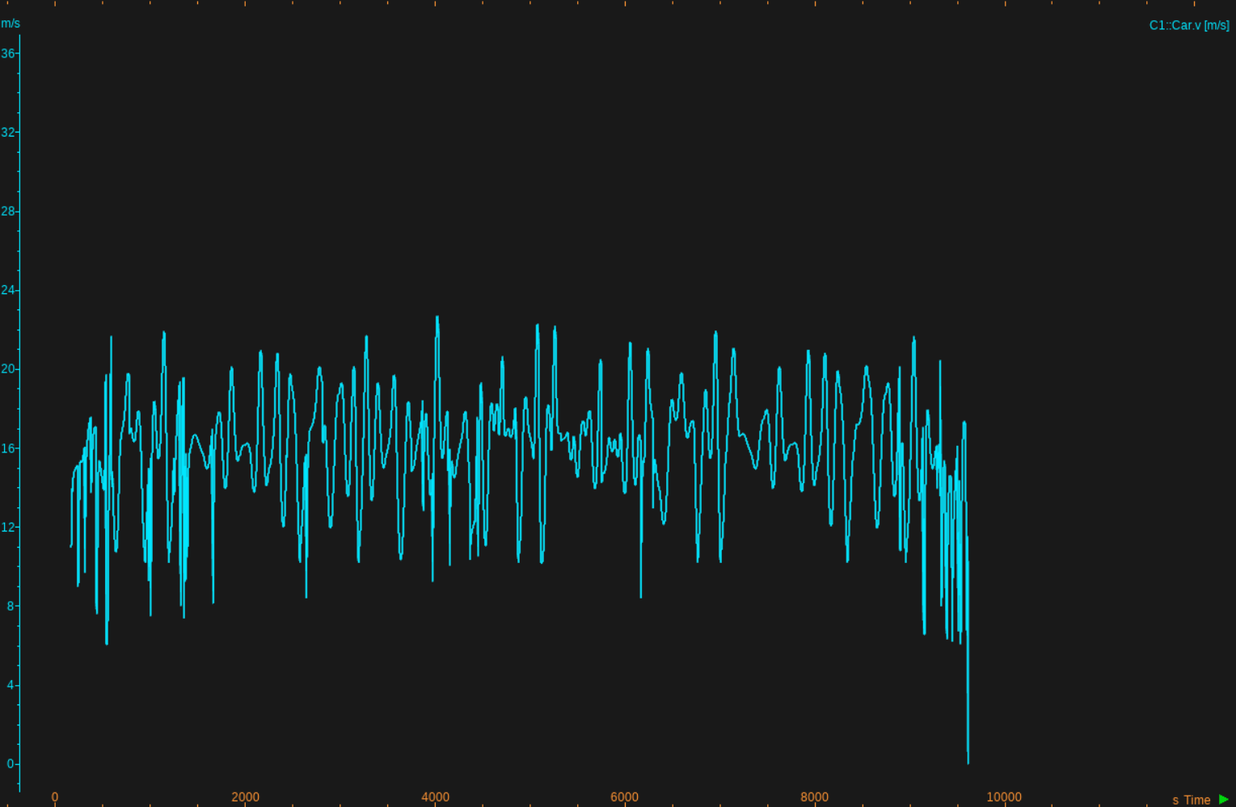
Figure 3: Vehicle velocity profile over the complete route

3. Phase 2 — AI-Integrated Charging Optimisation

3.1 System Architecture

3.1.1 Overview
The integrated system couples three primary components:
- CarMaker — high-fidelity vehicle dynamics and powertrain simulation engine (source of motor torque, total force, vehicle speed, distance travelled, and battery SoC).
- KUKSA Databroker (VSS) — middleware for publishing and subscribing to standardised Vehicle Signal Specification (VSS) signals.
- AI Agent System — a multi-agent optimiser (Requester and Optimizer agents implemented with uagents) that consumes vehicle state from KUKSA, computes optimal charging decisions, and writes results back to KUKSA for CarMaker consumption.

Data flow (logical):
CarMaker → Bridge (FMU / PyCarMaker script) → KUKSA → AI Agents → KUKSA → Bridge → CarMaker
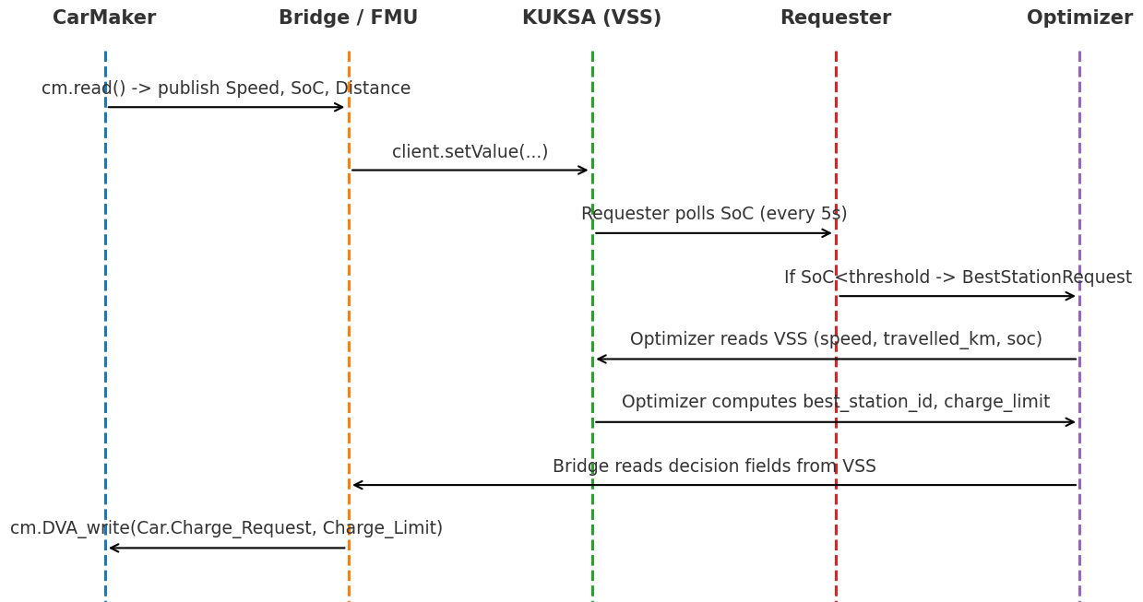
Figure 4: Additional velocity characteristics plot

3.1.2 Implementation Mapping
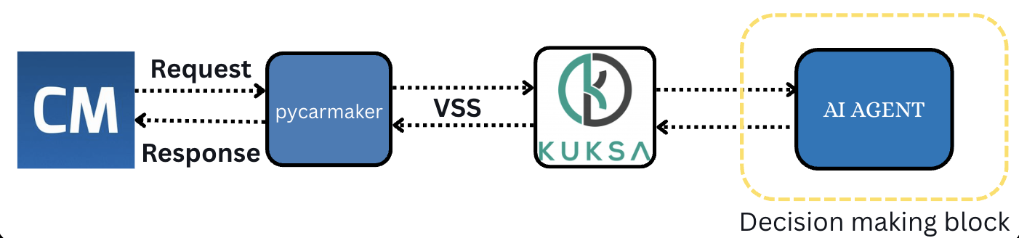
Figure 5: System data-flow diagram
The three integration pathways are implemented as follows:
- CarMaker → KUKSA (Bridge): Implemented using pycarmaker and kuksa_client. The bridge reads PT.BCU.BattHV.SOC, Car.Distance, and Car.v from CarMaker and pushes them into KUKSA via client.setValue().
- KUKSA → AI Agents: AI_Agents.py subscribes to VSS signals (Vehicle.Speed, Vehicle.TraveledDistance, Vehicle.Acceleration.Longitudinal) via the VSSSubscription helper.
- Decision Publishing: Car.Charge_Request activates the Optimizer Agent, which writes the selected best_station_id and Car.Charge_Limit back to KUKSA.
- Agent Orchestration: Bureau() runs both Optimizer and Requester agents concurrently.

3.2 AI Logic Design

3.2.1 Objective
The AI optimiser targets:
- Minimise total trip time (travel time + charging time).
- Guarantee safe reachability — the vehicle must always be able to reach the chosen charging station with SoC above MIN_SOC_ARRIVAL.
- Maintain a minimum residual SoC ≥ 20% at the end of the route.

The optimiser returns: (1) the best charging station ID, and (2) the required Charge Limit (target SoC).

3.2.2 Agent Interaction Design
The AI agents interact according to the following logic:
- AI Agent subscribes to live VSS values from KUKSA.
- Requester Agent monitors SoC continuously.
- If current SoC < 25%, the Requester Agent triggers the Optimizer Agent via a message.
- Optimizer Agent evaluates candidate stations on four criteria:
- Travel time to each station.
- Predicted SoC on arrival (must be ≥ 15%).
- Travel time from the station to the destination.
- Predicted SoC at the destination.
- Charge Limit is calculated to minimise charging time while guaranteeing a safe final SoC.
- Selected station_id and Charge_Limit are published to KUKSA via VSS for CarMaker consumption.

3.3 Bridge Highlights

3.3.1 Purpose and Role
The PyCarMaker bridge provides real-time data translation between CarMaker and KUKSA. Its primary responsibilities are:
- Temporal alignment of simulation state and AI decisions.
- Bidirectional signal translation between CarMaker quantities and VSS paths.
- Reliable event-driven triggering of charging decisions based on live SoC readings.

3.4 Performance Metrics and Evaluation Plan
The table below lists recommended performance metrics, their measurement methods, and target values for simulation-grade evaluation.

Metric | Definition & Measurement | Target
End-to-End Latency | Time from CarMaker state publish to optimizer decision write-back to CarMaker | < 200 ms
Decision Correctness | Fraction of feasible optimizer decisions; SoC at arrival ≥ MIN_SOC_ARRIVAL; final SoC ≥ MIN_SOC_FINISH | 100%
SoC Estimation Error | Mean Absolute Error between AI-estimated and CarMaker ground-truth SoC | MAE < 2–5 pp
Optimization Overhead | Wall-clock time for optimizer to evaluate all candidate stations per request | < 100 ms
Robustness / Stability | Zero crashes, no missed messages, no deadlocks across extended drive-cycle scenarios | Zero errors
Scalability | Latency and CPU use vs. number of stations/vehicles | Linear or sub-linear growth

4. Team Experience and Lessons Learned

4.1 Phase 1 — Simulink Modelling
- Built the vehicle and powertrain model in MATLAB Simulink.
- Optimised motor torque for energy efficiency while meeting performance targets.
- Validated the energy consumption baseline for charging calculations.

4.2 Phase 2 — AI Integration
- Connected CarMaker/Simulink signals (SoC, speed, distance) to KUKSA VSS.
- Designed AI agents (Requester + Optimizer) for charging-station selection.
- Returned optimal charging station ID and charge target to the simulator in real time.

4.3 Lessons Learned
- Torque-based SoC estimation is more reliable than distance-based methods.
- Event-driven FMUs improve system responsiveness compared to polling loops.
- Clear and consistent signal mapping in VSS is critical for effective debugging.
- Separating monitoring (Requester) and computation (Optimizer) agents improves overall responsiveness.

5. Simulation Results
The following plots show the AI-driven charging optimisation results for three different initial State of Charge (SoC) scenarios.

5.1 Results — Initial SoC: 50%
Figure 6a: Signal overview — 50% initial SoC
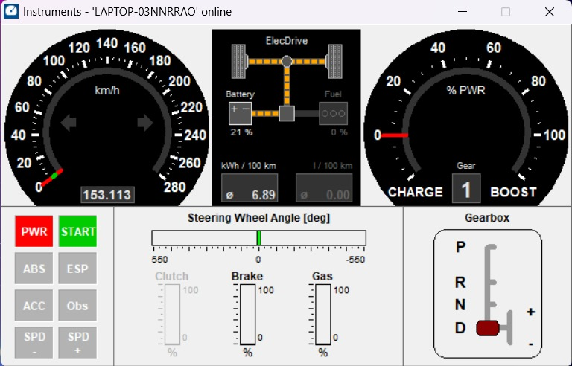
Figure 6b: Final SoC

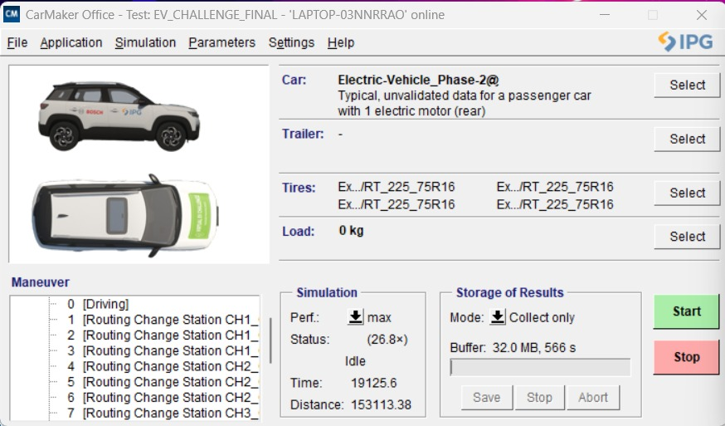
Figure 6c: Time and distance — 50% initial SoC

5.2 Results — Initial SoC: 40%
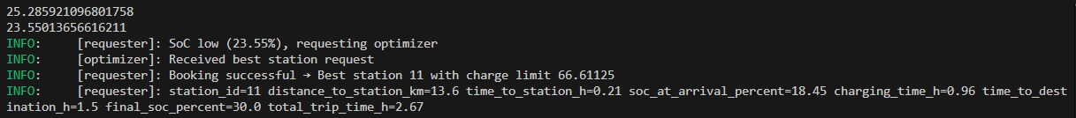
Figure 7a: Signal overview — 40% initial SoC

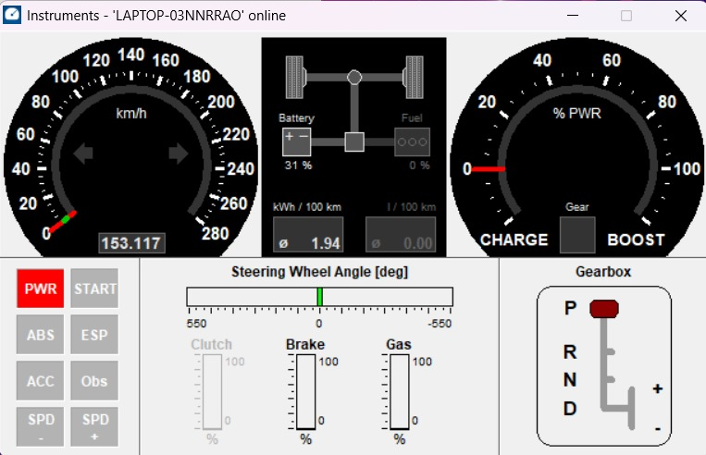
Figure 7b: Final SoC

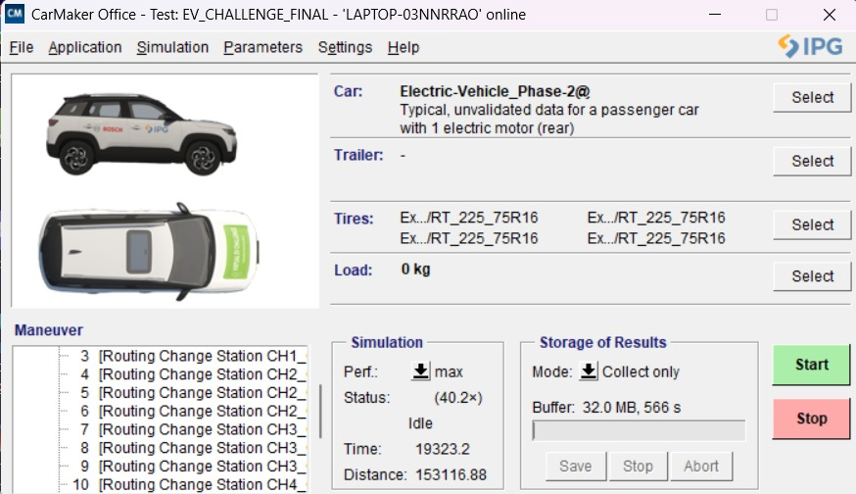
Figure 7c: Time and distance — 40% initial SoC

5.3 Results — Initial SoC: 30%

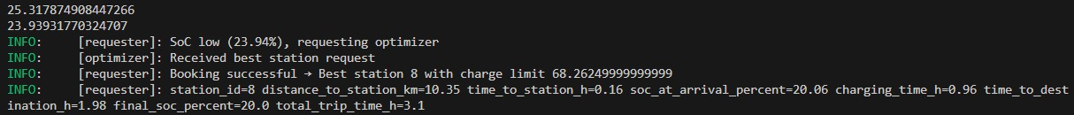
Figure 8a: Signal overview — 30% initial SoC

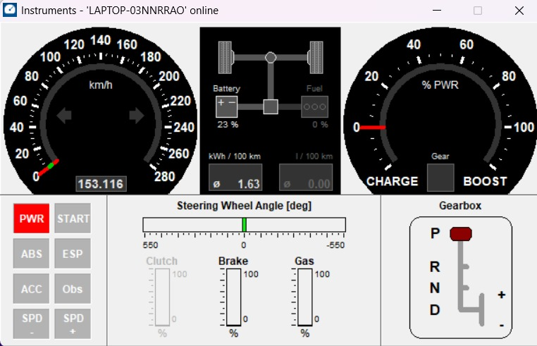
Figure 8b: Final SoC
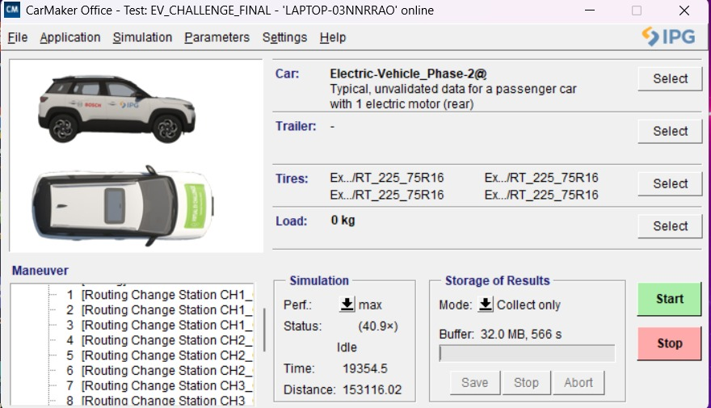
Figure 8c: Time and distance — 30% initial SoC

End of Report
IITG Racing · IIT Guwahati · EV Challenge 2025

