Deep Fake Audio Detection using Deep Learning

In propose work we are utilizing combination of CNN and LSTM to detect deep fake audio. CNN (Convolutional Neural Network) and LSTM (Long Short-Term Memory) are combined for deepf ake detection because CNN excels at extracting spatial features from audio frames, while LSTM analyses temporal patterns and inconsistencies over time, leading to a more comprehensive and accurate detection method.

CNNs for Spatial Feature Extraction:

CNNs are highly effective at identifying visual patterns and features within individual frames of a video, such as facial textures, lighting, and other spatial details.

LSTMs for Temporal Analysis:

LSTMs are designed to process sequential data, making them well-suited for analysing the temporal relationships between video frames. They can identify inconsistencies or unnatural movements that might be indicative of a deep fake.

To train above algorithms we have used deep fake audio dataset from KAGGLE repository which can be download from below URL

<https://www.kaggle.com/datasets/f0rtaza/fake-audio/data>

Each audio from above dataset is processed and extracted MFCC features and then perform shuffling and normalization to prepare training array. All processed training array will be split into train and test where application using 80% data for training and 20% for testing.

80% training features will be input to deep fake CNN + LSTM algorithm to train a model and this model will be applied on 20% test data to calculate prediction accuracy. In below screen showing CNN + LSTM layers along with time distributed layer to capture inconsistency over time.

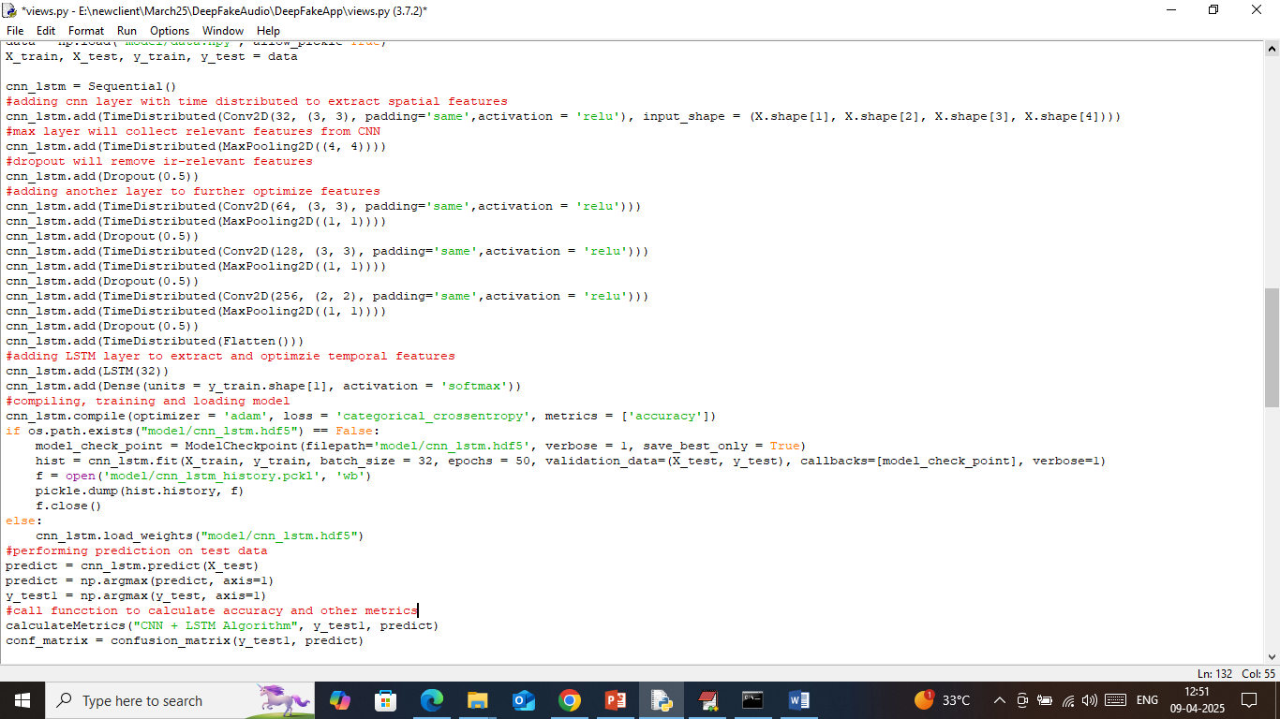

In above screen read red colour comments to know about CNN + LSTM deep fake audio detection model.

To implement this project we have designed following modules

1. User Login: user can login to system using username and password as ‘admin and admin’
2. Load & Process Audio Dataset: using this model will load and normalize all dataset audio MFCC features and then split into train and test where application using 80% images for training and 20% for testing
3. Train CNN + LSTM Deep Model: 80% training MFCC features will be input to deep learning CNN + LSTM algorithm to trained a model and this model will be applied on 20% test images to calculate prediction accuracy
4. Detect Deep Fake: using this module user can upload test audio and then application will extract MFCC features and then input to CNN + LSTM model to predict weather audio is original or Deep Fake.

SCREEN SHOTS

Install python 3.7.2 and then install all packages given in requirements.txt file and then double click on ‘run.bat’ file to start python server and then will get below page

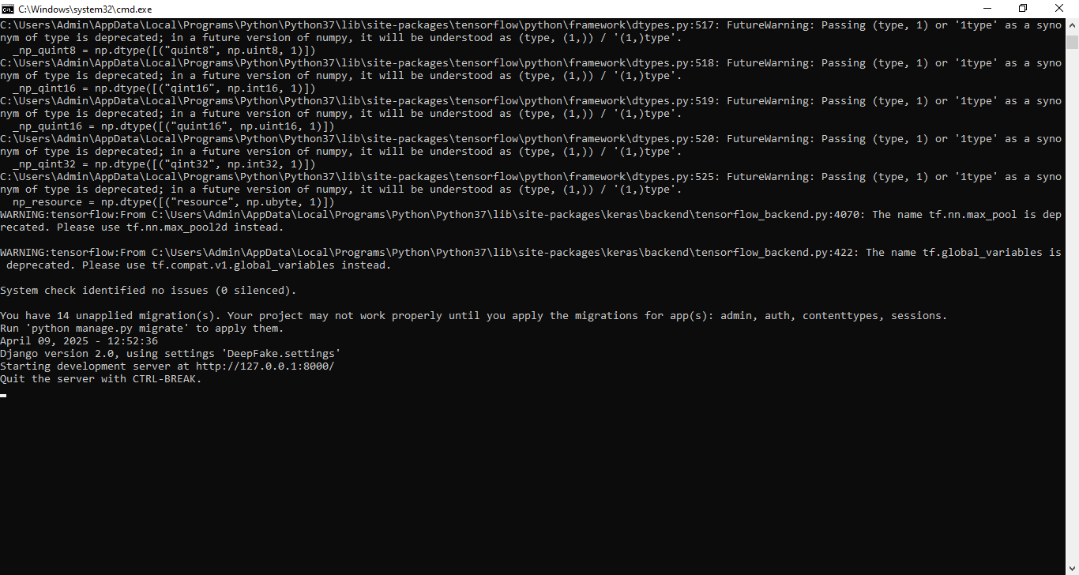

In above screen python server started and now open browser and enter URL as <http://127.0.0.1:8000/index.html> and then press enter key to get below page

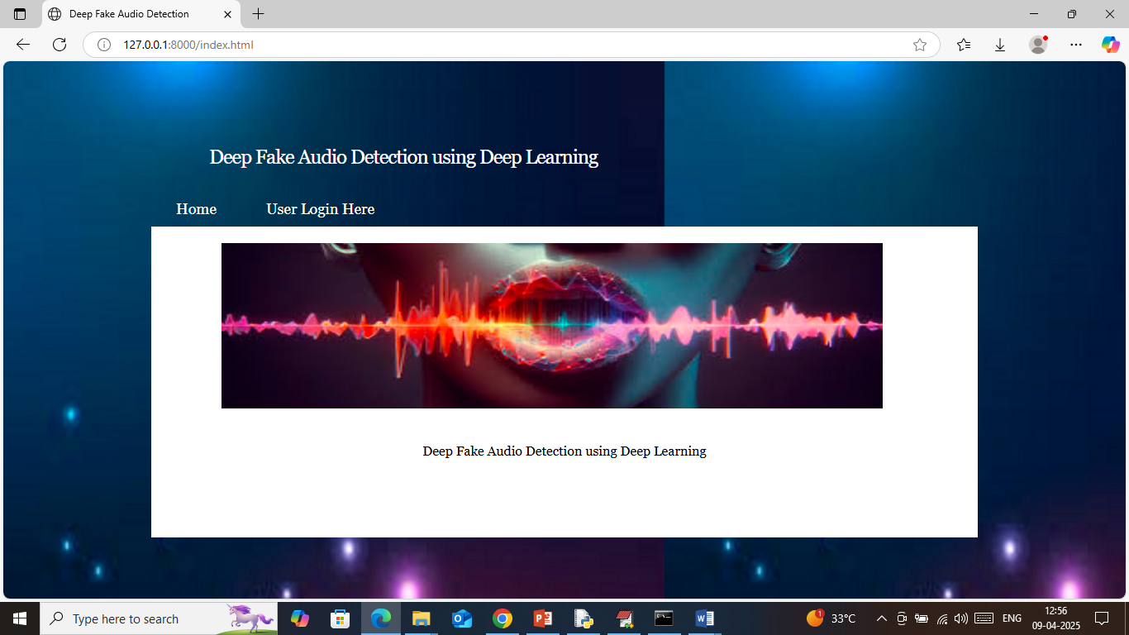

In above screen click on ‘User Login’ link to get below page

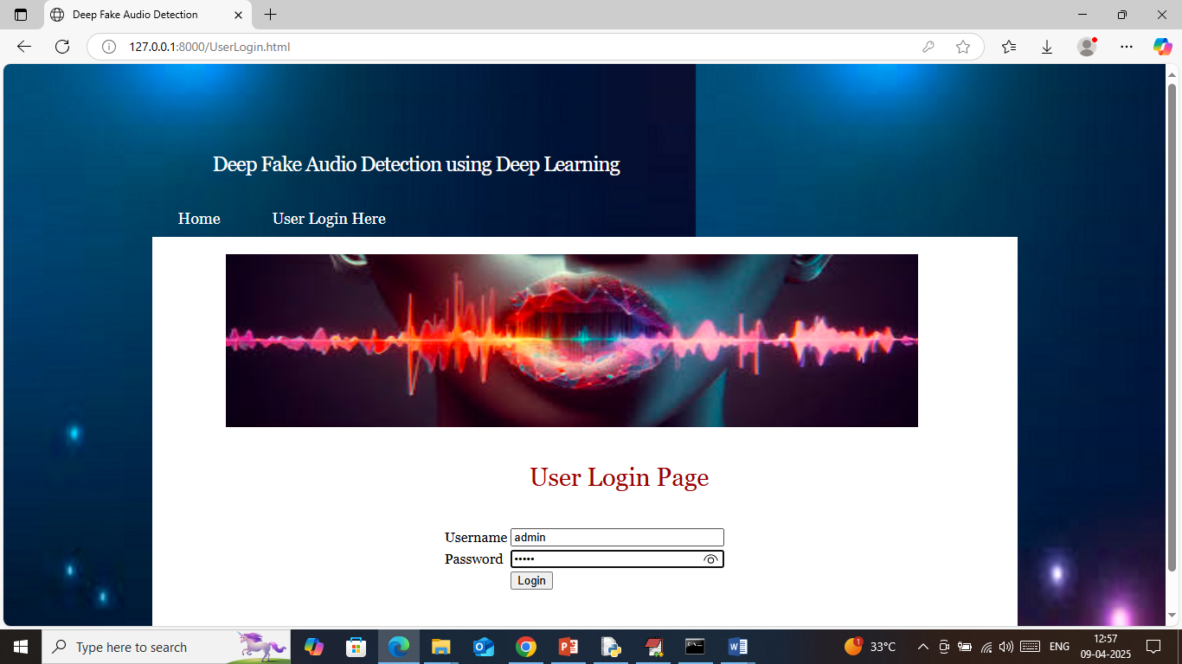

In above screen user is login and after login will get below page

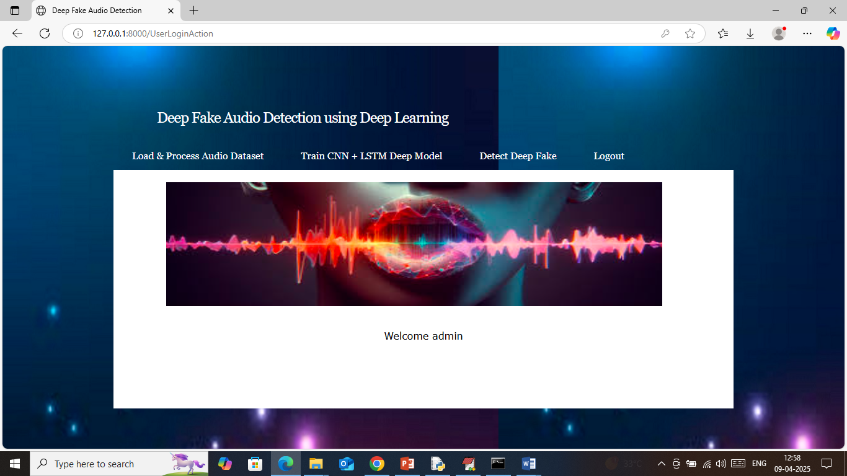

In above screen user can click on ‘Load & Process Audio Dataset’ link to load dataset and then will get below page

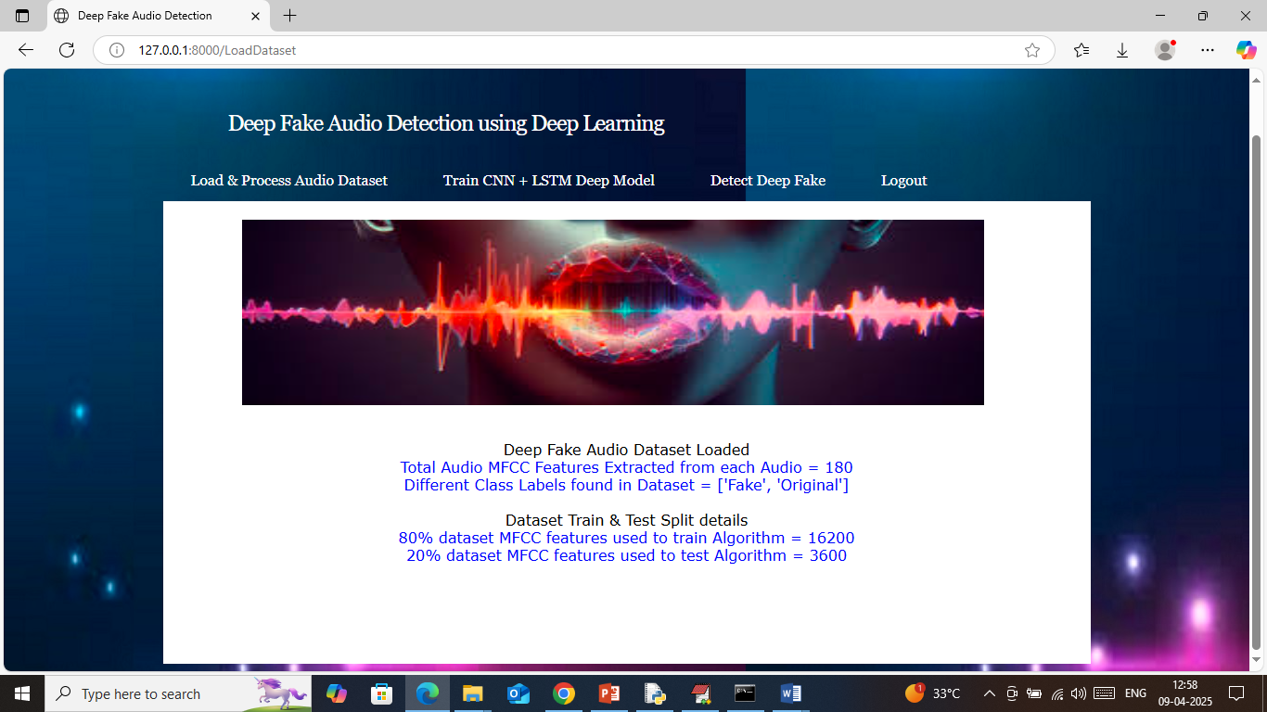

In above screen can see number of audio files loaded and processed from dataset and then can see train and test size. Now click on ‘Train CNN + LSTM Deep Model’ link to train al CNN algorithm and then will get below page

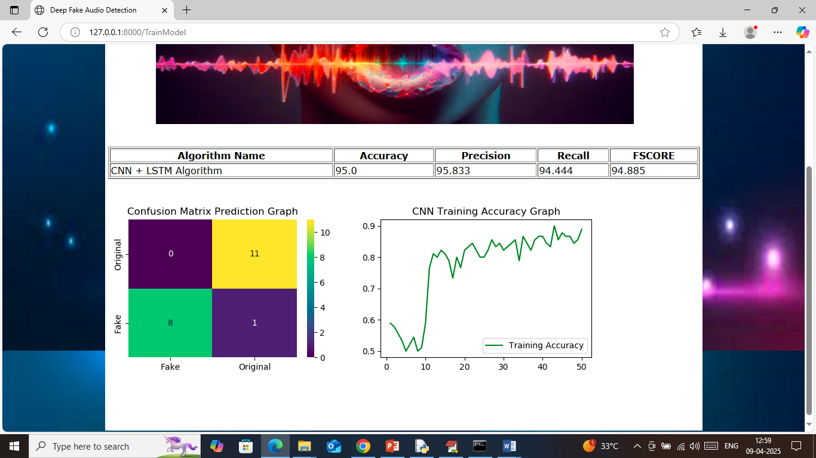

In above screen in table format can see accuracy, precision, recall, FSCORE of CNN + LSTM algorithm. In above screen can see CNN can detect deep fake audio with an accuracy of 95%. In confusion matrix graph x-axis represents Predicted Labels and y-axis represents true labels and then yellow and green boxes in diagonal represents correct prediction count and remaining blue boxes represents incorrect prediction count which are very few. In second graph can see training accuracy of CNN where x-axis represents ‘Number of training epochs’ and y-axis represents ‘accuracy’ and can see with each increasing epoch accuracy got increased and reached closer to 1. Now click on ‘Detect Deep Fake’ link to get below page

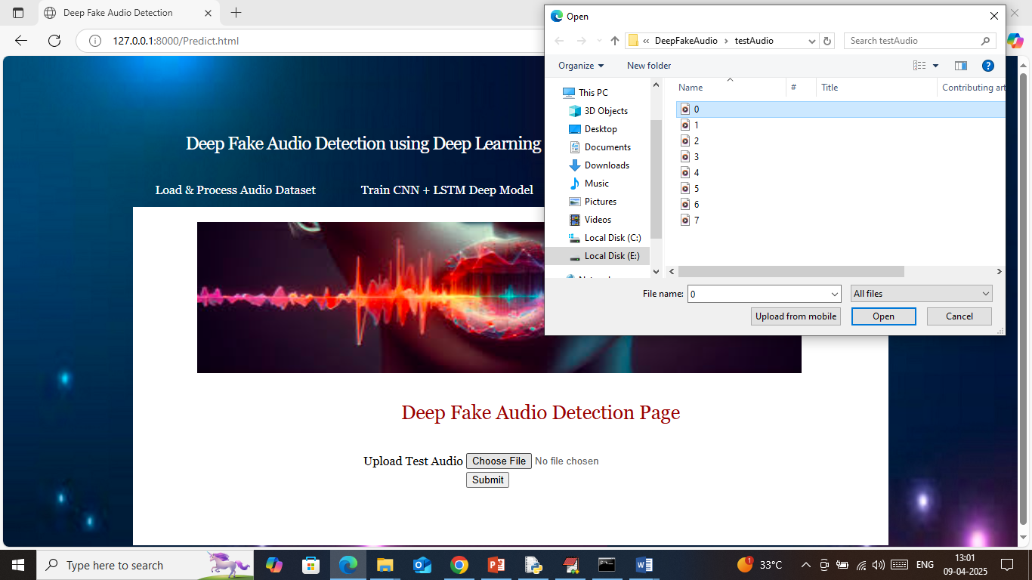

In above screen select and upload test audio file and then click on ‘Open and Submit’ button to get below output

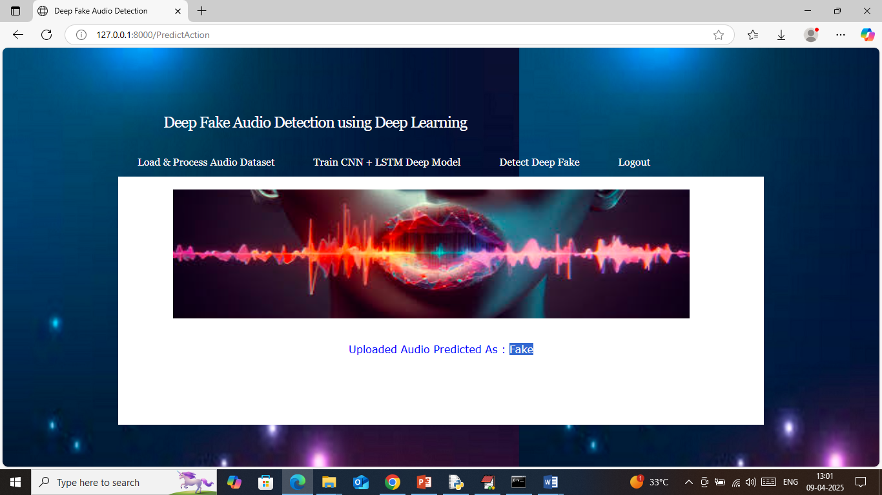

In above screen uploaded audio detected as “Fake” and similarly you can upload and test other videos

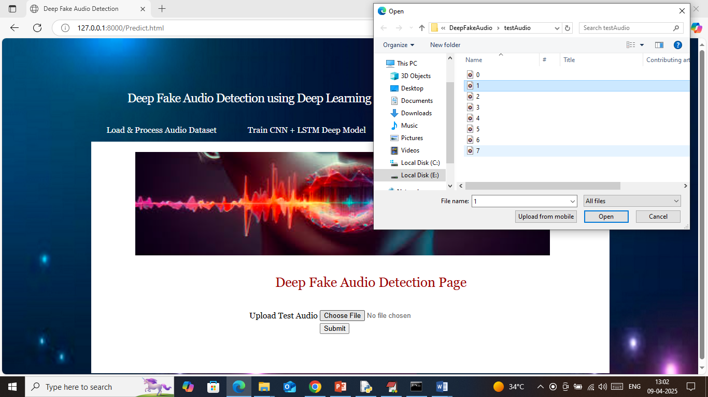

In above screen uploading another audio file and below is the output

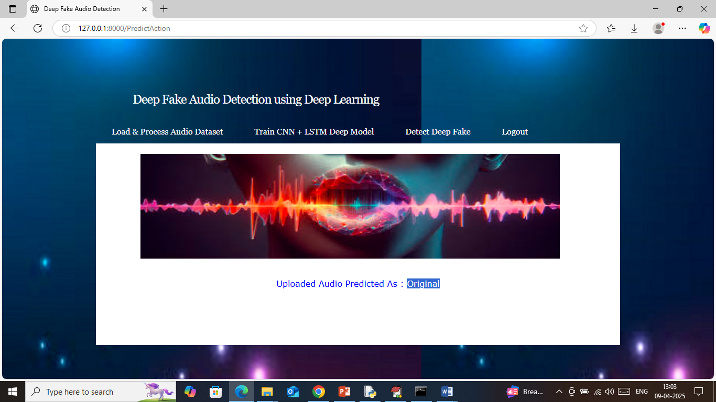

In above screen uploaded audio file detected as ‘Original’ and similarly you can test any other audio file