Rejuvenation readouts cannot distinguish younger from less old
A one-dimensional age score falls for any move away from the old state. Distance to a young target of the same type tells approach from departure.
Roger Kwon
Independent researcher, Seoul, Republic of Korea
Correspondence: kih7920@gmail.com

SUMMARY
Treatments said to rejuvenate cells are usually judged by a single score that falls when cells look younger. But such a score shows only which way cells moved, not where they ended up: it also falls when cells simply stop looking old, for example by drifting toward a different cell type, without becoming any more like young cells. We ask a more direct question: after treatment, are the cells closer to young cells of the same type than they were before? In skin fibroblasts from a 96-year-old donor that were partially reprogrammed (Lu et al.), the published aging score fell well below the level of a 22-year-old donor's untreated cells, which looks like strong rejuvenation. Yet the same cells ended about twice as far from the young donor's cells as they started, even when judged only by the genes that make up that score. The same was true with other published aging genes, with all genes, with hundreds of randomly chosen gene sets, and with an age score we built that follows donor age across several independent cohorts. Our measure does register cells getting closer when young cells are mixed into old ones, so it can see real rejuvenation when it happens, and the result is not the two donors' cells simply becoming more alike. A falling aging score therefore cannot tell rejuvenation apart from cells moving away from their old state in some other direction. We provide a frozen age score, young reference points and code for measuring distance to young cells instead.

INTRODUCTION
Partial reprogramming and other candidate rejuvenation interventions are evaluated by asking whether a cell's molecular profile has moved opposite to the direction of aging. Epigenetic clocks, curated aging signatures and correlation-based reversal scores share this form: a single number that falls when the cell is judged younger.
This form has a structural weakness: it records the direction a cell moves and not where it ends up. In the high-dimensional expression space of more than twenty thousand genes, almost every direction leads away from the old state, and only a narrow cone of them leads toward young cells of the same type. A score anchored on not-old falls across that whole space. In that space a displacement ends closer to the young target only when its length is less than twice the starting distance to the target times the cosine of the angle between the displacement and the target direction. A directional score carries the angle and discards the length, so it cannot evaluate that condition even in principle. Three outcomes therefore become hard to tell apart:
• Approach to young. The cell becomes more similar to a young cell of the same type and ends closer to it than it began. This is the intended outcome.
• Departure in the wrong direction. The cell becomes less similar to an old cell by becoming something else. Loss of the differentiated state is one such move, and the one with the clearest cost: in the limit it is dedifferentiation and loss of tissue function. It is not the only one. A shift in proliferative state, a stress response, or a change of subtype leaves the cell no closer to young while scoring just as well.
• Departure past the target. The cell moves in the right direction and does not stop, ending beyond the young state rather than at it. This scores highest of all on a directional readout, and it is the failure mode of complete reprogramming.
The distinction is concrete for reprogramming. Complete OSKM reprogramming proceeds through a mesenchymal-to-epithelial transition and ends in pluripotency; the whole trajectory moves away from the aged fibroblast state, and a score anchored only on not-old will register the whole of it as rejuvenation.
We therefore replace the direction with a target. For a given cell type there is a region of expression space that the intervention should approach: this cell type, young. Movement toward it is progress; movement past it, or orthogonal to it, is not. This turns identity from a competing axis into a stopping condition, and turns age from a direction into a distance.
Operationalizing this requires three things: a young target of the same cell type, measured on the same platform where possible; a statistic that separates closer-to-young from farther-from-old; and controls that detect the confounds which make the two look alike. Two controls do most of the work here. A dose-response positive control, in which known amounts of young cells are mixed into old ones, establishes that the statistic can see an approach at all and sets the noise floor as the value observed at zero dose. A reverse test, in which the roles of the young and aged samples are swapped, distinguishes rejuvenation from mutual convergence of two samples. We begin with the published readout whose behavior prompted the question, show that the behavior does not depend on which genes are read, then build an age ruler that outperforms that readout on donor age and show that the ruler is not exempt either.

RESULTS

A published aging score falls while the cells move away from young cells
Lu et al. use a mesenchymal-drift (MD) signature, the HALLMARK epithelial-mesenchymal transition gene set augmented with SNAI1, ZEB1, ZEB2, TWIST1 and TWIST2 (205 genes), as their readout of aging, and report that it falls when aged fibroblasts are partially reprogrammed. Their dataset GSE297234 is an OSKM reprogramming time course in dermal fibroblasts from a 96-year-old donor (GM00731) and a 22-year-old donor (GM23815), sampled at days 0, 3, 7 and 10. It is unusual among rejuvenation datasets in containing young cells of the same type, on the same platform, in the same experiment, which is what makes the question in this paper answerable. Cell states were labeled with the published state signatures (Methods). The population tested is the aged donor's partially reprogrammed cells (5,832 cells). They are overwhelmingly day-3 cells (5,220 of them), assayed while OSKM is still being expressed; this is the population the source paper treats as rejuvenated. Donors are never pooled, and the 22-year-old donor is a contrast, not a replicate.
We scored MD per cell with a reimplementation of the published algorithm (Methods), scoring both donors against the same control genes so that their scores are comparable. The score behaves as reported. In the aged donor it falls from 0.515 (95% cell-resampling interval 0.513 to 0.517; these intervals describe within-sample precision, not donor-level uncertainty) in day-0 fibroblasts to 0.158 (0.153 to 0.162) in partially reprogrammed cells, and continues downward through early pluripotency (0.147) to pluripotency (0.022). The relevant comparison is the difference between the two donors' day-0 fibroblasts, which is what 74 years of donor age look like on this scale: 0.046 (0.043 to 0.049). The drop on partial reprogramming is 7.7 times that difference (95% CI 7.3 to 8.2). Read as an age readout, the 96-year-old's partially reprogrammed cells are far younger than the 22-year-old's actual cells (Figure 1A).
We then asked where those cells are. Each population's counts were summed and normalized, and each gene was standardized against its mean and spread across cultured dermal fibroblasts from 652 adult GTEx donors, which serve throughout as a fixed reference and define a panel of 23,485 expressed genes (Methods). Restricted to the 205 MD genes, and with the young donor's untreated day-0 cells as the target, the aged donor's day-0 cells start 14.6 units away. After partial reprogramming they are 31.7 away: 2.2 times farther than they began. They cover 79% of the line from the aged donor's cells to the young donor's (progress 0.790, 95% CI 0.780 to 0.811), which a projection-based readout would score as substantial rejuvenation, but they also move 2.16 times that line's length off to the side. Covering most of the line is therefore compatible with ending much farther away (Figure 1B). The cells also travel a long way: 2.3 times the line between the two donors. A move longer than twice that line cannot end closer to the target whichever way it points, so these cells overshoot on length alone. Complete reprogramming goes further in the same way (pluripotent cells: progress 1.33, final distance 3.9 times the starting distance).
Two checks decide whether this is a real result or an insensitive measure. First, mixing known fractions of the young donor's day-0 cells into the aged donor's day-0 cells, a sample that genuinely moves toward young, gives steadily increasing progress (0.010, 0.096, 0.207 and 0.388 at 0%, 10%, 25% and 50%) and steadily decreasing distance to the young target (−0.007, −1.195, −2.676 and −5.143), with intervals that contain their point estimates. The measure sees a real approach of this size when one occurs. Second, with the roles of the donors reversed, the young donor's partially reprogrammed cells do not move toward the aged donor (progress −0.229, 95% CI −0.251 to −0.224) and end 2.7 times farther from it, so the forward result is not the two donors' cells becoming more alike.
The reason the score still falls is visible in the same genes. Approximating MD by the direction in which every MD gene decreases, the cells' displacement aligns with that direction at cosine 0.53, whereas the difference between the two donors' day-0 fibroblasts aligns with it at only 0.20. The score rewards a pattern that the donors' age difference resembles only weakly. MD genes are largely mesenchymal identity genes, so a falling MD score is in the first instance a statement about how fibroblast-like a cell remains, which is consistent with what Lu et al. describe.

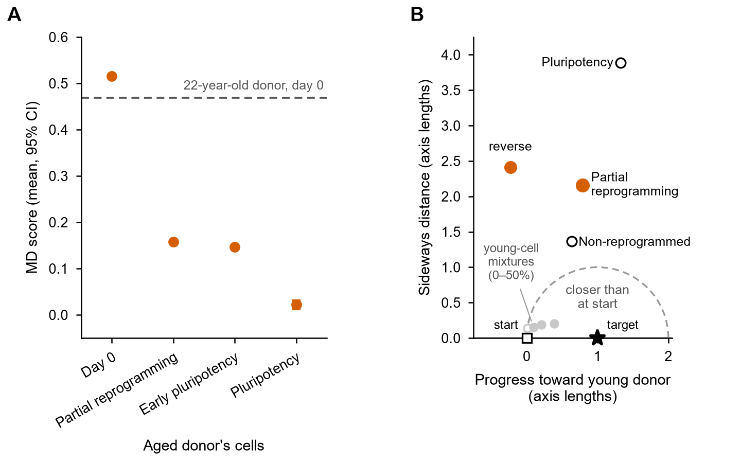
Figure 1. A published aging score falls while the cells move away from young cells. (A) MD score in the aged donor's cells by state, mean and 95% bootstrap interval over cells, with both donors scored against the same control genes. The dashed line is the 22-year-old donor's day-0 fibroblasts: the same score applied to cells that really are young. (B) The same cells in the 205 MD genes, drawn in the plane spanned by the line from the aged donor's day-0 cells (square, at 0) to the young donor's day-0 cells (star, at 1) and the direction perpendicular to it, in units of that line's length. Points inside the dashed circle are closer to the young target than the starting point was. Gray points are young-cell mixtures (0 to 50% young cells; open, 0%); the reverse test is drawn in its own frame with the donors swapped. Donors are never pooled.

The result does not depend on which genes are read
One reading of Figure 1 is that MD is simply the wrong list of genes, and that a list chosen for age rather than for mesenchymal identity would behave differently. We repeated the test in other gene spaces, rebuilding the target, the mixtures and the reverse test inside each one: the age-up and age-down lists that Lu et al. report alongside MD, derived from Fleischer et al. (3,089 of their 3,538 unique gene symbols are in the reference panel; the two published lists hold 1,533 and 2,007 entries, with one duplicated symbol each); all 23,485 genes of the panel; and, to ask whether any list at all would show an approach, 200 random gene sets of 205 genes and 200 of 3,089 genes, each matched to the real sets on expression level and on whether the genes are detected in these cells.
The answer is the same everywhere (Figure 2). In the age genes the partially reprogrammed cells cover 82% of the line toward the young donor and end 1.9 times farther from the young target than they started; in all genes, 67% and 2.0 times. Of the 400 random gene sets, none ends closer to the young target, in either direction of the test; the closest any comes is 1.81 times its starting distance. In all 400 sets the cells travel at least 1.95 times the length of the donor line, and in none of them is the move short enough to end closer given the direction it takes, so the overshoot does not depend on which genes are read. All 400 nonetheless register the 50% young-cell mixture as moving closer, so a gene set of this size is not too small to detect an approach.
The age lists are not arbitrary, which strengthens the point rather than weakening it. Their progress along the line toward the young donor, 0.822, is higher than that of all 200 random sets of the same size, so these genes do capture more of the difference between the two donors than random genes do, and the cells still end farther away.
Nor does the result depend on the other choices the test makes. The young target is a single donor, so we also defined young as the GTEx reference donors aged 20 to 39 and old as those aged 60 to 79. In all genes and in the MD genes, the partially reprogrammed cells end farther from the young group and farther still from the old one: they recede from both. In the age genes they end slightly closer to both, more so to the old group, which is movement toward fibroblasts in general rather than toward young ones (Supplementary Table S1, Supplementary Figure S1). This comparison crosses the gap between single-cell and bulk sequencing, so it shows departure clearly but could not show a small approach (Supplementary Note 1). Relabeling the cells, by clustering both donors together as Lu et al. did or by using their published per-cell labels, left every conclusion unchanged (Methods).

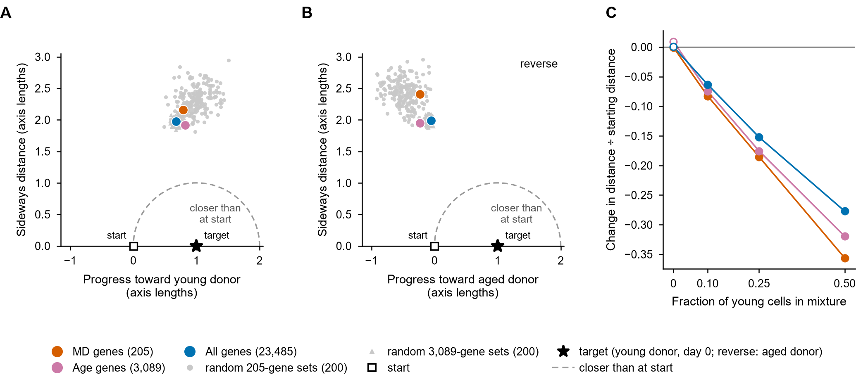
Figure 2. The result does not depend on which genes are read. (A) The test drawn as in Figure 1B for the MD genes (205), the published age-up and age-down genes (3,089) and all genes of the reference panel (23,485), with 200 random gene sets of each of the two smaller sizes matched on expression level and detection. Points inside the dashed circle are closer to the young target than the starting point was. (B) The reverse test, with the donors swapped. (C) Young-cell mixtures in the three gene spaces: change in distance to the young target divided by the starting distance, against the fraction of young cells mixed in; open symbols are the zero-mixture noise floor. No gene set ends inside the circle in A or B, and every gene set registers the mixtures as moving closer in C.

A frozen fibroblast age ruler orders donors by age
One objection remains: MD may simply be a poor measure of age, and a score that genuinely tracked donor age might not be misled. To test this we built an age score from public data. We trained a ridge-regression ruler on donor chronological age from all 23,485 genes of the reference panel, in the same 652 GTEx fibroblast donors, and froze its weights, training mean and standard deviation before any evaluation. The frozen ruler was then applied unchanged to held-out donors and to two external cohorts that differ in laboratory, protocol and sequencing platform (Table 1, Figure 3).

Table 1. Transfer of the frozen fibroblast ruler to held-out donors. ρ is Spearman correlation between the ruler score and donor age. The ruler orders donors; it is not a calibrated age in years. External cohorts are scored with the frozen unit-length projection (the direction of the fitted weights only: no added constant and no conversion into years). GTEx ages are public only as decade bins, so the GTEx rows correlate against bin midpoints. The dermal fibroblast atlas is scored with one value per person (65 donors).
Training set | Held-out cohort | n train → test | Spearman ρ (score vs age) | Permutation null
GTEx fibroblasts, site B1 | GTEx site C1 | 421 → 224 | +0.529 | p = 0.005
GTEx fibroblasts, site C1 | GTEx site B1 | 224 → 421 | +0.561 | p = 0.005
GTEx fibroblasts, 652 donors (frozen) | GSE226189, bulk | 652 → 82 | +0.549 | p = 0.005
GTEx fibroblasts, 652 donors (frozen) | Dermal fibroblast atlas, 10x, 65 donors | 652 → 65 | +0.433 | p = 0.005

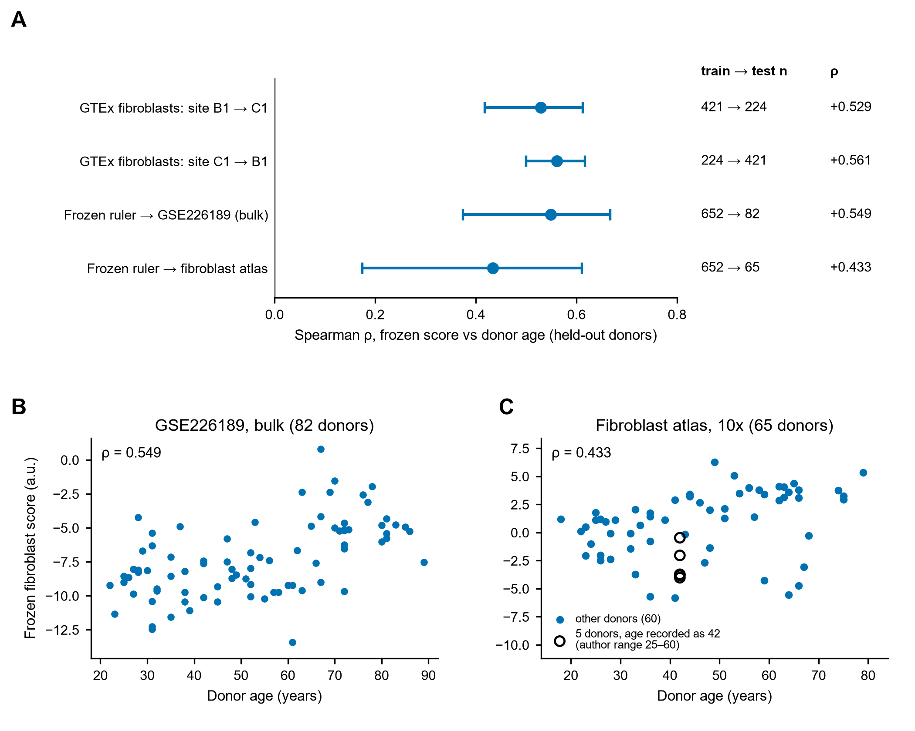
Figure 3. Transfer of the frozen fibroblast ruler. (A) Spearman ρ with donor age for every transfer in Table 1, with 95% percentile bootstrap intervals from 200 resamples of donors. (B) GSE226189 bulk cohort, 82 donors. (C) Dermal fibroblast atlas, 65 donors. Repeated samples from the same person are averaged; the 23 accessions from five donors of one constituent study, whose age is recorded as 42 but reported by the source authors only as 25 to 60 years, are drawn as open circles.

Two qualifications apply. First, transfer is an ordering, not a calibrated age. In the external cohorts the frozen score is a unit-length projection with no intercept or scale, so only the ordering can be evaluated, and we never use the ruler as an age estimate. Second, the permutation nulls shuffle donor ages with the expression matrix held fixed; p = 0.005 is the smallest value attainable with 200 permutations.
One of these transfers is weaker than it looks. The dermal fibroblast atlas integrates published studies; tracing each sequencing identifier to its source shows 65 people, including five donors whose recorded age of 42 is a placeholder for an author-reported range of 25 to 60 years. Scores were averaged within person before correlation (ρ = +0.433, 95% CI +0.174 to +0.610). The bulk cohort GSE226189, with 82 distinct donors, is the cleaner external test.

The ruler tracks donor age better than MD
If MD is to serve as an age readout, it should predict donor age. We compared three frozen instruments, none of them refit here, on two fibroblast cohorts that none of them was fitted on: the ruler, MD, and the difference between the age-up and age-down scores (Table 2, Figure 4).

Table 2. Three frozen instruments against donor age in two external fibroblast cohorts. Δρ is paired: both correlations are recomputed on the same resampled donors (B = 200), so the interval is on the difference itself rather than on the overlap of two separate intervals. Atlas scores are one value per person (65 donors).
Cohort | Ruler ρ | MD ρ | Age-up − age-down ρ | Δρ (ruler − MD) [95% CI] | Δρ (ruler − age-up/down) [95% CI]
Fibroblast atlas, 65 donors | 0.433 | 0.26 | 0.06 | +0.171 [−0.118, +0.412] | +0.372 [+0.094, +0.595]
GSE226189, bulk (82 donors) | 0.549 | 0.082 | 0.037 | +0.47 [+0.24, +0.70] | +0.51 [+0.25, +0.77]

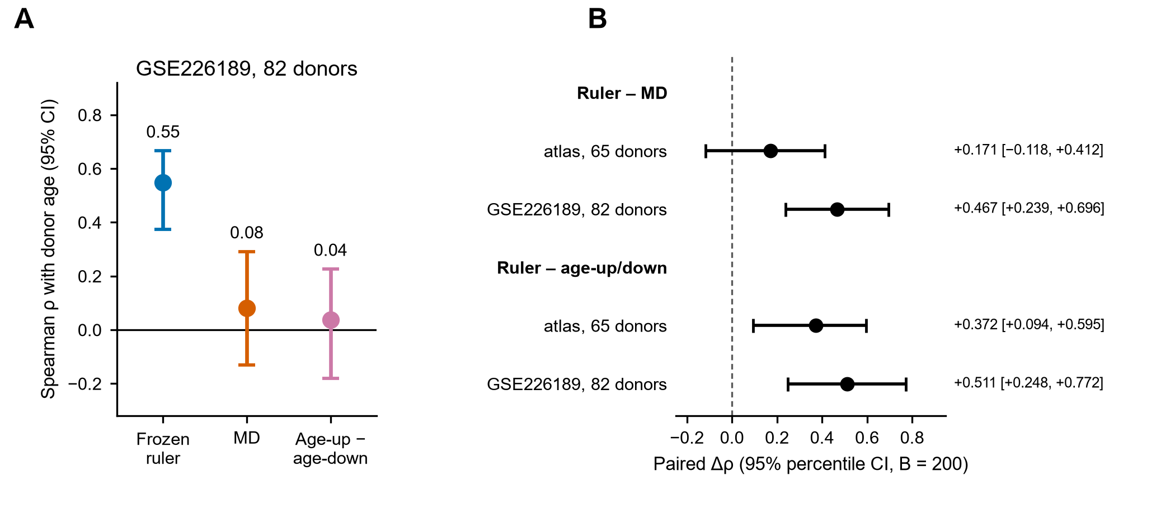
Figure 4. The frozen ruler against two curated instruments. (A) Spearman ρ with donor age for each instrument in GSE226189, with 95% percentile bootstrap intervals. (B) Paired Δρ (ruler minus the other instrument). Against MD, the atlas interval includes zero.

The evidence is therefore uneven, and we state it that way. In GSE226189 the ruler beats both curated instruments clearly, and neither MD nor the age-up and age-down lists order donors better than chance there (MD permutation p = 0.26). In the fibroblast atlas the ruler still beats the age-up and age-down lists (+0.372, 95% CI +0.094 to +0.595), but its advantage over MD (+0.171, CI −0.118 to +0.412) is not distinguishable from zero. The claim that survives is that the ruler tracks donor age better than MD in one clean cohort and at least as well in a second. MD was scored with the authors' gene list and a reimplementation of their algorithm (Methods).
Gene coverage also differed between instruments. The MD list was almost complete in both cohorts (202 and 204 of 205 genes), but the age-up list was substantially incomplete (986 and 1,040 of 1,533 genes in the atlas and GSE226189), as was the age-down list (1,595 and 1,745 of 2,007), so the ruler's advantage over the age-up and age-down lists may partly reflect missing genes rather than a weaker signature. The comparison with MD is not affected by this.
By the standard an age readout must meet, the ruler is at least as good as MD, and better in the cleaner cohort. What remains is whether that protects it from the failure shown in Figures 1 and 2.

A better age score makes the same mistake
The ruler reads the same 23,485 genes in which Figure 2 already places the reprogrammed cells, so its score and their position can be set side by side. On the ruler, the aged donor's day-0 cells score +3.22 and the young donor's day-0 cells −1.89. The aged donor's partially reprogrammed cells score +0.65, half of the way to the young donor; its early pluripotent cells score −2.62, already younger than the young donor; and its pluripotent cells score −10.40, far younger still (Figure 5A). In the same genes, the partially reprogrammed cells end twice as far from the young donor's cells as they started (Figure 2A), and the pluripotent cells nearly four times as far. The more strongly the ruler says the cells are getting younger, the farther they are from young cells. It is the same failure as MD's, in an instrument built to track donor age.
Part of the reason is a property of the ruler itself. Its score is anticorrelated with distance from its own training distribution: across 22 pseudobulks in the reprogramming dataset (one per donor, cell-state cluster and timepoint, with at least 20 cells), Spearman ρ between nearest-neighbor distance to the GTEx training donors and the frozen score is −0.625 (95% CI −0.834 to −0.320; Figure 5B), and the same sign holds within each donor separately (−0.78 and −0.81). Cells far outside the training data are scored as young. Because distance and reprogramming state move together here, this correlation cannot by itself separate an extrapolation artifact from genuine change, but it does show that a low score cannot be taken at face value.
Being better at age did not protect the ruler. Like MD, it reads movement away from the aged state as rejuvenation, because a single number has no way to register where the cells end up.

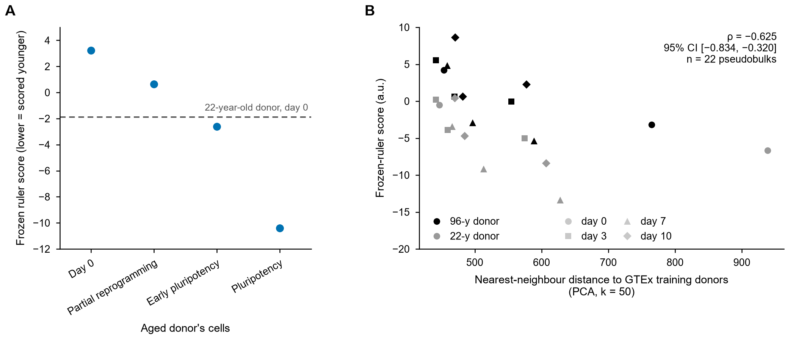
Figure 5. A better age score makes the same mistake. (A) Frozen ruler score of the aged donor's cells by state; lower is scored younger. The dashed line is the 22-year-old donor's day-0 fibroblasts. Each value is one pseudobulk, with each donor's states normalized together. In the same 23,485 genes, the partially reprogrammed cells end twice as far from the young donor's cells as they started (Figure 2A). (B) The ruler scores cells far from its training data as young. Each point is one donor × cell-state cluster × timepoint pseudobulk from the reprogramming dataset, with at least 20 cells (n = 22). Distance is the nearest-neighbor Euclidean distance to the GTEx training donors in a 50-component PCA space.

DISCUSSION
In the dataset where the distinction can be tested, what is scored as rejuvenation is well explained by departure from the aged state and is not accompanied by a measurable approach to a young cell of the same type. The MD score of the aged donor's partially reprogrammed fibroblasts falls by 7.7 times the difference between that donor and a 22-year-old donor in the same experiment, while in MD's own genes those cells end 2.2 times farther from the young donor's cells than they started. The same holds in the published age gene lists, in all 23,485 genes, in 400 random gene sets, against a GTEx-defined young group, and for a frozen ruler built to track donor age. Young-cell mixtures show the measure would have seen an approach had one occurred, and reverse tests show the movement is not mutual convergence of two donors.
This is not a claim that partial reprogramming fails to rejuvenate. Lu et al. report functional improvements, including in aged mouse liver, that transcriptome distance cannot adjudicate, and the in vivo results in particular lie outside what these data can test. Nor is it a claim that the confound went unnoticed: Lu et al. track cell state explicitly throughout their trajectory. The claim is narrower. A readout of this form cannot separate approach from departure, and in the data examined here the movement is too long to end closer to a young cell of the same type, whatever its direction.
The mechanism is the same in kind across readouts of this form. A curated identity-gene signature such as MD falls whenever the cell type is abandoned, which is why MD tracks position along the reprogramming trajectory well and donor age weakly. A directional score learned by regression can be confounded with distance from its own training distribution, so cells that leave the manifold can score young; we show this for our own ruler rather than only for other people's. A correlation-based reversal score ignores how far a cell moves, so it registers orientation without destination. Changing the genes does not help: the same cells end farther from the young target in every gene set we tested. The problem is the shape of the statistic, not its gene content.
The field already uses the right form of statistic for half of this problem. Cell identity is routinely judged by how closely an engineered population resembles a target cell type, as CellNet (Cahan et al.) and its successors do for reprogramming and direct conversion, and the finding that converted cells retain programs of their starting population is exactly a statement about where they ended up. Age is still judged by direction: a score that falls. Our proposal is that age be evaluated the way identity already is, against a target the intervention is supposed to reach, with the distance to that target reported rather than the sign of a projection. The two then have the same form and can be reported together, which is what a rejuvenation claim needs: this cell type, and young. Distance to a young control has been used before: Roux et al. report that transiently reprogrammed aged mouse cells end closer to young controls. Those cells were profiled after the reprogramming factors were withdrawn, and their displacement is small relative to the age gap; the cells tested here are assayed during OSKM expression and travel more than twice that gap.
The remedy is cheap to adopt. Define the young target on the same platform as the intervention. Report the change in distance to it alongside progress along a direction. Include a dose-response positive control, so that a null result can be told apart from an insensitive assay, and report the zero-dose point as the noise floor rather than assuming it is zero. Include a reverse test, so that mutual convergence of two samples is not read as rejuvenation of one. Report an identity check alongside the headline number. Check that every reported interval contains its point estimate, and say so when one does not. None of this requires new data: all of the analyses here were performed on public data.
A direct next test is whether any of the 1,836 transcription-factor perturbations in the Southard et al. fibroblast CRISPRa Perturb-seq screen produces a measurable approach to a young target rather than only departure from an old one.

LIMITATIONS
• The reprogramming analysis rests on two donors in one experiment, so donor-level variance cannot be estimated, and in the same-platform test age is confounded with individual. The aged-to-young donor axis is itself nearly orthogonal to the GTEx donor-age axis.
• The partially reprogrammed population tested is dominated by day-3 cells assayed during OSKM expression.
• Cell-state assignments in the reprogramming data are cluster-level signature labels, not lineage tracing. Our labels come from a reimplementation of the published pipeline, run on each donor separately; re-clustering both donors together and using the authors' published labels left every conclusion unchanged, but neither alternative is lineage tracing either.
• The GTEx-anchored positive control ends at the young centroid itself and runs entirely within bulk data, so it shows that a full approach is visible, not that a partial approach across the bulk-to-single-cell gap would be.
• The gene-space comparison tests whether the result depends on which genes are read, not whether some other signature could show an approach. The random sets are matched for size, expression level and detection, and none of the 400 showed one, but they are not an exhaustive search over gene sets.
• In the MD genes the published score is a per-cell module score and the geometry a Euclidean distance; the equal-weight direction used to explain why the score falls approximates the published score rather than reproducing it.
• Some distance intervals in the all-gene and age-gene tests do not contain their point estimates and are flagged invalid; claims that depend on them rest on point estimates. The zero-mixture progress offset in all genes (+0.115) is reported as a noise floor, but its direction was not explained (Supplementary Note 2).
• In the single-cell external fibroblast cohort, an integration of published studies, scores are one value per person (65 donors), and some recorded ages are placeholders. The ruler transfers, but its advantage over MD in that cohort is not distinguishable from zero.
• GTEx donor age is public only in decade bins, so the ruler was trained and evaluated against bin midpoints rather than exact ages.
• Not every number reported here is a gated, pre-specified result: readings were withdrawn and superseded during the project (the superseded text is retained in the archive), and descriptive summaries, namely the per-state scores, the ratios of final to starting distance and the extrapolation correlation, carry no decision rule.
• Transcriptome distance is a molecular proxy. It cannot adjudicate functional rejuvenation, in vivo results, or non-transcriptional mechanisms.
• In the same-platform test the displacement exceeds twice the donor gap, so no approach could have been registered whatever its direction; that test shows overshoot rather than a failed search for approach. The GTEx-anchored test, where an approach was attainable, gives a near-orthogonal result instead.

METHODS

Pre-registration and decision rules
Each gated analysis was specified in writing before any number was computed, including its statistics, nulls, positive controls, decision thresholds and the exact wording of each possible conclusion. A flag file was written before execution and the pre-registration text is reproduced verbatim in the results file for each analysis. Only the pre-registered reading whose conditions fired is reported as the conclusion of that analysis. Where a later analysis superseded an earlier reading, the earlier text was retained and marked withdrawn or superseded rather than edited. Nine readings across the project are marked this way, three of which concern analyses reported here; all are listed in the repository. These are self-administered protocols recorded in the project repository, not deposits with an external registry. Diagnostics and descriptive summaries are not treated as gated results. A published transcription-factor screen was analyzed in the same project and pre-registered in the same way, with its deviation recorded alongside it; it does not bear on the question tested here and is not reported in this paper. Their pre-registrations, code and results, including a transfer that failed its gate, are in the archive.

The ruler
The ruler is a ridge regression of donor chronological age on z-scored gene expression, fit through the n × n Gram matrix, and frozen with its coefficients and its training mean and standard deviation before any evaluation. The regularization parameter was selected over the grid 0.01, 0.03, 0.1, 0.3, 1, 3, 10, 30, 100, 300, 1000, 3000, 10000 by minimizing a leave-one-out residual sum of squares computed from the hat-matrix diagonal, not by grouped cross-validation. The frozen fibroblast ruler stores alpha = 0.01, the smallest value on the grid, so a smaller optimum cannot be excluded. The frozen fibroblast vector is the ridge coefficient vector, unit-normalized and sign-aligned so that the score increases with age. Transfers within GTEx use the full prediction (training mean age plus the ridge coefficients applied to the z-scored profile), which is in years. The external cohorts and all reprogramming analyses use the frozen unit-length score, which orders samples identically but has no intercept or scale and is not in years. Within-site fibroblast cross-validation, grouped by sequencing batch with up to five folds, reports ρ but does not choose alpha. The ruler was never refit on any evaluation cohort.
Training data. GTEx v10 cultured fibroblasts, 652 donors including the seven donors at the small collection site D1, 23,485 genes after filtering. Genes were retained at a count of at least 6 in at least 20% of samples. Counts were TMM-normalized (edgeR-style, log-ratio trim 0.30, absolute-expression trim 0.05, factors scaled to geometric mean 1), converted to log2 counts per million with prior count 2, and z-scored with the training mean and standard deviation; standard deviations below 1e-12 were set to 1. Site D1 is included in the freeze and excluded from the B1 to C1 transfer and from within-site cross-validation, which is stated rather than silently applied.
Donor age. GTEx releases donor age publicly only in decade bins, so every GTEx statistic, including the site transfers and the young and old anchors, uses bin midpoints or bin membership rather than exact ages. The external cohorts provide ages in years, except that some constituent studies of the fibroblast atlas report an age range or a single rounded age for several donors; those recorded values were used as given.
Analysis unit in the fibroblast atlas. The atlas's donor field holds one identifier per sequencing sample in several constituent studies. Each identifier was traced to its source study and the original author's donor identifier, and pseudobulk scores were averaged within each person before any correlation, permutation or bootstrap, giving 65 donors (64 after dropping pseudobulks with fewer than 30 cells, which gave the same conclusion). Seeds and resampling settings were unchanged. This grouping was not pre-registered. The pre-registered analysis treated each of the 93 pseudobulks as a unit and gave ρ = +0.455; we report the per-person analysis because repeated samples from one person are not independent, and it gives the lower value. The ruler-minus-MD difference computed on the 93 pseudobulks is superseded by the per-person value in Table 2.

Applying a frozen ruler to a new dataset
All datasets, including the external cohorts and the reprogramming data, are processed identically to the training set: counts summed per group, TMM-normalized, converted to log2 CPM with prior count 2 across that analysis's own pseudobulk panel, then z-scored with the frozen GTEx training mean and standard deviation. Genes absent from the new dataset are set to zero after the frozen z-score, as are genes present but all-zero in that panel. Of the 23,485 ruler genes, 21,351 are present in GSE226189, 17,047 in the fibroblast atlas and 20,452 in GSE297234. Because TMM is estimated within each analysis panel, a statistic computed on that panel is coupled to the panel's membership, which is why bootstrap resamples re-estimate it.

Displacement statistics
For a displacement d from an origin pseudobulk toward a target direction v we report three quantities. Cosine alignment is d·v / (‖d‖ ‖v‖). Progress along the axis is d·v / ‖v‖², which equals 0 at the origin and 1 at the target. The change in distance is ‖z_S − z_target‖ − ‖z_origin − z_target‖, so a positive value means the state ended farther from the target. The sideways component is ‖d − progress·v‖ / ‖v‖, in units of the axis length. In the same-platform test, where the axis ends at the target, final distance divided by starting distance equals √((1 − progress)² + sideways²), so a state ends closer only if it falls inside the unit circle drawn in Figures 1B and 2.
The two cosines in this paper are not interchangeable and are never combined. In the GTEx-anchored test the target direction is the unit vector from the old centroid to the young centroid, and the reported change in distance is to the young centroid. In the same-platform test the axis runs from one donor's day-0 cells to the other donor's day-0 cells, and progress is the projection defined above. This distinction matters numerically: the change in distance at pluripotency is +184 on the GTEx axis and +382 within the experiment, and those are two different measurements of two different things.
In the GTEx-anchored test, a state counts as approaching young only if its alignment is positive and beats both nulls and its distance to the young centroid decreases; in the same-platform test, only if its distance to the young target decreases. Alignment or progress alone is reported as departure from old, not as approach.

Cell-state labels
Cells were assigned to five states (fibroblast, partially reprogrammed, early pluripotent, pluripotent and non-reprogrammed) by Louvain clustering of each donor's cells separately, with a Python reimplementation of the published pipeline (log-normalization with regression on the mitochondrial fraction, 3,000 variable genes, 50 principal components, resolution 0.8; the published pipeline uses sctransform in Seurat, which was not available), and labeling each cluster with the published state signatures. States are pooled across timepoints within each donor. Two alternative labelings were used as checks. Re-clustering both donors together, as Lu et al. did, changed the label of 7.8% of the aged donor's cells and 8.3% of the young donor's. The authors' published per-cell states (16 sub-states in the combined object deposited with GSE297234, grouped into the five states by name) agree with ours for 80% of the aged donor's cells and 72% of the young donor's; cells absent from the published object were excluded. Where day-0 fibroblast membership changed, the day-0 half-split was redrawn with the same seed. With the joint labels, the change in distance to the young target was +133.3 in all genes and +17.5 in the MD genes (original labels +130.9 and +17.1); with the published labels, +135.8 and +17.8. In every case the mixture control passed and the interval on the forward-minus-reverse asymmetry excluded zero, and the MD drop was 7.8 and 8.0 times the donor gap (original 7.7). The GTEx-anchored change in distance to the young centroid was +9.4 with the joint labels and +15.8 with the published labels (original +9.4).

Signature scores and gene spaces
Signature scores. MD, the age-up and age-down lists and the cell-state signatures are the published gene lists, scored with a Python reimplementation of the Seurat AddModuleScore algorithm on log-normalized counts (24 expression bins, 100 control genes per bin, scale factor 10,000). For the per-state MD scores reported above and in Figure 1A, the two donors were placed on a single gene axis and one set of bins and control genes was drawn from the pooled cells of both donors, so that the two donors' scores are on the same scale; the source pipeline scores each donor separately, which widens the ratio of the reprogramming drop to the donor gap from 7.7 to 13.0 and does not otherwise change the result.
Gene spaces. A gene space is a subset of the reference panel's 23,485 genes. Every space uses the same TMM-normalized, frozen z-scored matrix, with the columns selected afterwards, so normalization is never re-estimated on a subset. Published symbols are matched to the panel's symbols exactly after trimming and upper-casing, with no alias resolution: 205 of 205 MD genes, 1,312 of 1,533 age-up genes and 1,777 of 2,007 age-down genes map, the two age lists do not overlap, and 43 genes are shared between MD and the age lists. Within each space the origin, the target, the axis, the mixture control and the reverse test are rebuilt from that space's own columns rather than projected from the full space. Cosines and distances are not comparable between spaces of different dimension, so every cross-space statement uses progress, the perpendicular component in axis lengths, the ratio of final to starting distance, or the random-set baseline. Random sets are drawn without replacement within strata defined by 24 equal-count bins of the frozen GTEx training mean crossed with whether the gene has any reads in the panel, so that a random set of a given size has the same expression profile and the same number of undetected genes as the real set it is compared with.

Nulls, intervals and multiple testing
All nulls use 200 draws and an empirical p-value of (exceedances + 1) / 201. Three constructions appear, and they are not interchangeable. A donor-label permutation shuffles donor age within the training bank, holding the expression matrix fixed, and is the null for every transfer statistic. A gene-permutation null shuffles the entries of the frozen target direction across genes, and tests whether a cosine is larger than for a direction with the same coefficient distribution. An anchor null rebuilds the young-minus-old direction from equal-size random splits of all GTEx fibroblast donors, ignoring age, and tests whether an alignment is specifically with age rather than with any donor contrast.
Confidence intervals are 200-draw percentile bootstraps at the 2.5th and 97.5th percentiles. The resampling unit is the donor for transfer statistics and the cell for displacement statistics. Paired comparisons recompute both quantities on the same resampled donors, so that the interval is on the difference rather than on two separate intervals. Any interval that does not contain its own point estimate is flagged invalid and is not used as a gate; this happens for distance, cosine and sideways-component intervals in the high-dimensional displacement tests and is reported at each occurrence.
Seeds are fixed: 20260914 for splits, permutations and null directions, 20260918 for bootstraps, with an independent generator per cell.

Positive controls
No test is interpreted until a control has recovered a known effect, and the controls are rebuilt inside each gene space rather than carried over from the full space. Two kinds are used. In the same-platform test, synthetic mixtures combine known fractions of young day-0 cells into aged day-0 cells at fixed total cell count; the control passes if progress increases monotonically with the mixing fraction, the interval on progress at the highest fraction excludes zero, and the change in distance at that fraction is negative. The zero-mixture point is reported as the noise floor and is not subtracted. In the GTEx-anchored test, five folds displace held-out old donors toward the training fold's young centroid; the bar was every fold cosine above 0.5, and the observed minimum was 0.615 in all genes, 0.733 in the MD genes and 0.681 in the age genes.

Datasets

Table 3. Datasets used in this paper. All are public. Accession-level detail and per-cohort sample tables are in the repository.
Dataset | Identifier | Use here
GTEx v10 cultured fibroblasts | GTEx Portal release v10 (dbGaP phs000424) | Ruler training (652 donors); young and old anchors (113 and 231 donors)
Consensus dermal fibroblast atlas | CELLxGENE a19d1667-a7b5-4556-9e5f-f9bfa690c0f1 | External fibroblast transfer, 65 donors, 10x assays only
Human skin fibroblast bulk RNA-seq | GSE226189 | External fibroblast transfer, 82 donors
OSKM reprogramming time course | GSE297234 | Reprogramming tests (two donors, days 0, 3, 7, 10)
Gene sets | MSigDB Hallmark EMT; Lu et al. supplementary tables | MD signature; age-up and age-down lists; cell-state signatures

Software
Analyses were implemented in Python 3.12.7 with numpy 2.5.3, scipy 1.18.1, pandas 3.0.5, scikit-learn 1.9.1, anndata 0.13.3.post0 and h5py 3.16.0, and figures were drawn with matplotlib 3.11.2. Versions were recorded from the analysis environment at the time of writing; the full listing is in the repository. Entry-point scripts, one per analysis, are listed in the repository README and reproduce every table in this paper from the frozen instruments and the public inputs. Seeds are given above. Seurat v5 and sctransform were not available in this environment; the AddModuleScore reimplementation (Signature scores, above) is a deviation from the published MD pipeline rather than a substitution.

DATA AND CODE AVAILABILITY
All input data are public and are listed in Table 3. Analysis code, the frozen instruments, the pre-registration documents with their timestamp flags, and every result table used in this paper are available at [GITHUB REPOSITORY URL] and archived at [ZENODO DOI]. The frozen fibroblast ruler is a single file containing the unit weight vector, the un-normalized coefficients and the training mean and standard deviation over 23,485 genes; the young and old GTEx anchors are provided as a separate file. The repository README lists the entry-point script that reproduces each table and figure. Raw input data are not redistributed and must be obtained from the sources in Table 3.

AUTHOR CONTRIBUTIONS
R.K. is the sole author. He conceived the study, specified the analyses and their pre-registered decision rules, directed their execution, and is responsible for the manuscript.

USE OF AI TOOLS
Analysis code was written by AI coding agents under the author's written pre-registration protocols, and the manuscript was drafted with AI assistance. The author reviewed all analyses and takes full responsibility.

ACKNOWLEDGMENTS
The author thanks the investigators and consortia who generated and publicly released the datasets analyzed here, including the GTEx Consortium, the authors of the studies integrated in the dermal fibroblast atlas, and the authors of GSE226189 and GSE297234. The Genotype-Tissue Expression (GTEx) Project was supported by the Common Fund of the Office of the Director of the National Institutes of Health, and by NCI, NHGRI, NHLBI, NIDA, NIMH and NINDS. The data used for the analyses described in this manuscript were obtained from the GTEx Portal. This work received no specific funding.

REFERENCES
1. Lu, J. Y. et al. Prevalent mesenchymal drift in aging and disease is reversed by partial reprogramming. Cell 188, 5895–5911.e17 (2025).
2. Southard, K. M. et al. Comprehensive transcription factor perturbations recapitulate fibroblast transcriptional states. Nat. Genet. 57, 2323–2334 (2025).
3. GTEx Consortium. The GTEx Consortium atlas of genetic regulatory effects across human tissues. Science 369, 1318–1330 (2020).
4. Ascensión, A. M. & Izeta, A. A consensus single-cell transcriptomic atlas of dermal fibroblast heterogeneity. bioRxiv 2024.09.05.611379 (2024).
5. Fleischer, J. G. et al. Predicting age from the transcriptome of human dermal fibroblasts. Genome Biol. 19, 221 (2018).
6. Liberzon, A. et al. The Molecular Signatures Database hallmark gene set collection. Cell Syst. 1, 417–425 (2015).
7. Hao, Y. et al. Dictionary learning for integrative, multimodal and scalable single-cell analysis. Nat. Biotechnol. 42, 293–304 (2024).
8. Robinson, M. D. & Oshlack, A. A scaling normalization method for differential expression analysis of RNA-seq data. Genome Biol. 11, R25 (2010).
9. Takahashi, K. & Yamanaka, S. Induction of pluripotent stem cells from mouse embryonic and adult fibroblast cultures by defined factors. Cell 126, 663–676 (2006).
10. Ocampo, A. et al. In vivo amelioration of age-associated hallmarks by partial reprogramming. Cell 167, 1719–1733.e12 (2016).
11. Gill, D. et al. Multi-omic rejuvenation of human cells by maturation phase transient reprogramming. eLife 11, e71624 (2022).
12. Horvath, S. DNA methylation age of human tissues and cell types. Genome Biol. 14, R115 (2013).
13. Hannum, G. et al. Genome-wide methylation profiles reveal quantitative views of human aging rates. Mol. Cell 49, 359–367 (2013).
14. Kabacik, S. et al. The relationship between epigenetic age and the hallmarks of aging in human cells. Nat. Aging 2, 484–493 (2022).
15. Tsitsipatis, D. et al. Transcriptomes of human primary skin fibroblasts of healthy individuals reveal age-associated mRNAs and long noncoding RNAs. Aging Cell 22, e13915 (2023).
16. Cahan, P. et al. CellNet: network biology applied to stem cell engineering. Cell 158, 903–915 (2014).
17. Roux, A. E. et al. Diverse partial reprogramming strategies restore youthful gene expression and transiently suppress cell identity. Cell Syst. 13, 574–587.e11 (2022).

SUPPLEMENTARY INFORMATION

Supplementary Note 1. Young defined by GTEx donors
Anchors were the mean expression of the GTEx reference donors aged 20 to 39 (n = 113) and 60 to 79 (n = 231), with the 40 to 59 bins excluded. In all genes, the aged donor's partially reprogrammed displacement is almost orthogonal to the young-minus-old axis (cosine +0.077). That small alignment survives a gene-permutation null (p = 0.005) but not a null in which GTEx donors are split at random ignoring age (p = 0.39), so it is not specifically an age alignment. The cells end farther from the young centroid (+9.4) and farther from the old centroid (+10.9): they recede from both. A five-fold positive control, in which held-out old GTEx donors are displaced toward the young centroid, gave fold cosines of 0.615 to 0.874, above the bar of 0.5, so the statistic registers a genuine approach when one occurs (Supplementary Figure S1D); the control also passes in the MD genes (0.733 to 0.895) and the age genes (0.681 to 0.895).
That control has a limit worth stating. It runs entirely within GTEx bulk data and ends at the young centroid itself, whereas the reprogramming origin is a single-cell pseudobulk that already sits 467 units from the young centroid while the young and old centroids are only 32 apart (42.0 and 3.3 in the MD genes; 164.0 and 12.3 in the age genes). The GTEx-anchored distances are therefore dominated by the platform gap, and the control does not show that a partial approach would be visible across that gap. This is why the main test uses a young target measured in the same experiment.
Along the full trajectory, cosine alignment with the youth axis rises from partially reprogrammed to early pluripotent to pluripotent cells (+0.077, +0.117, +0.126), while the change in distance to young fibroblasts rises far faster (+9.4, +30.5, +184.0) and the ruler score falls (+0.65, −2.62, −10.40). The farther the cells travel from the aged fibroblast state, the younger they look on a directional score and the less they resemble a young fibroblast. The distance traveled is not monotonic across these states (271.7, 268.6, 546.4 units), so cosine order and displacement order are not the same ordering.

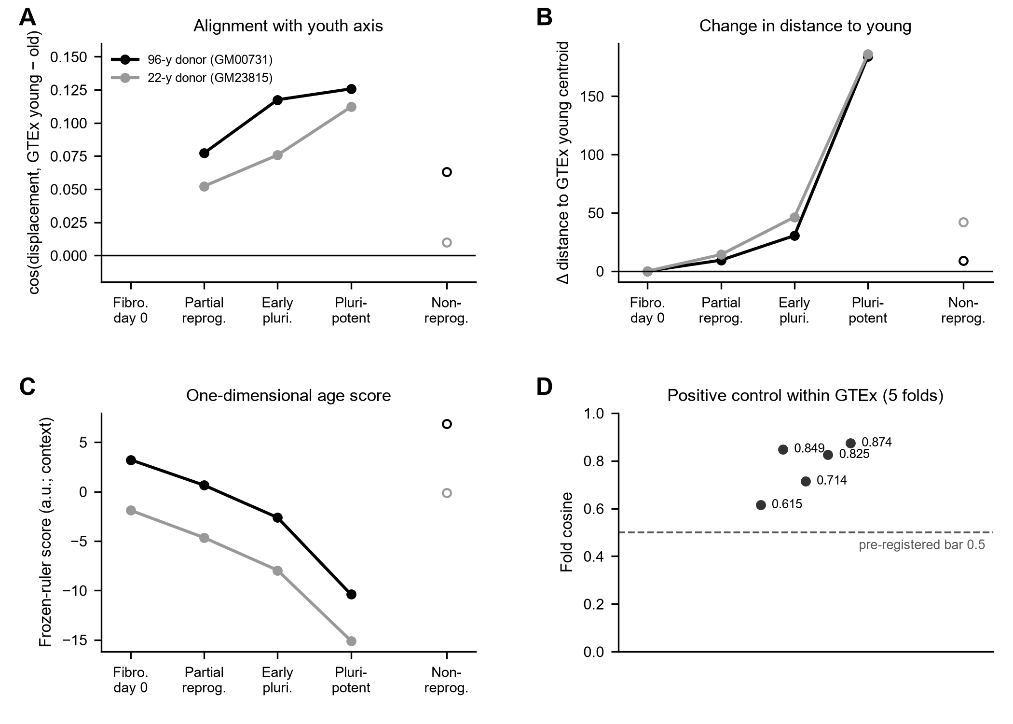
Supplementary Figure S1. Reprogramming states against a GTEx-defined youth axis, all genes. (A) Cosine between each state's displacement from day-0 fibroblasts and the GTEx young-minus-old direction. (B) Change in Euclidean distance to the GTEx young centroid; positive is farther. (C) The frozen ruler score of each state, shown as context. (D) Positive control: the 652 GTEx fibroblast donors were split into five folds; in each fold, held-out old donors were displaced toward that fold's young centroid. Open symbols in A to C are non-reprogrammed cells (OSKM-exposed cells that remained off the reprogramming path), not a second day-0 sample. Donors are never pooled; the 22-year-old donor is a contrast, not a replicate.
Supplementary Table S1. The GTEx-anchored test in three gene spaces, aged donor (GM00731). Change in Euclidean distance from the donor's day-0 fibroblasts to the GTEx young (20 to 39 years) and old (60 to 79 years) centroids, restricted to each gene space; positive is farther. The last column is the lowest fold cosine of the five-fold positive control in that space (pass bar 0.5). In every space the day-0 cells start far from both centroids relative to the young-to-old gap (all genes 467.5 against 32.3; MD genes 42.0 against 3.3; age genes 164.0 against 12.3), so this test shows departure but could not show a small approach.
Gene space | Cell state (aged donor) | Change in distance to GTEx young | Change in distance to GTEx old | Five-fold control, lowest fold cosine
All genes (23,485) | Partially reprogrammed | +9.4 | +10.9 | 0.615
 | Early pluripotent | +30.5 | +32.7
 | Pluripotent | +184.0 | +188.3
 | Non-reprogrammed | +8.9 | +9.8
MD genes (205) | Partially reprogrammed | +6.5 | +7.0 | 0.733
 | Early pluripotent | +7.4 | +8.0
 | Pluripotent | +28.2 | +29.2
 | Non-reprogrammed | −1.4 | −1.3
Age genes (3,089) | Partially reprogrammed | −5.4 | −5.9 | 0.681
 | Early pluripotent | +1.7 | +2.1
 | Pluripotent | +44.7 | +45.9
 | Non-reprogrammed | −1.0 | −0.7

Supplementary Note 2. The same-platform test in all genes
In all 23,485 genes, the young-cell mixtures at 0%, 10%, 25% and 50% produced monotonically increasing progress (0.115, 0.182, 0.283, 0.441) and monotonically decreasing distance (+0.07, −7.87, −18.91, −34.44), so the statistic could have detected an approach had one occurred. Two caveats attach to that control. The zero-mixture point does not sit at zero progress (+0.115); the anchors are built from one random half of the day-0 cells and the mixtures from the other, so some offset is expected, but why it leans toward the young target was not resolved by our diagnostics, and it is reported as the statistic's noise floor rather than subtracted. In the MD genes the same offset is 0.010. And in all genes the bootstrap intervals on the distance values do not contain their point estimates and are flagged invalid, so there the monotonicity claim rests on the point estimates alone; the intervals on progress, used as the gates, are valid.
With the roles of the donors reversed, the young donor's partially reprogrammed cells do not move toward the aged donor at all in all genes (progress −0.057, 95% CI −0.063 to −0.054), giving a clear asymmetry (+0.732, CI +0.724 to +0.740). The forward movement is therefore not symmetric mutual convergence. But it is also not obviously age: the aged-to-young donor axis is itself nearly orthogonal to the GTEx donor-age axis (cosine 0.039), so with one donor at each age we cannot separate age from everything else that differs between two cell lines, including proliferative state and culture history. The test can, and does, say that the cells did not approach the young line.

