Dragonflies and damselflies are both part of the order Odonata. They are insects with six legs and three body parts: head, thorax and abdomen. The Sub-Orders are Anisoptera for dragonflies and Zygoptera damselflies.

Generally, dragonflies are larger than damselflies. They have larger wings that stick out sideways from their bodies. They are fast, powerful flyers. They are usually thicker in the head, thorax and abdomen than damselflies. Damselflies generally have their wings folded back over their thorax and abdomen. Most are smaller than dragonflies. They have weak, fluttery flights, but can show short bursts of speed.

Dragonflies and damselflies live around water. They need it to reproduce. The nymphs live in water. This means ponds, wetlands and streams. Having said that, dragonflies and damselflies wander. They also get caught up in the wind of weather systems. I have seen them in the parking lot at the shopping center on Snow Road.

A general life cycle of dragonflies and damselflies is that the male and female mate (wheels), the female lays eggs on plants in the water, the eggs hatch, the nymphs spend one or more years in the water. They eventually climb up out of the water onto plants. Their exoskeleton will split down the back. The dragonfly comes out. It pumps fluid into its wings and abdomen. The wings and abdomen dry out and stiffen. They spend one season as adults.

Damselfly nymphs:
https://www.inaturalist.org/observations/365748250

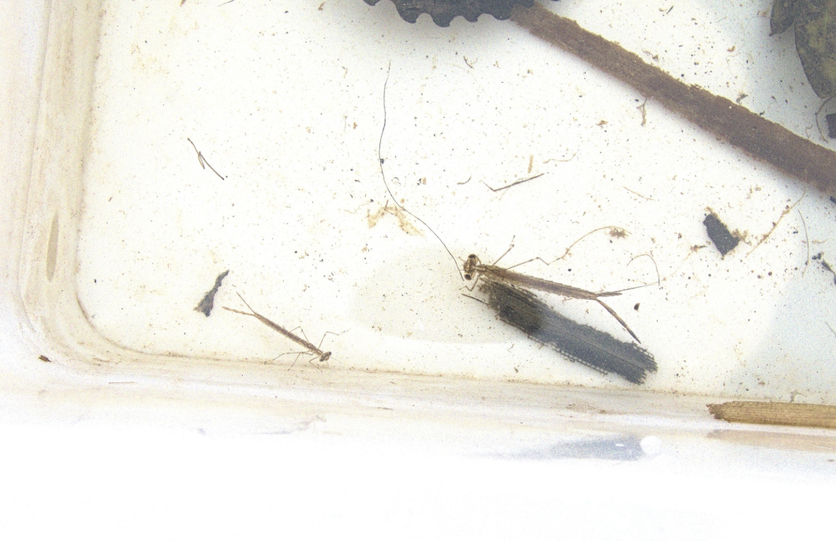

Sequence of a common green darner emerging:
https://www.inaturalist.org/observations/313103592

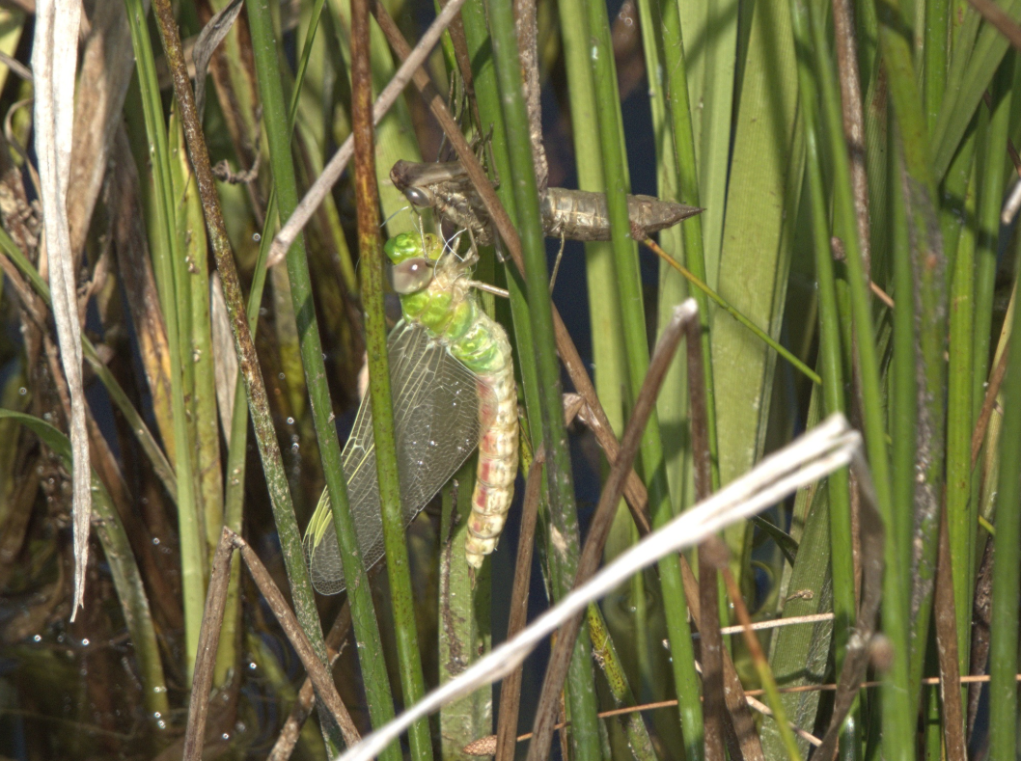

Common whitetail:
https://www.inaturalist.org/observations/301270434

